Your Instructor — Imran Ahmad, PhD
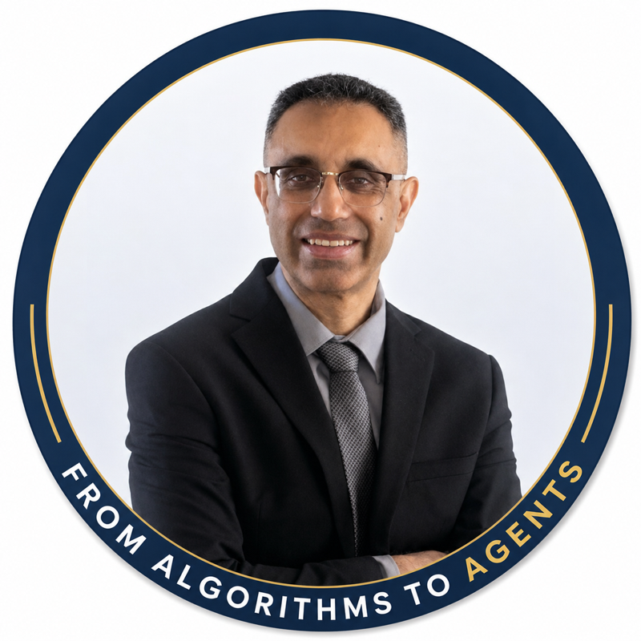
Google Cloud Authorized Trainer · Google Certified Professional – Data Engineer · AWS Authorized Instructor (AAI) · Microsoft Certified Trainer (MCT) · Author, Packt Publishing — linkedin.com/in/cloudanum · github.com/cloudanum · Ottawa, ON, Canada. 20+ years designing, building, and teaching large-scale data systems — across Google Cloud, AWS, and Azure.

Multi-cloud by practice, not by slide
Imran works and teaches across all three major clouds — Google Cloud, AWS, and Azure — and holds instructor credentials on each side of the fence: Google Cloud Authorized Trainer and Google Certified Professional Data Engineer, AWS Authorized Instructor (AAI), and Microsoft Certified Trainer (MCT). That matters in this room: your world is SQL Server, SSIS, and Power BI, and your target is BigQuery — he is fluent in both, and can translate between them instead of reading you a Google script.

Large-scale data engineering — the craft
- Production pipelines at national scale. He architects and builds production data pipelines over high-volume, multi-source datasets — distributed processing with PySpark and cloud data platforms feeding mission-critical, high-stakes workflows where reliability and auditability are not optional.
- A PhD in data processing. His doctoral research attacked the core problem of moving and processing very large datasets across distributed computing infrastructure — culminating in a large-scale data-processing algorithm of his own design, built on cloud/grid computing.
- Pioneered techniques for large-scale processing. That work introduced scheduling and data-movement techniques for processable bulk data that were ahead of their time — published in peer-reviewed venues (ACM, IEEE) and applied to real data-intensive science, including experiments generating neutrino-particle data.
- A trainer of data teams. Hundreds of corporate engagements worldwide — including data engineering and cloud training for Citibank, JP Morgan, the United Nations, Deloitte, and the European Commission — most of them, like yours, senior teams modernizing from on-prem platforms to cloud data stacks.

AI and agents — the second act
- Author of four Packt books, including 30 Agents Every AI Engineer Must Build, the bestselling 50 Algorithms Every Programmer Should Know, and Architecting AI Software Systems.
- Builds agentic AI systems for high-stakes, mission-critical workflows — LLM-based extraction and triage systems delivered to production validation teams.
- ATLAS — an open-source, production-grade Agentic RAG platform (LangGraph, corrective RAG, self-verifying answers), built as a public showcase of industrial LLM engineering standards.
- Authored a 9-module Designing and Deploying AI Agents curriculum with a full lab series, and an Agentic Security: Attack and Defend AI Agents course; 32K+ followers read his writing on applied AI.

In the classroom
Visiting Professor at the University of Ottawa, and a long-tenured authorized instructor with ROI Training. His calibration rule for this room: you are senior in data engineering and new to one console — so we skip re-teaching what you own and spend our time on where things live in GCP.
"I build large data systems for a living. These two days map that craft onto Google Cloud — through your migration, not a generic tour."

The books
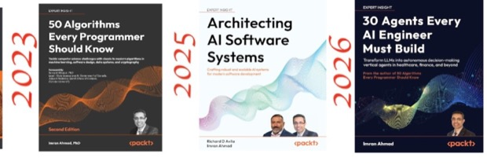
30 Agents Every AI Engineer Must Build (Packt) — thirty production-ready agent architectures: perception, memory, reasoning, planning, multi-agent collaboration, and ethical alignment. The full source code and labs are open: github.com/PacktPublishing/30-Agents-Every-AI-Engineer-Must-Build. His other titles: 50 Algorithms Every Programmer Should Know (the bestseller, second edition), 40 Algorithms Every Programmer Should Know, and Architecting AI Software Systems.

Everything from class — links worth keeping
Link | What it is
survey.anum.cloud | Pre-course survey — fill in your row before Monday 9:00 AM
github.anum.cloud | This student pack — schedules, notes, lab companions, slides (Word + PDF)
meet.google.com/ogk-ivdv-bhi | Google Meet — join here both days, 9:00 AM CT
Google Skills classroom | All hands-on labs (temporary GCP projects)
Google check-in | Google's attendance record for the class
On-demand credits | 50 free lab credits per training day, valid 30 days — re-run the labs after class
Course evaluation | 3 minutes at the end of Day 2
Book code | All 30 agents, open source

Google Cloud & data engineering — the reading list I hand to data teams
Curated from the ROI instructor community's Google Cloud Helpful Links doc, filtered to what your migration actually touches.
BigQuery, end to end
- BigQuery introduction and BigQuery under the hood — start here
- Standard SQL reference — your T-SQL habits, translated
- Partitioned tables and clustered tables — your tuning toolkit
- Performance best practices, query plan explanation, and controlling costs
- Batch loading, the Data Transfer Service, and scheduled queries
- External data on Cloud Storage and slots, explained
- bigquery-utils — community UDFs worth stealing, and the BigQuery sketchnote for your wall
Migration and replication
- Datastream overview, supported sources, and the replicate-to-BigQuery quickstart
- Storage Transfer Service and on-premises transfers — for the historical bulk moves
Dataform — your Silver→Gold tool
- Dataform overview, SQL workflows, assertions, and the release lifecycle that maps to your CI/CD discipline
Cloud Storage — your Bronze layer
- Introduction, best practices, lifecycle management, and the gcloud storage CLI
Staying current
- Google Cloud blog — data analytics, release notes, and what's new every week
- ROI Training's Google Cloud certification roadmap — where to go after these two days (the 3-day Data Warehousing course is next)
- Looker Studio with BigQuery — for the Power BI authors curious about the Google-side BI option

Scan to connect

linkedin.com/in/cloudanum — course follow-ups welcome. That's where the agents writing, the book updates, and the weekly applied-AI newsletter live.

