**Assignement**

**Step 1 – git reprository created**

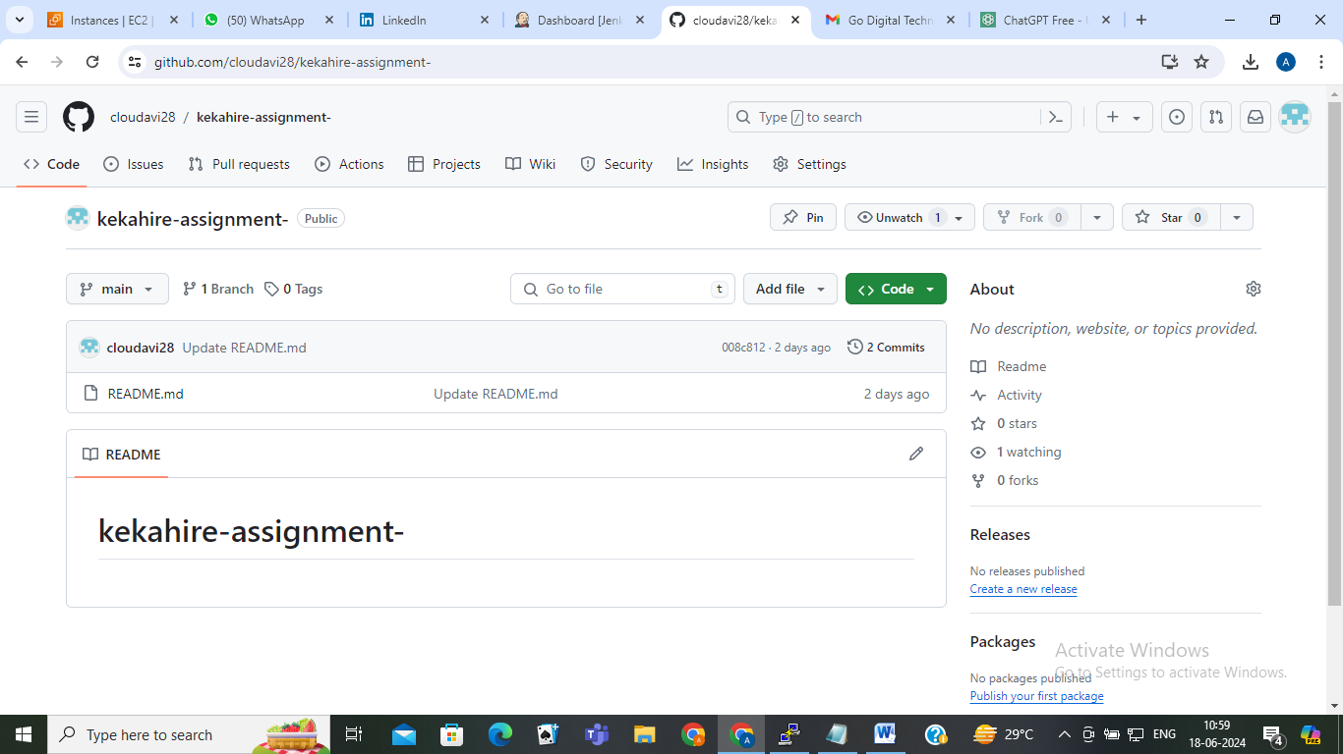

**STEP 2 – CREATE A DOCKER FILE**

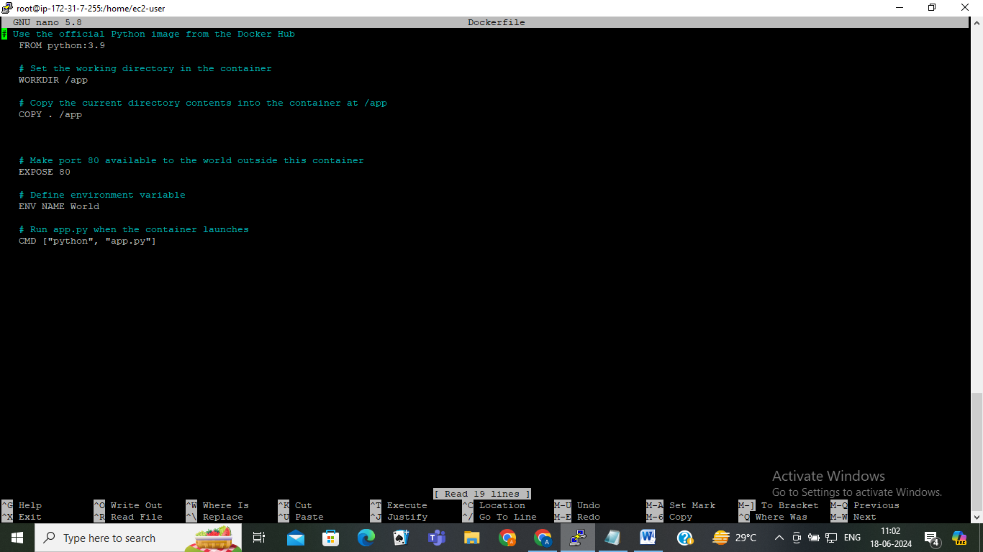

**USED COMMAND –**

**>> nano docker file**

**>>docker build –t assignment .**

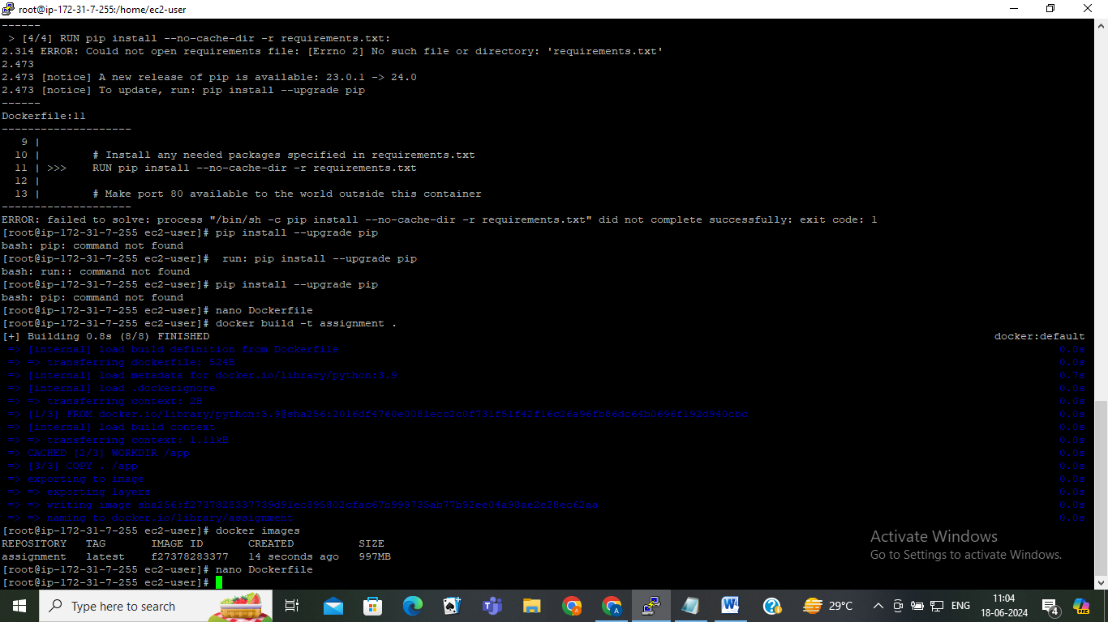

**Created image names AS “assignment”**

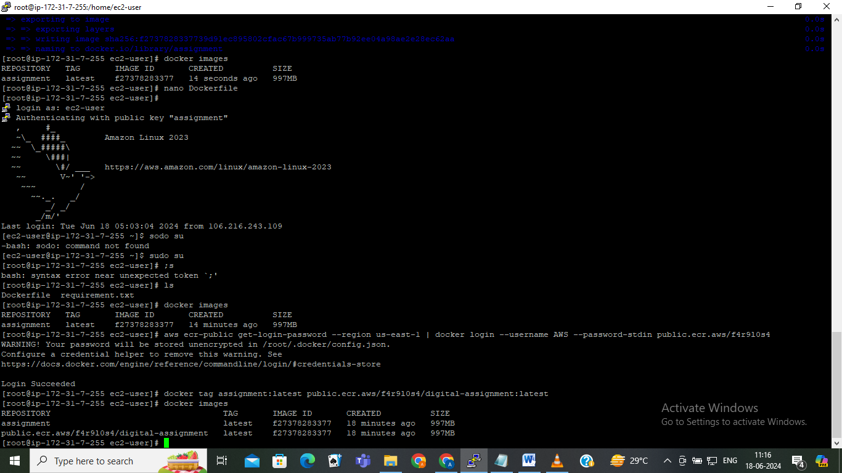

New image name as pass second command

Used command to push image

docker push <provided image name>

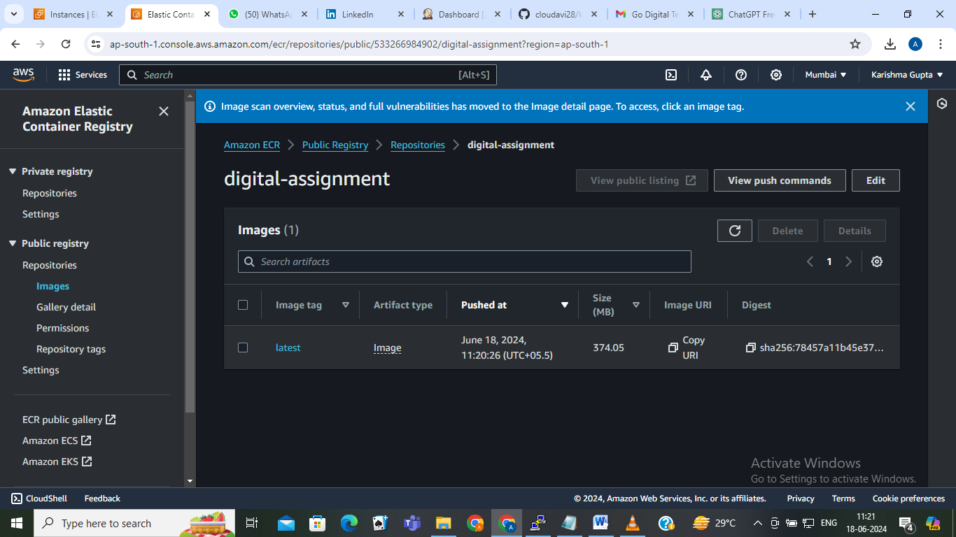Uploaded image in ecr