1. **Angular 2**

<https://angular.io/docs/ts/latest/quickstart.html>

<https://www.quora.com/Why-is-Angular-2-not-available-in-Bower>

Please note, Angular 2 requires node/npm not bower to install dependencies. All the files present right now are required for Angular 2 to work. I am using gulp stack with systemjs and gulp tasks are to enable javascript and css code linting/checking, manage development and production environment, and to watch for changes during development environment. In production environment assets are bundled and minimized. This is the default way in Angular 2 stack. Angular 2 uses ES6 and typescript which can’t be compiled on the client side so all the setup and files are required. Please see docs/README.md for deployment steps.

1. **Application Structure**

docs – contains technical and verification steps in Documentation.docx, swagger, postman files

secyield – maven project root

secyield/src – backend source folder

secyield/src/main/sql – sql scripts

angular2 – angular source folder

angular2/src – angular source code

angular2/typings – angular typescript plugin dependencies

angular2/tools – gulp tasks to automate development environment

Both backend and frontend are deployed independently, as angular 2 required nodejs for development, it is required to run with npm start. Once angular is compiled it will produce a html and js bundle which can be deployed to any web server by just copying them.

1. **Verification Steps**

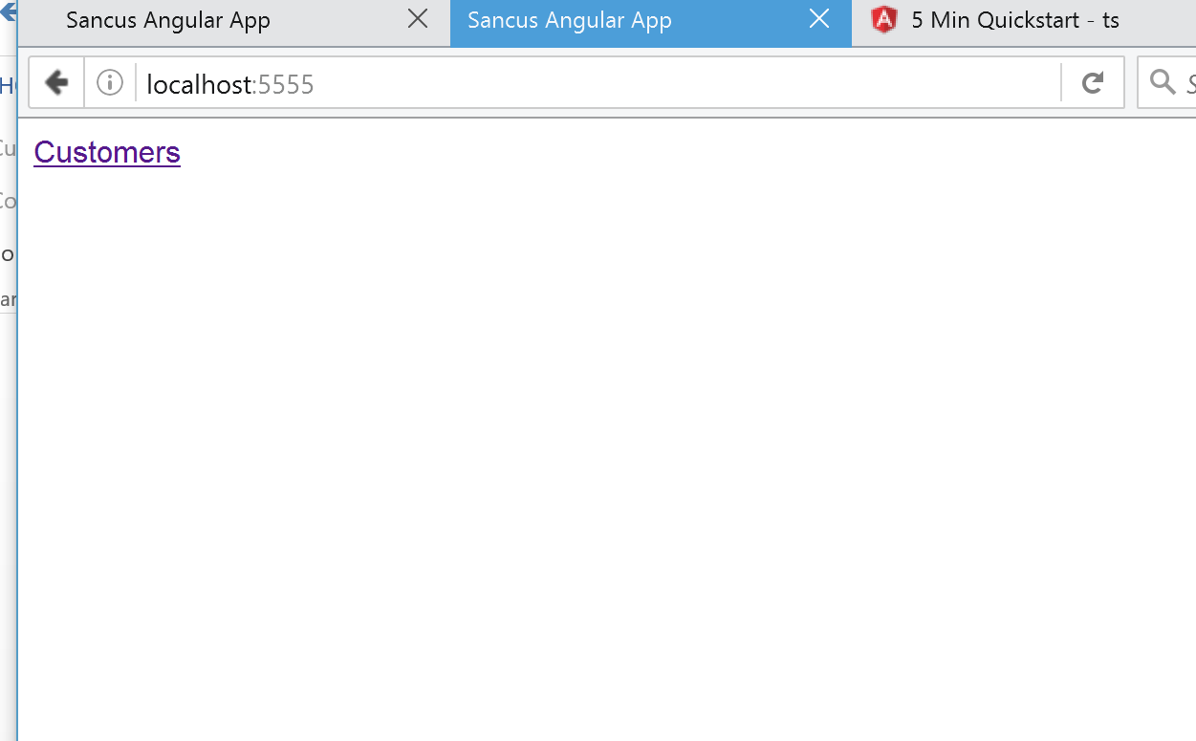

1. Click on the Customers link above.
2. Following screen will be displayed that shows list of customers:

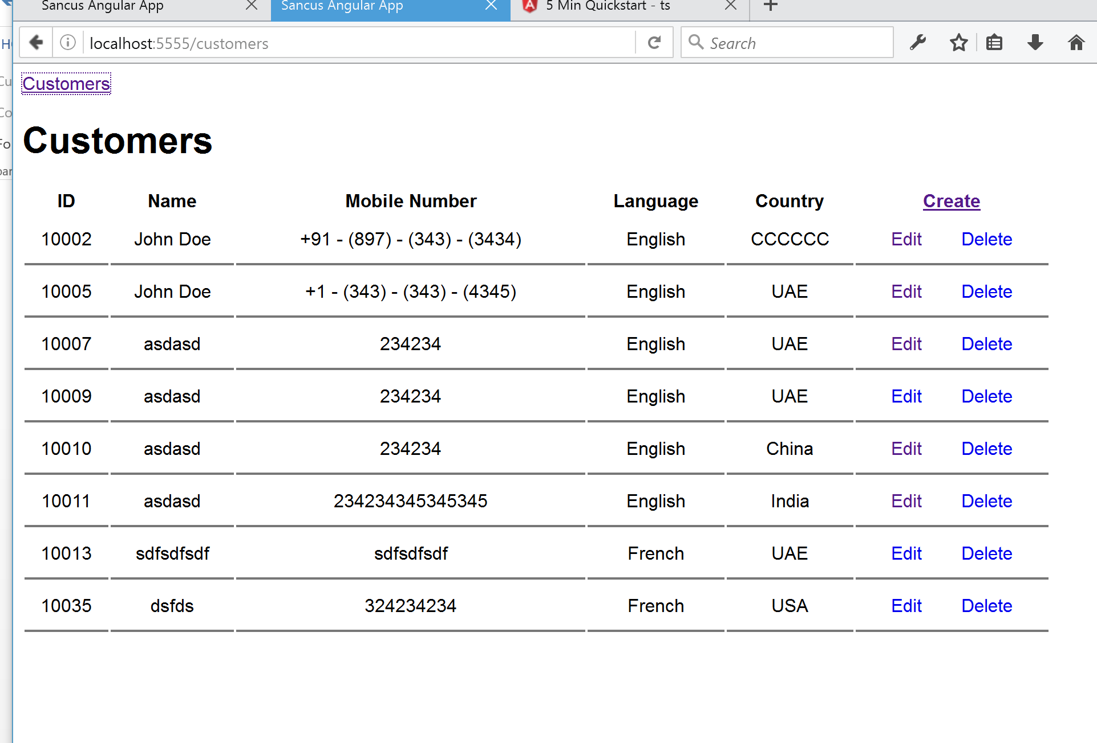

1. Click on + link on top right of table to add new customer as below:

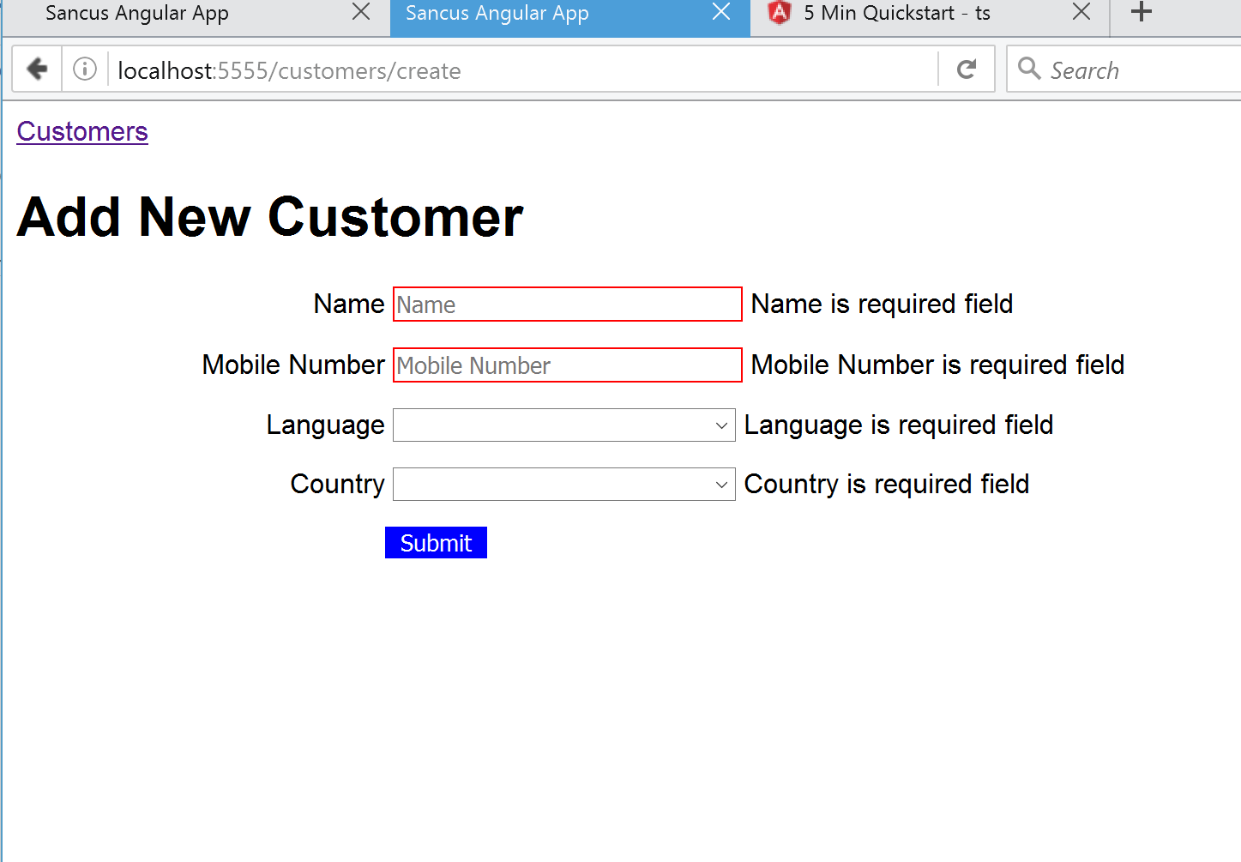

1. Similarly, update & delete works as shown below:

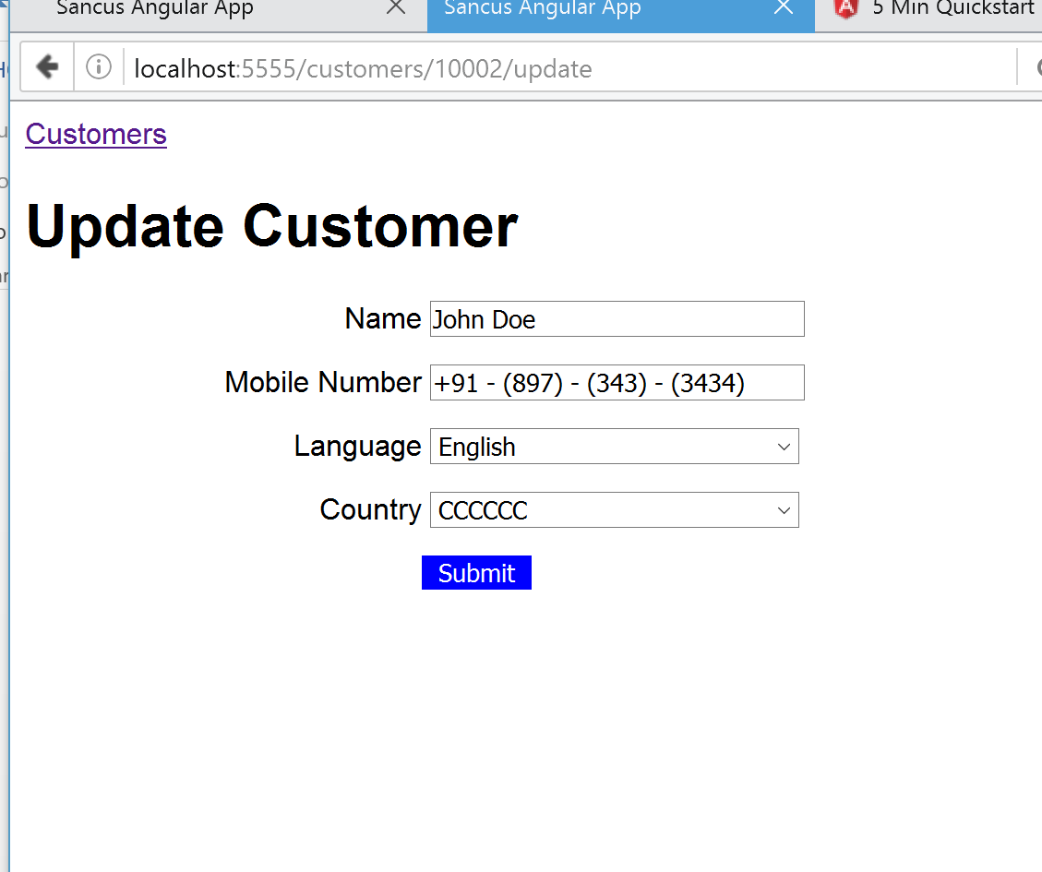

1. **SonarCube Dashboard at** [**http://localhost:9000**](http://localhost:9000)

