Analysis Results
General Information

Analysis date | 2026/06/01 16:13:48
Sample name | Ni-ZnCdS | Measurement date | 2026/06/01 15:45:59
File name | Fe-ZnCdS.ras | Operator | administrator
Comment

Measurement profile
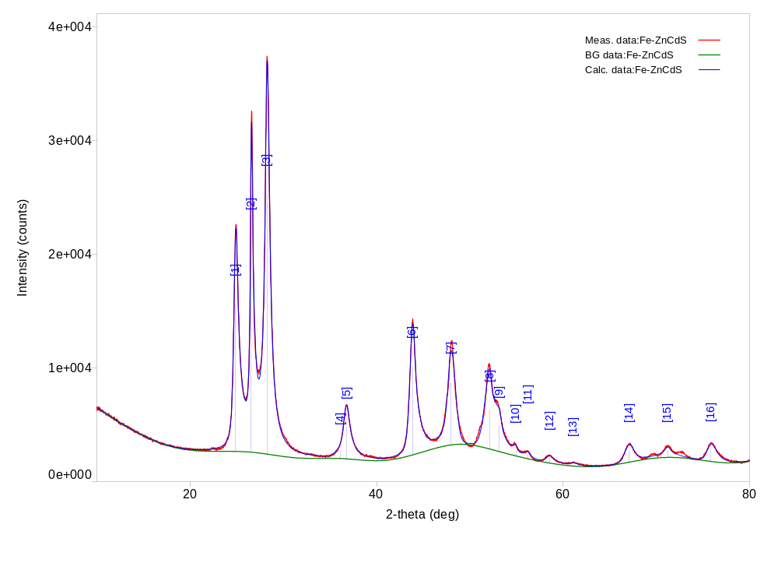

Measurement conditions

X-Ray | 40 kV , 150 mA | Scan speed / Duration time | 10.0000 deg/min
Goniometer | SmartLab | Step width | 0.0200 deg
Attachment | Standard | Scan axis | Theta/2-Theta
Filter | Cu_K-beta | Scan range | 10.0000 - 80.0000 deg
CBO selection slit | BB | Incident slit | 2/3deg
Diffrected beam mono. | None | Length limiting slit | 10.0mm
Detector | D/teX Ultra | Receiving slit #1 | 20.000mm
Scan mode | CONTINUOUS | Receiving slit #2 | 20.000mm

Qualitative analysis results

Phase name | Formula | Figure of merit | Phase reg. detail | DB card number
Cadmium Zinc Sulfide | ( Cd0.8 Zn0.2 ) S | 0.297 | ICDD (PDF2.DAT) | 00-049-1302

Phase name | Formula | Space group | Phase reg. detail | DB card number
Cadmium Zinc Sulfide | ( Cd0.8 Zn0.2 ) S | 186 : P63mc | ICDD (PDF2.DAT) | 00-049-1302

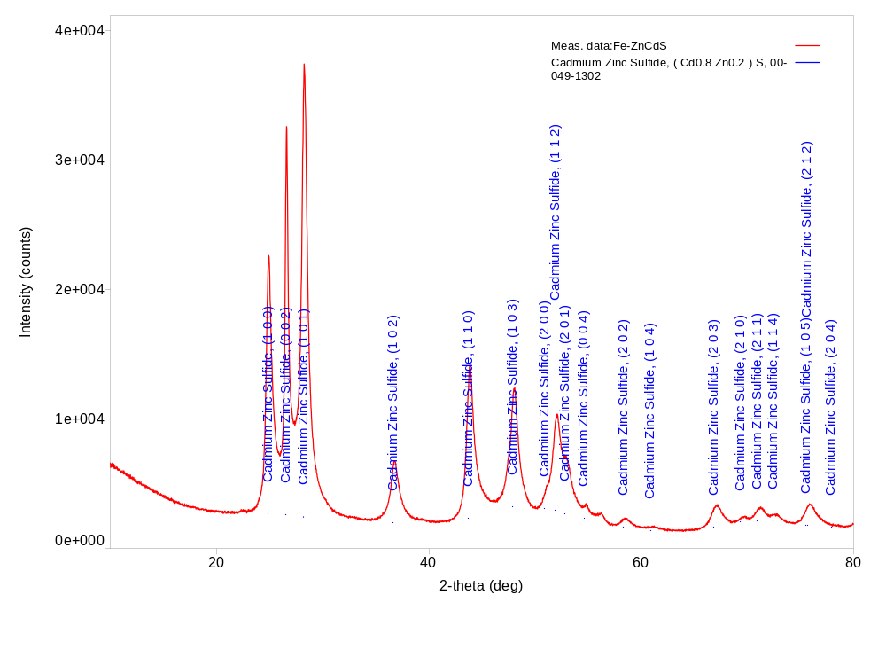

Peak list

No. | 2-theta(deg) | d(ang.) | FWHM(deg) | Int. I(counts deg) | Size(ang.) | Rel. int. I(a.u.)
1 | 24.884(6) | 3.5753(8) | 0.610(8) | 12653(65) | 139.3(18) | 55.69
2 | 26.553(6) | 3.3542(7) | 0.324(7) | 10637(67) | 263(6) | 46.81
3 | 28.238(4) | 3.1578(5) | 0.604(5) | 22723(64) | 141.6(12) | 100.00
4 | 36.12(6) | 2.485(4) | 1.33(8) | 973(115) | 65(4) | 4.28
5 | 36.777(7) | 2.4418(4) | 0.819(13) | 3246(111) | 106.7(17) | 14.28
6 | 43.851(6) | 2.0629(3) | 0.769(8) | 9107(38) | 116.4(11) | 40.08
7 | 47.951(13) | 1.8957(5) | 0.953(12) | 6579(64) | 95.3(12) | 28.95
8 | 52.142(13) | 1.7527(4) | 0.87(4) | 3918(495) | 106(5) | 17.24
9 | 53.12(3) | 1.7228(10) | 1.52(13) | 4409(482) | 61(5) | 19.41
10 | 54.94(2) | 1.6699(7) | 0.57(8) | 313(41) | 164(22) | 1.38
11 | 56.23(3) | 1.6345(8) | 0.65(7) | 280(25) | 145(17) | 1.23
12 | 58.56(3) | 1.5750(8) | 1.02(5) | 617(19) | 94(4) | 2.72
13 | 61.12(4) | 1.5150(10) | 1.07(9) | 232(15) | 90(7) | 1.02
14 | 67.09(2) | 1.3939(4) | 1.15(2) | 1478(22) | 86.5(15) | 6.50
15 | 71.23(5) | 1.3228(8) | 0.99(9) | 1225(35) | 103(9) | 5.39
16 | 75.87(3) | 1.2530(4) | 1.22(3) | 1632(31) | 86(2) | 7.18

Parameters used for WPPF
Profile parameters

Common parameter | Background | Data | Fe-ZnCdS
 |  | Function name | B-spline
 |  | param0 | 54405.303764052689
 |  | param1 | 41453.375167823418
 |  | param2 | 18043.773763341764
 |  | param3 | 24793.75972402727
 |  | param4 | 15896.835479358087
 |  | param5 | 18201.790221255043
 |  | param6 | 13276.341222279038
 |  | param7 | 22070.227511194873
 |  | param8 | 30155.216285288112
 |  | param9 | 22133.76365847058
 |  | param10 | 13222.613532351012
 |  | param11 | 8319.1169057390543
 |  | param12 | 18101.718314987873
 |  | param13 | 17997.93106222399
 |  | param14 | 13585.558685387679
 |  | param15 | 13534.275283608604
 |  | param16 | 15034.547390505359
 |  | node0 | 10
 |  | node1 | 18.280000000000001
 |  | node2 | 26.559999999999999
 |  | node3 | 31.399999999999999
 |  | node4 | 36.240000000000002
 |  | node5 | 41.079999999999998
 |  | node6 | 45.060000000000002
 |  | node7 | 49.039999999999999
 |  | node8 | 53.020000000000003
 |  | node9 | 57.020000000000003
 |  | node10 | 64.680000000000007
 |  | node11 | 69.780000000000001
 |  | node12 | 73.180000000000007
 |  | node13 | 76.579999999999998
 |  | node14 | 80
Common parameter | Peak shift
 |  | Function name | Shift axial displacement
 |  | param0 | -0.053728163366739787
 |  | param1 | 0
 |  | param2 | 0
Cadmium Zinc Sulfide | Scale factor | s | 2543(90)
 | FWHM | U | 1.2327
 |  | V | 0.9558
 |  | W | 0.0621
 | Asym. factor | A0 | -0.2602
 |  | A1 | 0.0000
 | Decay rate factor | etaL0/mL0 | 0.7377
 |  | etaL1/mL1 | 0.0000
 |  | etaL2/mL2 | 0.0000
 |  | etaH0/mH0 | 1.2697
 |  | etaH1/mH1 | -0.2874
 |  | etaH2/mH2 | 0.0000
 | Preferred orientationMarch-Dollase | h | 0
 |  | k | 0
 |  | l | 0
 |  | March coefficient | 1.000000

Structure parameters

Data set name | Phase Name | Element | x | y | z | Occupancy | Temperature factor

Data set name | Rwp | Rp | Re | S | Chi^2 | Maximum shift/e.s.d.
Fe-ZnCdS | 0 | 0 | 0 | 0 | 0 | 0

Lattice parameters
Angular correction

Use external standard

Analysis results

Data set name | a(A) | b(A) | c(A) | alpha(deg) | beta(deg) | gamma(deg)
Fe-ZnCdS | 4.126(2) | 4.126(2) | 6.695(4) | 90.000000 | 90.000000 | 120.000000

Phase name | a(A) | b(A) | c(A) | alpha(deg) | beta(deg) | gamma(deg) | V(A^3)
Cadmium Zinc Sulfide | 4.126(2) | 4.126(2) | 6.695(4) | 90.000000 | 90.000000 | 120.000000 | 98.70(10)

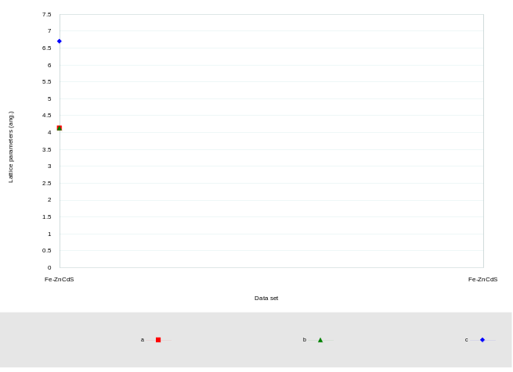

Crystallinity

Data set name | Crystallinity(%)

CrystallinityGraph.emf

Crystallite size and lattice strain
Williamson-Hall method

Data set name | Crystallite size(A) | Strain(%)
Fe-ZnCdS | 103(7) | 0.53(10)

Phase name | Crystallite size(A) | Distribution RSD | Strain(%) | Distribution type
Cadmium Zinc Sulfide | 103(7) | - | 0.53(10) | -

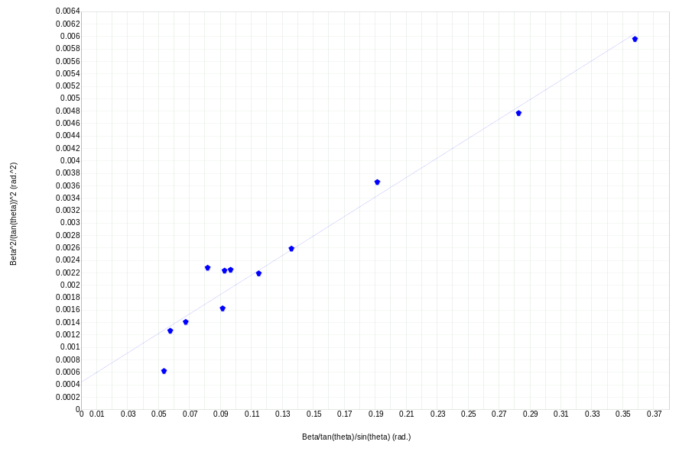

Quantitative analysis results (RIR)

Phase name | Content(%)
Cadmium Zinc Sulfide | 0.000000

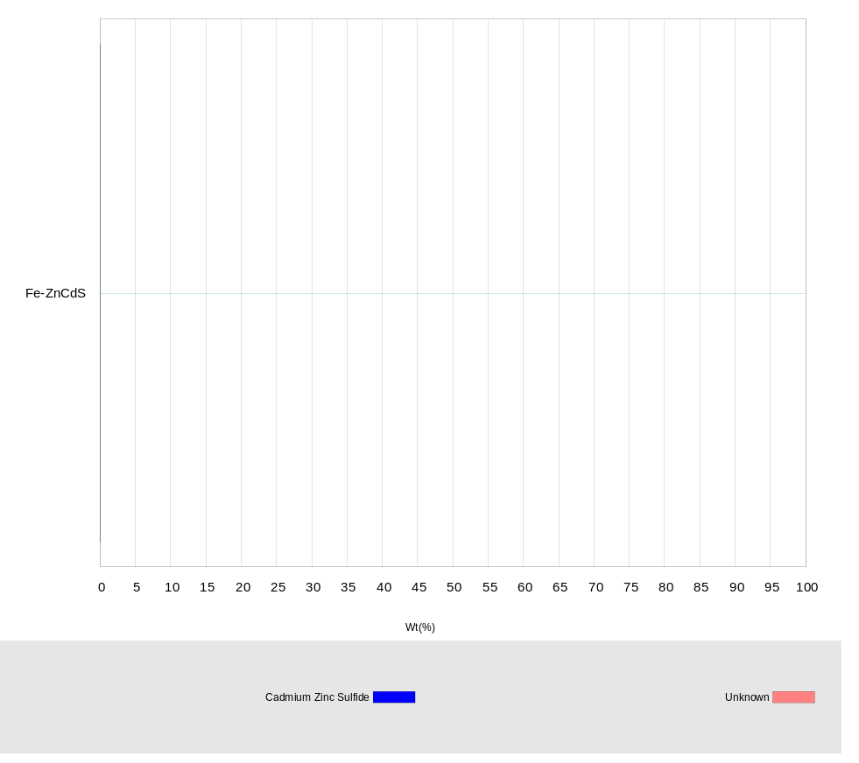

Quantitative analysis results (WPPF)

Quantitative analysis results (standard addition method)
Calibration data
QuantityCalibration.emf

Quantitative analysis results (External Standard method)
Calibration data
QuantityCalibration.emf

Quantitative analysis results (internal standard method)
Calibration Data
QuantityCalibration.emf

Stress
Stress constants

Analytical conditions

Analysis results

StressGraph.emf

Cluster analysis results
Dendrogram

ClusterDendrogram.emf

Measurement profiles

Cluster

Sample well

ClusterSamplePlate.emf

PCA view

ClusterPCA3DGraph.emf
Eigenvalue graph

ClusterPCAGraph.emf

Crystallite size distribution analysis results
Crystallite size distribution

Crystallite size distribution graph

SizeDistribution.emf

Crystal structure analysis results
Indexing

Phase name | Formula | Figure of merit | Phase reg. detail | DB card number
Cadmium Zinc Sulfide | ( Cd0.8 Zn0.2 ) S | 0.297 | ICDD (PDF2.DAT) | 00-049-1302

Quantitative analysis results

Lattice information

Phase name | a(A) | b(A) | c(A) | alpha(deg) | beta(deg) | gamma(deg) | V(A^3)
Cadmium Zinc Sulfide | 4.126(2) | 4.126(2) | 6.695(4) | 90.000000 | 90.000000 | 120.000000 | 98.70(10)

Phase name | Space group | Z | Z' | Calc. density(g/cm^3)
Cadmium Zinc Sulfide | 186 : P63mc | 2 | 0.167 | 4.400

Structure determination

Refinement

Measurement range: 10.0000-80.0000deg Refinement range: 10.0000-80.0000deg (1.20 A)
Number of refined parameters: 0
Phase name | Atomic coords | # of indep. reflns
Cadmium Zinc Sulfide | - | 19

Rwp = - S = -

Crystal structure

Cadmium Zinc Sulfide
