**Steps for Automating interactive Website setup:**

* Visit <https://app.vagrantup.com/boxes/search> and download a vagrant file (Create a folder in a directory, you can name it “vagrant-vms”)
* Open the Git CLI and type----- cd /c/vagrant-vms
* mkdir IAAC
* cd IAAC/
* mkdir wordpress (This is for the interactive website)
* cd wordpress (To Setup the Static website first)
* vagrant init geerlingguy/ubuntu2004 (the box name from the cloud)
* Provision your vagrantfile (Use Notepad++)
* Check the provisioning step docs and For completion steps use as a guide: <https://ubuntu.com/tutorials/install-and-configure-wordpress#2-install-dependencies>

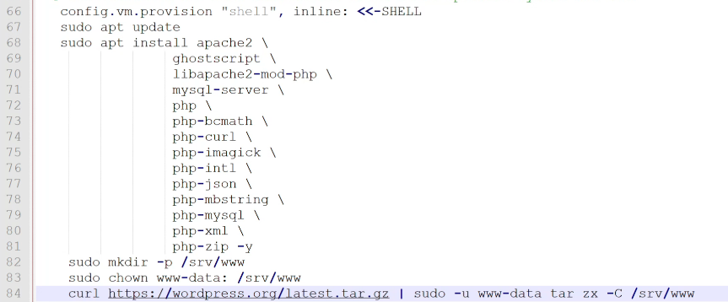

For steps 4: open notepad and paste the command virtualhost, save as wordpress.conf (file type: all types) in the same wordpress directory and copy to: /etc/apache2/sites-available/wordpress.conf

Go back to your notepad++ and type the command to copy it:

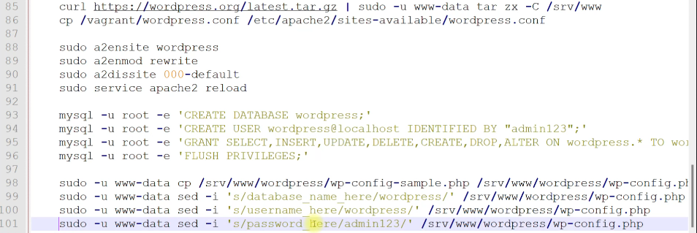

Skip the last step in step 6:

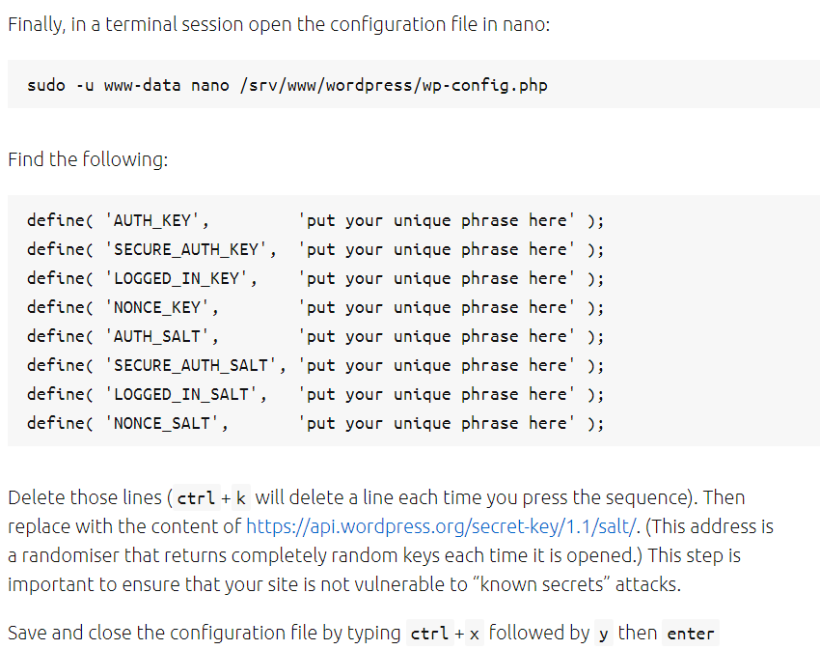

Save the Notepad++ used to provision the vagrantfile

Go to your git CLI and finish

* vagrant up
* vagrant ssh
* sudo –i
* For step 7

Get your vm IP from ipconfig and use it in your browser instead of the localhost

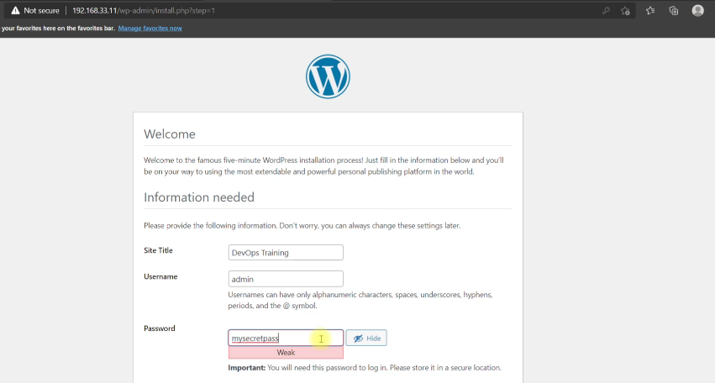

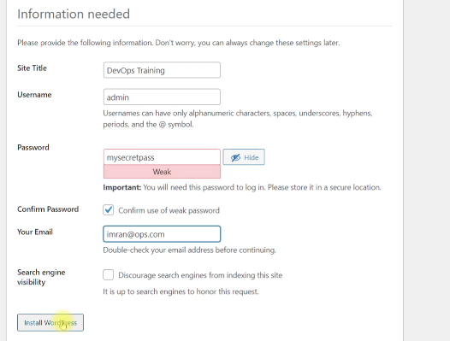

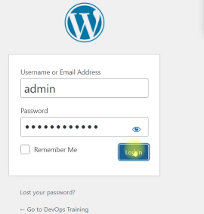

Login with the credentials you used not the database credentials and configure your wordpress site… Goodluck!!!