**Here we would use provisioning. These method is known as Infrastructure As A Code (IAAC)**

**Examples of IAAC are Terraform and Cloudform**

**Steps for Automating Static Website setup:**

* Visit <https://app.vagrantup.com/boxes/search> and select a box for a vagrant file
* Create a folder in a directory, you can name it “vagrant-vms”
* Open the Git CLI and type 🡺
* cd /c/vagrant-vms
* mkdir IAAC
* cd IAAC/
* mkdir website (This is for the static website)
* cd website
* vagrant init geerlingguy/centos7 (the box name from the cloud)
* Provision your vagrantfile (Use Notepad++)

Check the provisioning step docs

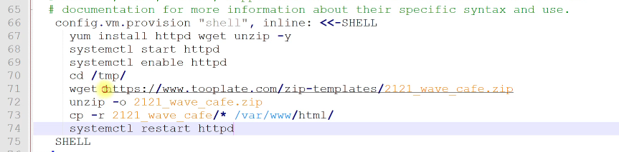

* vagrant up
* vagrant ssh
* sudo –i