**Here we would use provisioning. These method is known as Infrastructure As A Code (IAAC)**

**Examples of IAAC are Terraform and Cloudform**

**Static Website setup locally on your VM**

* Visit <https://app.vagrantup.com/boxes/search> and download a vagrant file (Create a folder in a directory, you can name it “vagrant-vms”)
* Open the Git CLI and type----- cd /c/vagrant-vms
* mkdir (Name of the project) ……. This is to create a directory
* cd /c/vagrant-vms/(Name of the project directory created)
* vagrant init ubuntu/trusty64 (the box name from the cloud)
* Provision your vagrantfile (upgrade,update and install apache or httpd, start apache or httpd)
* vagrant up
* vagrant ssh
* sudo –i
* cd /var/www/html/ (use any of the two steps below)

(When you have the codes to setup your site)

* vi index.html (copy your html codes here)
* systemctl restart httpd
* systemctl status httpd

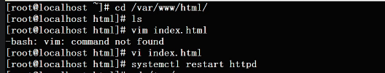

* Open your browser and check the IP addresss gotten using the ipconfig on your system

OR:

(When you have the website link to setup your site)

* Open the link and right click on the page, then click on “inspect” or use F12 to open the developer
* Click on the Network tab
* Head to the website on the right and click the download button to fetch the link on the right in the developer tool (Network tab)
* Look for the .zip file and click on it once, then click on Headers. You will see the download link (copy it)
* cd /tmp/
* wget (paste the website link)
* ls
* unzip (name of project.zip file)

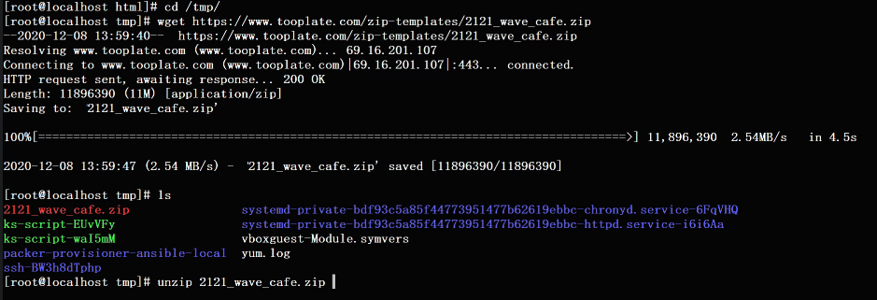

* ls
* cd into the unzipped folder
* ls
* cp –r * /var/www/html/ ………copy the project into the var/www/html
* y to overwrite

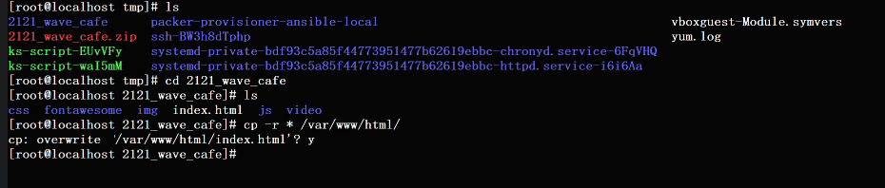

* systemctl restart httpd
* systemctl status httpd
* Open your browser and check the IP addresss gotten using the ipconfig on your system