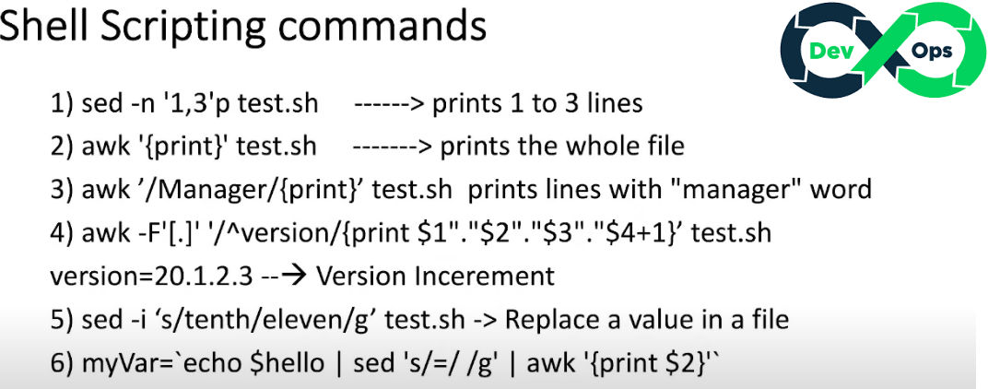

* SED means Stream Editor which helps to extract the data print only few lines from your database file. SED command is a stream editor that can perform insertion, deletion, and substitution of text.
* AWK is used to extract the whole file from the database. (S……. means substitute & G ……… means Global).

Awk is a programming language and a POSIX specification that originated at AT&T Bell Laboratories in 1977. Its name comes from the initials of its designers: **Aho, Weinberger, and Kernighan**. Awk features user-defined functions, multiple input streams, TCP/IP networking access, and a rich set of regular expressions.

**AUTOMATION SCRIPTS**

**JFROG is a repository where application binary files are stored**

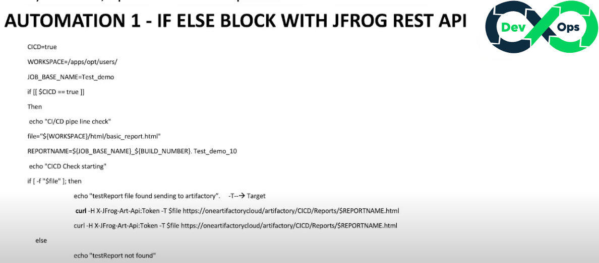

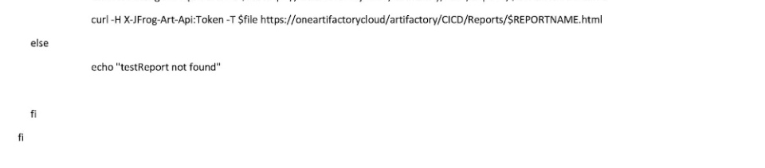

Where:

-H means Header

-X means type of request

-T means type of file

Use these shell script to update multiple data in a database

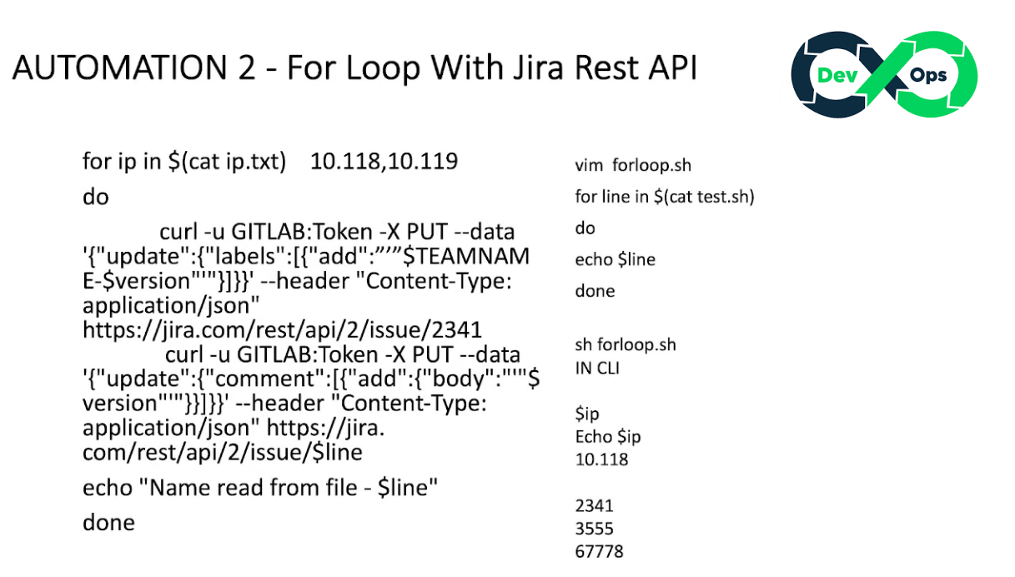

Where:

-U means Username and Password

- means

Use these script to check how many jar files are running in an instance where multiple files up to 10 are running.

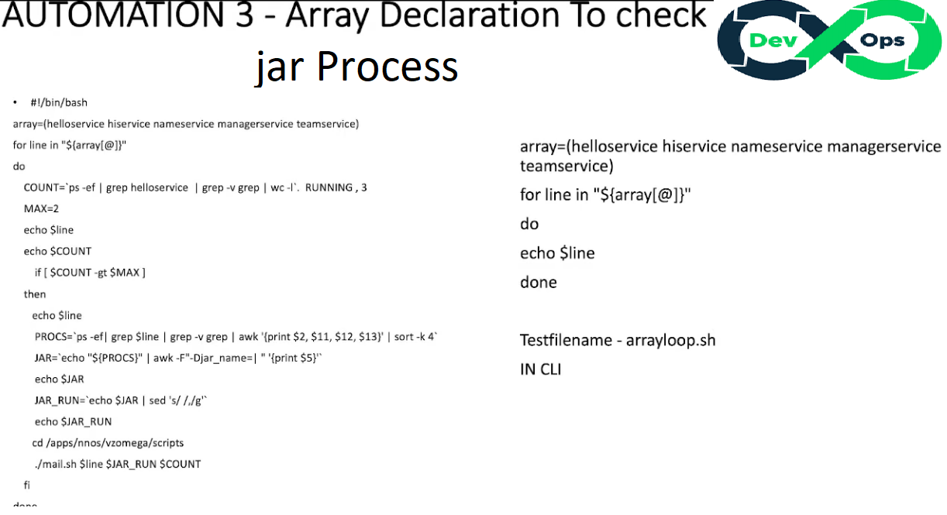

Where:

$(array[@]) means extract the array values, @ refers to each process values

Ps –ef means ps refers to process value, -ef helps to extract all the process values

| means pipe symbol

Grep helloservice means to bring only the value helloservice

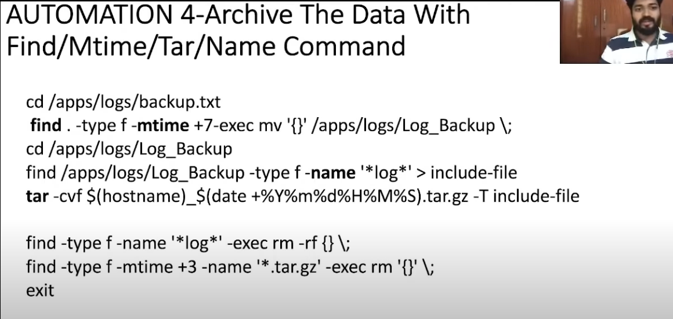

The Line with find -mtime Means files within just a week and M means Modified time

The Line tar -cvf means to archive the file

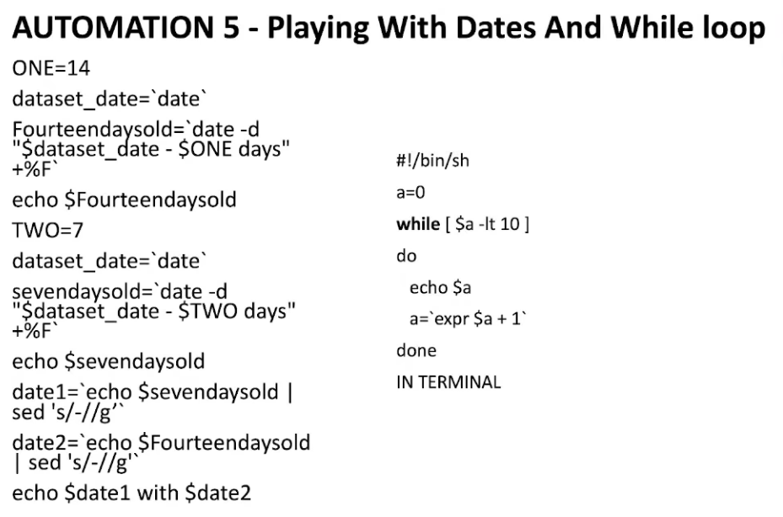

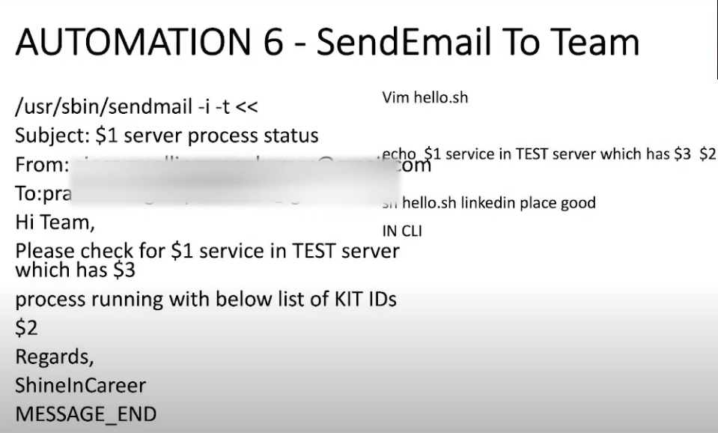

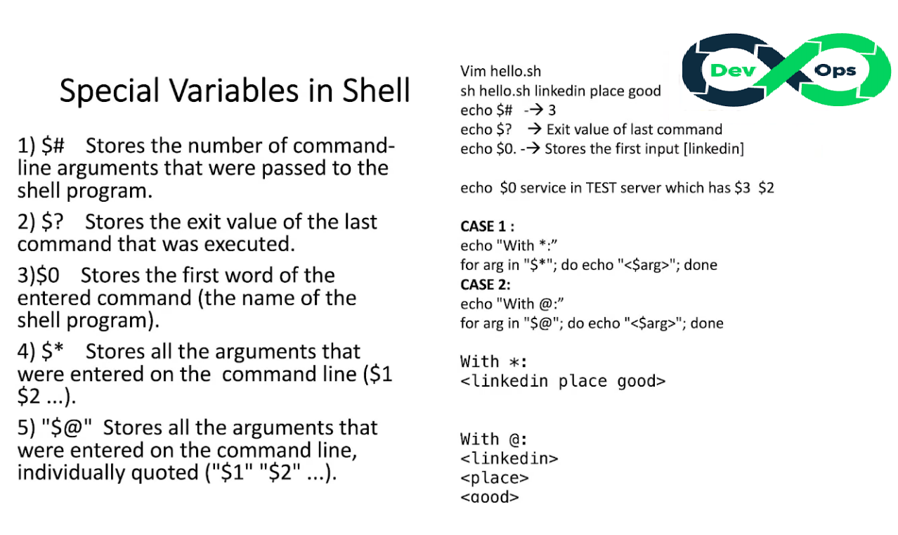

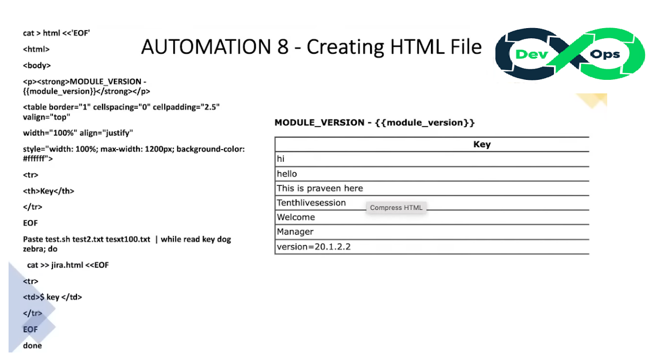

EOF means End Of File

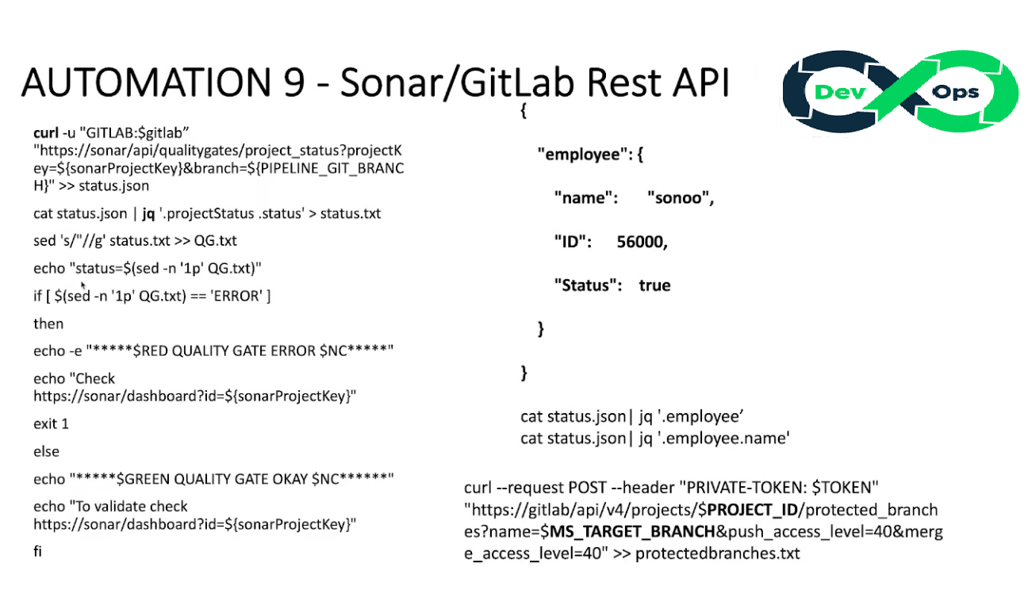

Assuming your project has five services and each has repositories in gitlab with banches each