**What is Vagrant?**

Vagrant is a tool used for building and managing virtual machine environments in a single workflow. Vagrant is an open-source tool that helps us to automate the creation and management of Virtual Machines.

In a nutshell, we can specify the configuration of a virtual machine in a simple configuration file, and Vagrant creates the same Virtual machine using just one simple command.

For more info: ( <https://developer.hashicorp.com/vagrant/intro> )

**The vagrant architecture**

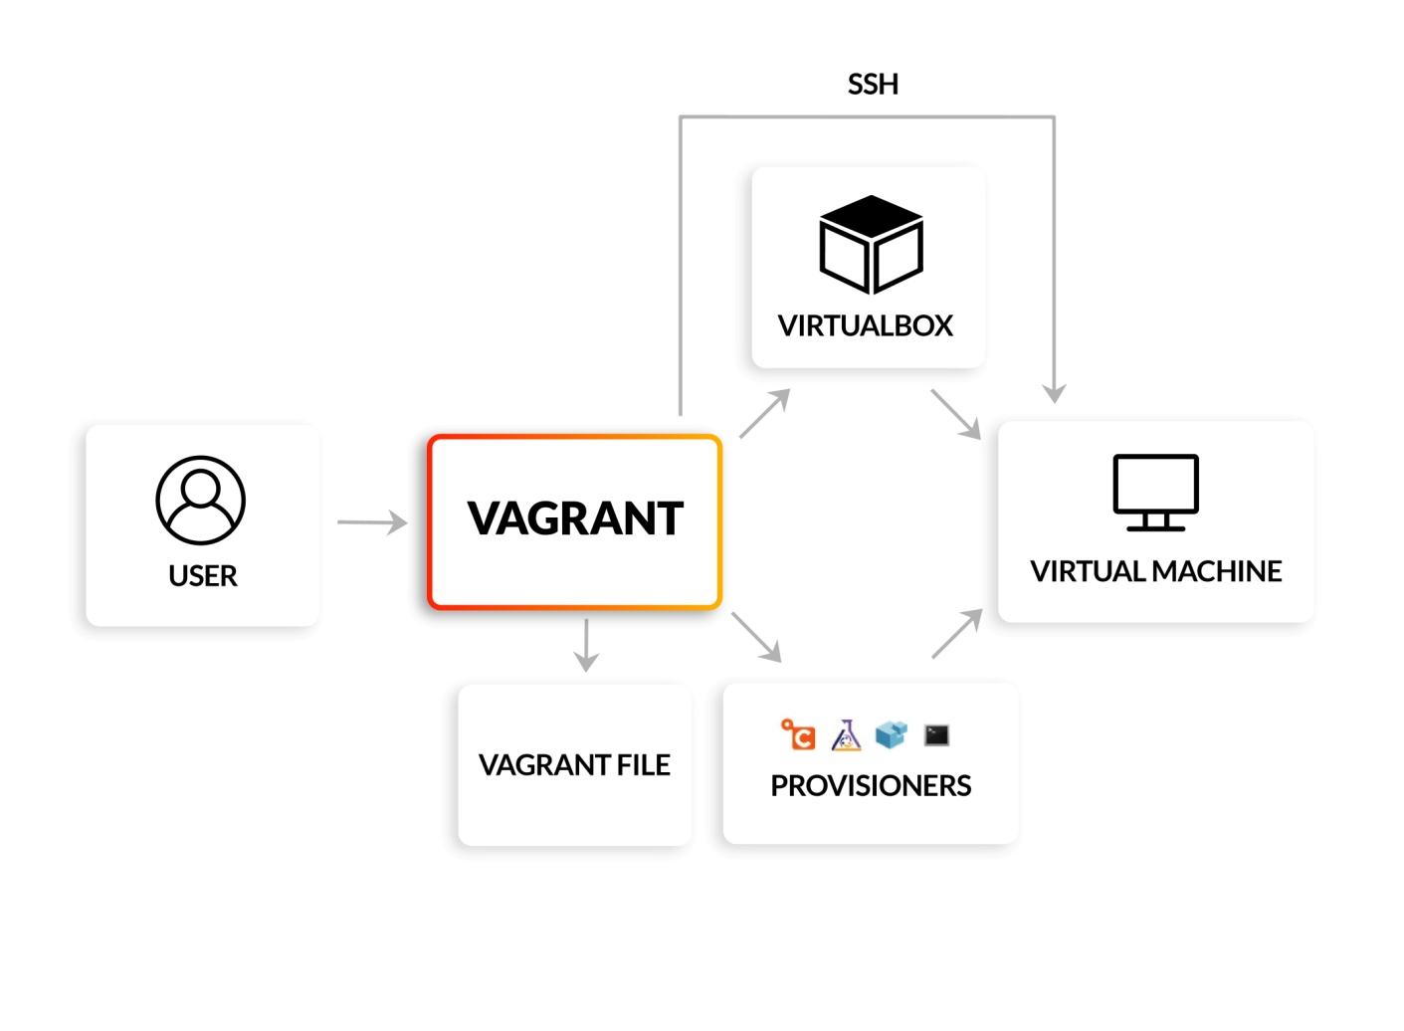

**Is Vagrant same as Docker?**

**Vagrant vs Docker?**

Docker is a technology for creating and running Linux containers, while Vagrant is a machine provisioning tool used to create VMs and then populate them with applications. In other words, you use Vagrant to create a VM and install Docker. Then, once Docker is installed, that VM can run containers.

**What is Vagrant cloud?**

Vagrant Cloud is a hosted service for finding virtual machine boxes, sharing boxes, and managing. Vagrant Shares (reverse proxy to any port on your vagrant boxes).

<https://app.vagrantup.com/boxes/search>

Next study area: Check Steps to create a Vagrant file! (Steps(Vagrant file!)