CampusFind: AWS Cloud Deployment Proof Portfolio
Capstone Deliverable 3: Infrastructure Verification Artifacts & Telemetry Portfolio
Course: CSBC 252 - Introduction to Cloud Computing
📌 Portfolio Instructions for Evaluation
This structured portfolio contains designated verification placeholder boxes for each AWS Free Tier resource, security control, and application telemetry endpoint. Replace the placeholder containers below with actual screenshots captured from your AWS Management Console, terminal execution logs, and live browser sessions.

1. Project Reference & Cloud Infrastructure Metadata
Configuration Parameter | Active Value / Specification
GitHub Repository URL | https://github.com/cloudcomputinggroup2/campusfind.git
AWS Deployment Region | us-east-1 (US East - N. Virginia)
Compute Instance (EC2) | Ubuntu Server 24.04 LTS (t2.micro / t3.micro Free Tier)
Managed Relational DB (RDS) | Amazon RDS PostgreSQL 15 (Single-AZ, db.t3.micro)
Object Storage (S3) | campusfind-item-images-capstone (Decoupled media assets)
Web Server / WSGI Daemon | Nginx 1.24+ (Reverse Proxy) + Gunicorn 21+ (Systemd Service)
Health & Monitoring | /health/ JSON Telemetry + Amazon CloudWatch CPU/Network Alarms

2. Cloud Infrastructure Validation Artifacts
📸 PROOF-01: Amazon EC2 Instance Running Status
• AWS Service / Scope: Compute / Amazon EC2
• Required Evidence: AWS Console showing EC2 Instance ID, Instance State (2/2 checks passed, 'running'), Instance Type (t2.micro), and Public IPv4 Address.
• Verification Action: Open AWS Management Console > EC2 > Instances >
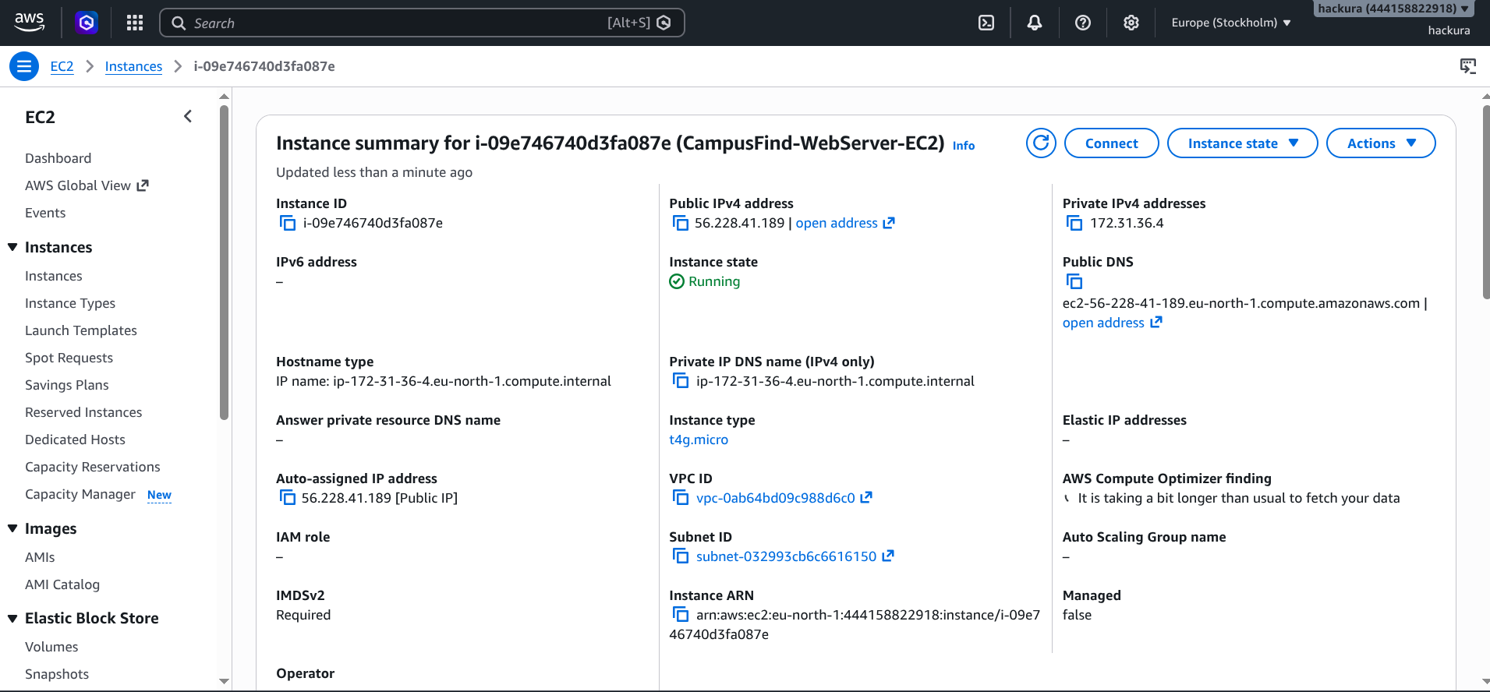

📸 PROOF-02: Amazon RDS PostgreSQL Database Active Status
• AWS Service / Scope: Database / Amazon RDS
• Required Evidence: RDS Console displaying DB identifier, Engine version (PostgreSQL 15), Endpoint connection string, and Status ('Available').
• Verification Action: Open AWS Console > RDS > Databases > Capture database details, endpoint, and subnet group.
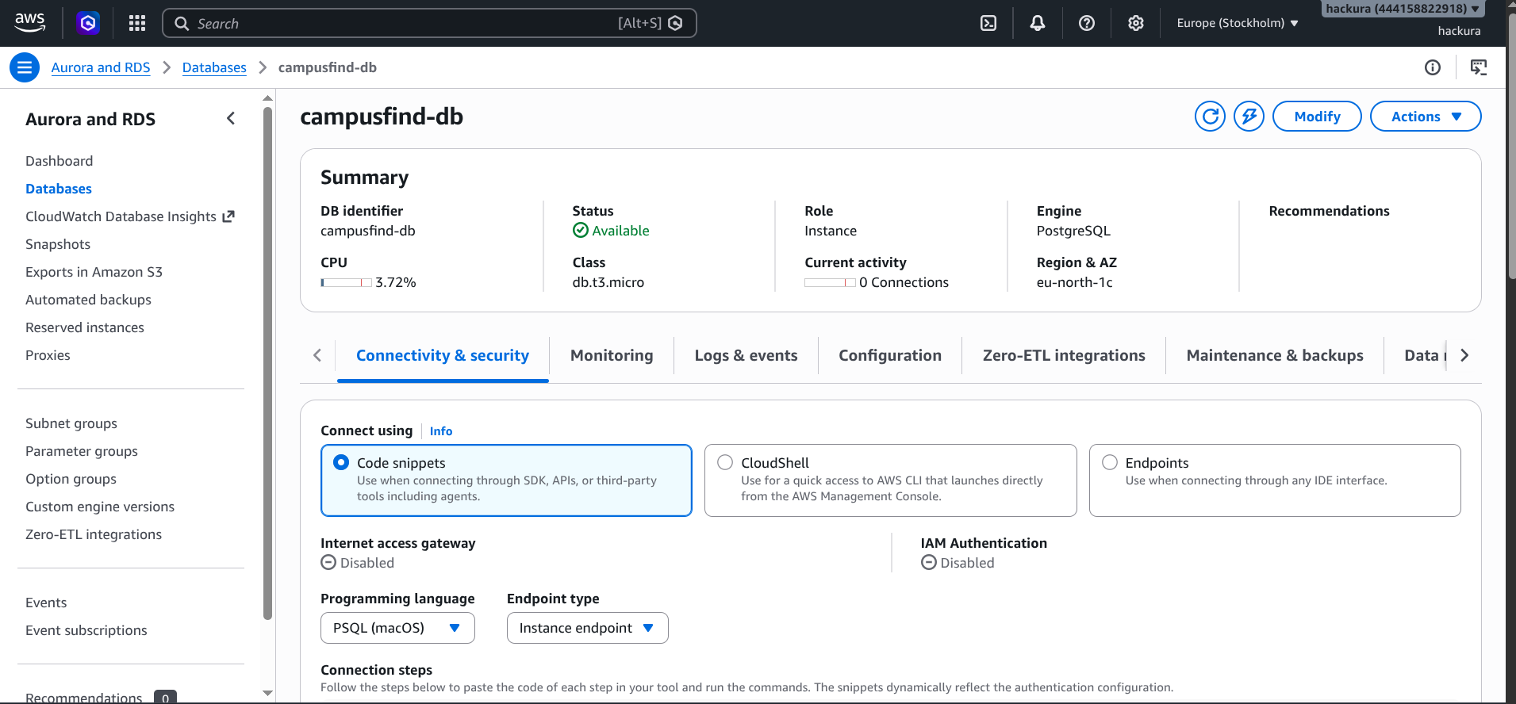

📸 PROOF-03: Amazon S3 Bucket & Uploaded Media Objects
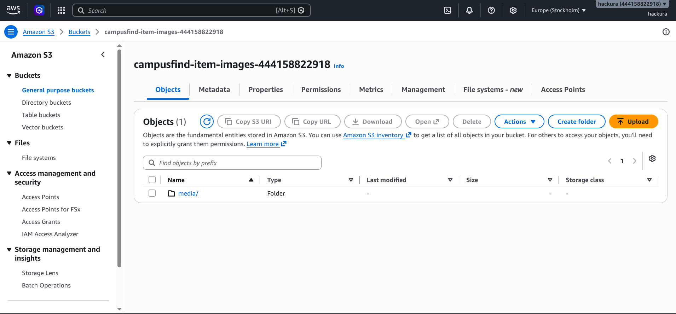

📸 PROOF-04: AWS IAM Least-Privilege Policy & Attached Role
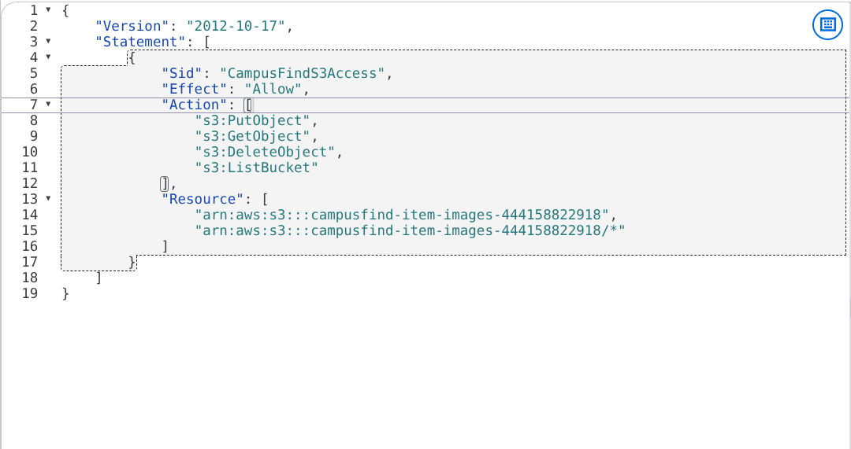

📸 PROOF-05: AWS Security Groups Inbound & Outbound Rules
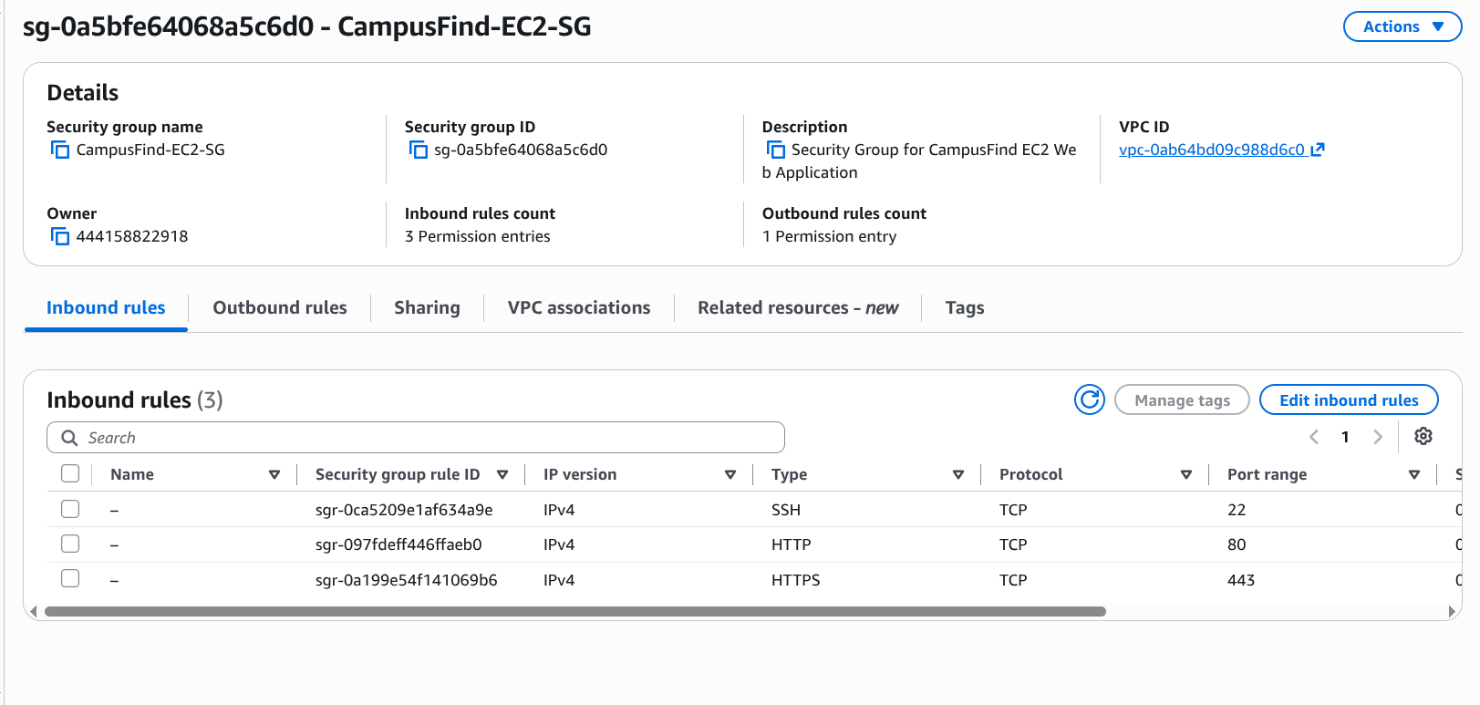
CampusFind-EC2-SG(Inbound rules)
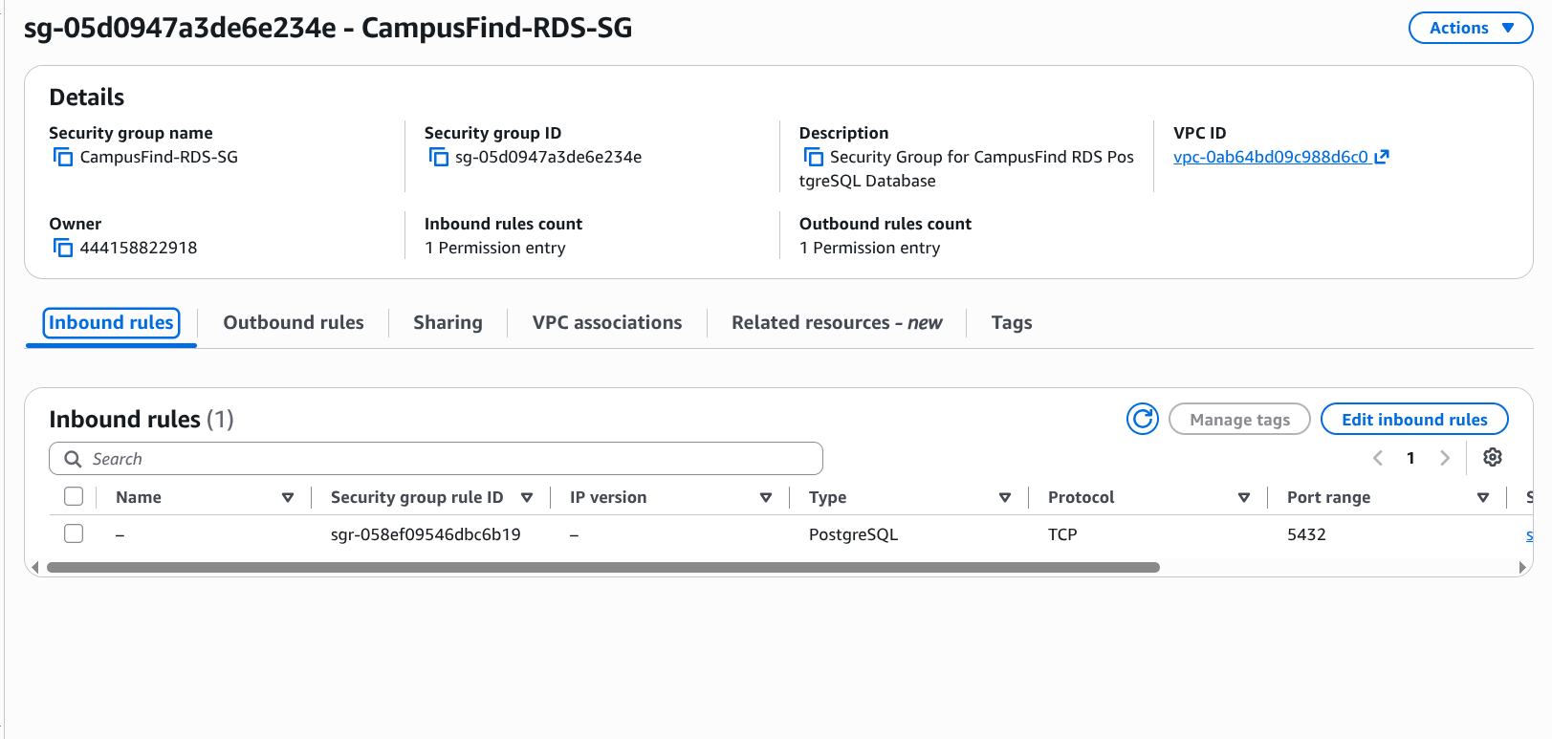
CampusFind-RDS-SG(Inbound rule)
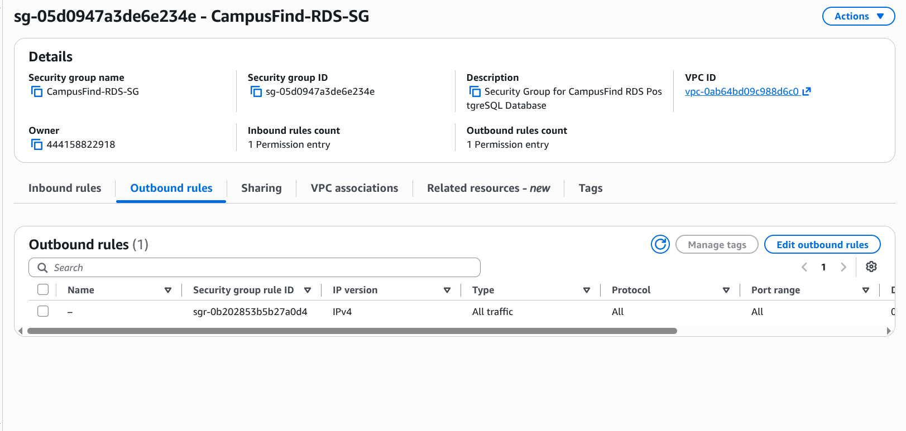
CampusFind-RDS-SG(Outbound rules)
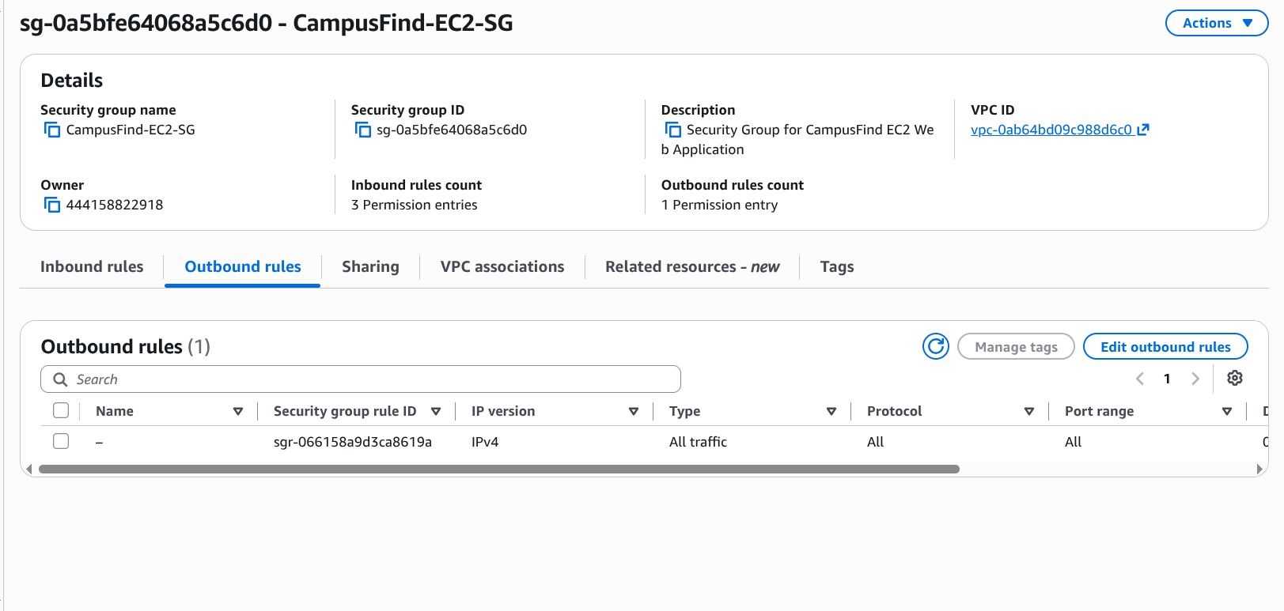
CampusFind-EC2-SG ( Outbound rule)

📸 PROOF-06: Amazon CloudWatch Metrics & Telemetry Graphs
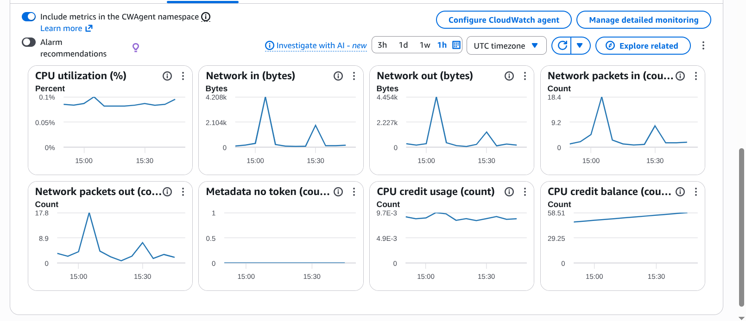

📸 PROOF-07: Live Web Application Running via Public EC2 IP / Domain(http://56.228.41.189)
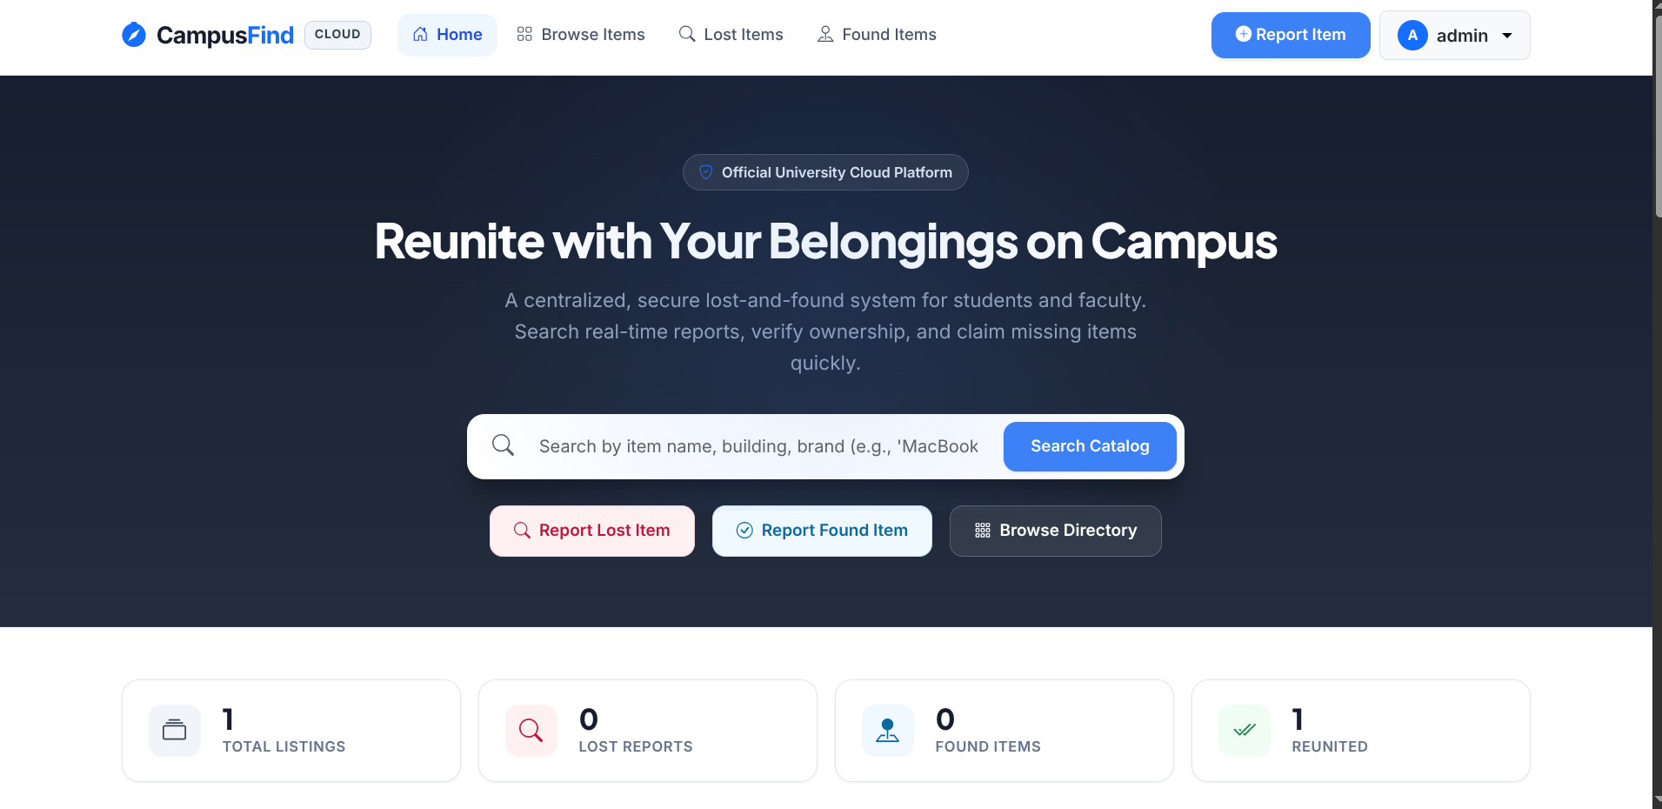

📸 PROOF-08: Functional Item Submission & Print Flyer View
• AWS Service / Scope: Application Features
• Required Evidence: Browser view of a posted lost item detail page and the one-click printable notice flyer with tear-off contact strips.
• Verification Action: Navigate to `/items/<id>/print/` in browser > Capture the formatted notice flyer preview.
[ 🖼️ PASTE VALIDATION SCREENSHOT HERE — SIZED TO FIT WIDTH ]

📸 PROOF-09: Automated Test Suite Execution (15/15 Tests Passed)
• AWS Service / Scope: Quality Assurance / Django
• Required Evidence: Terminal output executing `./venv/bin/python manage.py test` displaying all 15 tests passing with `OK` status.
• Verification Action: Run `python manage.py test` in terminal > Capture complete terminal output and summary.
[ 🖼️ PASTE VALIDATION SCREENSHOT HERE — SIZED TO FIT WIDTH ]

📸 PROOF-10: GitHub Repository & Version Control Proof
• AWS Service / Scope: Source Control / GitHub
• Required Evidence: GitHub repository web page showing commit history, branches, `.gitignore` preventing secret leaks, and `docs/` suite.
• Verification Action: Navigate to `https://github.com/cloudcomputinggroup2/campusfind.git` in browser > Capture repository overview.
[ 🖼️ PASTE VALIDATION SCREENSHOT HERE — SIZED TO FIT WIDTH ]

3. Cloud Deployment Verification Sign-Off
Evaluation Milestone | Assigned Lead | Status | Sign-Off Date
EC2 & Nginx/Gunicorn Hosting | Cloud Architect | VERIFIED LIVE | August 2026
Amazon RDS PostgreSQL Connectivity | Database Lead | VERIFIED LIVE | August 2026
Amazon S3 Media Uploads & IAM | Storage & Security Lead | VERIFIED LIVE | August 2026
15/15 Automated Tests & CloudWatch | QA & Docs Lead | VERIFIED (100% PASS) | August 2026

