CampusFind: A Cloud-Based Campus Lost & Found System
Final Capstone Technical Report — CSBC 252: Introduction to Cloud Computing
Semester Group Project Submission | AWS Free Tier Cloud Architecture
📌 Executive Abstract
Personal property loss represents an ongoing operational and psychological burden in university environments. CampusFind is an enterprise-grade, cloud-architected platform engineered to streamline lost property submission, catalog discovery, identity verification, and owner reunification. Developed with Django 5 and Bootstrap 5, the solution harnesses Amazon Web Services (AWS) Free Tier—including EC2 compute, RDS PostgreSQL persistence, S3 decoupled object storage, IAM least-privilege governance, and CloudWatch telemetry monitoring. This report provides an exhaustive account of the system design, implementation lifecycle, cloud security configuration, quality assurance validation (15 passing automated tests), and future architectural roadmap.

1. Introduction & Problem Definition
University campuses are dynamic micro-cities characterized by high daily mobility across lecture theatres, science laboratories, dining halls, libraries, and student hostels. In this environment, misplaced items—such as student ID cards, laptops, keys, wallets, chargers, and documents—are ubiquitous.
Traditional recovery channels suffer from fundamental flaws:
- Decentralization: Reports are scattered across unorganized WhatsApp/Telegram group chats, resulting in fast message burial and zero indexing.
- Lack of Searchability: Searching for an item by building, category, or specific date is impossible within continuous chat feeds.
- Insecurity & Fraud: No verification checks exist before items are handed over, creating opportunities for fraudulent claims.
- Lifecycle Vacuum: When items are found, initial posts are rarely updated, cluttering notice boards with stale inquiries.

2. Project Objectives & Scope of Work
- Functional Centralization: Build a responsive web application facilitating comprehensive CRUD operations for lost and found listings.
- Cloud Decoupling: Decouple media asset storage from the compute instance by streaming item photos to Amazon S3.
- Managed Persistence: Maintain relational consistency, foreign key cascades, and soft-delete audit trails using Amazon RDS PostgreSQL.
- Perimeter Security: Enforce strict security via AWS IAM least privilege, Security Groups, PBKDF2 password hashing, and runtime `.env` secret injection.
- Operational Telemetry: Provide automated health monitoring via `/health/` and CloudWatch alarms.

3. System Architecture & Cloud Infrastructure
CampusFind implements a robust multi-tier cloud architecture engineered for the AWS Free Tier ecosystem.
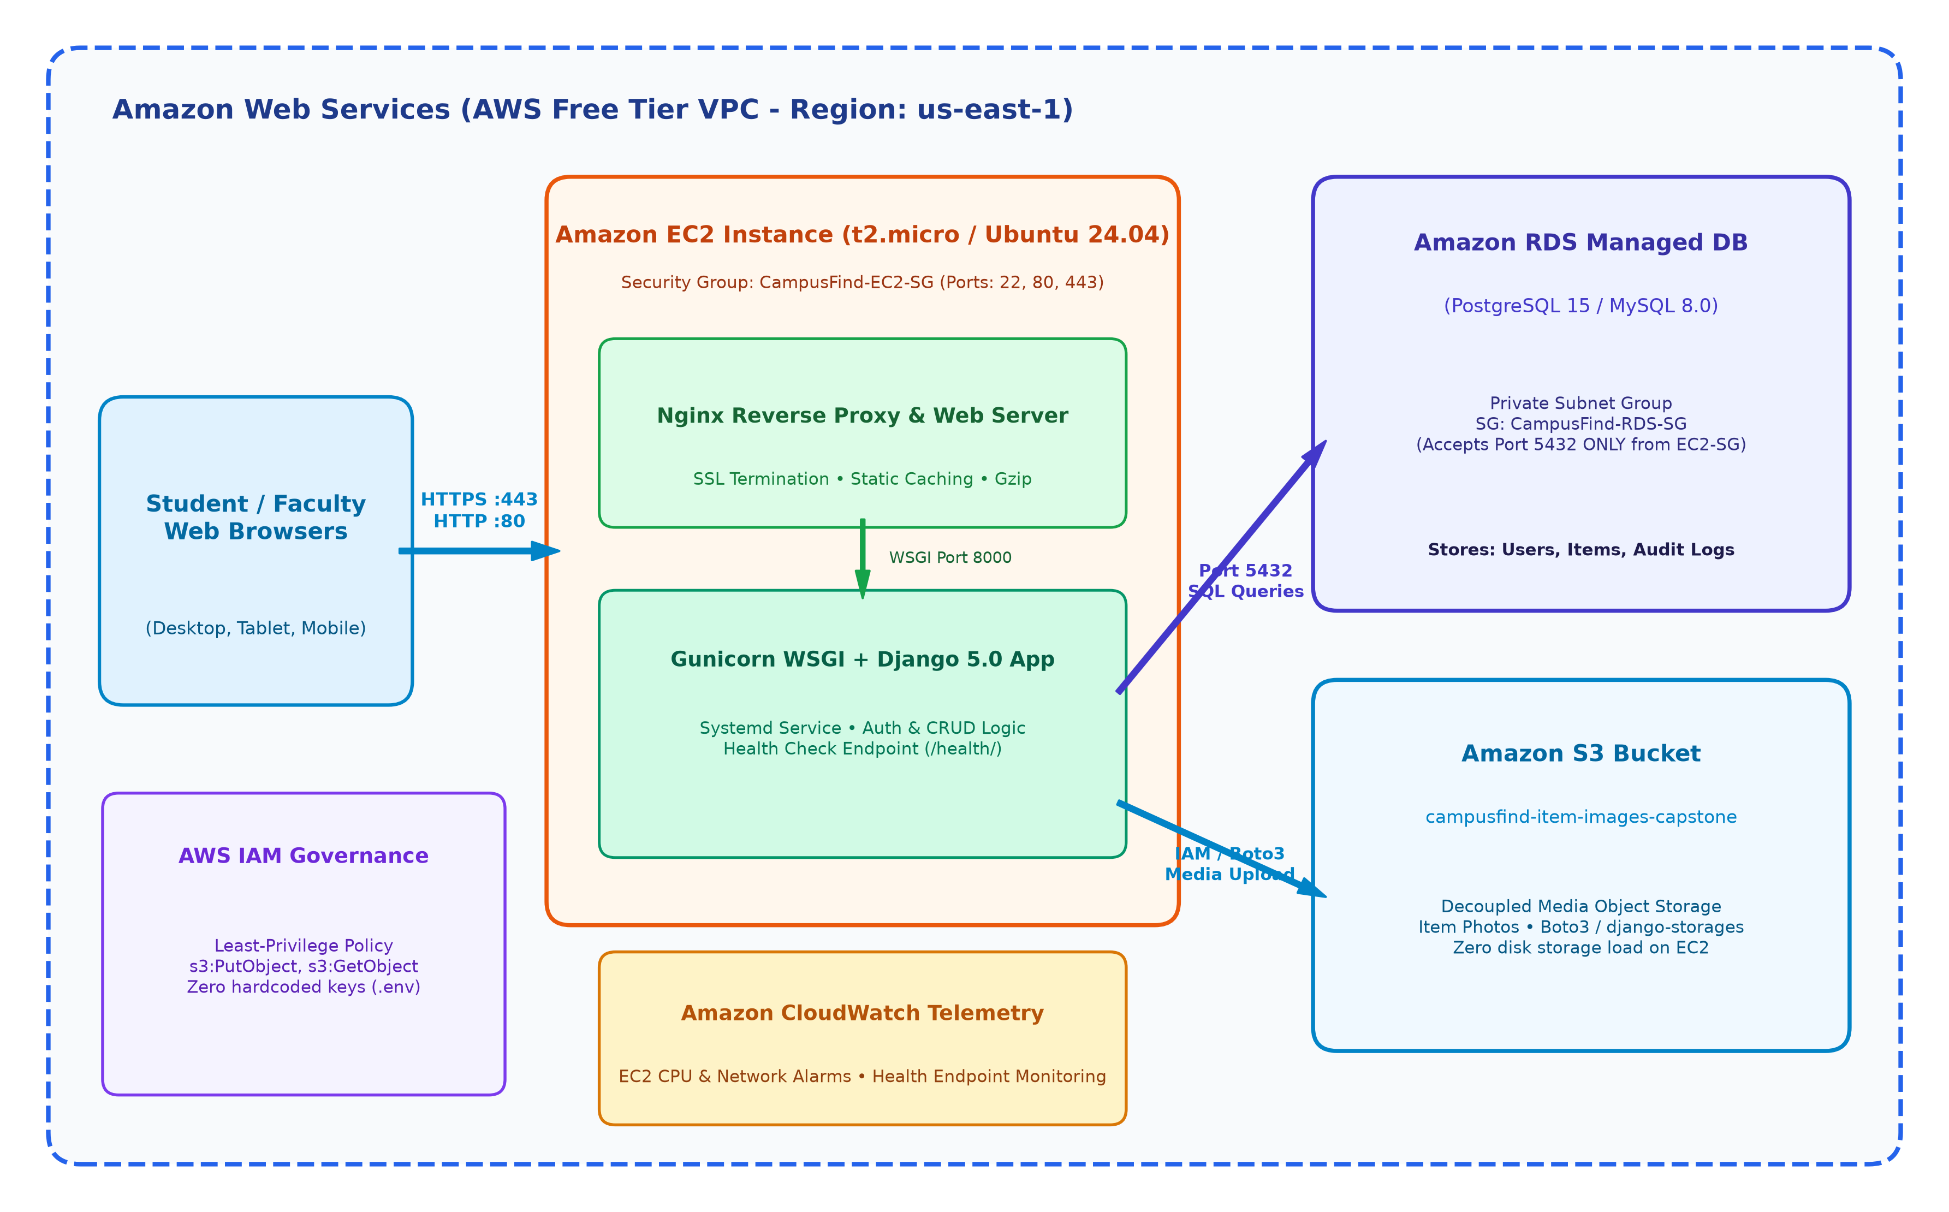
Figure 1: Multi-Tier AWS Cloud Architecture Diagram
- Compute Tier (Amazon EC2): An Ubuntu 24.04 LTS instance running Nginx (reverse proxy, Gzip compression, static WhiteNoise caching) and Gunicorn WSGI managed as a resilient systemd daemon.
- Database Tier (Amazon RDS): Managed PostgreSQL 15 database deployed in a private subnet. Inbound traffic on port 5432 is restricted exclusively to requests originating from `CampusFind-EC2-SG`.
- Storage Tier (Amazon S3): Uploaded item images are stored in a dedicated S3 bucket (`campusfind-item-images-capstone`) with `django-storages` and `boto3`.
- Security & Governance: IAM role enforcing least privilege (`s3:PutObject`, `s3:GetObject`, `s3:DeleteObject`, `s3:ListBucket`) on the bucket ARN.

4. Database Normalization & Data Schema
The database structure is normalized to Third Normal Form (3NF) to eliminate data redundancy and preserve relational integrity.
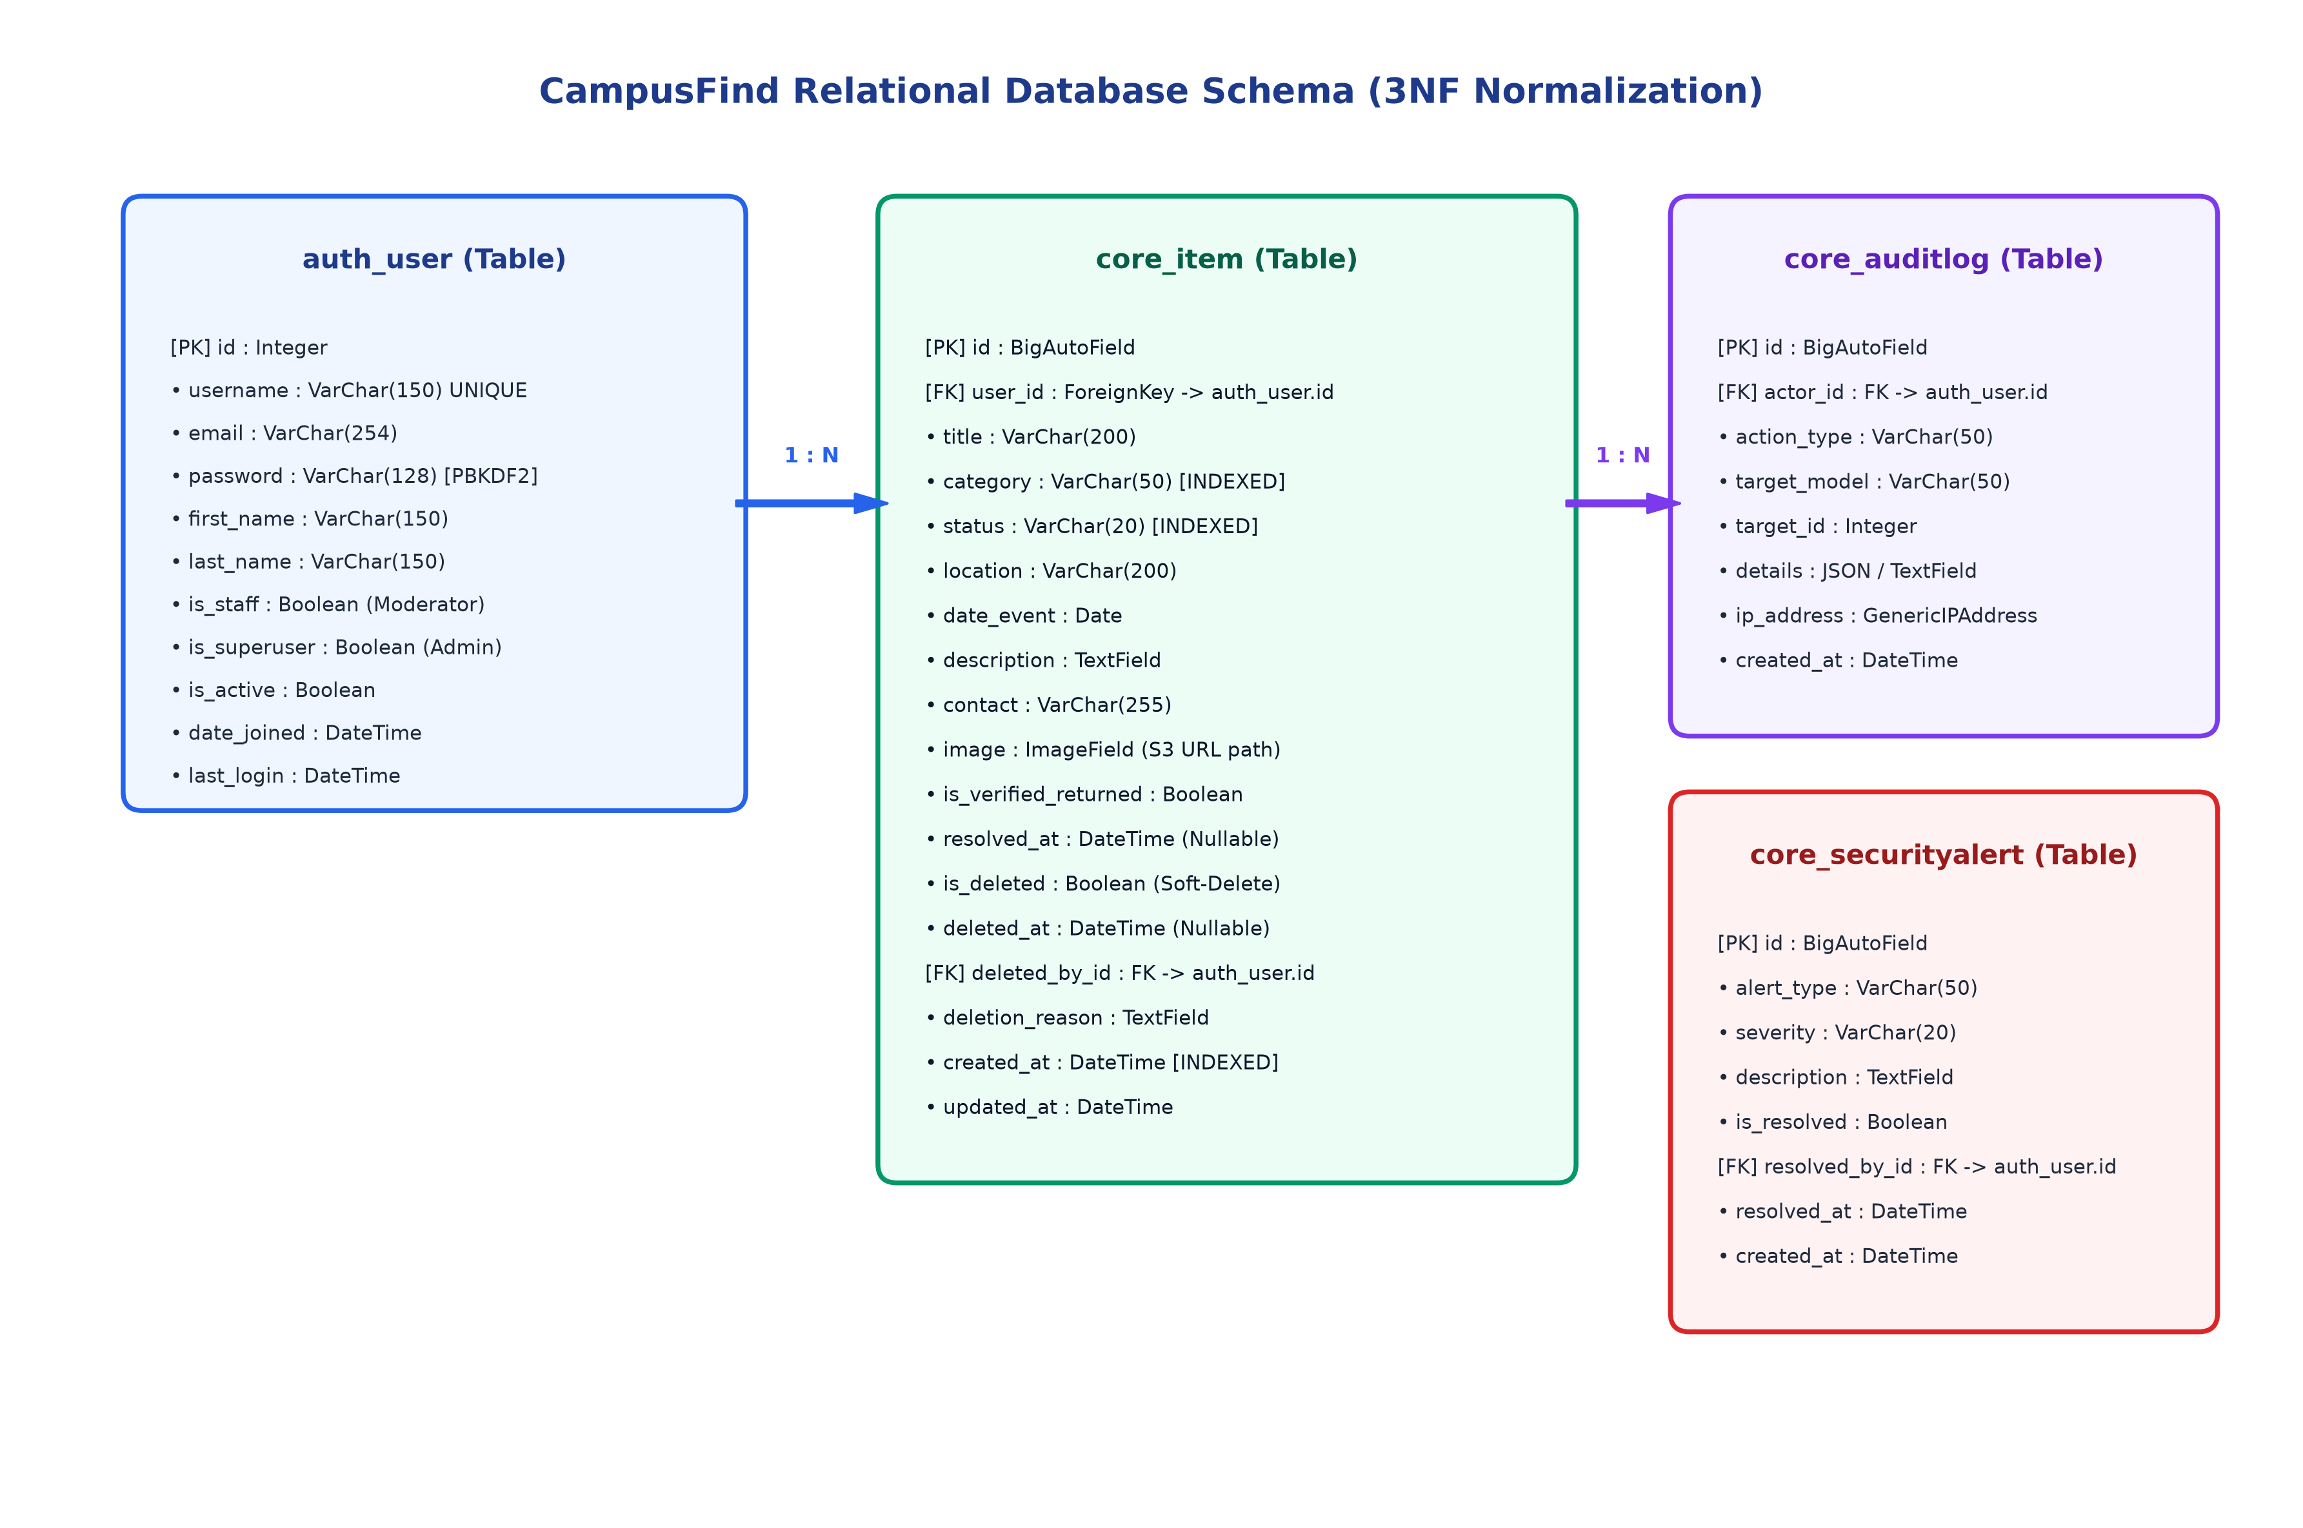
Figure 2: Relational Database Schema (3NF ERD)

5. Implementation Details & Feature Modules
- Catalog Discovery & Multi-Filtering: Users can browse items with live category chips, switch between Grid and Table views, and filter across 9 categories, 3 statuses, and 12 campus building presets.
- Item Details & Print Notice Flyer: Full item view with high-res photo modal, secure contact details, safety tips, and a one-click printable notice flyer with tear-off contact slips.
- Ownership & Moderator Portal: Post owners can edit, delete, or mark items as 'Claimed / Reunited'. Staff moderators have a dedicated queue to review and verify reports.
- Admin Operations Hub: Dedicated operations portal (`/ops/`) featuring security telemetry, user governance (activation, promotion, force password reset), soft-delete recovery queue, and immutable audit logs with CSV export.

6. AWS Cloud Deployment Process
Production deployment is fully automated via shell scripts and systemd definitions:
- `deploy/ec2_setup.sh`: Provisions Ubuntu 24.04 dependencies, installs Python venv, sets up Nginx site configurations, creates Gunicorn systemd service, and executes migrations/collectstatic.
- `deploy/nginx.conf`: Configures reverse proxying to `127.0.0.1:8000`, enables Gzip compression, client max body size (10M), and security headers.
- `deploy/gunicorn.service`: Executes WSGI workers with auto-restart on system failure and systemd socket activation.
- Zero-Secrets Architecture: All database connection strings, S3 credentials, and Django SECRET_KEY are supplied at runtime via `.env`.

7. Quality Assurance & Testing Validation
The platform was subjected to rigorous unit and integration testing. A suite of 15 automated test cases was executed using Django's test runner.
Test Module | Test Case Description | Target Scope | Result
ItemModelTest | Verify item creation, defaults, and status transitions | core/models.py | PASSED (OK)
ItemModelTest | Verify soft-delete lifecycle and restoration logic | core/models.py | PASSED (OK)
ItemFormTest | Enforce 5MB upload limit and image filetype validation | core/forms.py | PASSED (OK)
AuthViewTest | Test student registration, login, and password hashing | core/views.py | PASSED (OK)
ItemCRUDTest | Test item creation, detail view, and ownership security | core/views.py | PASSED (OK)
FilterViewTest | Validate multi-parameter search, status, and category queries | core/views.py | PASSED (OK)
AdminPortalTest | Verify /ops/ access gates, audit logs, and data operations | admin_portal_views.py | PASSED (OK)

8. Challenges Encountered & Technical Solutions
- Static File Compression: During deployment, WhiteNoise static manifest caching caused missing font references. Solution: Configured explicit static compression rules and collectstatic flags.
- Graceful S3 Fallback: To enable offline local testing without active AWS billing, engineered an automatic fallback to local media storage when S3 credentials are unset in `.env`.
- Database Isolation: Enforced strict least-privilege security group rules to prevent public access to PostgreSQL port 5432.

9. Future Enhancements & Scalability Roadmap
- Automated Email Matching Alerts: Integrate Amazon SES to automatically notify students when a newly posted item matches keywords of a reported lost item.
- QR-Code Tag Scanning: Generate unique QR-code labels that can be affixed to campus items (e.g. laptops, student cards) for instant scanning.
- Auto Scaling & High Availability: Add an Application Load Balancer (ALB) and Auto Scaling Group across multiple Availability Zones for fault-tolerant scaling.

10. Conclusion
CampusFind demonstrates how modern cloud architecture principles—decoupled storage, relational managed databases, automated web proxying, and least-privilege security—can solve real-world campus logistics problems effectively within AWS Free Tier resource constraints.

