CampusFind: System Design & Architectural Blueprint
Capstone Deliverable 2: Architectural Specifications, ERD, Use Cases & Wireframes
Course: CSBC 252 - Introduction to Cloud Computing

1. AWS Multi-Tier Cloud Architecture
The CampusFind cloud platform utilizes a decoupled multi-tier architecture designed for high availability, least-privilege security, and seamless horizontal scaling within the AWS Free Tier.
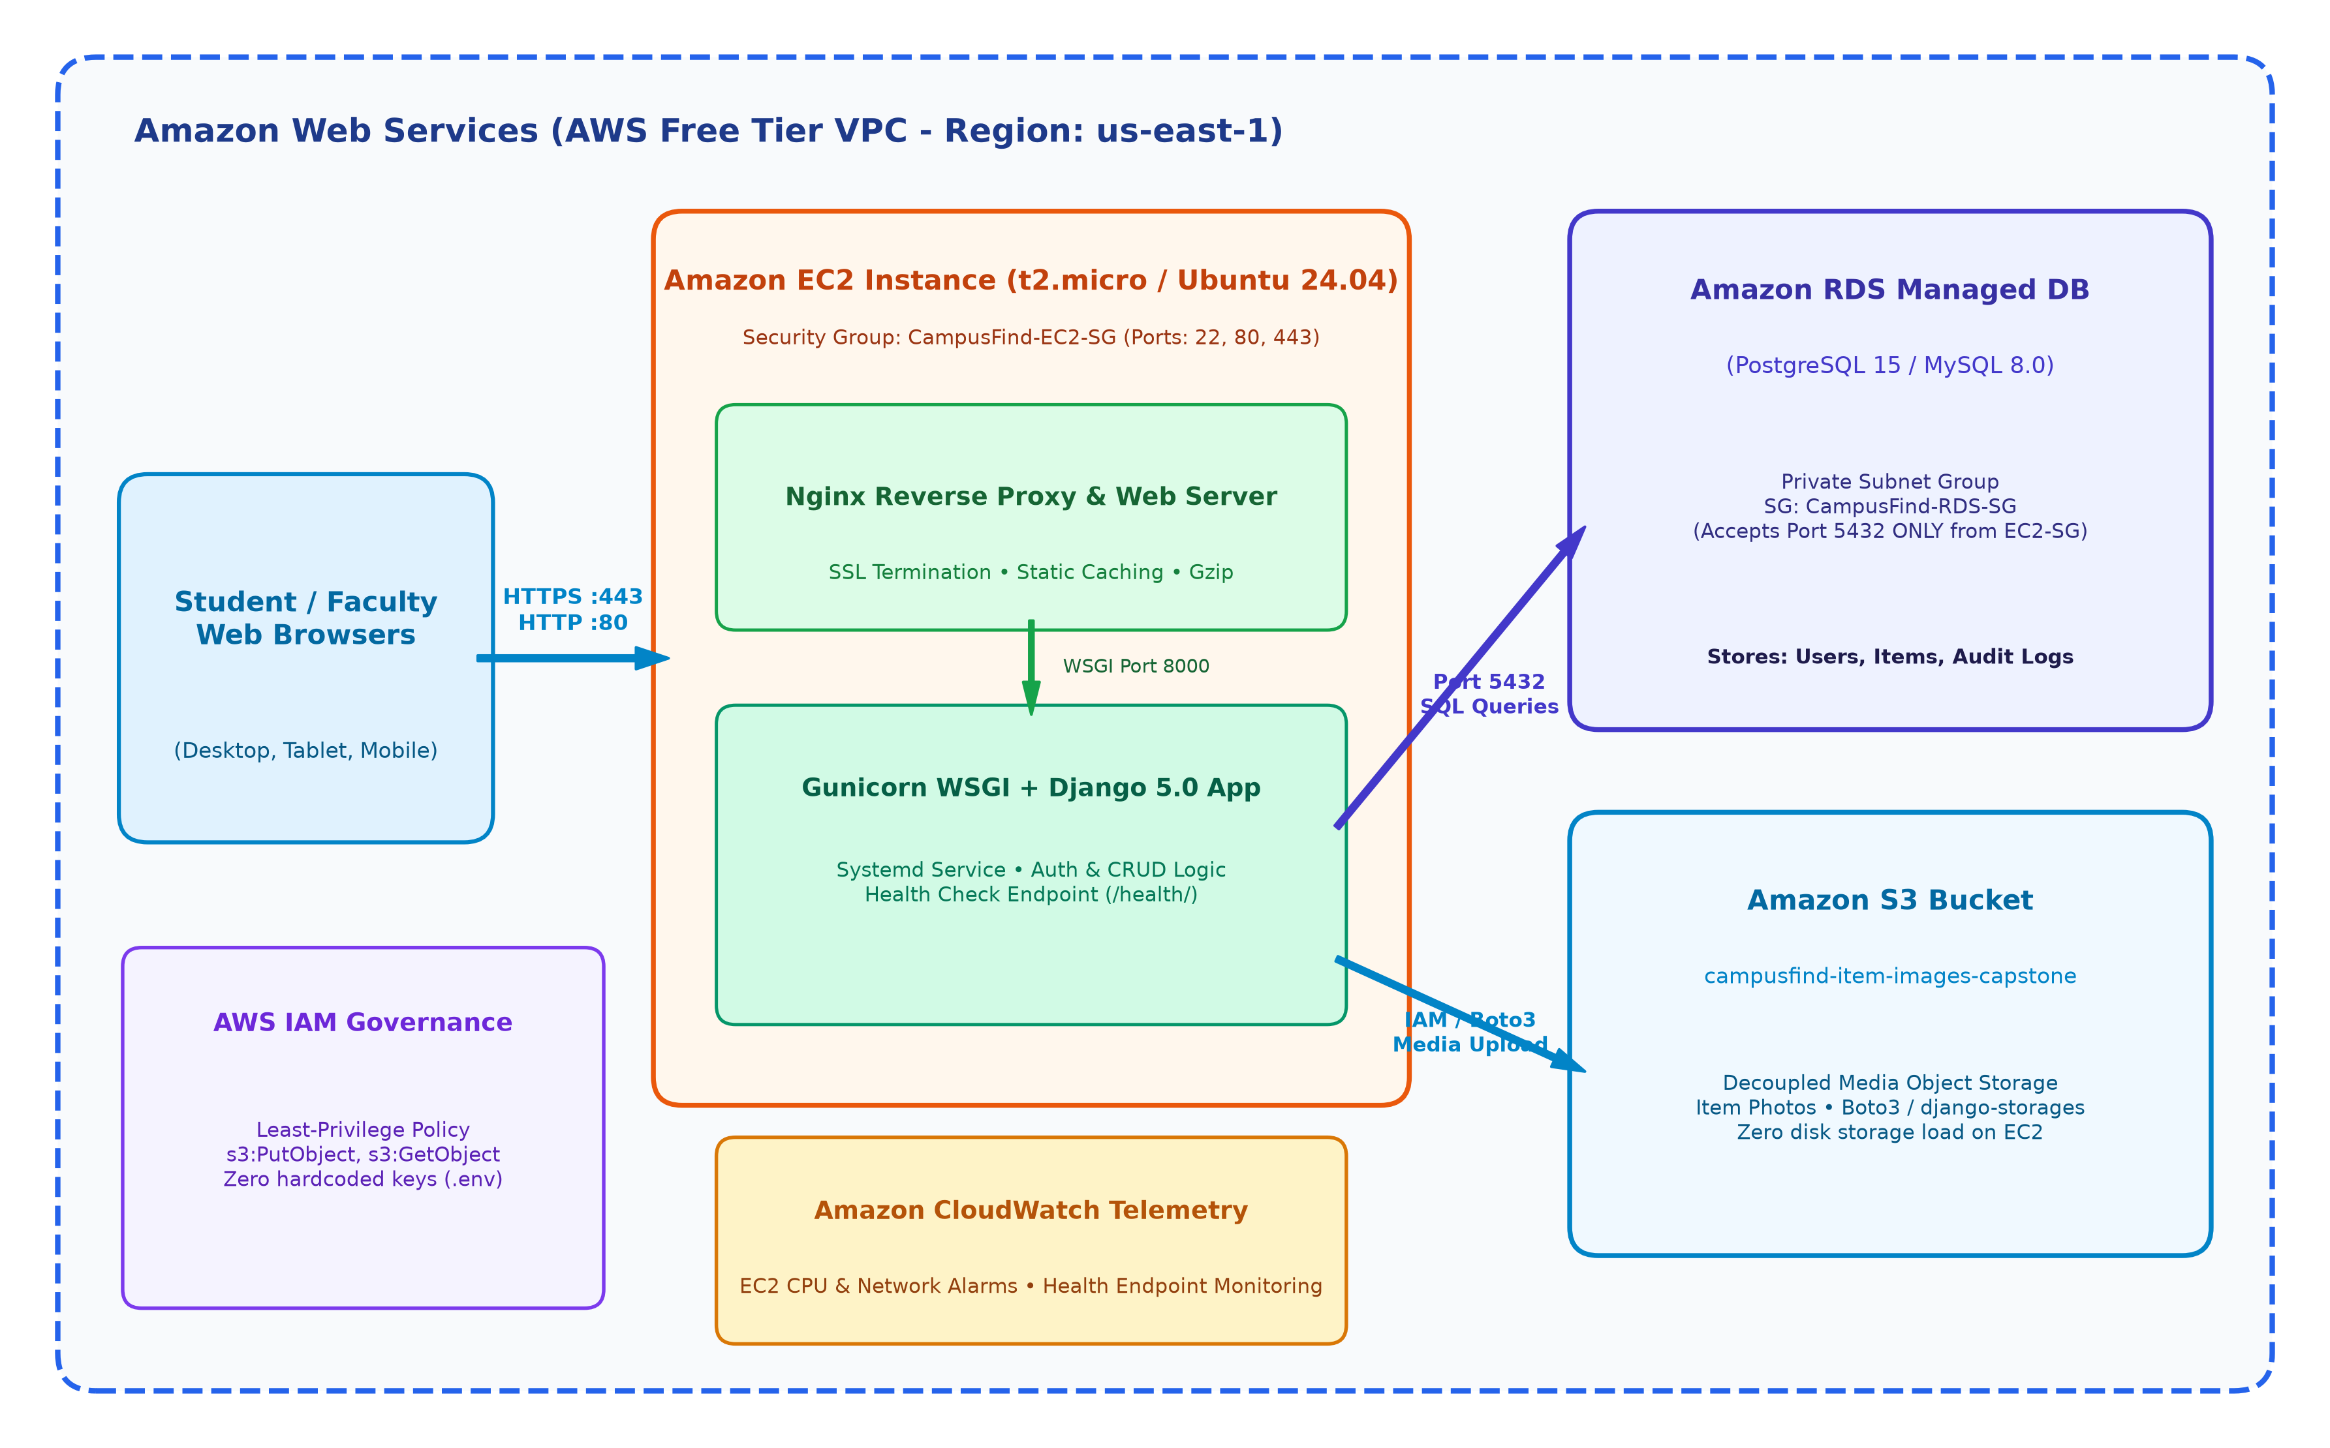
Figure 1: AWS Multi-Tier Cloud Architecture & Network Topology
- Web / Compute Tier (EC2): Public-facing Ubuntu 24.04 instance running Nginx as a reverse proxy for SSL termination, static file caching, and request forwarding to Gunicorn WSGI on port 8000.
- Data Tier (Amazon RDS): PostgreSQL 15 hosted in a private DB subnet group. Inbound access on port 5432 is restricted exclusively to requests originating from `CampusFind-EC2-SG`.
- Object Storage Tier (Amazon S3): Item photographs are streamed directly to Amazon S3 (`campusfind-item-images-capstone`), ensuring zero ephemeral storage load on the EC2 instance.
- Telemetry & Health Tier: EC2 CPU utilization, network traffic, and `/health/` status are monitored continuously.

2. Use Case Specifications & Actor Matrix
CampusFind recognizes three distinct user roles: (1) Student / Campus Users, (2) Campus Staff / Moderators, and (3) System Operations Administrators.
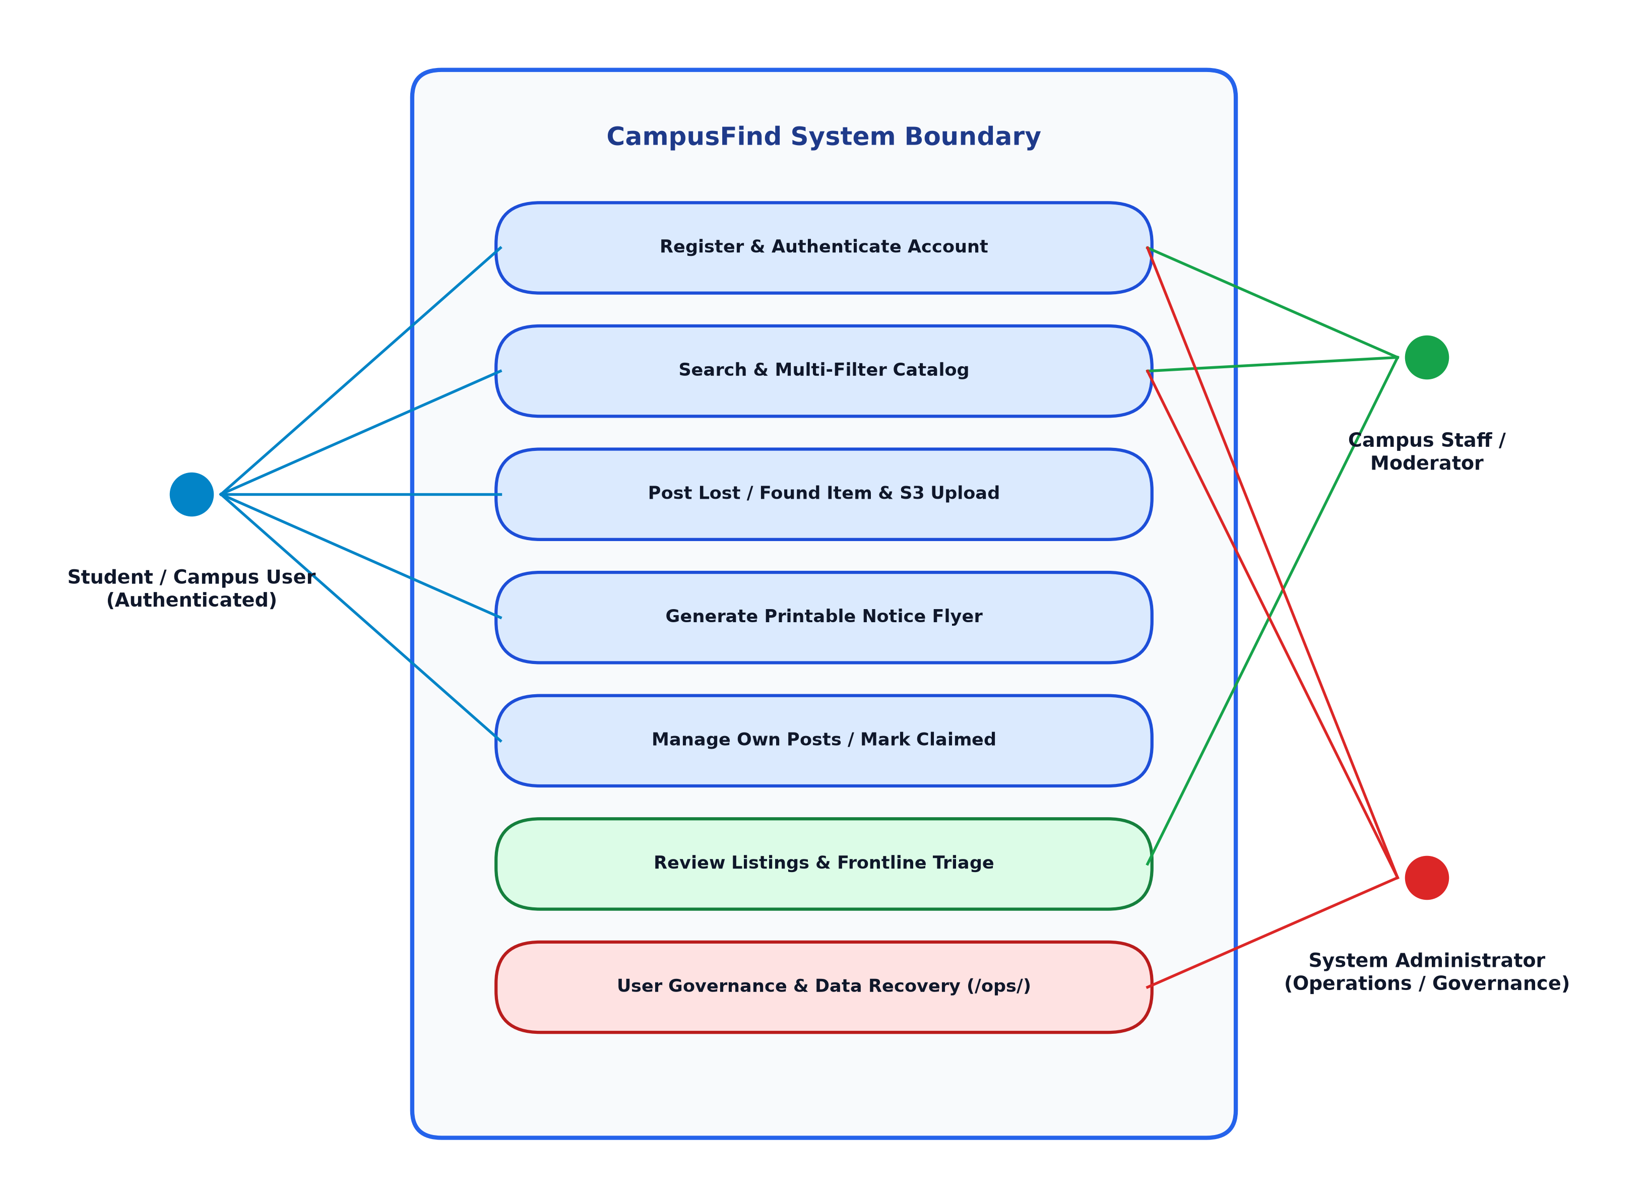
Figure 2: UML Use Case Diagram across Campus User, Moderator, and Administrator Actors
Use Case ID | Use Case Title | Primary Actor | Key Action & Precondition
UC-01 | Register & Authenticate | Campus User | User registers with student username/email; password hashed via PBKDF2.
UC-02 | Search & Multi-Filter Catalog | All Users / Public | Filter live catalog by keyword, status, category, location preset, and date.
UC-03 | Post Lost / Found Item | Authenticated User | Submit item with 5MB photo; uploaded securely to Amazon S3 bucket.
UC-04 | Generate Print Flyer | Campus User | One-click print view formatted with tear-off contact strips for bulletin boards.
UC-05 | Mark Claimed / Reunited | Post Owner / Staff | Toggle item status to Claimed; timestamps resolution for campus analytics.
UC-06 | Admin Operations (/ops/) | System Administrator | User account governance, soft-delete queue recovery, and immutable audit logs.

3. Database Schema Design (3NF Normalization)
The relational database structure adheres to Third Normal Form (3NF), decoupling authentication, item postings, administrative audit logs, and security telemetry.
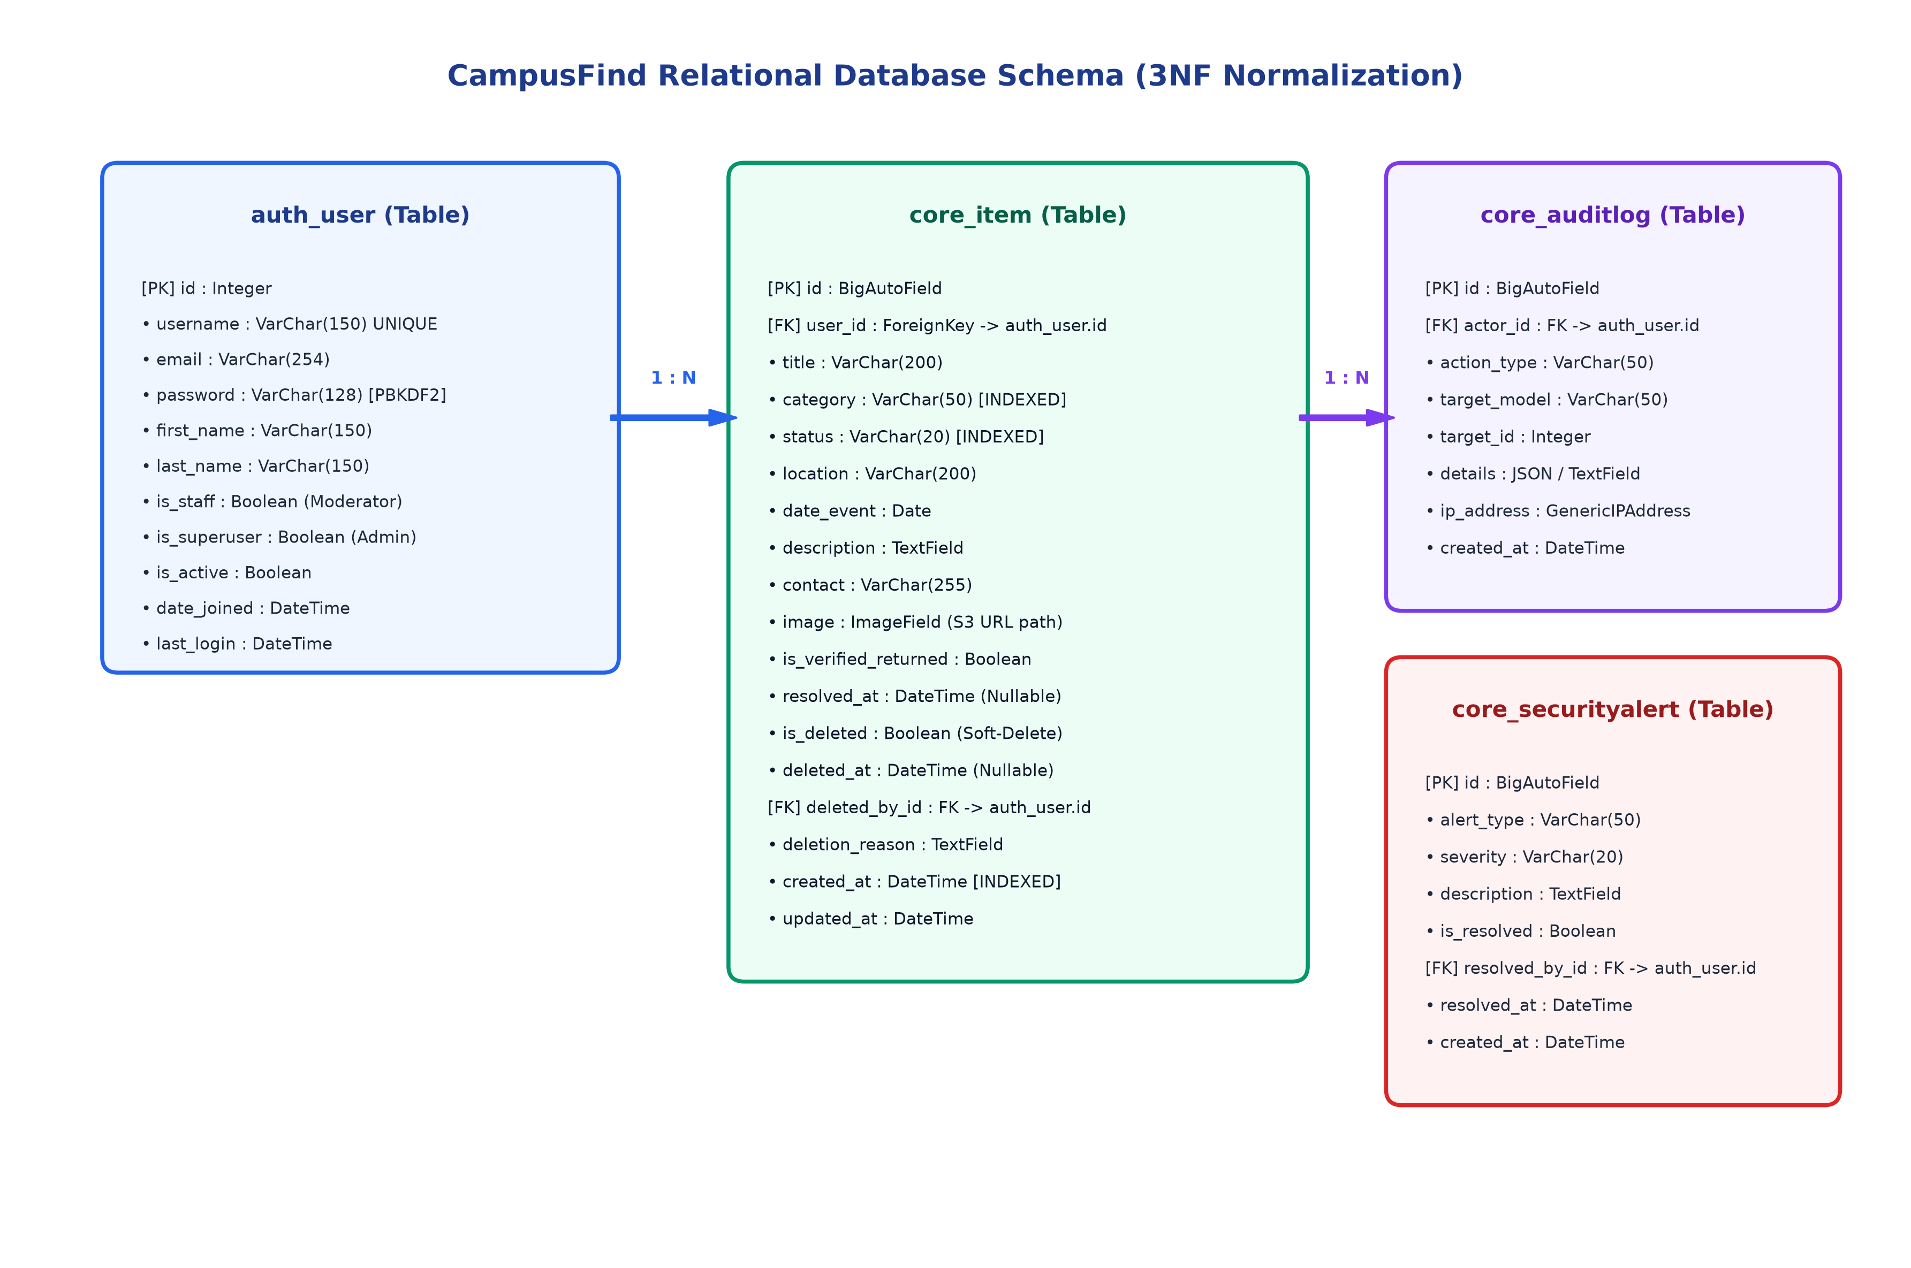
Figure 3: Entity Relationship Diagram (ERD) with Table Attributes and Foreign Keys

Data Dictionary & Key Table Specifications:
- auth_user: `id` (PK, Int), `username` (VarChar 150), `email` (VarChar 254), `password` (PBKDF2 Hash), `is_staff` (Bool), `is_superuser` (Bool), `date_joined` (DateTime).
- core_item: `id` (PK, BigInt), `user_id` (FK -> auth_user.id), `title` (VarChar 200), `category` (VarChar 50, Indexed), `status` (VarChar 20, Indexed), `location` (VarChar 200), `date_event` (Date), `description` (TextField), `contact` (VarChar 255), `image` (ImageField / S3 URL), `is_deleted` (Bool), `created_at` (DateTime, Indexed).
- core_auditlog: `id` (PK, BigInt), `actor_id` (FK -> auth_user.id), `action_type` (VarChar 50), `target_model` (VarChar 50), `target_id` (Int), `details` (JSON / TextField), `ip_address` (GenericIPAddress), `created_at` (DateTime).
- core_securityalert: `id` (PK, BigInt), `alert_type` (VarChar 50), `severity` (VarChar 20), `description` (TextField), `is_resolved` (Bool), `resolved_by_id` (FK -> auth_user.id), `created_at` (DateTime).

4. User Interface Architecture & Navigation Flow
The presentation layer is designed with Bootstrap 5.3, offering responsive interfaces across mobile, tablet, and desktop viewports.
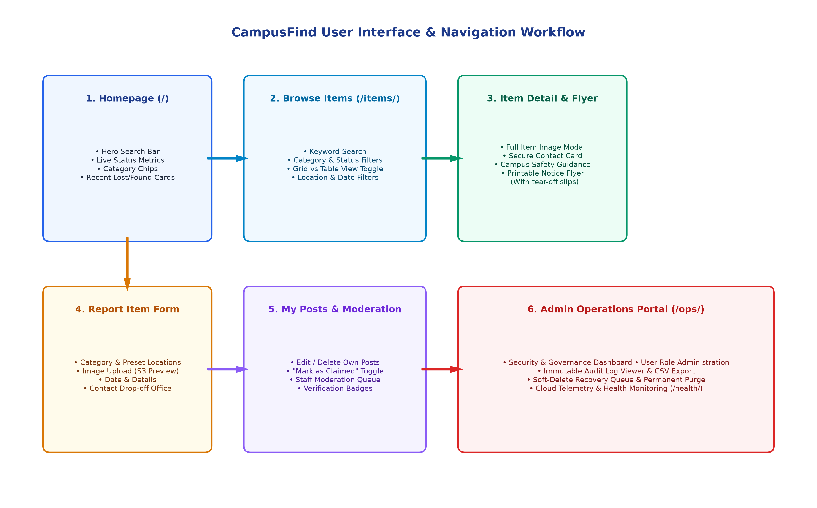
Figure 4: CampusFind User Interface Wireframe & Screen Transition Architecture

