General

HTTP/HTTPS vs WebSockets

* HTTP/HTTPS

1. When a request a sent to the server a connection is opened between client & server.
2. Connection gets closed, once server sends response to the initial request.
3. For every new request their would-be new connection opened & closed.
4. http/https is unidirectional (sender sends a request & server responds to the request but vice versa is not an option).

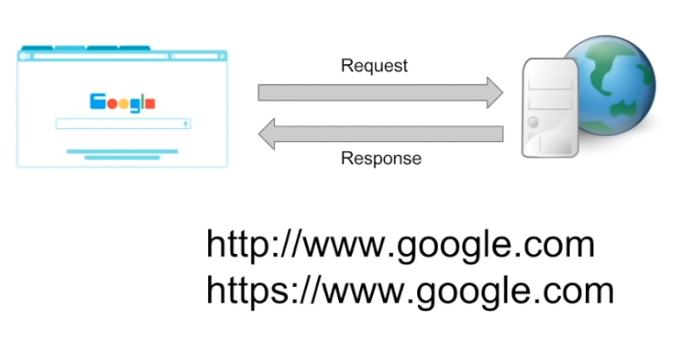

* WebSockets
  + 1. When a request a sent to the server a connection is opened between client & server.
    2. Connection doesn’t get closed, once server sends response to the initial request.
    3. For every new request there won’t be any new connection rather it will use same opened connection.
    4. WebSockets are bidirectional (that means both client & server can send/receive requests like Chatting apps, Gamming apps, RealTime apps).

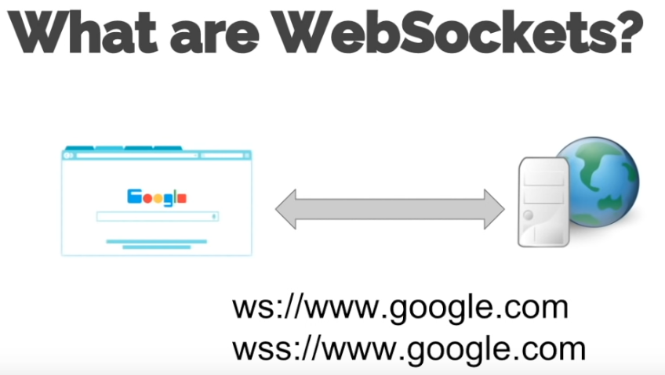

Example

* + - 1. **Trading application**

Site polls for updated data on server continuously updates on the site using WebSockets (without ajax)



* + - 1. **Chat App**

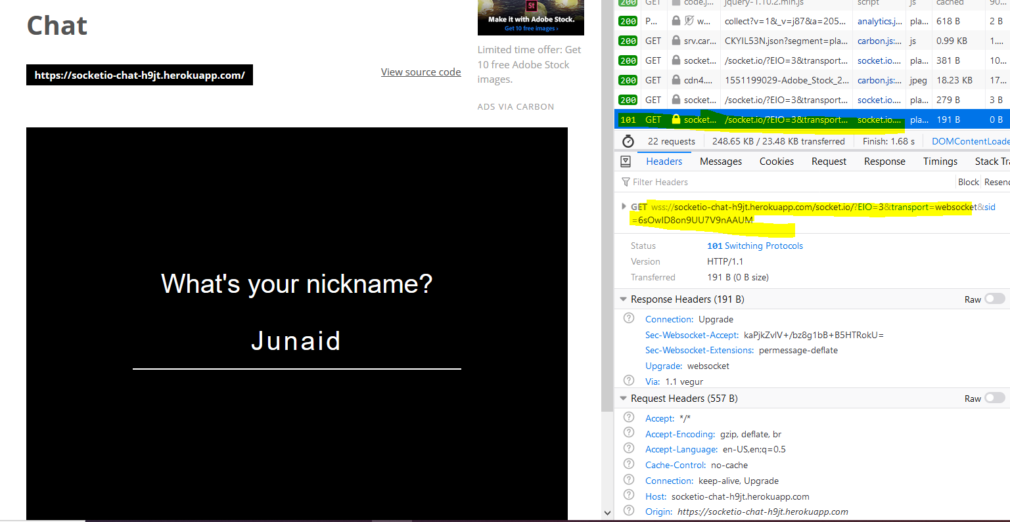

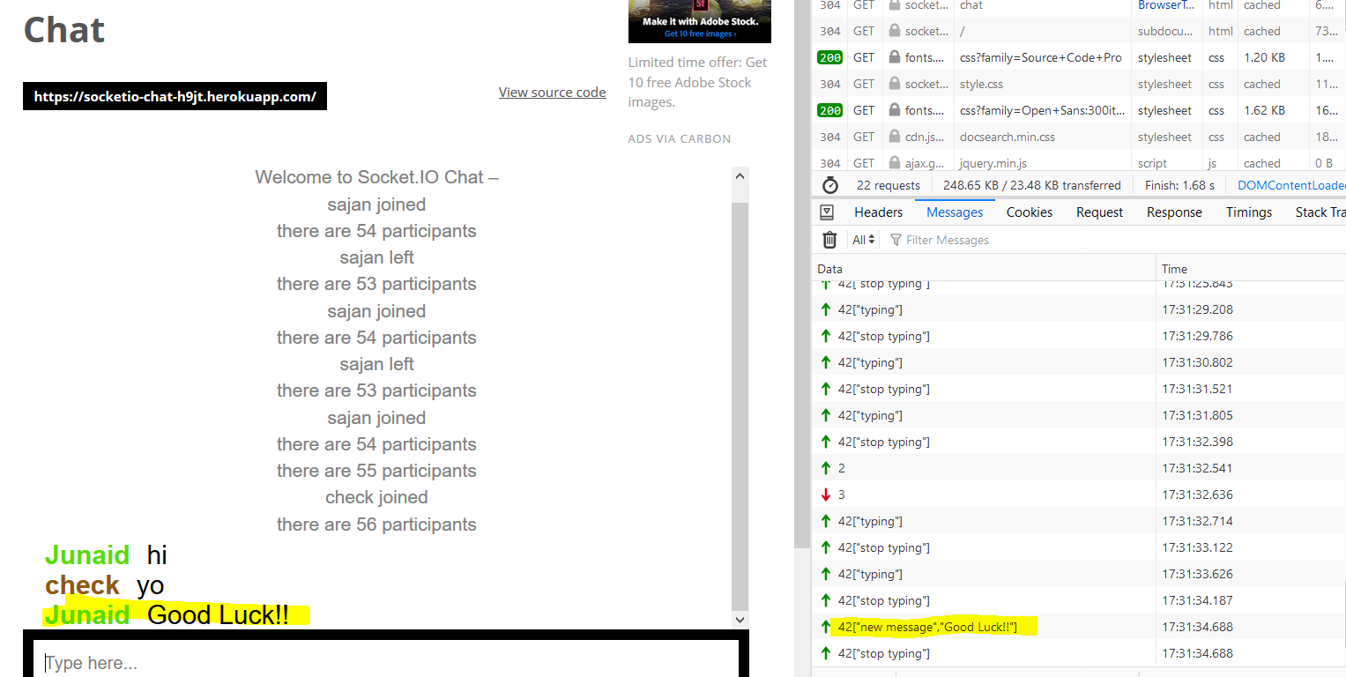

HTTP1.1 vs HTTP 2

