Fridge Recipe Tracker — Engineering Report
Team Project Part 1 · Programming Fundamentals · AI-assisted, food-waste-aware recipe planner (procedural Python CLI)
Lab group: [LabGroup] Team: [TeamNumber] | Submission: 14 October 2026
Members: [Name (Student ID), Name (Student ID), …] | Repository: github.com/clouden56/PROJECTKITCHEN

1. Problem and Objectives
Households routinely discard food that was simply forgotten until it expired, then spend more on groceries or takeaway, and face daily "what can I cook?" decision fatigue. Fridge Recipe Tracker is a command-line kitchen assistant that records fridge and pantry items with expiry dates and asks Google Gemini for a recipe that uses the most urgent items first. The AI output is never trusted blindly: a deterministic rule engine accepts, flags or rejects every suggestion before it reaches the user.
- Track inventory (name, quantity, unit, location, expiry) in flat JSON files that survive restarts and container rebuilds.
- Generate recipes with AI under the user's meal type, time limit, allergies and must-include ingredients, using a strict JSON response schema.
- Decide with business rules: allergen gate (with a synonym map, e.g. dairy → milk, cheese, butter), ≥ 50 % ingredient-match threshold, cook-time limit, must-include check, and a minimum of two inventory items before calling the API.
- Measure impact: an expiry-priority score (expired/today +40, 1–3 days +30, 4–7 days +15, otherwise +5, capped at 100) and an estimate of grams of food diverted from waste.

2. Architecture
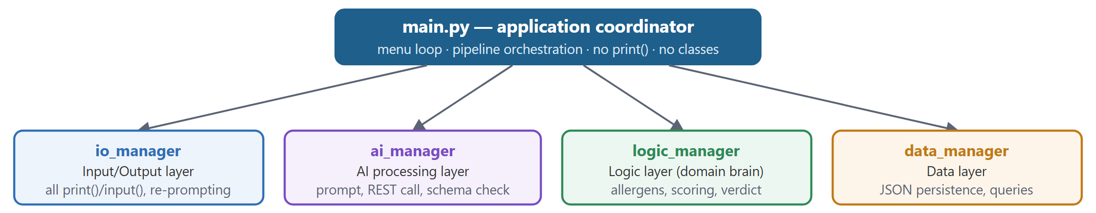
Figure 1. Hub-and-spoke modular architecture. No manager imports another manager; only main.py composes them, so each layer can be tested and replaced in isolation.
Module | Single responsibility | Key procedural functions (all typed; bold = framework API)
io_manager | Collect and validate every keystroke and return typed dicts; render every line of output. The only module that calls print() or input(). | prompt_recipe_generation_criteria, prompt_new_ingredient, prompt_history_filter, display_inventory, display_recipe_card, display_recipe_history
ai_manager | Build the prompt, call the Gemini REST API with a model cascade, and validate the JSON schema. Contains no domain rules. | build_prompt, call_api, parse_response, validate_response, process, classify_api_error
logic_manager | Apply the business rules to validated AI output and produce a verdict: ACCEPTED, FLAGGED or REJECTED. | evaluate, score, route, evaluate_allergen_safety, calculate_ingredient_match_ratio, check_mandatory_ingredients
data_manager | Load, save and query flat JSON files; survive missing, corrupt or unwritable files. | save, load, query(filter_fn), load_inventory, save_inventory, quarantine_corrupt_file, query_items_by_expiry

Design conventions. The program is 100 % procedural: there are zero class definitions, and an automated test scans every .py file to enforce this. Layers exchange only plain dict/list values. Failures are returned as values ((success, result, error_message) tuples, defaults or False), so an exception never crosses a layer boundary and the menu loop cannot crash. Diagnostics go to data/app.log through logging, keeping the terminal UI clean.

3. Data Flow Diagram and Exception Handling Matrix
The unit of work (the record) is a recipe request. Every request passes through ai_manager, and the validated AI output drives every decision in logic_manager; inventory items are reference data that the request carries. Figure 2 follows one request (menu option 4): each numbered box is a state of the data, each arrow the function that transforms it, and swimlanes show which layer owns each state.
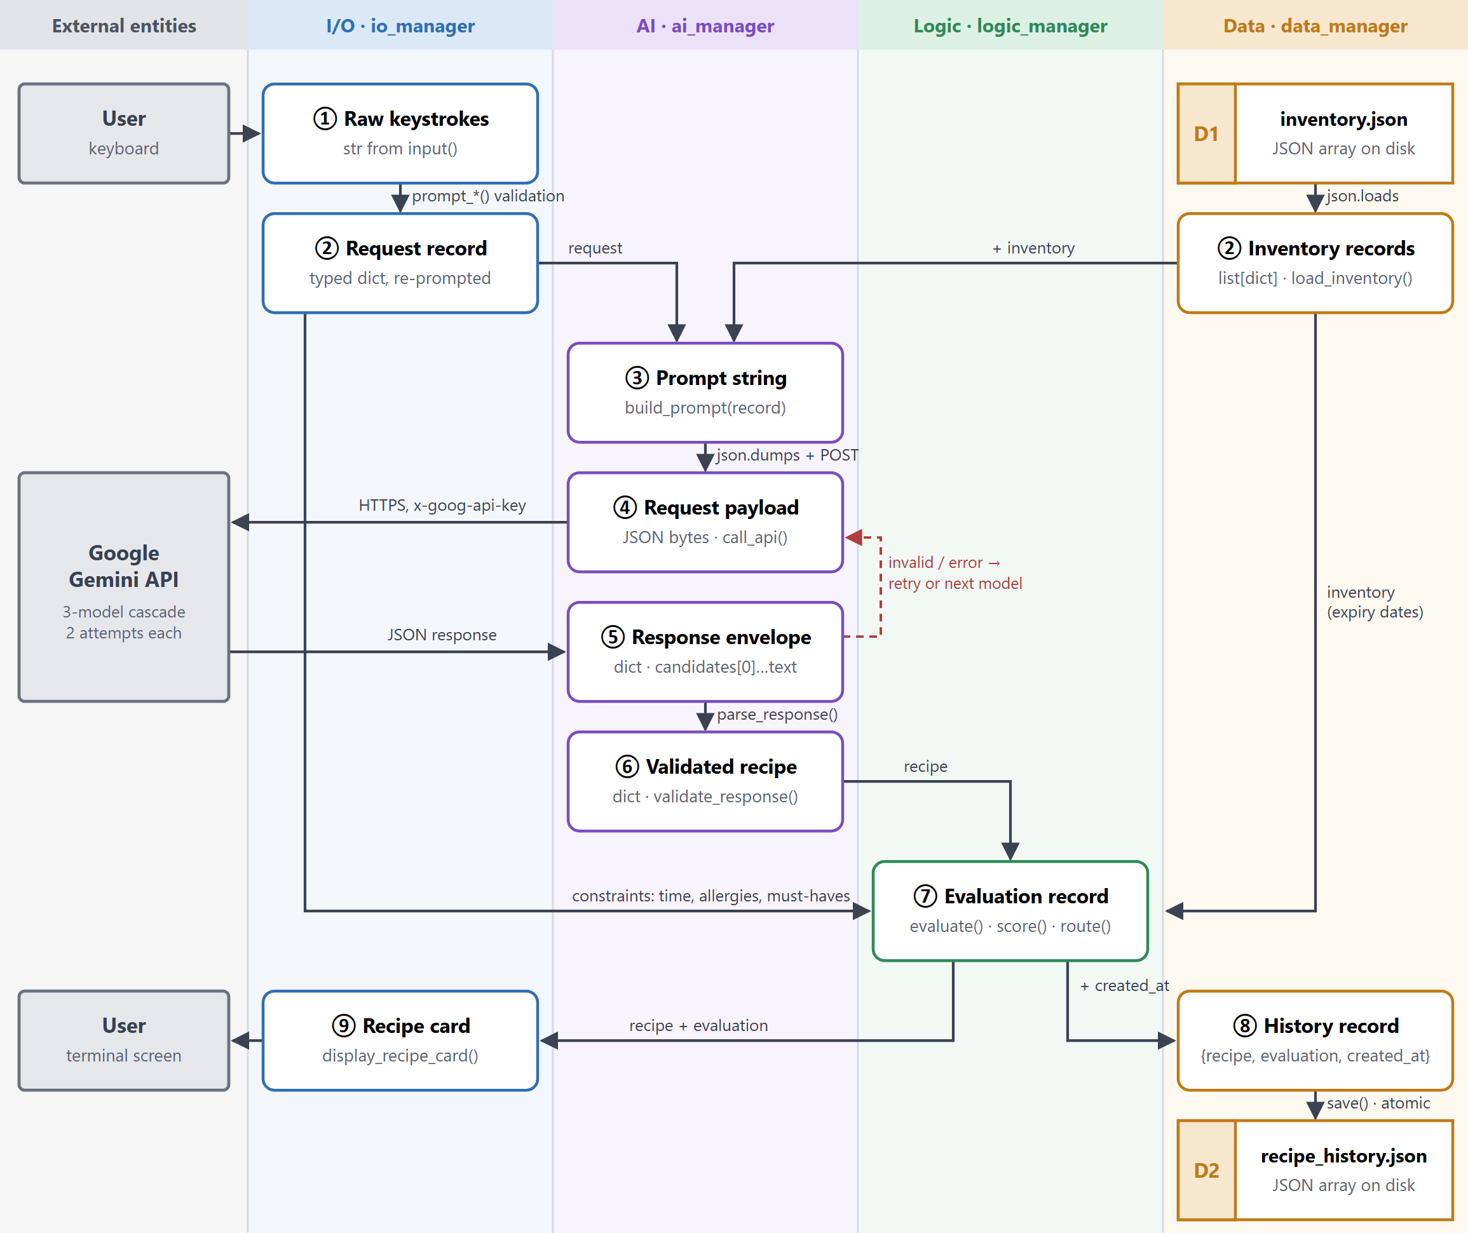
Figure 2. Data flow from user input → AI payload → file storage. The dashed red loop is the recovery path for a failed or invalid response; if every attempt fails, the user sees an error, nothing is written to D2, and control returns to the menu.
Failure class | Detected by | Handling & recovery → what the user sees | Detail · tests
API connection failure | call_api(): URLError, TimeoutError, HTTPError; classify_api_error() | Logged and returned as (False, None, msg), never raised. Transient errors back off and retry, then fall back to the next model; a bad key aborts at once; nothing is saved. → [ERROR] "AI API service temporarily unavailable…" | #1–5 · T9 T12
Malformed API response | parse_response(), validate_response() | Prose, truncated, empty or blocked replies and schema violations (missing keys, wrong types, out-of-range values) are rejected with a reason and retried. Invalid data never reaches logic_manager. | #6–10 · T4 T8 T9
Corrupt or missing data file | load_json_data(), save_json_data() | A missing file returns []. A corrupt file is logged, moved to a .bak backup, and [] is returned. Writes are atomic; write failures return False. → The app keeps running. | #11–16 · T3 T10
Invalid user input | io_manager prompt_*() loops | Type, range and required-field checks re-prompt until the value is valid; only typed dicts leave io_manager. Ctrl+C or EOF exits cleanly with code 0. | #17–21 · T11 T12

Table 3. Exception handling matrix (summary); every scenario is broken down in Section 4 with the automated test that proves it.

Inventory path (menu option 2): user input → file storage
Figure 3. The quantity is coerced to a positive finite float and the date to the canonical YYYY-MM-DD string; an existing item with the same name (case-insensitive) is updated rather than duplicated, and a new item gets the next ing-NNN id.

State of the data at each stage
Example values come from the automated end-to-end test (T12), which drives the real CLI with scripted keystrokes and a hardcoded Gemini response.
State | Type | Transformation | Example value
① Raw keystrokes | str | input() inside io_manager only | "4", "1", "20", "nuts", "", ""
② Request record | dict | prompt_recipe_generation_criteria(): typed, trimmed, comma-split | {"meal_type": "Breakfast", "max_cook_time_mins": 20, "allergies": ["nuts"], "mandatory_ingredients": [], "additional_notes": ""}
② Inventory records | list[dict] | load_inventory(): JSON → objects; non-dict rows dropped | [{"id": "ing-001", "name": "Eggs", "quantity": 6, "unit": "pcs", "location": "Fridge", "expiry_date": "2026-10-09"}, …]
③ Prompt string | str | build_prompt(record): inventory + constraints + required JSON schema | "…- Eggs (6 pcs, Location: Fridge, Expiry: 2026-10-09) … Restrictions to avoid: nuts … You MUST respond strictly with a valid JSON object…"
④ Request payload | bytes | call_api(): JSON-encoded POST, key in x-goog-api-key header | {"contents": [{"parts": [{"text": "<prompt ③>"}]}], "generationConfig": {"responseMimeType": "application/json", "temperature": 0.0}}
⑤ Response envelope | dict | json.loads() of the HTTP body | {"candidates": [{"content": {"parts": [{"text": "{\"recipe_name\": \"Spinach & Cheddar Omelette\", …}"}]}, "finishReason": "STOP"}]}
⑥ Validated recipe | dict | parse_response() → validate_response(): 8 fields type-checked, range-checked, trimmed | {"recipe_name": "Spinach & Cheddar Omelette", "estimated_cook_time_mins": 15, "ingredients_used": ["3 Eggs", "50g Cheddar Cheese, shredded", "1 cup fresh Spinach"], "missing_ingredients": [], "required_tools": [...], "instructions": [...], …}
⑦ Evaluation record | dict | evaluate(record) → score(), route() | {"outcome": "ACCEPTED", "status_code": "OPTIMAL_MATCH", "match_ratio": 1.0, "expiry_priority_score": 100.0, "rescued_items": [Eggs, Cheddar Cheese, Spinach], "waste_diverted_grams": 950, …}
⑧ History record → D2 | dict → JSON | save(record): append, write .tmp, atomic os.replace() | {"recipe": {⑥}, "evaluation": {⑦}, "created_at": "2026-10-08 14:52:10"} appended to data/recipe_history.json
⑨ Recipe card | text | display_recipe_card(⑥, ⑦) | Outcome Status : [ACCEPTED] - OPTIMAL_MATCH · Expiry Priority : 100.0 / 100 · Food Waste Saved: ~950 grams

How route() turns the evaluation into a verdict (⑦)
# | Condition (checked in order; first match wins) | Outcome | status_code
1 | Any ingredient matches a user allergen or a synonym of one | REJECTED | ALLERGEN_CONTAMINATION
2 | Ingredient match ratio < 50 % (pantry staples such as salt, black pepper and cooking oil are not counted) | REJECTED | INSUFFICIENT_INGREDIENTS
3 | A must-include ingredient is absent from the recipe | FLAGGED | MISSING_MANDATORY_INGREDIENT
4 | Cook time exceeds the user's limit | FLAGGED | EXCEEDS_TIME_LIMIT
5 | Some ingredients missing, but ratio ≥ 50 % | FLAGGED | MISSING_SOME_INGREDIENTS
6 | Otherwise | ACCEPTED | OPTIMAL_MATCH

4. Exception Handling Matrix (Detailed)
Every scenario behind the four required failure classes in Table 3. The Test column names the automated test (Section 5) that triggers it offline and asserts the stated behaviour. No failure is allowed to crash the menu loop.
# | Scenario | Detected by | Handling & recovery → what the user sees | Test
A. API connection failure
1 | No API key configured | get_api_key() returns "" in process() | Fails fast, before any network call. → [ERROR] "Gemini API key is not configured…", then back to the menu. | T9 T12
2 | Network down, DNS failure, refused connection, or 30 s timeout | URLError / TimeoutError caught in call_api | Returned as (False, None, msg) and logged; classified retry: 1.5 s back-off, 2 attempts × 3 models; nothing saved. → "AI API service temporarily unavailable…" if all fail. | T9
3 | Rate limited or server busy (HTTP 429 / 5xx) | HTTPError → classify_api_error() = retry | Back off, retry the same model, then move down the cascade. → Invisible if a retry succeeds. | T9
4 | Invalid or revoked key (401, 403, API_KEY_INVALID) | classify_api_error() = abort | Stops after one call, because no other model can succeed with a bad key. → "AI request rejected (check your GEMINI_API_KEY)". | T9 T12
5 | Model retired or request rejected (404 / 400) | classify_api_error() = next_model | Skips the second attempt and moves to the next model in the cascade. → Invisible if a fallback model succeeds. | T9
B. Malformed API response
6 | HTTP body is not JSON, or JSON is not an object | JSONDecodeError / isinstance check in call_api | Counted as a failed attempt → retry, then cascade. | T9
7 | No candidates (safety block), no parts, empty text, or a candidate that is not an object | Guard clauses + AttributeError / TypeError in parse_response | Returns (False, {}, reason) and never raises; the request loop tries again. | T8
8 | Prose or truncated JSON instead of a JSON object | JSONDecodeError in parse_response | Rejected; the next valid response is used (a malformed-then-valid sequence is tested). | T8 T9
9 | Valid JSON wrapped in ```json fences | strip_markdown_fences() | Fences are stripped and the JSON accepted (tolerant reader). → Normal recipe card. | T8
10 | Missing field, wrong type ("about 10 minutes", true), negative or NaN cook time, empty name, ingredients or steps | validate_response() (8 required fields, types, ranges) | Rejected with a field-specific reason; invalid data never reaches the logic layer. → After the final attempt: [ERROR] with the last reason; nothing saved. | T4 T8
C. Corrupt or missing data file
11 | File or data/ folder missing (first run, fresh container), or empty file | os.path.exists and an empty-content check in load_json_data | Returns [] and creates the folder; the file is created on first save. → "Your inventory is currently empty…" | T3 T10
12 | Corrupt JSON (truncated or hand-edited) | JSONDecodeError in load_json_data | Logged; the file is moved to *.corrupt-<timestamp>.bak, so the next save cannot overwrite the original bytes; the app continues with []. | T3 T10
13 | Wrong shape (object instead of array, non-object rows) | isinstance filters in load_inventory / load | Invalid rows are dropped and valid rows kept. | T10
14 | Unreadable file (permissions, invalid UTF-8) | OSError / UnicodeDecodeError | Logged; the default [] is returned and the app keeps running. | —
15 | Write fails (read-only disk, bad path, unserialisable value) | OSError / TypeError / ValueError in save_json_data | Returns False and removes the temp file; the caller reports it. → [ERROR] "Failed to save inventory to storage." | T10
16 | Crash or power loss during a save | Prevented by design | Data is written to file.tmp and then swapped in with an atomic os.replace(), so the stored file is never half-written. | T10
D. Invalid user input
17 | Blank text; non-numeric or out-of-range menu, meal or storage choice | prompt_menu_choice, prompt_string, prompt_meal_type, prompt_storage_location | Re-prompts in a loop; the allergy list is trimmed and blank entries dropped. → "Invalid option. Please choose between 1 and 7." | T11
18 | Bad or impossible date (12-10-2026, 2026-02-30) | strptime ValueError in prompt_date | Re-prompts with an example; the date is stored canonically as YYYY-MM-DD. | T11 T12
19 | Zero, negative, non-numeric, inf or nan quantity or cook time | prompt_positive_number (ValueError, math.isfinite, > 0) | Re-prompts. → "Number must be strictly greater than 0." / "…a finite value." | T11 T12
20 | Removing an unknown item; fewer than 2 items before an AI request | remove_inventory_item flag; rule in handle_generate_recipe | Nothing is saved and no API call is made. → [WARNING] "…was not found" / "…add more items". | T12
21 | Ctrl+C or closed input stream (EOF, e.g. docker run without -it) | KeyboardInterrupt / EOFError in main() | Clean exit with code 0; every action had already been saved. → "Input stream closed. Exiting … safely." | T12

5. Automated Testing
tests/test_pipeline.py is a procedural test runner: it defines no classes and never contacts the live API. It uses hardcoded sample Gemini responses (tests/sample_ai_responses.py), each a full generateContent envelope as the real API returns it, and substitutes call_api and the keyboard reader with scripted stand-ins. It exits non-zero on any failure, so CI and Docker can gate on it.
ID | Test | What it proves
T1 | Zero-classes constraint | A regex scan of every .py file finds no class definition
T2 | print / input localisation | A grep-strict scan finds print( and input( only in src/io_manager.py
T3 | Data persistence & resilience | save/load round trip, query(filter_fn) incl. a raising filter, expiry query, corrupt-file fallback
T4 | AI schema validation | A valid payload is accepted; a missing field, wrong type or empty list is rejected
T5 | Logic multi-condition rules | Allergen gate, score(), and the ACCEPTED / FLAGGED / REJECTED branches of evaluate()
T6 | Logic rules on sample AI responses | Six hardcoded responses → parse_response → validate_response → evaluate reach every verdict, with exact score (100), ratio (0.6) and waste (950 g)
T7 | Logic helper functions | route() rule order, fixed-date expiry maths, fuzzy matching, staples, unit conversion
T8 | Malformed AI responses | Nine malformed envelopes are rejected without raising; a fenced-JSON response is accepted
T9 | Offline API failure handling | Network down, timeout, non-JSON body, invalid key, 404 cascade, 429 recovery, missing key, real refused socket
T10 | Corrupt & unwritable files | Quarantine to .bak, empty and wrong-shape files, atomic save, write failure returns False
T11 | I/O re-prompting | Every prompt rejects blank, text, out-of-range, bad-date and inf/nan input until a valid value is given
T12 | End-to-end pipeline (offline) | Drives the real CLI: add item → JSON file; recipe → history record; history query; API 401 → nothing saved; EOF → clean exit

Result: 12/12 pass locally (Python 3.14, Windows 11) and inside the Docker image (Python 3.12-slim, Linux), with no API key and no network: docker compose run --rm test.

6. DevOps: Version Control, CI and Docker

Git workflow
- Work happens on feature branches (e.g. feature/part1-deliverables) and is merged into main by pull request once CI passes.
- One logical change per commit, with a descriptive message, e.g. "quarantine corrupt data files and make JSON saves atomic".
- .env is git-ignored (only .env.example is committed), and the API key is sent in a header, never in a URL.

Docker
- Dockerfile sits in the repository root and builds on python:3.12-slim with zero third-party packages (standard library only), giving a 43 MB compressed image.
- /app/data is a volume, so data persists between runs. docker compose run --rm app starts the app; the test service needs no .env.

CI pipeline (.github/workflows/ci.yml)
GitHub Actions runs on every push and on every pull request into main:
- Lint & test on Python 3.10 and 3.12: ruff (syntax errors, undefined names), byte-compile, then the full offline suite with an empty API key.
- Docker, after step 1 passes: build the image, run the suite inside the container, and smoke-test that the CLI starts and exits cleanly.
A red job blocks the merge, so main always builds, passes its tests and runs in a container.

7. Known Limitations
- Ingredient matching is lexical (substring and plural stemming), so "coconut milk" matches "milk". Semantic or AI-assisted matching would be more precise.
- The waste figure is a heuristic: about 100 g per countable unit, with the whole stock of each rescued item counted. Quantities are not decremented after cooking.
- Pantry staples do not lower the match ratio, but they are still listed as missing and can therefore produce an informational FLAGGED verdict.

