Get me the IP address of a particular domain (guvi.in). . Test the connectivity between 2 nodes

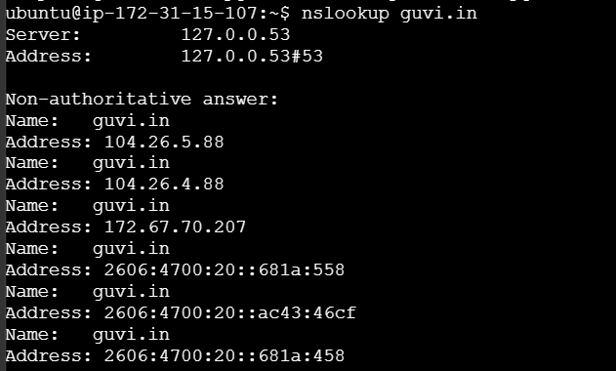

How do I find my CPU/memory usage of my server?

top command

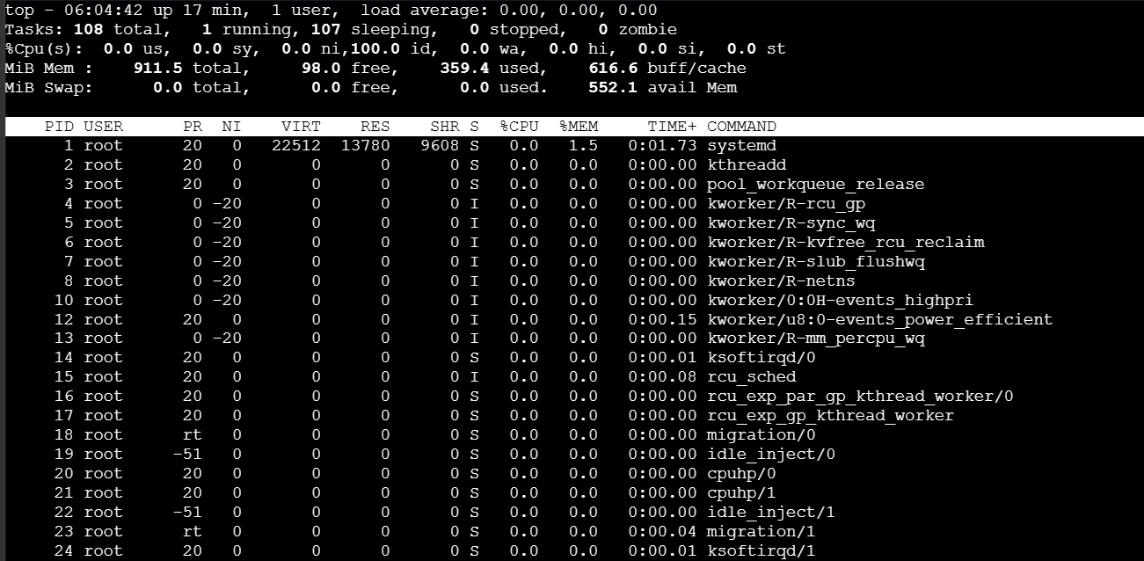

Test the connectivity between 2 nodes

Server 1:

Security group:
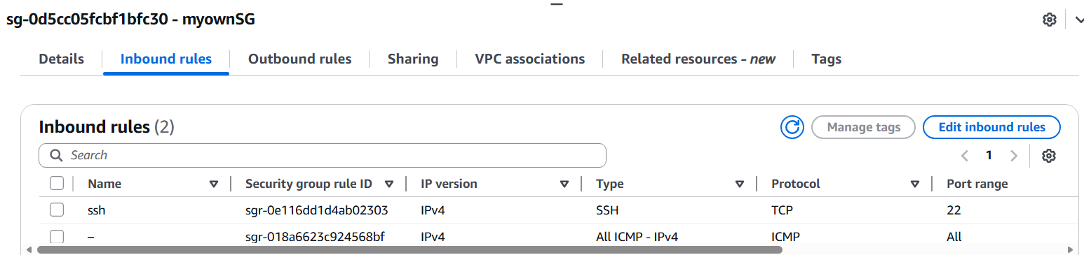

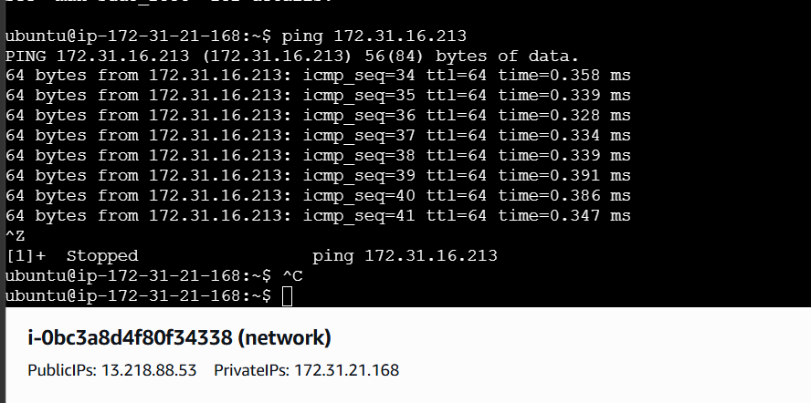

Server 2:

Security Group
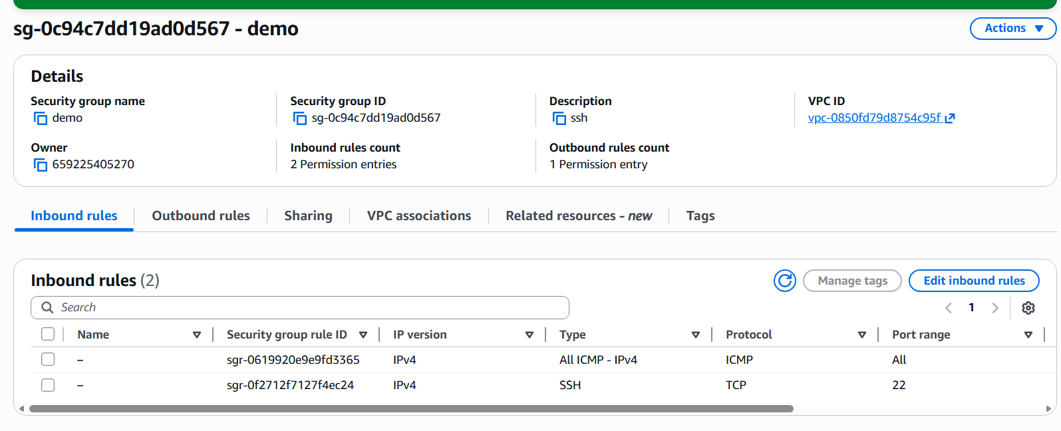

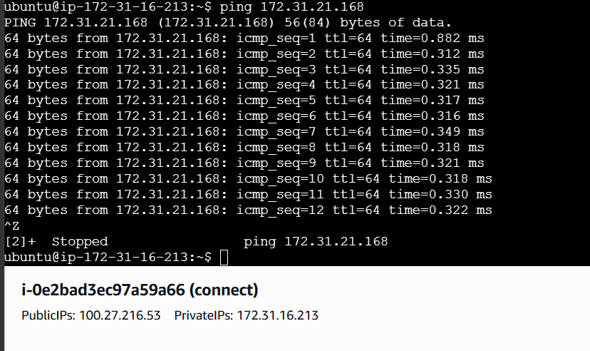

I have deployed an application in guvi.com:9000, and logs show my app is running, but I’m unable to view the page. Check whether my port is open or not ?

