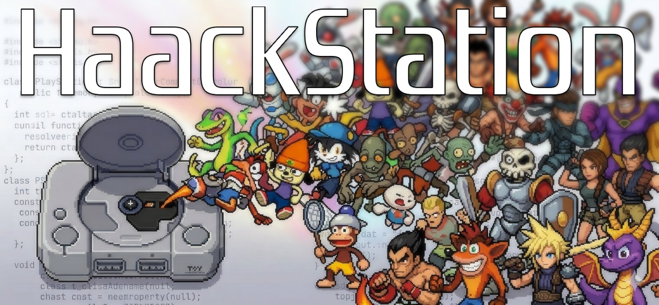

HaackStation
PlayStation 1 Emulator Frontend
Development Diary | Complete Project History
Open Source | GPLv2 | Started March 2026
github.com/cloudhaacker/HaackStation

About This Document
This diary is a living, transparent record of HaackStation from its first conversation to its ongoing development. Written for three audiences:

- Anyone curious about what an AI-assisted open source project looks like from the inside
- Content creators who want the full story in one place
- Future contributors who want to understand every design decision and why it was made

Nothing is hidden. Every design choice, every build battle, every honest assessment of difficulty is documented here. Transparency is a core value of this project.

AI Assistance Disclosure
"HaackStation is openly and proudly an AI-assisted project. The vision, name, feature list, all testing, and hardware validation are the project author's. The frontend code was written by Claude (Anthropic AI), directed by the author. The emulation core (Beetle PSX HW) was written entirely by the libretro team."

We believe honest disclosure about AI tooling matters. This project is an experiment in what is possible when someone with a vision but limited coding experience works with a sophisticated AI assistant. That story is worth telling openly.

Project Overview

What HaackStation Is
A PlayStation 1 emulator frontend with a modern feature layer, built on Beetle PSX HW (Mednafen) via the libretro interface. HaackStation targets:

- Controller-first UI — the entire interface navigable with a gamepad, no mouse required
- Accuracy — inheriting Beetle PSX HW's cycle-accurate emulation
- Modern features — screenshots, save states, achievements, scraping, fast forward, rewind
- Cross-platform — Windows (primary), Android/Ayn Thor handheld (Phase 5), Linux/Mac (Phase 5)
- Open source — GPLv2, fully transparent, free forever

The project's defining philosophy: every feature is free, the code is open, and the development process is documented honestly. No paywalls, no obfuscation.

Feature Status (Current — March 2026)

Feature / Component | Status
Splash screen with logo and Zrnic font | Done
Game shelf UI with spring scroll animations | Done
Controller + keyboard navigation (full UI) | Done
M3U deduplication and auto-generation | Done
Disc format handler (ISO, BIN/CUE, CHD, M3U) | Done
Libretro bridge (dynamic core loading) | Done
Game boots and is playable (Crash Bandicoot, Dragon Warrior VII, Legend of Dragoon) | Done
Audio playback with resampling | Done
Frame-accurate timing (high-res performance counter) | Done
Settings screen (6 tabs, all settings wired) | Done
Save states with screenshot thumbnails | Done
In-game menu (Start+Y) | Done
RetroAchievements infrastructure (rcheevos 12.3) | Done
ScreenScraper.fr game scraper (cover art, screenshots, back cover) | Done
Game Details Panel (Y button) | Done
Per-game screenshot folders (media/screenshots/[title]/) | Done
Fast Boot (skip BIOS logo) | Done
Fast Forward (held R2/F, 500ms threshold, 2x-8x) | Done
Play history (recently_played.json) | Done
Mouse cursor hidden in fullscreen | Done
RA achievement unlock submissions | Blocked (pending RA approval ~July 2026)
CHD hashing for RetroAchievements | Blocked (needs MAME CHD library)
Audio hitch fix (~15s queue overflow) | In Progress
Shelf-flip L1/R1 (Recently Played / Favorites) | Planned
Rewind (hold L2) | Planned
Favorites system | Planned
Text input dialog (on-screen keyboard) | Planned
Input remapping UI | Planned
Dynamic shelf sizing | Planned
Trophy Room (PS4/PS5 style) | Planned
Memory Card Manager UI with PS1 animated icons | Planned
Spinning CD case animation | Planned
Color themes | Planned
Ambient music player | Planned
Android / Ayn Thor APK | Planned
OpenGL hardware renderer (unlocks upscaling) | Planned
Netplay | Planned

Development Diary

Day 1 — March 2026

Session 1: Project Foundation
The project began when the author tried to get Grok to build a PS1 emulator. It could not. Switching to Claude led to a very different conversation.

The author's key insight — "Could these separate systems not be built as parts that come together?" — unlocked the correct architecture. Use a proven emulation core, build everything above it as original work.

Key decisions made on Day 1:
- Beetle PSX HW as the emulation core (libretro interface, GPLv2)
- LibretroBridge adapter pattern — frontend never modifies the core
- GPLv2 licence — free forever, no exceptions
- HaackStation name
- Bold EmulationStation-style UI with a deep navy palette
- Ayn Thor Android handheld as a target platform
- Full AI disclosure from day one — no hiding it

Files created in Session 1: CMakeLists.txt, app.h/cpp, main.cpp, controller_nav.h/cpp, disc_formats.h/cpp, libretro_bridge.h (architecture), audio/texture/shader module stubs, README.md with transparency statement.

Day 2 — March 2026

Session 2: The UI Layer
Today's session built everything the user actually sees. HaackStation now has a real UI.

Three major components built in Session 2:

ThemeEngine — the visual foundation. Deep navy palette, all drawing primitives, font system using the Zrnic typeface by Apostrophic Labs, spring-based easing functions, footer hint bar that always shows context-sensitive button labels.

GameBrowser — the main game shelf. Spring-scroll physics with configurable spring constant and damping. Card grid with selection animation. Cover art lazy loading with cache. M3U deduplication: a two-pass scan that silently suppresses disc files referenced by M3U playlists, showing one clean entry per multi-disc game with a disc count badge.

SettingsScreen — five fully controller-navigable tabs (General, Video, Audio, Textures, About). Every setting type implemented: TOGGLE, CHOICE, SLIDER, PATH, ACTION, LABEL. The About tab credits Beetle PSX HW, the libretro team, Claude as the code author, and includes the AI disclosure in the running application itself.

The project now had a real UI. If you launched the frontend at the end of Day 2 (without the core), you would see a styled game shelf with cover art support, a header, footer hints, and a controller-navigable grid.

Day 3 — March 2026

The Build Battle
Getting HaackStation to compile on Windows with Visual Studio 2026 took longer than writing the code. Every issue is documented here for future contributors.

Issues resolved during the Windows/MSVC build:
- SDL2 header structure — VC zip puts headers in include/ but code uses SDL2/SDL.h. Fix: create include/SDL2/ subfolder and copy headers in.
- Same fix needed for SDL2_ttf and SDL2_image.
- Include path resolution — MSVC is stricter than GCC. Fixed by adding every subfolder explicitly to target_include_directories.
- Regex raw strings — sed-based fix scripts mangled R"(...)" raw string literals. Fixed by rewriting disc_formats.cpp without regex, using simple string searches.
- SettingItem aggregate initialization — MSVC strict about structs with std::function members. Fixed with explicit helper functions (makeToggle, makeChoice, etc.).
- Audio device ID — SDL_QueueAudio hardcoded to device 1 instead of actual handle. One-line fix.
- Frame timing — SDL_GetTicks has 1ms resolution. Replaced with SDL_GetPerformanceCounter for sub-millisecond precision.

The lesson: Windows + MSVC + CMake has real sharp edges that GCC/Linux development hides. Document every fix. Future contributors will thank you.

First Game Boot
Crash Bandicoot ran on HaackStation on Day 3. The first PS1 game ever to boot on this frontend.


RetroAchievements notification on first boot — Crash Bandicoot, 47 achievements available

The sequence that led to first boot:
- Build succeeded after resolving all MSVC compatibility issues
- SDL DLLs and core DLL copied to build output folder
- BIOS files (scph1001, scph5500, scph5501, scph5502) placed in bios/ folder
- HaackStation.exe launched — splash screen appeared with Zrnic font
- Game shelf showed Crash Bandicoot after scanner found the ROMs path
- A button on Xbox One controller triggered launch — controller vibrated (rumble working)
- Core loaded game, went black briefly, then Crash Bandicoot title screen appeared
- Game was playable — first level completed

Issues found and fixed immediately after first boot:
- Speed too fast — frame throttling was using 16ms hardcoded. Fixed with high-res performance counter using core-reported FPS (59.94 NTSC).
- No audio — SDL_QueueAudio using wrong device ID. Fixed.
- Audio crackling — buffer size too small. Increased to 4096, added linear resampler for rate mismatch.
- Start button not opening Settings — controller event consumed by game browser before app-level handler. Fixed with continue statement.
- Select button quitting game accidentally — changed to Start+Select combo (standard emulator convention).
- Dark shelf after exiting game — launch animation fade state not reset. Added resetAfterGame().
- Hardware renderer crash — Beetle HW requests OpenGL context but we haven't set that up yet. Fixed by returning false from SET_HW_RENDER callback, forcing software renderer fallback.

Visual Gallery — Screenshots & Design

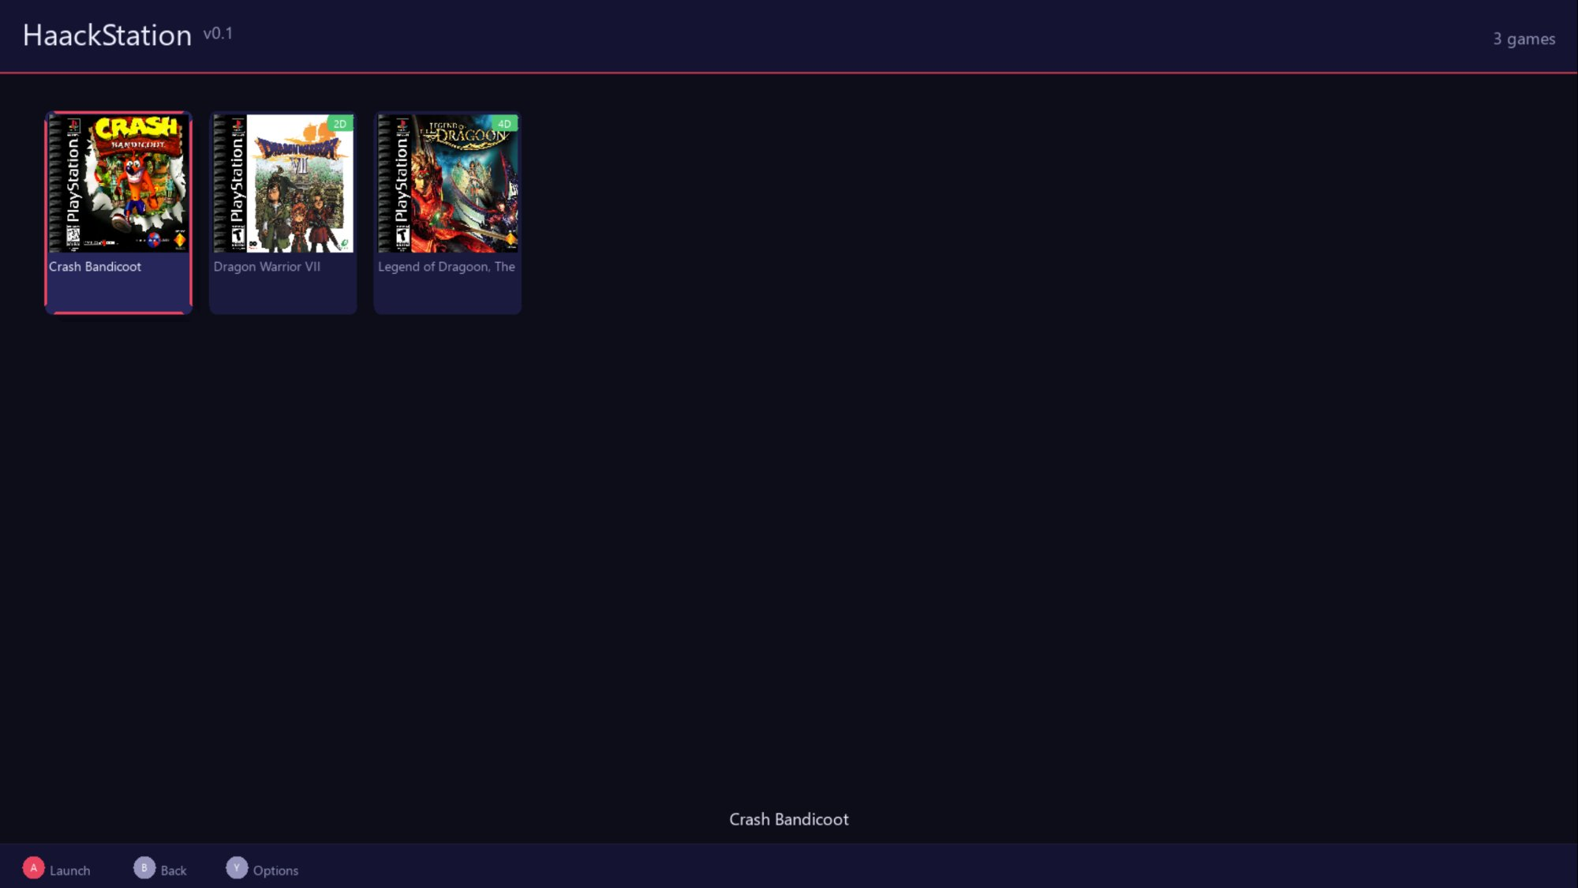
The HaackStation game shelf — spring-scroll animations, cover art, multi-disc badges

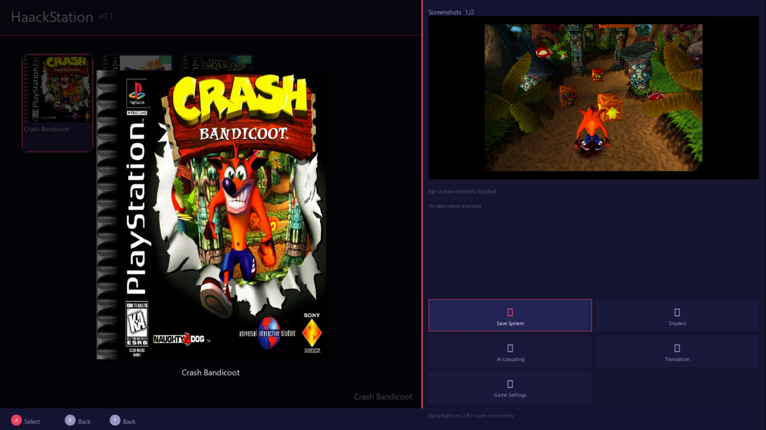
Game Details Panel — Crash Bandicoot with scraped screenshot, 16:9 letterboxed display

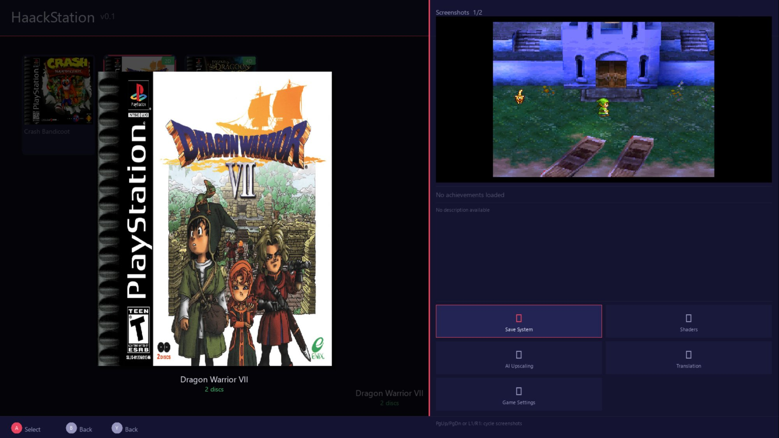
Game Details Panel — Dragon Warrior VII (multi-disc game, 2 discs shown)

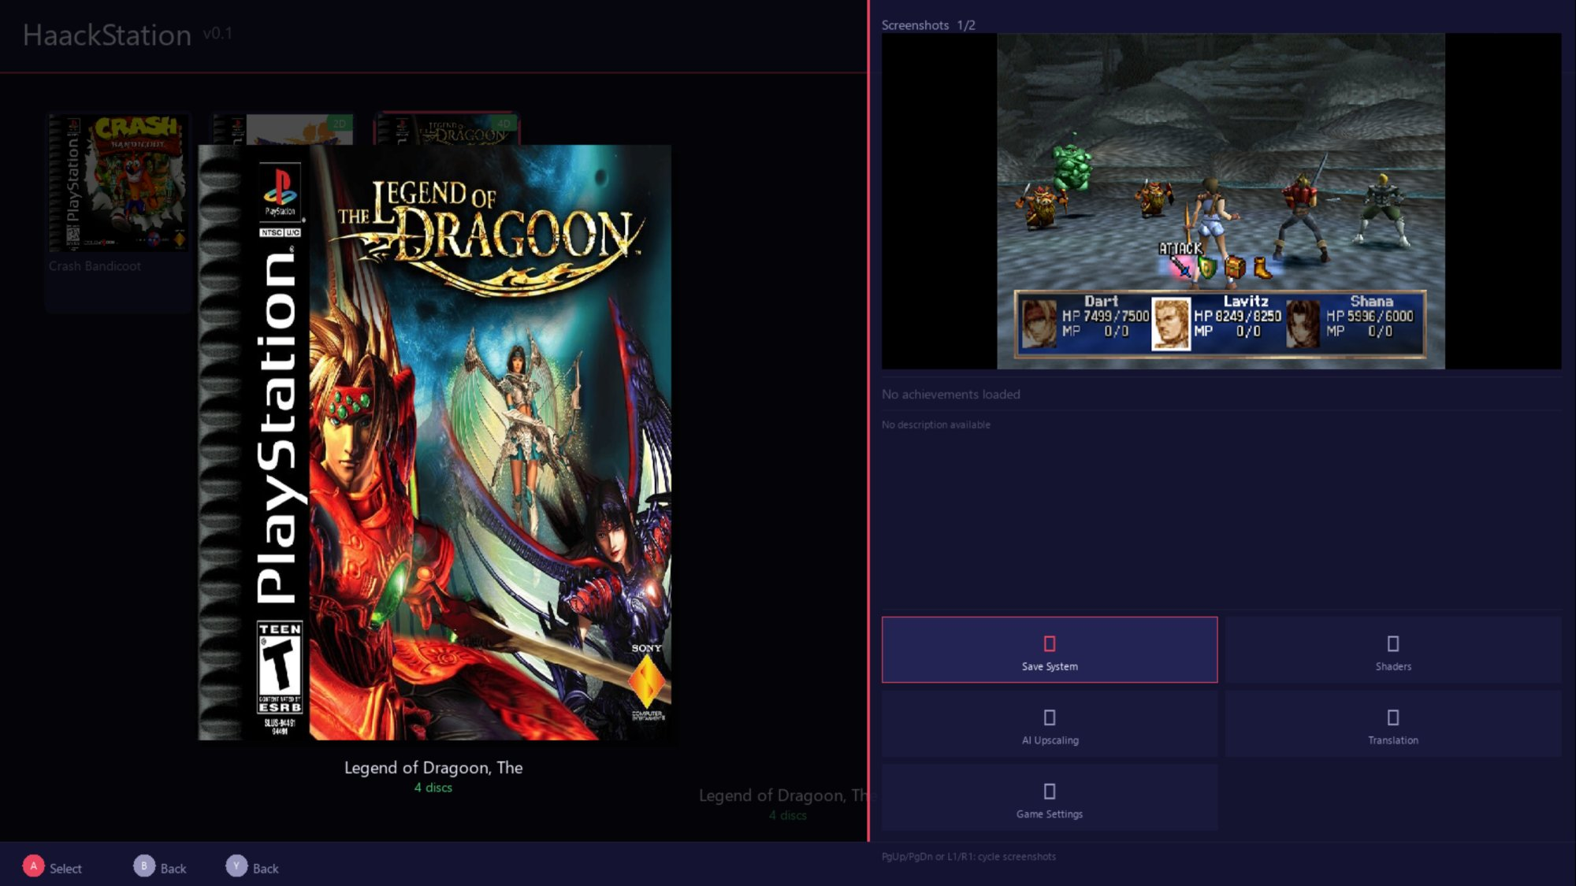
Game Details Panel — The Legend of Dragoon (4-disc epic, battle screenshot)

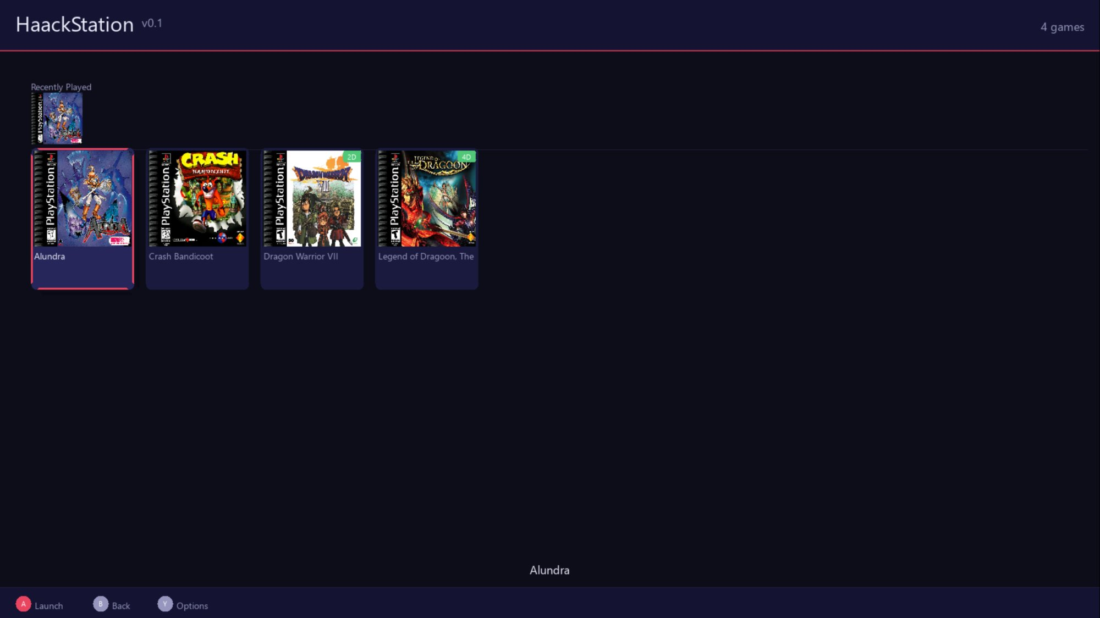
Recently Played row above the main game shelf (design pending refinement)

Early Design Sketches
John's hand-drawn sketches that guided the UI development — from napkin to reality.

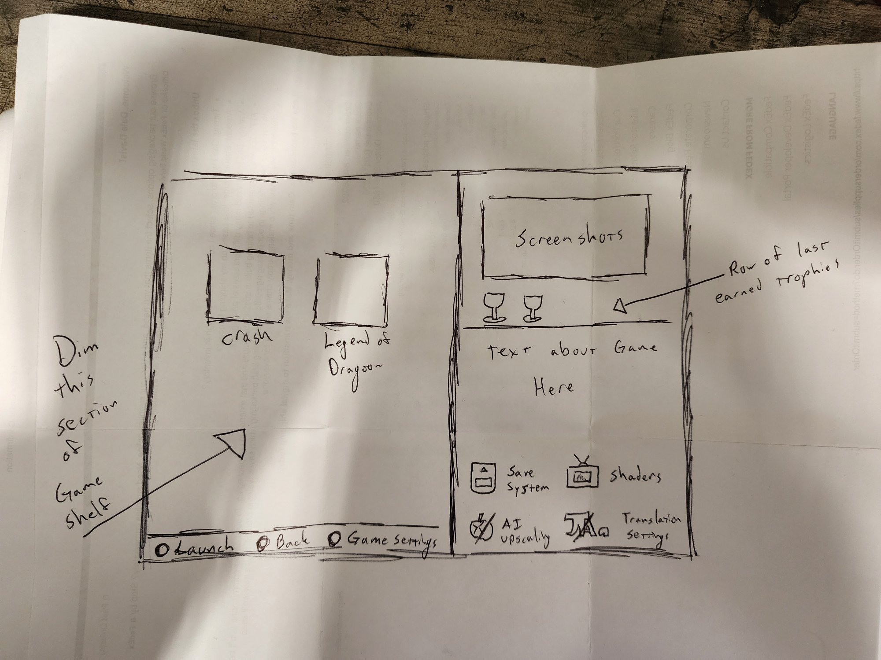
Original sketch of the Game Details Panel — screenshots, trophy row, description, and 2x2 icon grid

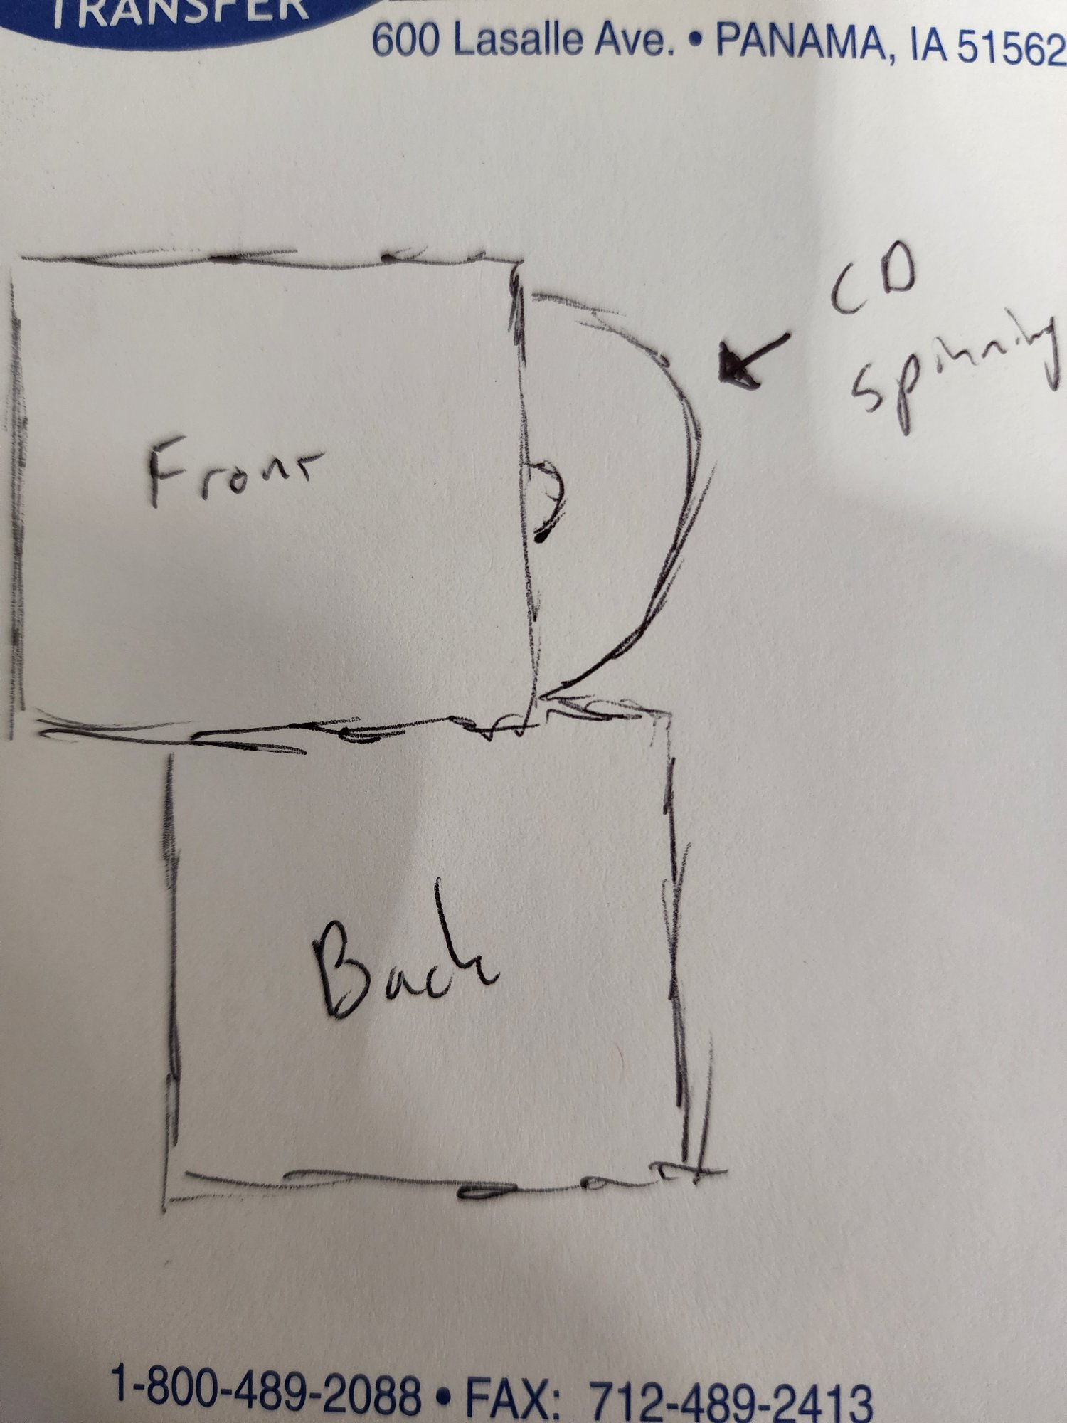
Sketch: Cover art system — front cover with spinning CD visible at right edge

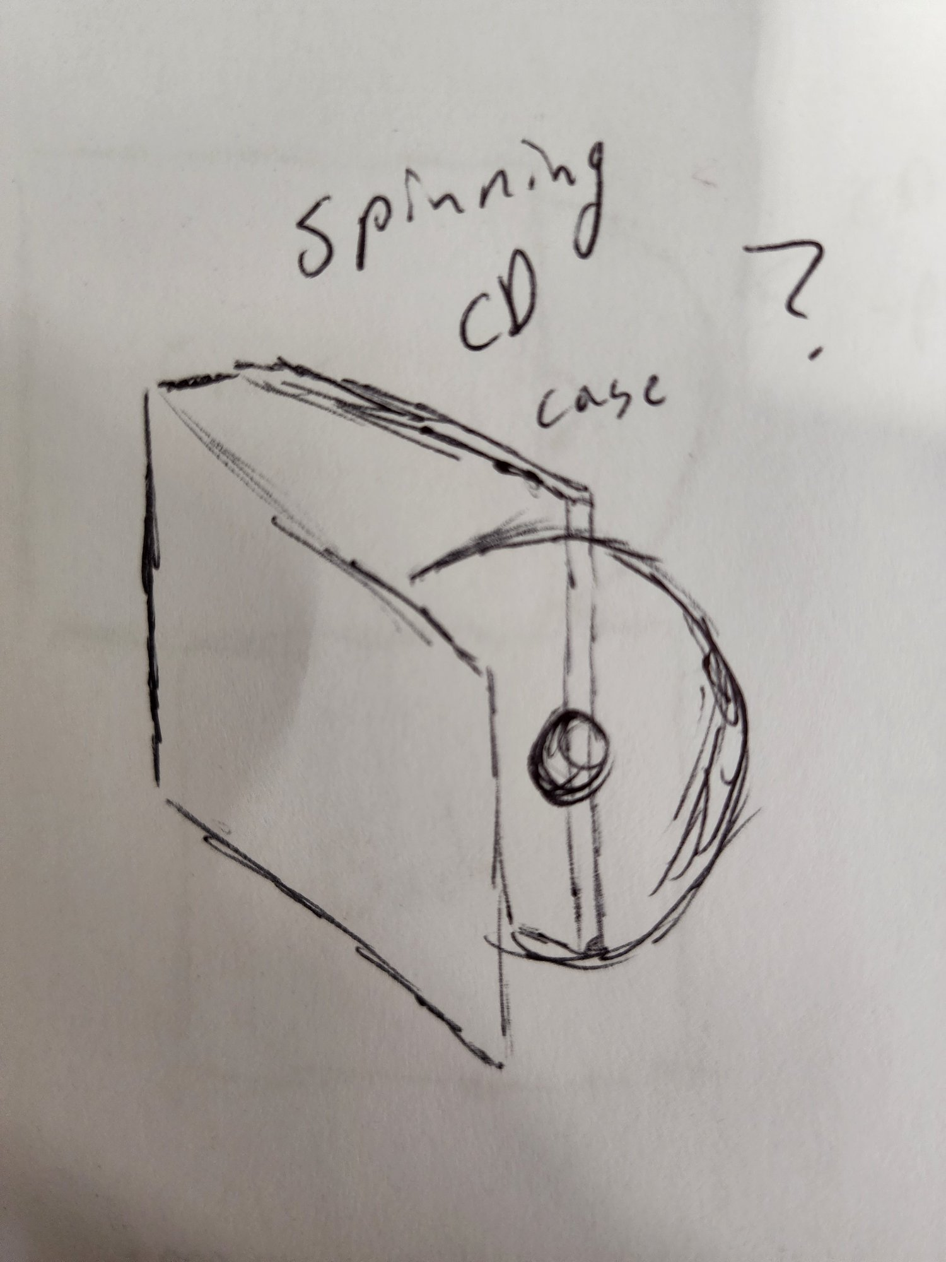
Sketch: Full 3D jewel case animation concept — Phase 4 planned feature

Branding & Artwork
All artwork generated with Google Gemini AI, directed by the project author. Minor corrections and compositing by the author.

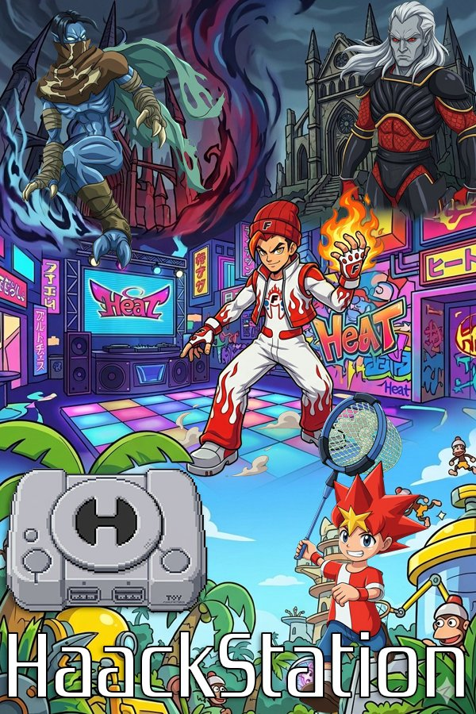
Steam Cover Art — generated with Gemini AI, directed by project author


Steam Wide Cover / Banner — PS1 character collage with HaackStation branding

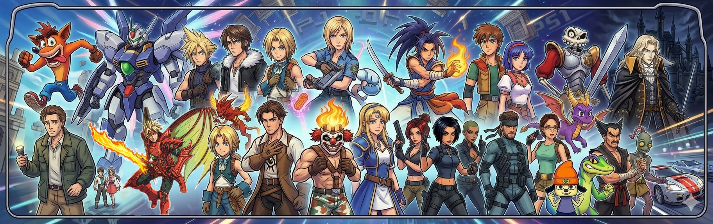
Steam Background — wide panoramic PS1 character artwork

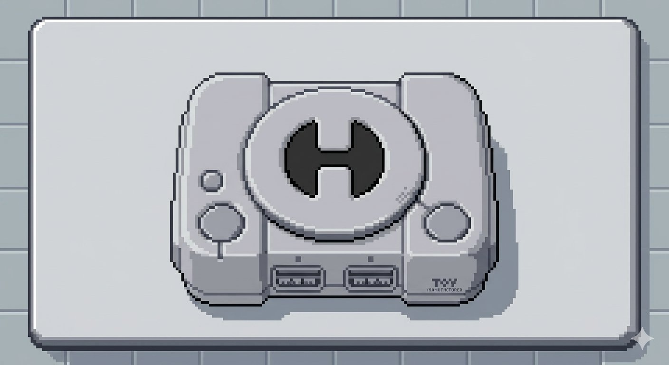
HaackStation Logo — pixel art PS1 console with H symbol, used in splash screen

Major Feature Deep Dives

RetroAchievements Integration
HaackStation integrates rcheevos 12.3 using the rc_client API. The full pipeline is working:
- Login with token/password fallback — session tokens auto-saved after password login
- ROM hashing via rc_hash — BIN/CUE works perfectly (CHD pending MAME library)
- Game identification — Crash Bandicoot ID:10434 (47 achievements), Dragon Quest VII ID:11289 (81 achievements)
- Achievement tracking — rc_client_do_frame() called every emulated frame
- Notifications — slide in from bottom-right, blue for game-loaded, gold for unlocks

Current blocker: RA server rejects unlock submissions with "Unknown Emulator" flag. This is a recognition/approval issue, not a code issue.

RA Response (March 2026)
"Hi John, Thanks for reaching out and for the detailed write-up on HaackStation. We have a few items to address before we can move forward... Per our Hardcore Compliance Requirements, the emulator must have been publicly available for at least 6 months before it will be considered for hardcore compliance approval."

The response was professional and constructive. Action items: make GitHub repo public (clock starts now), reapply ~July/August 2026. The infrastructure is complete and correct — this is purely a recognition issue.

ScreenScraper Integration
Full ScreenScraper.fr API v2 integration. Each scrape downloads:
- Front cover art (box-2D) → media/covers/[title].png
- Back cover art (box-2D-back) → media/covers/[title]_back.jpg
- In-game screenshot → media/screenshots/[title]/01_screenshot.jpg
- Title screen → media/screenshots/[title]/02_titlescreen.jpg
- Fan art → media/screenshots/[title]/03_fanart.jpg
- Game metadata (description, developer, publisher, release date, rating)

Region preference: US → World → EU → SS → JP. Skip logic checks cover and screenshot folder independently — partially scraped games continue seamlessly.

Fast Forward & Fast Boot

Fast Boot
beetle_psx_hw_skip_bios core option skips the PS1 BIOS logo animation on startup. A subtle but important timing bug was fixed: the option must be in m_coreOptions before retro_init() fires. The fix was explicitly calling loadCore() in launchGame() before setting the option, ensuring it's available for the first game launch.

Fast Forward
Hold R2 (controller) or F key (keyboard) for N× speed. Design decisions:
- 500ms hold threshold prevents accidental triggers during normal R2 use
- Audio muted during extra frames to prevent SDL queue overflow — not during the base frame
- RA still ticks every frame during FF so achievements can't be missed
- >>Nx badge indicator top-right corner while active
- Speed configurable in Settings → Emulation: 2×/4×/6×/8×

Known Audio Issue — ~15 Second Hitch
A periodic audio stutter occurs approximately every 15 seconds during gameplay. The interval is consistent with the SDL audio queue hitting a size ceiling. This is not random crackling (that was fixed by increasing the buffer) — this is a queue management issue.

Root cause: SDL queue mode allows the queue to grow unboundedly. During fast forward or slight sample rate mismatches, the queue exceeds SDL's internal limit (~15 seconds of audio at 44100Hz stereo) and either blocks or drops, causing the hitch.

Fix planned for next session: add queue depth monitoring in cb_audioSampleBatch(), clear excess audio during fast forward, verify sample rate matching between core output and SDL device.

Full Roadmap

Phase 3 — Core Experience (Current)

Remaining:
- Audio hitch fix (SDL queue management)
- Shelf-flip L1/R1 — PS4/PS5 style shelf switching: Main / Recently Played / Favorites
- Rewind — hold L2 for real-time rewind via ring buffer of save states
- Favorites — mark with button press, appears in shelf-flip
- Screenshot capture — button combo saves to screenshots/ folder
- Text input dialog — on-screen keyboard for PATH fields
- Input remapping — visual controller diagram, per-game and global
- Dynamic shelf sizing — cards adapt to library size and window dimensions
- Fast Boot per-game override via per_game_settings
- HLE BIOS option (run without BIOS file)
- Widescreen / overclock in per-game settings
- Run-Ahead setting
- Custom RA unlock sound
- RA official recognition — reapply July/August 2026

Phase 4 — Polish & Community Features
- Trophy Room — PS4/PS5 style achievement showcase per-game and overall
- Memory Card Manager UI — MCR file reading, animated PS1 save icons, copy/delete/backup
- Spinning CD case animation — Phase 4a: flat front/back + spinning disc; Phase 4b: full 3D jewel case
- Back cover display — wire scraped _back.jpg into details panel with flip gesture
- Color themes — 4 built-in, community-shareable palette files
- Ambient music player — music/ folder, crossfade, now-playing bar
- Cloud save state sync — Google Drive API
- CHD hashing for RA — MAME CHD library integration
- Shader Pack Manager UI
- Cheat Code Manager — GameShark/Action Replay via libretro cheat injection
- Game Time Tracking — hours played per game, shown on shelf card
- Search/Filter — type to filter, filter by genre/region
- Responsive/scalable UI — percentage-based layout for all resolutions and devices

Phase 5 — Platform Expansion
- Android / Ayn Thor APK — CMake Android NDK, SDL2 for Android, touch controls
- OpenGL Hardware Renderer — unlocks PGXP, internal resolution upscaling, texture filtering
- PGXP — fixes wobbly polygons and texture warping
- Internal Resolution Upscaling — 2×–8×+
- Post-Processing Shaders — CRT, scanlines, bloom
- AI Texture Upscaling — NCNN inference
- Netplay — rollback netplay via libretro netpacket API
- On-the-Fly Translation — Tesseract OCR + Argos Translate (offline, Japanese PS1 RPGs)
- Mac/Linux support — SDL2 cross-platform, minimal extra work
- Multi-System Support — point libretro bridge at other cores (PS2, PSP, N64, SNES)

Technical Architecture

HaackStation is organized as independent modules, each responsible for exactly one concern:

- HaackStation executable — frontend, UI, application lifecycle
- LibretroBridge — adapter layer between HaackStation and the emulation core
- Beetle PSX HW — the emulation core (DLL loaded dynamically, never modified)
- HaackAudio — on-the-fly audio replacement pipeline (architecture stub)
- HaackTextures — texture replacement and AI upscaling (architecture stub)
- HaackShaders — shader preset manager, RetroArch-compatible (architecture stub)

Technology stack: C++17, CMake 3.20+, MSVC (Visual Studio 2026), SDL2/SDL2_ttf/SDL2_image, libretro API, rcheevos 12.3 (rc_client), ScreenScraper.fr API v2.

Controller-First Design Philosophy
The ControllerNav class is the foundation of HaackStation's UX. Every screen reads from ControllerNav only — no screen reads SDL directly. Abstract NavActions (UP, DOWN, CONFIRM, BACK, MENU, OPTIONS, SHOULDER_L, SHOULDER_R) mean the entire UI works identically with any gamepad, keyboard, or the Ayn Thor's built-in controls.

The ThemeEngine's footer hint bar always shows context-sensitive button labels (Launch, Back, Options) so the user is never guessing what a button does. This is borrowed from the best PS4/PS5 UX patterns.

Keyboard Layout (Conflict-Free)
A careful conflict-free keyboard layout was developed across multiple sessions. WASD is reserved exclusively for in-game PS1 buttons (A=Square, S=Triangle, W=R1) — it is not used for UI navigation. App-level shortcuts are intercepted before screen routing:

- SHELF: Arrows=Navigate, X=Launch, Enter=Settings, F2=Details, Esc=Quit
- INGAME: Arrows=D-pad, X=Cross(×), Z=Circle(○), A=Square(□), S=Triangle(△), Q=L1, W=R1, E=L2, R=R2, Enter=Start, Space=Select, F=Fast Forward (hold 500ms), F1=In-game menu, Esc=Quit to shelf
- DETAILS: Arrows=Navigate, PageUp/Down=Cycle screenshots, Z=Close
- GLOBAL: F11=Fullscreen

Credits & Acknowledgements

Emulation Core
Beetle PSX HW / Mednafen — the libretro team and all Mednafen contributors. Every accurate frame HaackStation renders is their achievement. mednafen — the original PS1 emulation layer, credited to byuu and all contributors. This project would not exist without their work.

Project Author
John Haack — vision, feature requirements, all design decisions, hardware testing, community direction. First game booted: Crash Bandicoot, Day 3, March 2026. GitHub: github.com/cloudhaacker/HaackStation

AI Development Tools
Frontend architecture, feature layer code, build system, and documentation written with Claude (Anthropic AI). Disclosed openly from day one. The human conceived the vision, made every design decision, and does all testing. The AI wrote the code under direction.

Assets
Logo and all Steam artwork: generated with Google Gemini AI, directed and refined by the project author. Font: Zrnic by Apostrophic Labs (dafont.com/zrnic.font). Both credited in the README and About screen.

Libraries
- SDL2, SDL2_ttf, SDL2_image — zlib licence, free for any use
- rcheevos 12.3 — RetroAchievements library, MIT licence
- All headers and binaries from official releases

The Community
To the emulation community, to RetroAchievements for building something worth achieving in, and to everyone who has kept PlayStation 1 gaming alive for 30 years: HaackStation is for you.

Legal
HaackStation is licensed under the GNU General Public License v2.0, inherited from Beetle PSX HW. PlayStation is a registered trademark of Sony Interactive Entertainment LLC. HaackStation is not affiliated with Sony Interactive Entertainment. BIOS files and game ROMs are never distributed with this project — users supply their own from hardware they own.

