DBT Training Assignment
Healthcare Clinic Network
Postgres -> dbt -> Snowflake (HEALTHCARE_DW)

1. Overview & Scenario
You are building the analytics layer for CloudCare, a network of healthcare clinics. Source data lives in Postgres and is landed into Snowflake's RAW schema. Your job is to transform messy operational data into clean, tested, business-ready models — and to track how key records change over time.
This assignment exercises all five core dbt building blocks. You must deliver at least 5 of each:
Component | Count | Expectation
Models | 6 | 3 staging views, 1 intermediate, 2 marts (dim + fact)
Snapshots | 5 | SCD-2 history for patients, doctors, appointments, clinics, plans
Macros | 7 | Cleansing trio + initcap, try_to_date, fee_band, audit columns(
Tests | 5+ | Generic (YAML), 3 singular
Seeds | 5 | Plan tiers, appointment types, status codes, dept map, regions

2. Source Tables
Six tables are provided in training_source_data.sql. Load them into Supabase (public schema), then into Snowflake RAW. The data deliberately contains quality problems for you to fix.
Table | Rows | Notable issues
clinics | 5 | Y/N/1/0 flags, one Test garbage row, bad date
patients | 12 | Dirty names (John123, Smith_xfh, ravi@@), trailing/double spaces, bad emails, duplicate, mixed date formats
doctors | 7 | Whitespace in name, Y/N/1/0 availability, negative fee test row
appointments | 15 | Lowercase status, negative fee, NULL date, orphan patient & doctor, status transitions for SCD-2
payments | 8 | Stored in cents, negative amount, orphan appointment
insurance_plans | 4 | is_active flag changes over time for SCD-2
See the Entity-Relationship diagram below for how the tables relate.
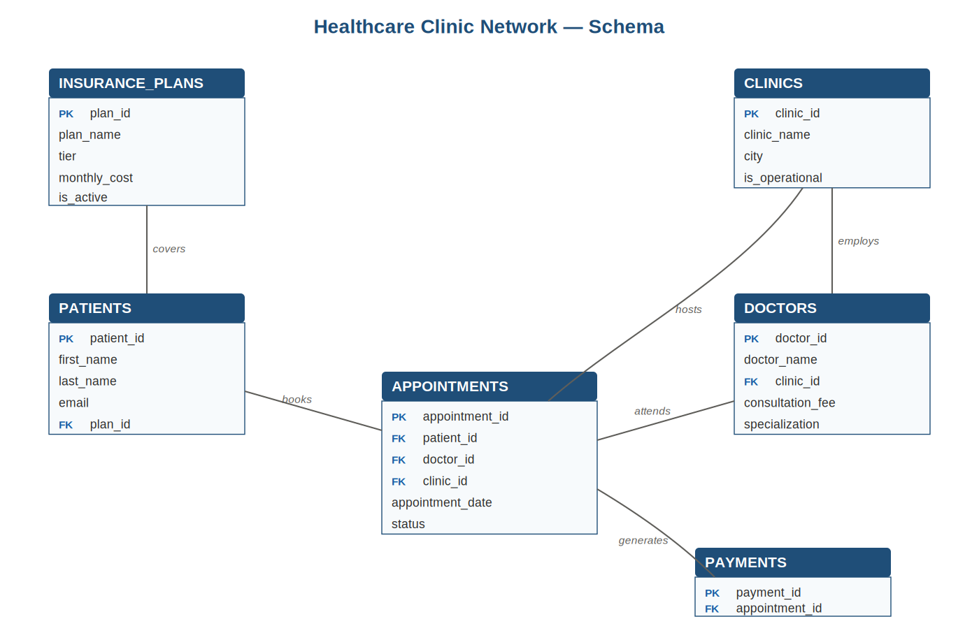
Figure 1: Healthcare Clinic Network entity-relationship diagram

3. Macros (build 7)
Macros are reusable SQL functions. The cleansing trio is the heart of this assignment — they demonstrate macro composition (clean_name calls the other two).
# | Macro | Purpose
1 | trim_whitespace(col) | Collapse leading/trailing/double spaces to single
2 | remove_special_chars(col, mode) | Strip junk; mode='name' keeps letters/space/'/-, mode='digits' keeps 0-9
3 | clean_name(col) | COMPOSITION: remove_special_chars -> trim_whitespace -> initcap
4 | initcap(col) | Cross-warehouse proper case (Snowflake native, DuckDB fallback)
5 | try_to_date(col) | Safe date parse; bad formats become NULL
6 | fee_band(col) | Categorize numeric into Low/Medium/High
7 | generate_audit_columns() | Append _model_run_at and _dbt_run_id consistently

Cleansing requirements
- 'John123' -> 'John' (strip trailing digits)
- 'ravi@@' -> 'Ravi' (strip special chars, then title case)
- ' Mary Jane ' -> 'Mary Jane' (collapse whitespace)
- "O'Brien" and 'Anne-Marie' must be PRESERVED — real names contain apostrophes and hyphens
- Known limitation to discuss: 'Smith_xfh' -> 'Smithxfh' (underscore joins the parts). Why? What would you change to get 'Smith'?

4. Models (build 6)
Model | Layer | Materialization | Requirements
stg_patients | staging | view | Apply clean_name to first/last name, try_to_date on DOB, normalise gender, dedupe by email, filter bad rows
stg_doctors | staging | view | trim_whitespace on name, yn_to_boolean availability, fee_band, filter invalid
stg_appointments | staging | view | Uppercase status, filter NULL date/negative fee, INNER JOIN to enforce FK integrity
int_appointment_enriched | intermediate | ephemeral | Shared join of appointments + patients + doctors
dim_patients | marts | table | Surrogate key, appointment metrics, join plan_tiers seed for tier
fct_appointments | marts | table | Surrogate key, patient+doctor context, payment rollups (cents/100)

Expected staging row counts
stg_patients: 12 -> 9 (dropped: 106 bad email, 109 test row, 110 duplicate of 101)
stg_doctors: 7 -> 6 (dropped: 207 test/negative fee)
stg_appointments: 15 -> ~9 (dropped: negative fee, NULL date, orphans, and rows whose patient/doctor were filtered upstream)

5. Snapshots (build 5)
Snapshots track how rows change over time (Slowly Changing Dimension Type 2). Build the first snapshot, run the DAY 2 change script at the bottom of the source SQL, then snapshot again to see history captured.
Snapshot | Strategy | Tracks
scd_patients | timestamp | Contact info & plan changes (uses updated_at)
scd_doctors | check | Fee, availability, clinic reassignment
scd_appointments | timestamp | Status transitions (SCHEDULED -> COMPLETED)
scd_clinics | check | Operational status, city
scd_insurance_plans | check | Plan activation/retirement, cost, tier
timestamp strategy = trust the updated_at column. check strategy = compare specific columns for any change. Know when to use each.

6. Tests (build 5+)
Cover three kinds:

Generic tests (in schema.yml) If possible
- not_null + unique on every primary/surrogate key
- relationships: fct_appointments.patient_id -> dim_patients.patient_id
- accepted_values on appointment status

tests (one .sql each in tests)
- assert_appointment_fee_non_negative — no negative fees survive
- assert_no_future_appointments — completed appts can't be dated in the future
- assert_patient_spend_reconciles — dim total_spend matches fact sum

7. Seeds (build 5)
Seeds are CSV reference tables loaded with dbt seed. Provided in seeds/:
Seed | Contents
plan_tiers.csv | plan_id -> plan name, tier, tier_rank (joined into dim_patients)
appointment_types.csv | type code -> description, is_billable
status_codes.csv | status -> description, is_final
specialization_dept.csv | specialization -> department, floor
city_region.csv | city -> state, region

8. Build & Run Sequence
dbt debug # 1. connection works?
dbt deps # 2. install dbt_utils
dbt seed # 3. load the 5 CSVs
dbt snapshot # 4. first snapshot (baseline)
dbt run # 5. build all 6 models
dbt test # 6. run all tests
# -- now run the DAY 2 change script in Supabase --
dbt snapshot # 7. capture the changes as history
dbt docs generate && dbt docs serve # 8. view lineage
— End of Assignment —

