The Tulip Data City is located in Bangalore, India. It is operated by Tulip Telecom Ltd and was created in partnership with IBM, and several other tech firms, at a cost of ~$700 million (1). When it opened in 2012, it was the 3rd largest data center in the world. Today it ranks as the 10th largest in size at nearly one million sq.ft as well as 10th in power consumption at 90 MW/yr (2). Power to the Tulip Data City is supplied by 2 kV substations with a load capacity of 40 MVA (3). There is full back up capacity. The PUE is currently ~1.5 which climbs to 1.94 at full capacity (3). The annual IT load is 60MW (2). The current cost of one unit of electricity in Bangalore is Rs 7.55, which equates to $0.1 (4). Using these figures, the annual cost to operate the Tulip Data City is roughly $78.5 million (5, 6). The Tulip Data City does not utilize any renewable energy and thus has a rather large carbon footprint of 477, 770 tons which equates to 105, 330 CO2 car equivalents (6).

1. <https://www.firstpost.com/business/biztech/tulip-telecom-unveils-asias-largest-worlds-third-largest-dc-in-bengaluru-1886925.html>
2. <http://worldstopdatacenters.com/tulip-data-city/>
3. <https://tulipdatacity.wordpress.com/about/>
4. <https://www.thenewsminute.com/article/electricity-bill-bengaluru-households-increase-about-5-june-102691>
5. <https://www.quora.com/Data-Centers-What-is-the-cost-per-MW-to-power-a-datacenter>
6. <https://www.schneider-electric.com/en/work/solutions/system/s1/data-center-and-network-systems/trade-off-tools/data-center-carbon-footprint-comparison-calculator/>

Wind energy is created when the wind turns a large turbine attached to a generator to convert kinetic energy from the wind into mechanical energy in the form of electricity. Wind turbines which supply power to the grid are very large, typically 80 meters or more tall, and are often clustered into large groups at a single location (1). These turbine groups have become known as “wind farms”. Wind farms can be located on land or in the ocean. Turbines located in the ocean tend to be bigger than those on land. Besides being a clean, renewable and widely available resource, wind energy is also very cost efficient at around 2-6 cents per kilowatt-hour (1). In the US wind power accounts for 6.5% of the total energy production (2). In contrast, Denmark, which has a high proportion of Data Centers, creates 39% of their energy needs via wind power (3). As shown in the table, currently there are relatively few wind-powered data centers worldwide, however some of the major Cloud providers such as Google and Microsoft have made commitments to offset their carbon footprint by purchasing renewable energy credits from wind energy providers. In addition, there a many wind-powered data centers planned or under construction throughout the world.

|  |  |  |  |
| --- | --- | --- | --- |
| **Name** | **Company** | **Location** | **Status** |
| Other World Computing HQ | MacSales.com | Woodstock, IL | Active |
| Wyoming Data Center | Green House Data | Cheyenne, WY | Active* |
| Oklahoma Data Center | Google | Mayes County, OK | Active* |
| Iowa Data Center | Google | Council Bluffs, Iowa | Active* |
| Papillion Data Center | Facebook | Papillion, NE | Active |
| Fort Worth Data Center | Facebook | Ft. Worth, TX | Active |
| Virtual Earth Data Center | Microsoft | Boulder, CO | Active |
| San Antonio Data Center | Microsoft | San Antonio, TX | Active* |
| Wyoming Data Center | Microsoft | Cheyenne, WY | Active |
| Dublin Data Centers (4) | Microsoft | County Kerry, Ireland | Planned |
| WindCORES | Green IT | Paderborn, Germany | Planned |
| Dallas Data Center | Akamai | Dallas, TX | Planned |
| Denmark Data Center | Facebook | Odense, Denmark | Planned |
| Sweden Data Center | Facebook | Lulea, Sweden | Planned |
| Midwest Data Center | Facebook | New Albany, OH | Planned |
| Viborg Data Center | Apple | Viborg, Denmark | Planned |
| Aabenraa Data Center | Apple | Aabenraa, Denmark | Planned |
| Aabenraa DC | Google | Aabenraa, Denmark | Planned |
| Fredericia DC | Google | Fredericia, Denmark | Planned |
| Minnesota DC | Google | Becker, MN | Planned |

*Operated via Renewable Energy Credits (REC) purchased from wind energy providers through long term Power Purchase Agreements (PPA)

1. <https://www.energy.gov/eere/wind/advantages-and-challenges-wind-energy>
2. <https://www.awea.org/2018-market-report_us-wind-power-grew-8-percent-in-2018>
3. <https://en.wikipedia.org/wiki/Wind_power_by_country>
4. <https://www.datacenterdynamics.com/news/microsoft-adopts-googles-approach-to-buying-wind-power/>

Microsoft San Antonio DC failure

Date: 9/4/18 – 9/7/18

Data Center: Microsoft Azure South Central Data Center in San Antonio Tx

Category: Weather-related

Description: Lightning strike caused a voltage spike which damaged a cooling system leading to automatic shutoff of hardware (1,2).

Duration: Some Azure services were restored the following day, however it took 80.5 hours for full recovery (2).

Impact: More than 40 Azure services, including Azure Active Directory, Azure DevOps and Resource Manager were unavailable (2,3). In addition, Office 365 SaaS including Skype, Exchange, SharePoint, Power BI and Teams were also unavailable (2,3). In total it was estimated that >30% of North American Azure users as well as users as far away as western Europe were affected (see map 2, 4, 6).

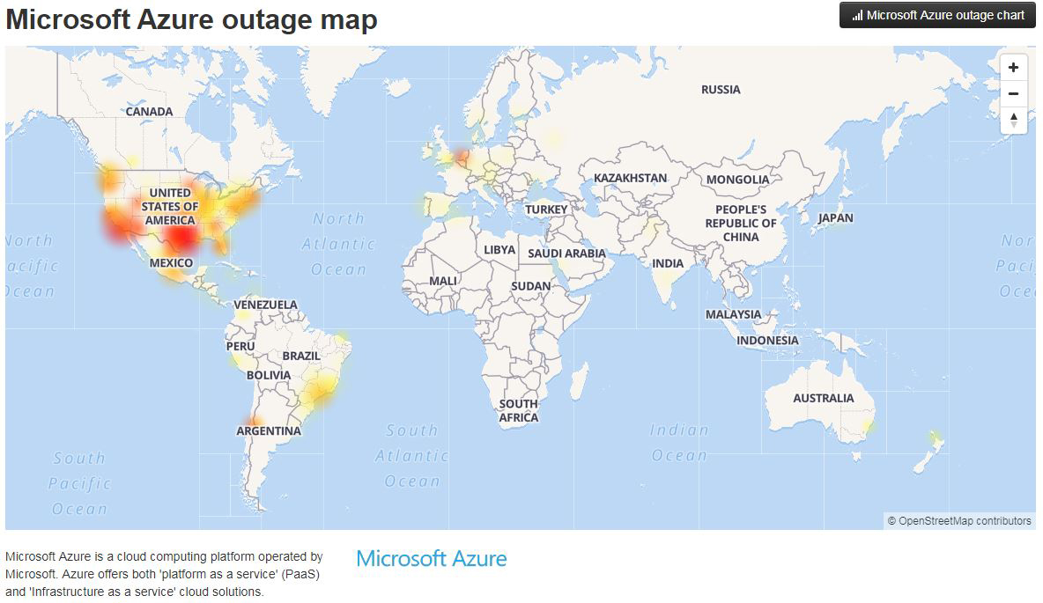Cost: Estimates of the economic impact ranged from $2.1 – $4.5 billion (5).

1. <https://www.datacenterknowledge.com/uptime/microsoft-lames-severe-weather-azure-cloud-outage>
2. <https://www.datacenterdynamics.com/news/microsoft-azure-suffers-outage-after-cooling-issue/>
3. <https://www.datacenterknowledge.com/microsoft/azure-outage-proves-hard-way-availability-zones-are-good-idea>
4. <https://www.onmsft.com/news/azure-outage-update-services-still-down-as-outage-hits-san-antonio-data-center>
5. <https://www.lloyds.com/news-and-risk-insight/press-releases/2018/01/failure-of-a-top-cloud-service-provider-could-cost-us-economy-$15-billion>
6. <https://rcpmag.com/articles/2018/09/04/~/media/ECG/redmondmag/Images/2018/09/0904red_outage_b.ashx>

In 2012 Google made a commitment to eventually utilize 100% renewable energy for the entire company worldwide, including offices and data centers (1). It took Google five years to achieve this goal and in doing so it has become the largest corporate buyer of renewable energy in the world, spending $3.5 billion dollars to purchase 2.6 gigawatts over 7 years (1). While Google does directly utilize much of the renewable energy it purchases, it is not always possible in all its data center and office locations to connect to renewable energy sources. To offset this limitation the renewable energy industry has developed a system where they provide a Renewable Energy Credits or certificate (REC) for the amount of energy the sell. Google purchases an equivalent value of RECs to that of the fossil fuel energy consumed throughout the entire corporation (2). In this way Google can claim they are able to utilize 100% renewable energy. By far the largest amount of renewable energy Google purchases is wind energy and has many long-term purchase agreements with wind energy providers in the US Midwest, Northern Europe and Chile (1, 2). Recently, Google has announced major investments in renewable energy data centers in Minnesota, Finland and Denmark worth close to $2 billion (3-5). Lastly, it is not surprising that Google, a leading developer of AI algorithms that power its search engine, has committed major resources to use machine learning to optimize its data centers (6). The result of these efforts were a 40% reduction in cooling system energy use and 15% overall reduced energy consumption (6, 7).

1. [https://static.googleusercontent.com/media/www.google.com/en//green/pdf/achieving-100-renewable-energy-purchasing-goal.pdf](https://static.googleusercontent.com/media/www.google.com/en/green/pdf/achieving-100-renewable-energy-purchasing-goal.pdf)
2. <https://sustainability.google/projects/ppa/>
3. <https://www.datacenterknowledge.com/google-alphabet/google-said-be-planning-600m-wind-powered-data-center-land-lakes>
4. <https://www.reuters.com/article/us-alphabet-denmark/google-to-invest-data-center-and-green-energy-in-denmark-idUSKCN1NP0GC>
5. <https://www.blog.google/around-the-globe/google-europe/accelerating-europes-clean-energy-transition/>
6. <https://sustainability.google/projects/machine-learning/>
7. <https://blog.google/outreach-initiatives/environment/deepmind-ai-reduces-energy-used-for/>