Game Development with Big Data

Tangee L. Beverly

Elizabeth City State University

Elizabeth City, NC 27890

tlbeverly96@gmail.comGregor von Laszewski

School of Computing and Informatics

Indiana University

Bloomington, IN 47408

Laszewski@gmail.com

**ABSTRACT**

The game industry has come a long way from board games to extensive multi-player games with impressive graphics. Game developers create games for people's enjoyment. Big Data is a larger set of data that reveals set of patterns, trends, human behavior and interactions, so with the use of big data it plays a very important role with the gaming industry. It is used to collect the information about the gamers to keep them engaged of that particular game and use that data to help make the game better. Python is a well-known programming language that big data scientist uses to hold the big data.  By learning to code with python we created a hangman game and a word counter to count the words in a text file. We are aimed in this paper to discuss the reasons and benefits for game developers to learn the python programming and understand the use of the Big Data in game development.

**Categories and Subject Descriptors**

[**Programming Languages**]: Python

**General Terms**

Programming, Python, Game Development, Game Design, Game Developer, Big Data, Big Data scientist

**Keywords**

Big Data, Python, Data Scientist, Game Development.

# INTRODUCTION

The gaming industry is booming by making $20 billion annual in America and it is bigger than the movie industry. Game Industry is rapidly growing and reached beyond to every specific age group. Different age groups who are familiar with the technology had at least some form of game it can be a simple game app on their smart phones. There are some whom may be interested in to have a career in game designing. There are many things they should know while on their journey to become a game developer. Python, is the top most highly recommended programming language for beginners in programming. Also, Python is used for Big Data to hold all the information and that is a benefit from different aspects for the research. By, learning the simple and easy to read python programming language can already put them ahead of the game. The task was learning python, create a game using python and understand the role of Big Data in game development. Game development impacted many people across the world. There are some who are hardcore gamers, develop games, or both. The game industry is high demands as of now surpassing the movie industry. Game Development is involving as many people are developing games and there many resources out there that can help people create games. Programming plays a major key point in game development and those common languages are C and C ++. For beginning programmers who are still interested in creating a game; Python is another common programming language.

Python is easy to under programming language for beginners in coding. We discovered that python is well known to help with certain tasks. Throughout this research the main task was to learn Python which only took two weeks to complete. In addition, we researched the basics of Big Data while keeping in mind game design. Big data is good for leading to new discoveries. Data Scientist are here to gather that data and present it to different organizations.

Many companies are relying on Big Data and even the Game industry. The game industry can benefit from the Big Data to help improve and make more money.  Python is a good programming language that many Data scientists use, because it has many libraries for collecting and organizing data. It should be highly recommended that game developers understand the benefit of Big Data.

We created a hangman game and as well a word counter in a text file. To fully comprehend the benefits of learning python that many Data Scientists use for Big Data.

# Game Development

The process of creating a video game. Game development has recently made an impact over these years. To one person to a group of people are partaking in the game development field. This is a major benefit for everyone, because each person is bringing their individual ideas to game designing. As the increase of people developing games then it will help evolve the game designing to make it better than before. Game development can be simple as making a workable code of a game in a programming language. For first time game developers will not be easy and it will not go as they may want their game to be like [5]. This whole process is a trial and error. We started off to create a basic hangman game in python. As newcomers to python we faced errors throughout the process. The best feeling a beginning game developer will experience is finally making the game work. It is weight lifted off your shoulders and relieved that it is finally completed.

# Game Industry

The gaming industry has evolved from late nights with friends or family enjoying simple board games to extensive multi-player games with outstanding graphics; such as, Dota,Halo, COD, etc. Billions of people across the world can interact with each other playing games online [2]. Computer games has also made great impacts as of today. There were simple games pinball and Pacman, but there are games like league of legends, World of Warcraft, and Counterstrike. Game players are able to make customizations to their characters, chat with others around the world, better options, and most importantly WIFI. The game industry made over $100 billion in America and larger than the movie industry. It is rapidly growing with new individuals combining their game development skills to create an even better game to please the customers. The gaming industry reached out to all different age group, but restricting certain games for minors. Overall, the game industry has made an impact to all age groups in this year of 2016. In the 2016 video gaming in US statistics shows that 67 percent of Americans aged between 18 and 29 years admitted to playing video games, and total of 58 percent of Americans within the 30 to 49 age admitted as well [7]. (see figure 1)

# Big Data

Picture a big tangle up hair balls all over your room. The pain of cleaning and breaking it apart. That is the general concept of big data. It is a collection of data from a digital source inside and outside of your company that represents a source for analysis. Google, eBay, and LinkedIn were the first to be tested with big data. Big Data made such an impact on the industries such as, education, health care, banking etc. Companies used Big Data as their advantage for advertising, sales, transactional systems, customer’s history, social chats, etc. Big Data is making an enormous impact globally.

# Python for Big Data

As stated repeatedly in the research paper that is python is a good starting point for game development. It is one of the easiest fastest programming language to understand and code. Aakanksha Khanna article about “Python for Big Data Analytics explains that “Python cuts development time in half with its simple to read syntax and easy compilation feature. Debugging your programs is a breeze in Python with its built in debugger. Using Python makes Programmers more productive and their programs ultimately better. Python is continued to be a favorite option for data scientists who use it for building and using Machine learning applications and other scientific computations. Python is free to use, even for the commercial products, because of its OSI-approved open source license. Python has evolved as the most preferred Language for Data Analytics and the increasing search trends on python also indicates that Python is the next “Big Thing” and a must for Professionals in the Data Analytics domain.” Python has many benefits for data scientists to keep wanting to use that program for big data [4].

# Hadoop

It was invented by Google back in the old days so they could index all the rich textural and structural information they were collecting, and present actionable results to the users. Yahoo has an important role in developing Hadoop for enterprise applications. Hadoop was designed to solve problems where you have a large amount of data meaning a mixture of complex data that doesn’t fit in the table [6]. Hadoop is originally written in Java, but programs in Hadoop doesn’t necessarily need to be written in only Java, but in any programming language. Programs written makes things a lot easier and simpler.

# Game Industry use Big Data

The game industry uses big data as opportunity to make more money and improve the gaming experience. All industries rely on their happy customer, if they are not happy then that means losing money. Big Data comes along to help saves the day. Game players leaves massive amount of data as they are playing the game. It can be computer, app, console any type of games; game players leave data in their trail. Big data is created by the gamers. Mark Van Rijmenam is the founder of Datafloq. According, to Mark Van Rijmenam take on this is “They create massive data streams about everything they do within a game. How they interact, how long they play, when they play, with whom, how much they spend on virtual products, with whom they chat etc. If the gaming profile is linked to social networks or a gamer is asked to enter demographical data, the information can be enriched with what the gamer likes in real life and gaming companies can adapt the game in real life to the profile of the gamer.” He also states that, “Big Data technologies also help to optimize in-game performance and end-user experience. When for example the databases and servers of the games have to cope with a steep increase in online players, it is important to have sufficient capacity. With Big Data it is possible to predict the peaks in demand to anticipate on the required capacity and scale accordingly. This will improve the gaming experience (who likes a slow game) and thus the end-user experience.” Game developers should not miss this opportunity with big data, it is very beneficial. It gives game developers a chance to improve their games to make their players happy and want to continue to be interested in the games [4]. (see figure 2)

# Conclusions

In this research paper, we provided an effective way to understand the importance of Big data to industries specially the game industry. Also, working with the python language that connects big data and game development. There are many greatest with python that helps maintain big data and the language can be used to create games as well. It should be highly recommended that game developers understand and to be expose to the benefits of Big Data. We created a hangman game and as well a word counter in a text file. To fully comprehend the benefits of learning python that many Data Scientists use for Big Data.

# ACKNOWLEDGMENTS

Our thanks go to the director of Center …(CERSER) Linda B. Hayden for providing this opportunity and Indiana University, Dr. Lamara Warren and the faculty Gregor von Laszewski follow by the graduate students: Supun Kamburugamuve, Pulasthi Wickramasinghe.

# REFERENCES

1. Agrawal, Vaishnavi. "5 Major Benefits of Big Data for Your CIO." Datafloq Read RSS. N.p., n.d. Web. 25 July 2016
2. Davenport, Tom. "Three Big Benefits of Big Data Analytics." Analytics, Business Intelligence and Data Management. N.p., n.d. Web. 23 June 2016.
3. Singla, Rachayeta. "Big Data Analytics for Transforming the Gaming Industry." *PromptCloud*. N.p., Feb.-Mar. 2015. Web. 22 July 2016.
4. "The Gaming Industry Turns To Big Data To Improve The Gaming Experience." Datafloq Read RSS. N.p., n.d. Web. 23 June 2016.
5. Totilo, Stephen, and Zoe Quinn. "A Beginner's Guide To Making Your First Video Game." *Kotaku*. N.p., 28 Jan. 2013. Web. 22 July 2016.
6. Turner, James. "Hadoop: What It Is, How It Works, and What It Can Do." *O'Reilly Media*. N.p., 2011. Web. 22 July 2016.
7. "U.S. Video Gamers Age 2016 | Statistic." *Statista*. N.p., n.d. Web. 22 July 2016.
8. "Why B2B Marketing Needs Data Crawling & Analytics." *PromptCloud*. N.p., 24 Dec. 2014. Web. 22 July 2016.

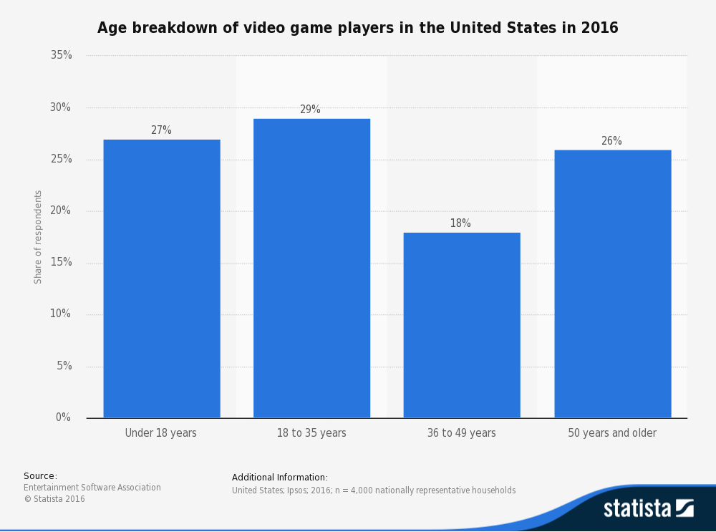 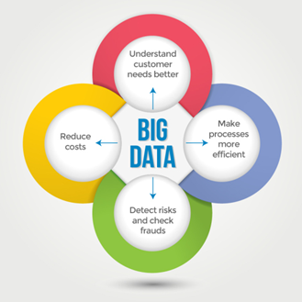

*Figure 1 shows the age graph of users playing games Figure 2 shows the key benefits for Big Data.*

Columns on Last Page Should Be Made As Close As Possible to Equal Length