Visual Studio Installation



Not Just Skill Training

Enabling environment and scope to grow career

PRESENTED BY: CloudnLoud Team



**Download from Microsoft officially Page**

Install the Visual Studio Community Edition which is free. Follow below link and click on download Visual Studio.

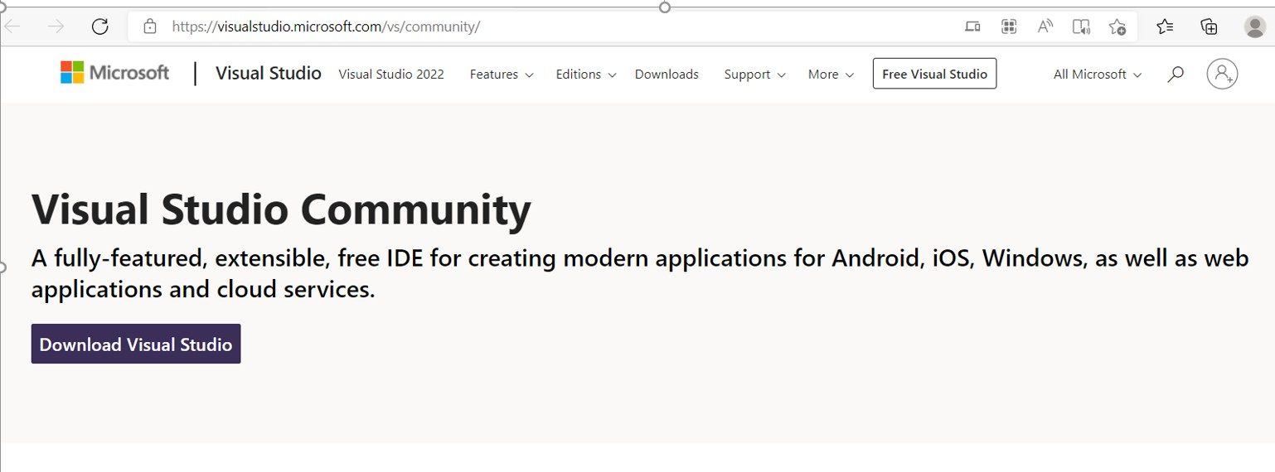

**Note :** Professional and enterprise version are licensed



**Open the Visualstudio.exc from download folder**

After downloaded double click on VisualStudioSetup.exc file which is downloaded.

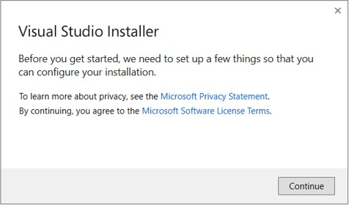



**Select workload need to installed.**

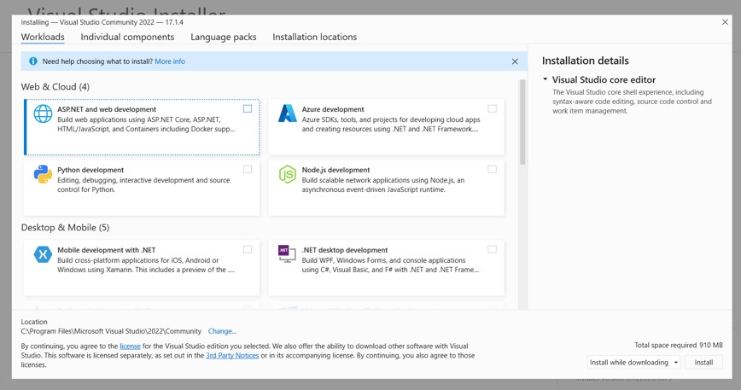

It will ask for workloads, Check all the necessary workloads to install in visual studio.



**Select workload need to installed.**

# Workload:

* ASP. Net and Web development.
* Azure Development.
* Visual Studio Extension Development.
* Add if you need anything wanted.

# Language packs:

* Select English as default

# Installation Location:

* Keep all the installation in C:\Program files



**Open the Visualstudio.exc from download folder**

# Individual Components

* Select all the .NET Framework(To support all downgraded project)

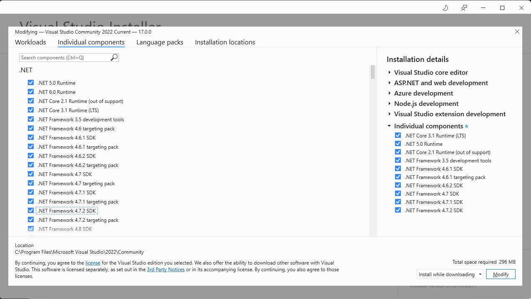

**Provide Installation locations**

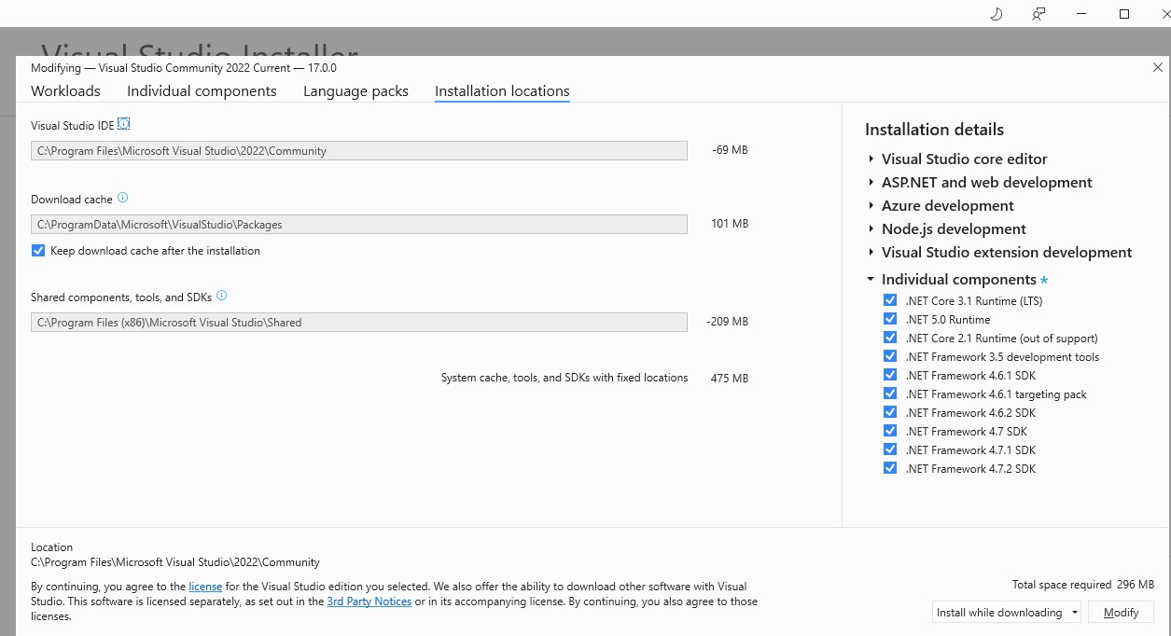

Select Install and downloading, it will take some time to install VS



**Install Visual Studio**

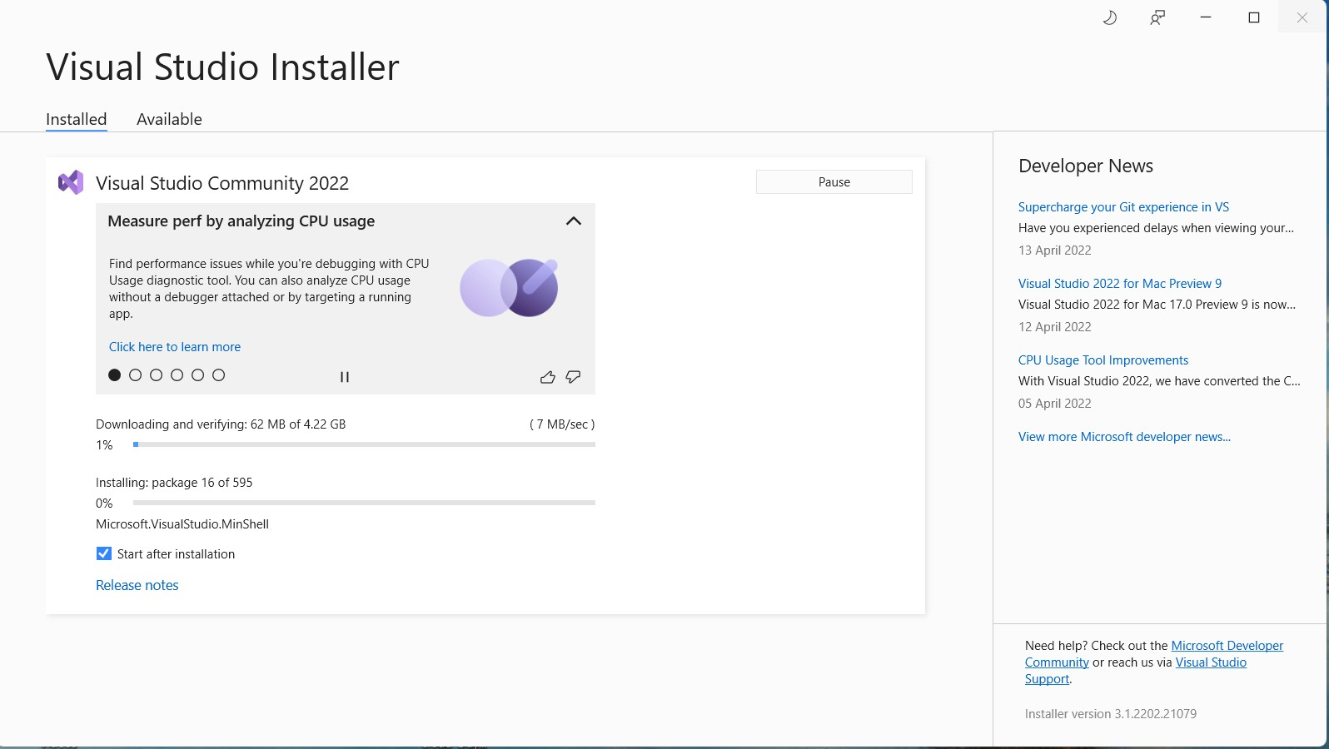



Select Theme to finish the installation

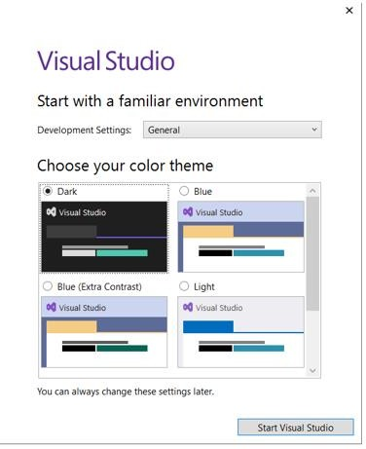

Select the Theme which you preferred. **9**



Installation Completed

When you see the window your are successfully installed VS

1. 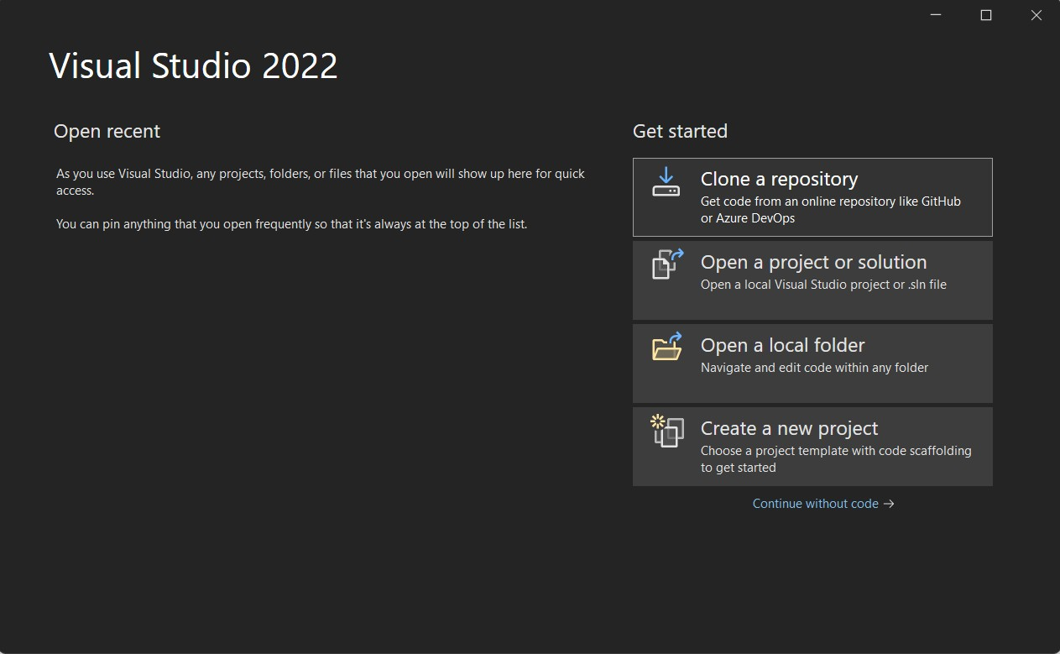Clone a repository(You can clone project from github
2. Open a project(To open existing project)
3. Open a Folder(to open project folder)
4. Create a new project



Clone project from GitHub using Visual studio

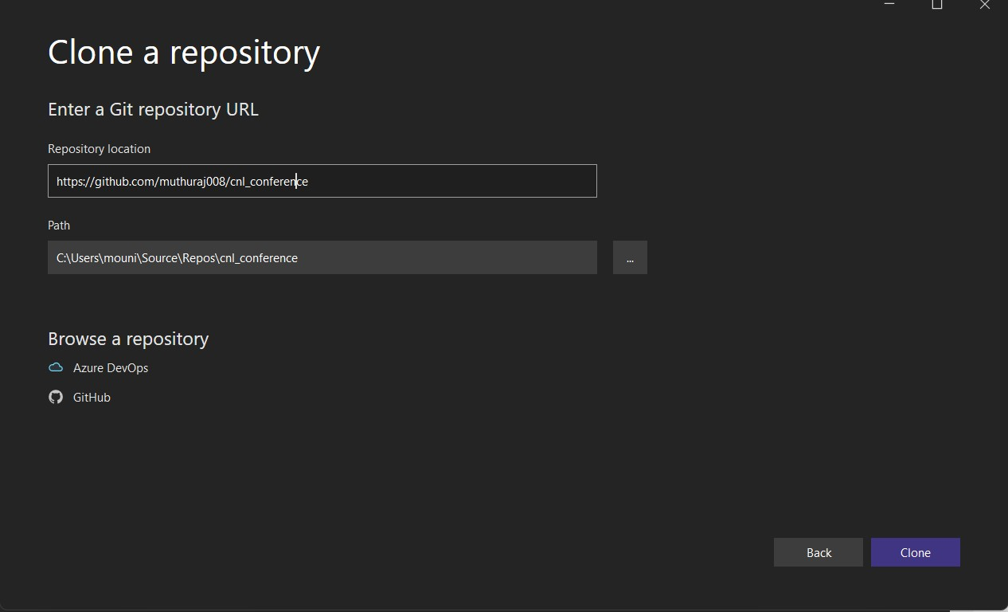

1. Enter the repository URL of GitHub in Repository location.
2. Provide the local path where to clone project.
3. After clicking on clone the project will be clone in respective path.

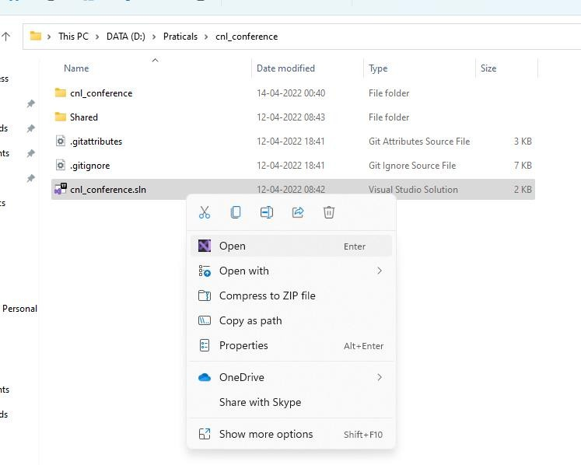

To Open a cloned project

* + Get into cloned project folder in local.
  + Open the solution file in Visual studio.



**Thank you. We’d love to hear from you!**

