1. Pull the latest codes at <https://github.com/cloudoa/appbank.git> into *<your workspace> (such as, D:\WorkSpace\PHP\AppBank)*
2. Run _tools\WAMP5 v1.7.4免费版\wamp5_1.7.4.exe to install WAMP5
3. (During installing or launching WAMP5, I forgot the step…) Setup DocumentRoot as *<your workspace> (such as, D:\WorkSpace\PHP\AppBank)*
4. Check all services working at the system tray icon. (See the picture below)

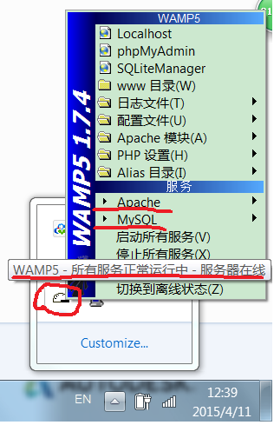

1. <http://localhost> (if your 80 port is occupied, you need to change WAMP5 port.)

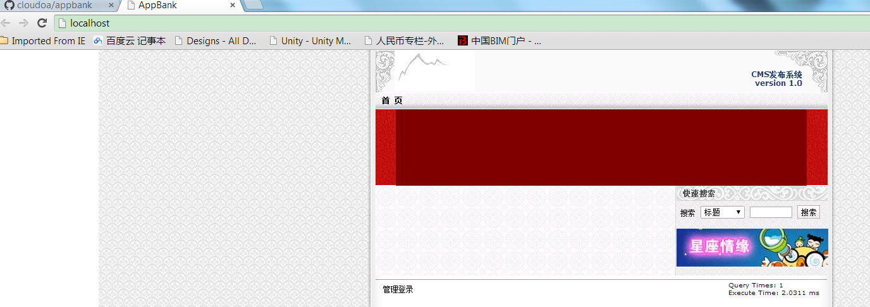

Click “搜索” button, you will find an item recorded by me.

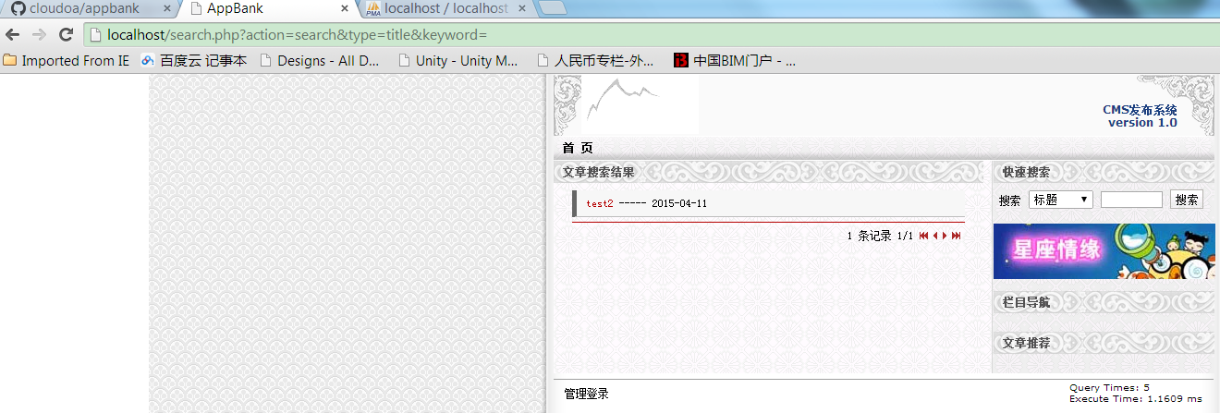

1. <http://localhost/admin/> 用户名：admin，密码：admin

这就是它的后台，我们就需要修改这个后台程序，改成AppBank的。上面那条test2就是我通过后台录入的。当然，目前这个版本还有很多地方不能工作，我们可以慢慢改进，甚至重写大部分的实现。

前台只是demo，我们不用太花心思。