username: cloudover9

password: Csci230

------------------------------------------------------------------------------------------------------
Creating a table

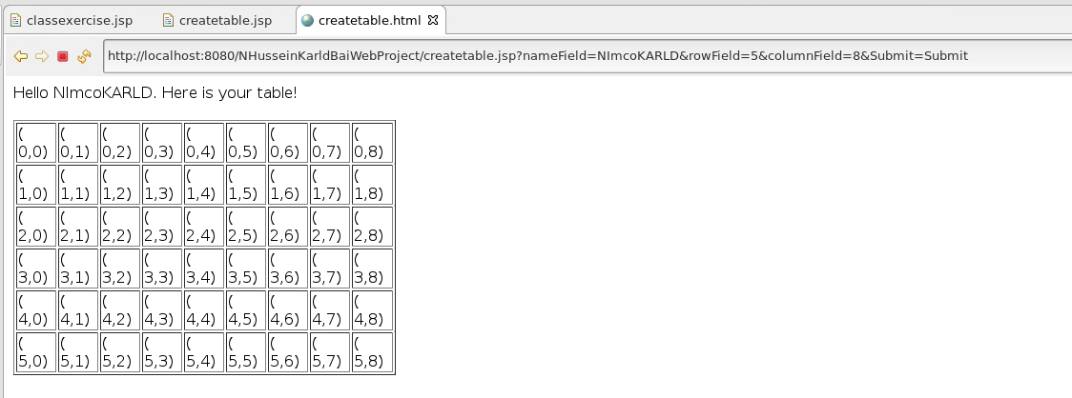

Error message for when row is < 0.
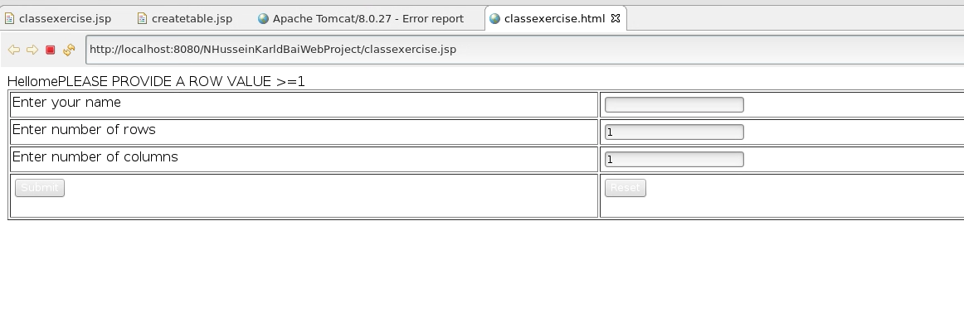
Our issue is that we are displaying the error message without reading the value of row first, and that the name value is displaying the last name that was entered as well.

Once we do enter a negative value for either the row or column value in classexcercise page, our screen ended up looking like this.

