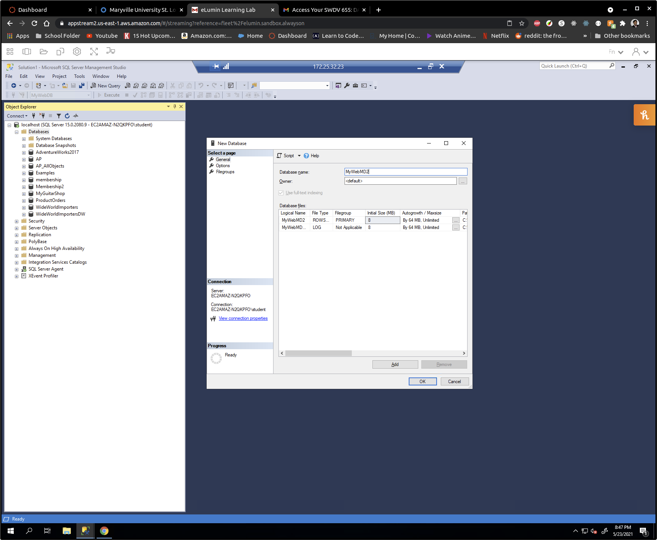

Hector Alvarez

Week3  
My Guitar Shop Assignment

Part B

b.1 – Create Database

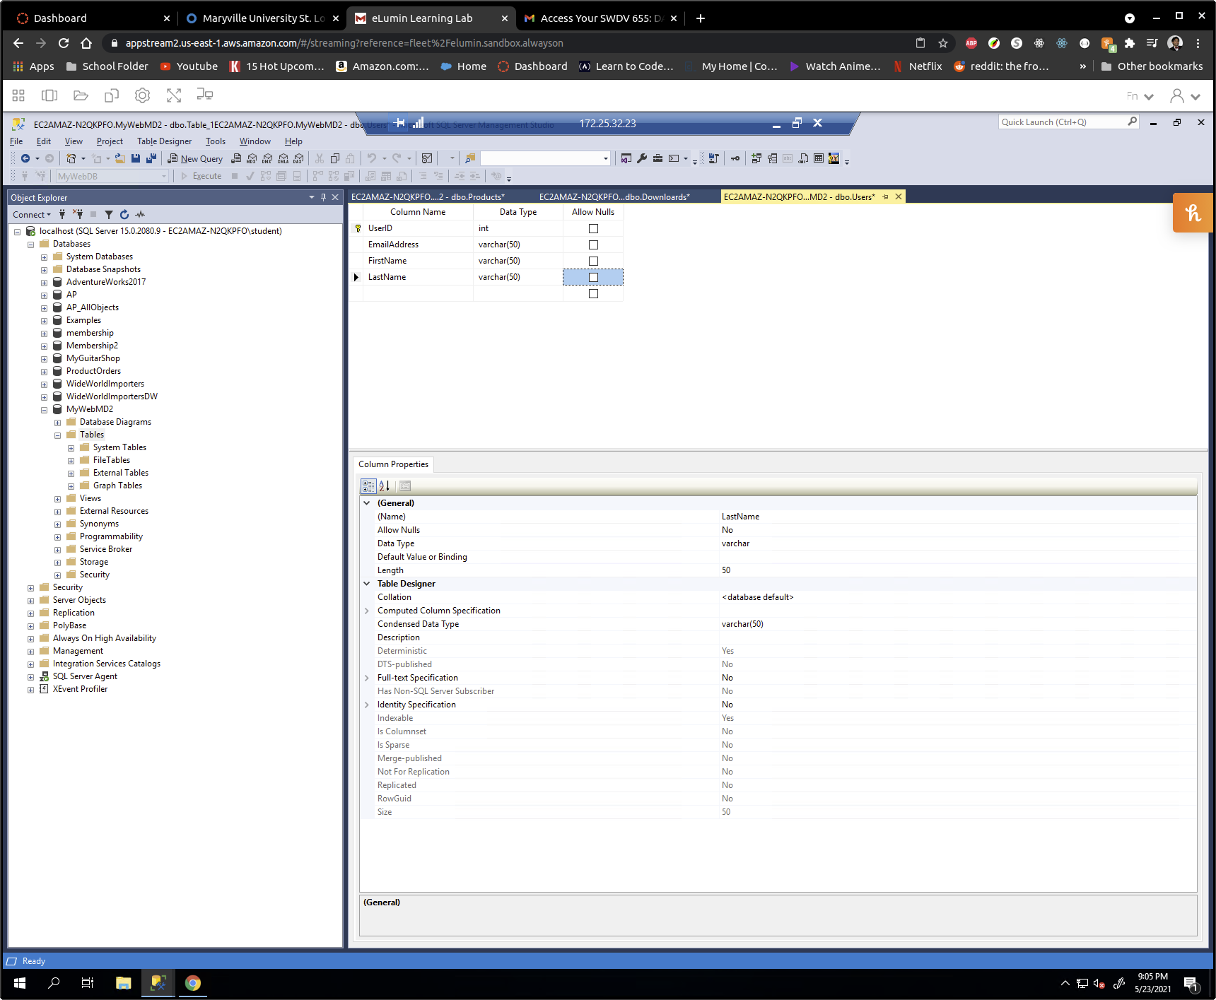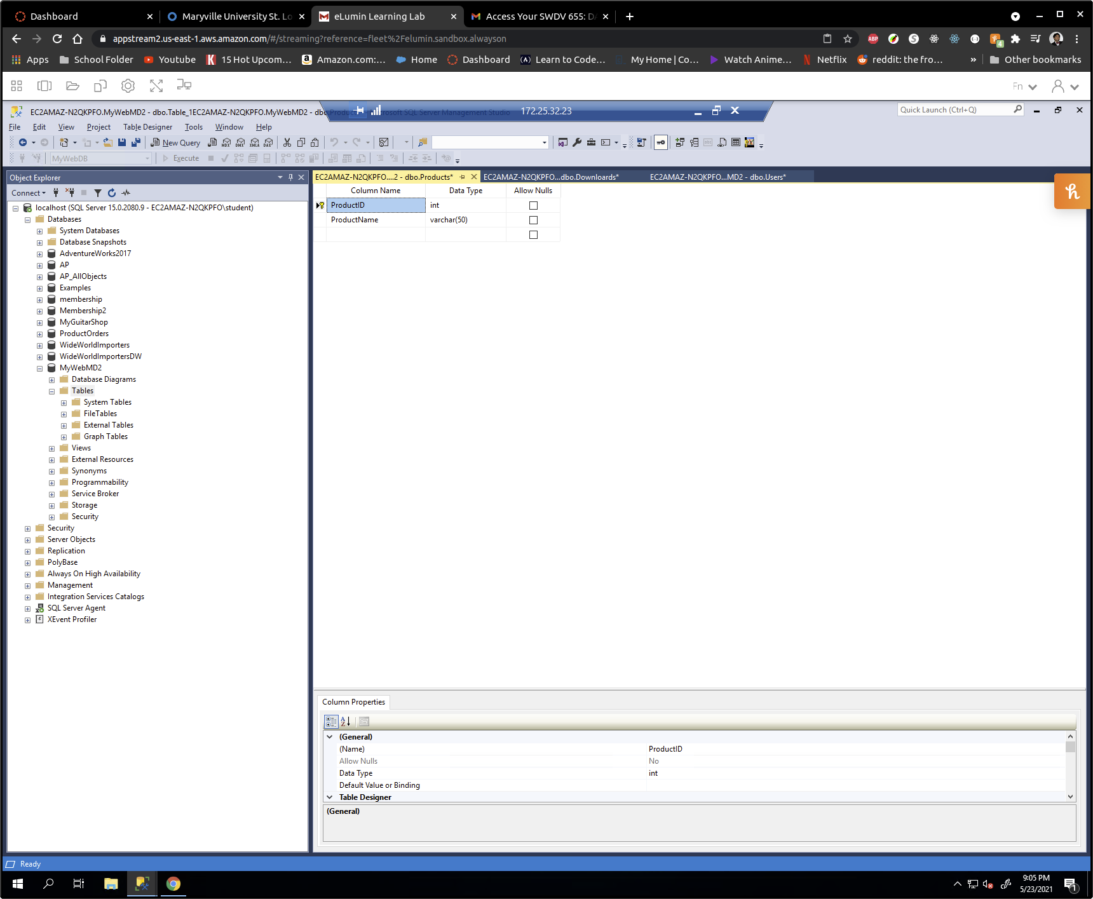B.2 -B.3 (and B.5) Create Tables - Define the UserID column in the Users table, the ProductsID column in the Products table, and the DownloadID column in the Downloads table as primary keys and identity columns.

Define the columns so none of them allow null values.

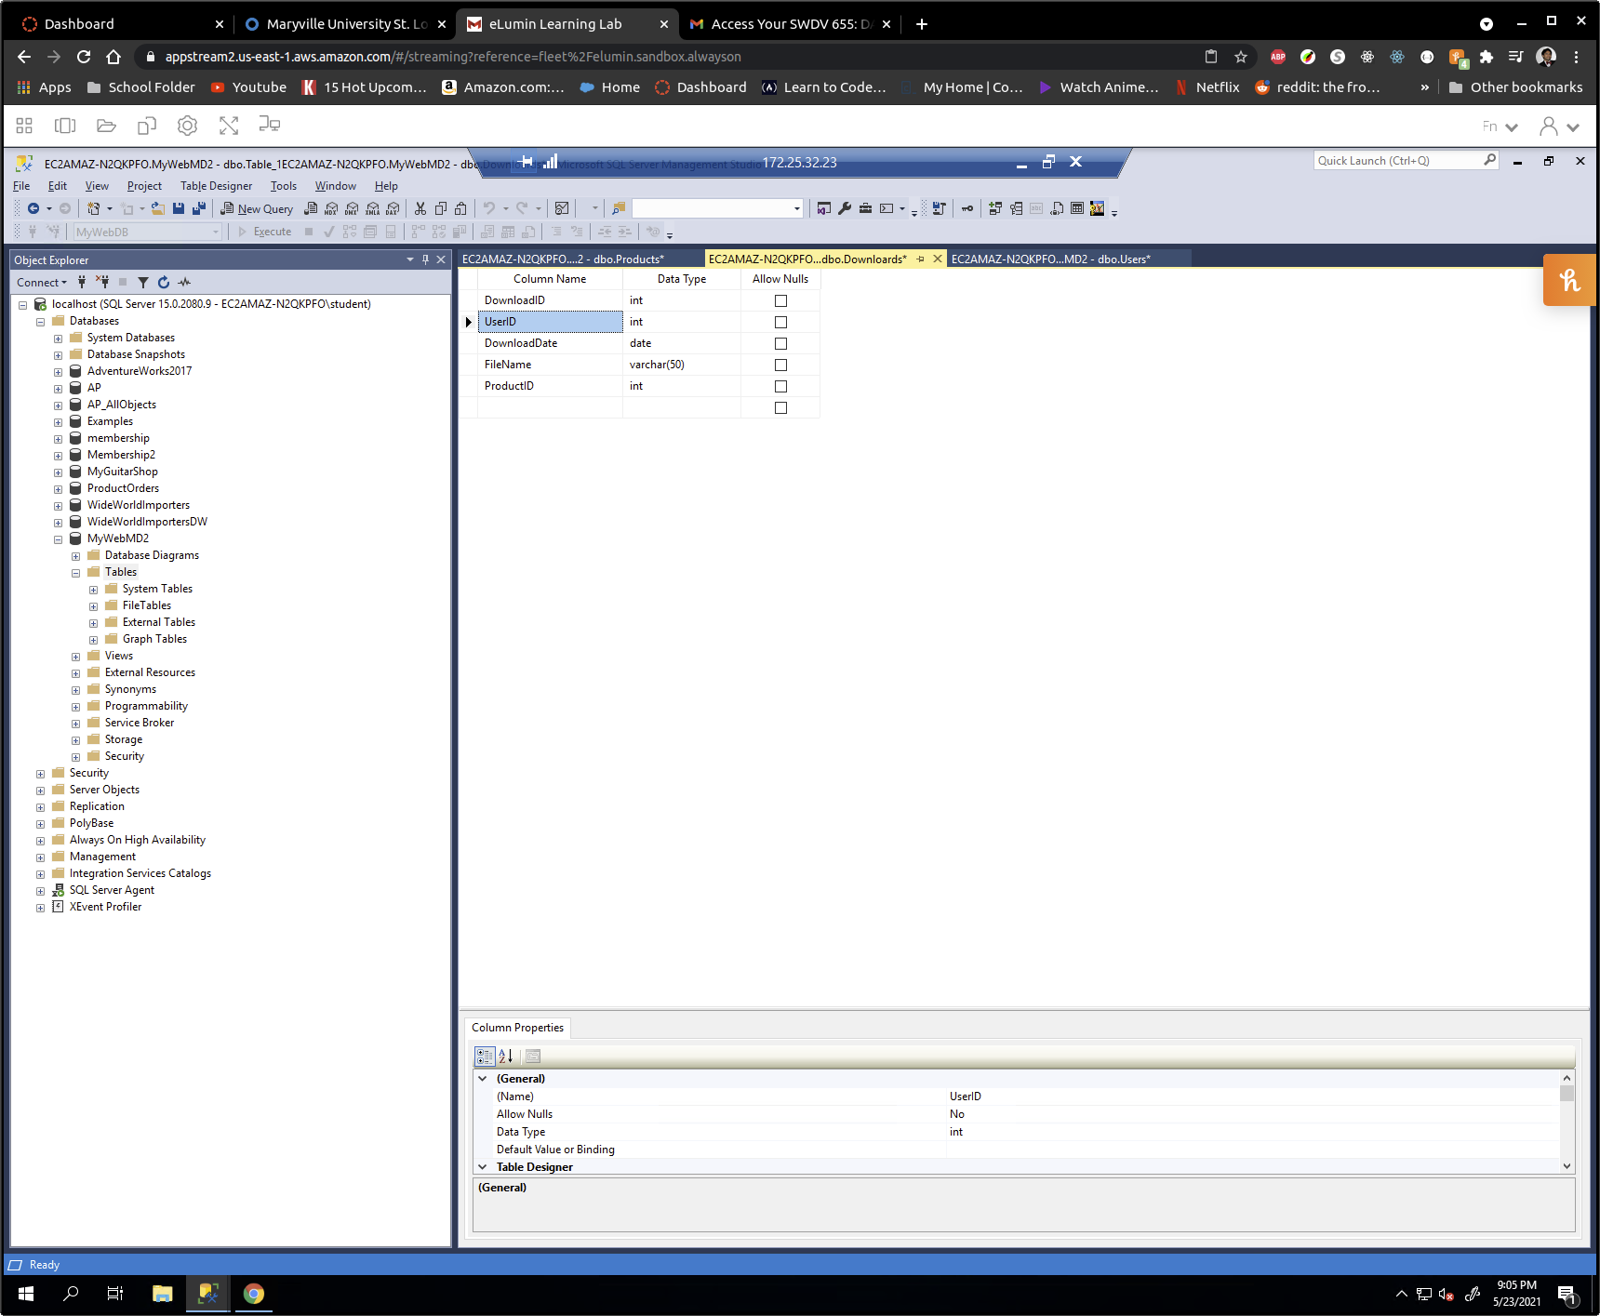

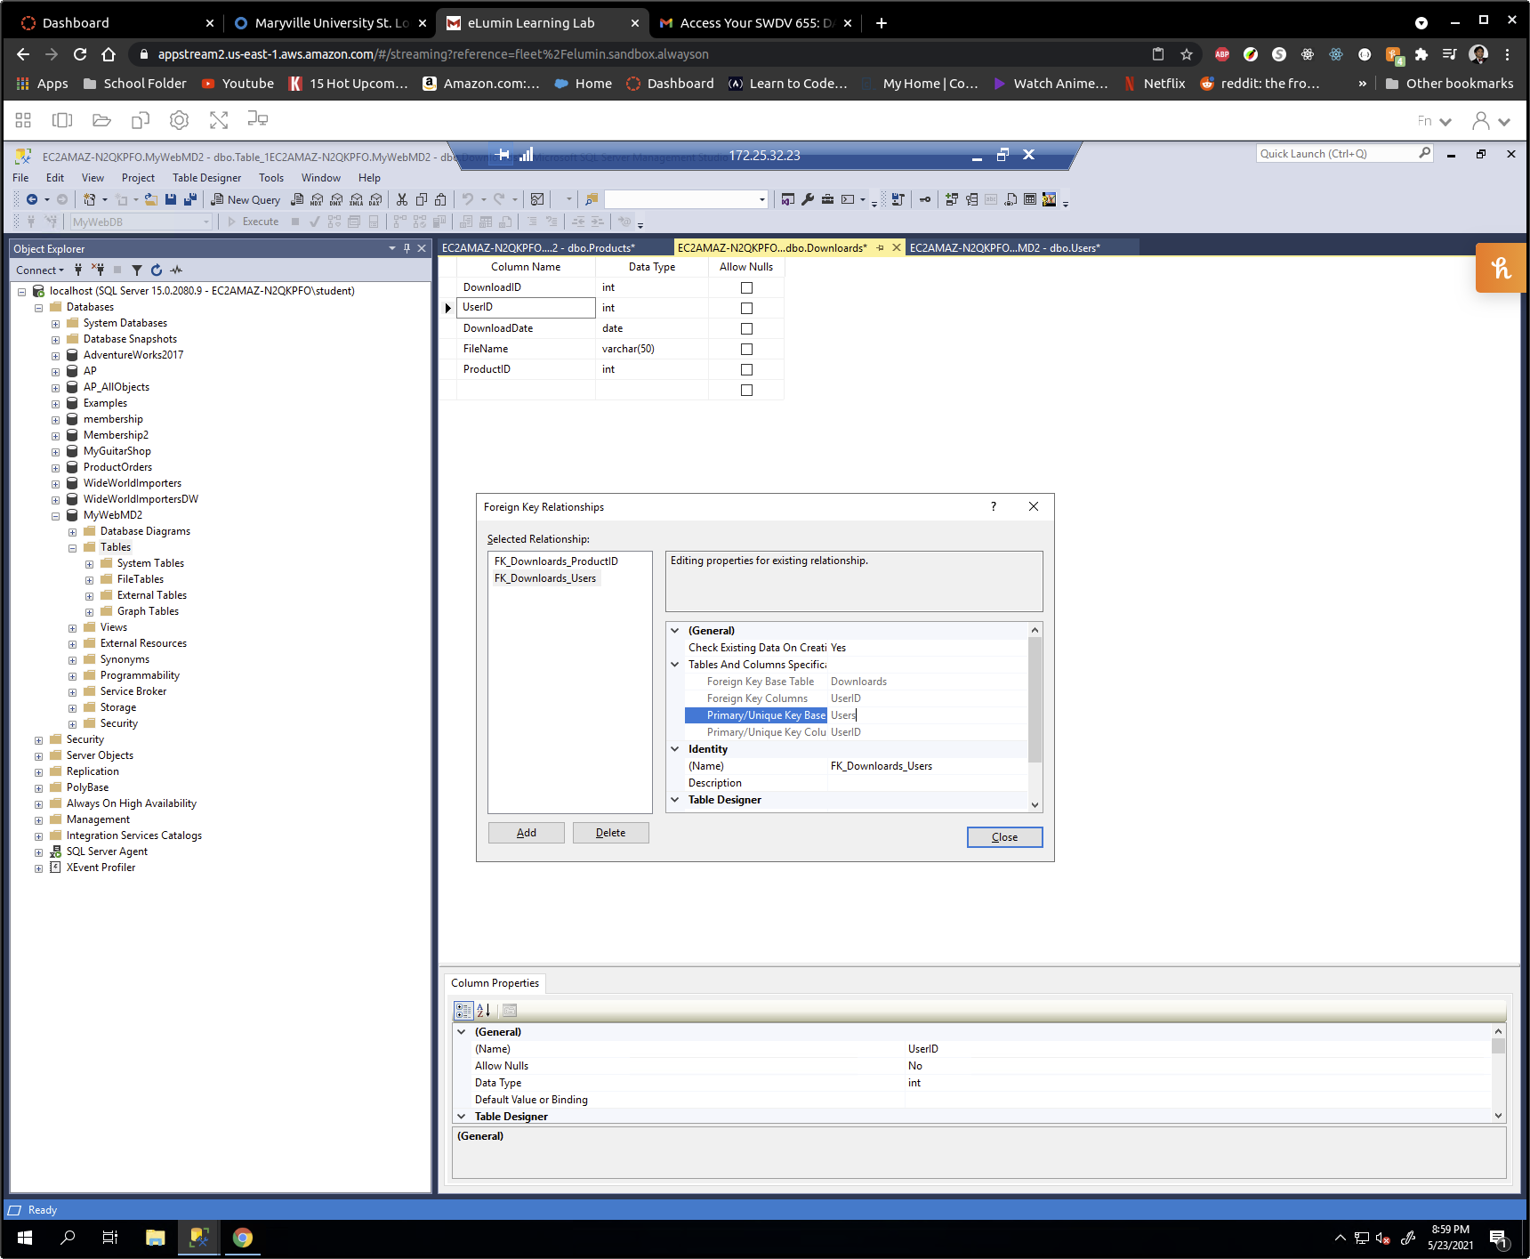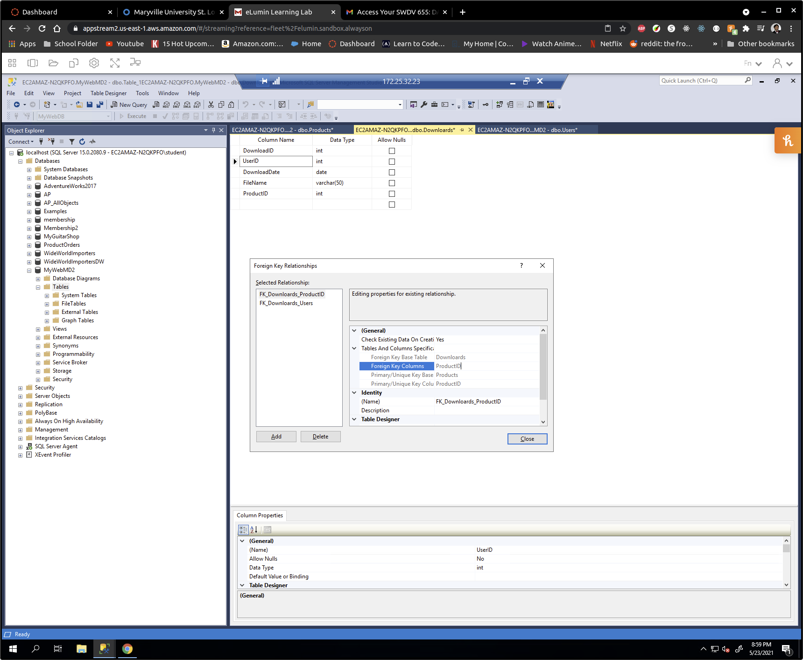B.4 - In the Downloads table, set the UserID and ProductID column as the foreign keys.

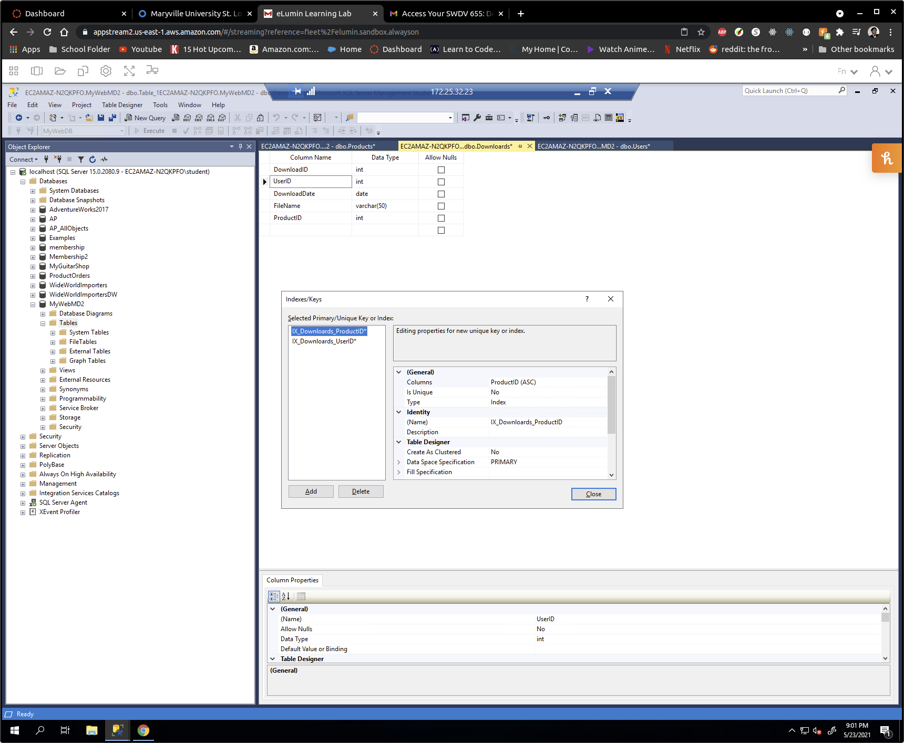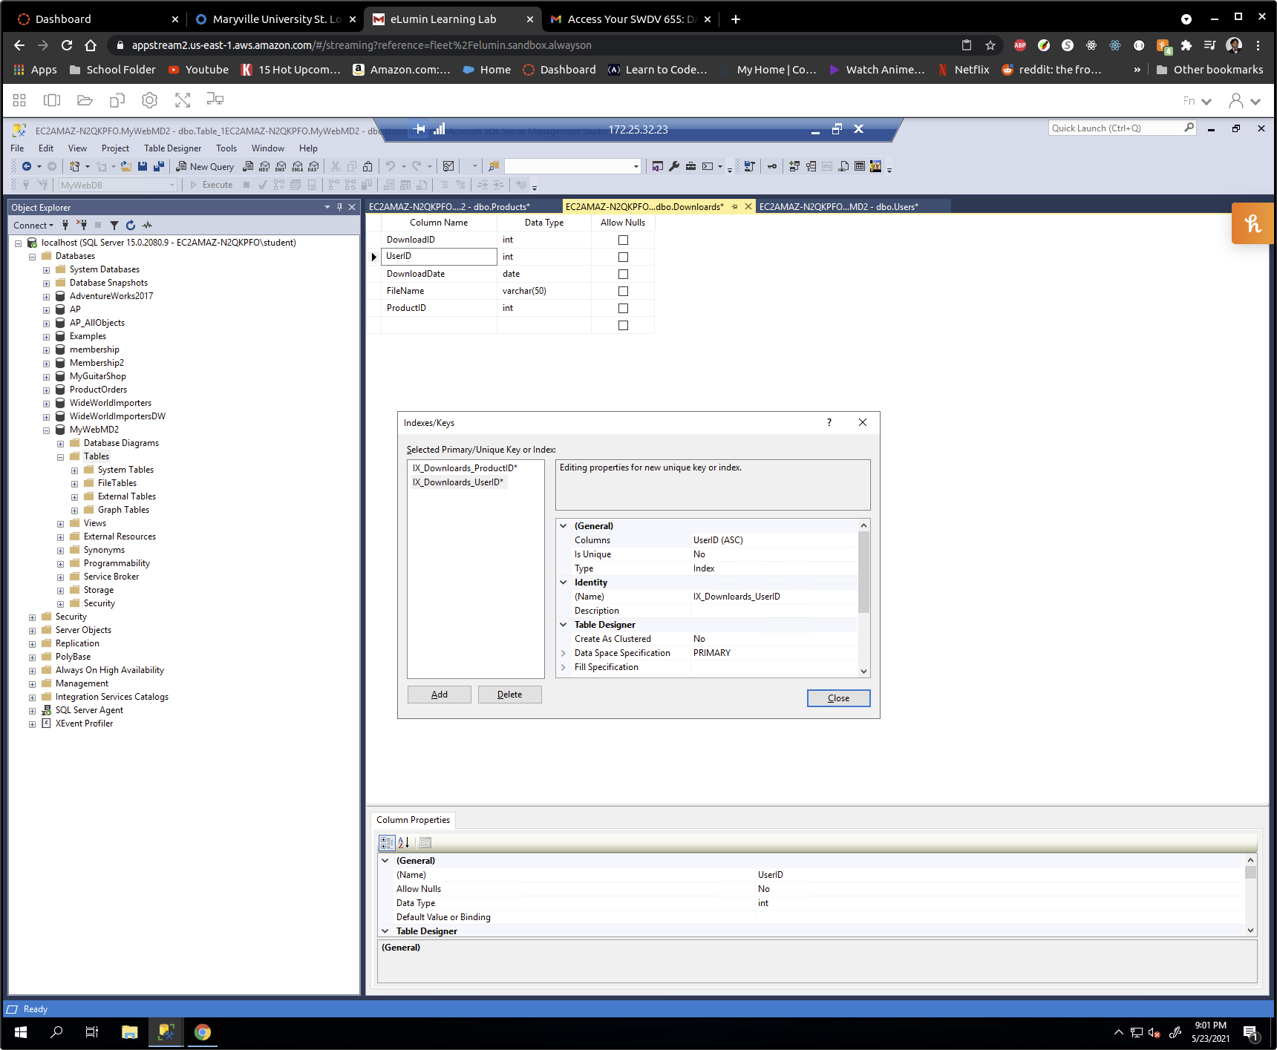B6. -Use the Management Studio to create indexes for the foreign keys in the Downloads table.