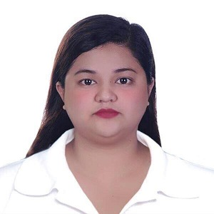Sta. Cruz Village Sudapin

Kidapawan City, 9400

+63 917 129 7636

[erekadyanjavier@gmail.com](mailto:erekadyanjavier@gmail.com)

OBJECTIVE

Motivated and dedicated Hotel and Restaurant management graduate

seeking to apply my abilities to any positions related to my experience.

HIGHLIGHTS

Operate a cash register Customer Service

Working under pressure Time Management

Trustworthy Money Handling

Leadership Work unsupervised

Team Work Serving

EDUCATION

University of the Immaculate Conception Davao City,

Philippines, 8000

Bachelor of Science in Hotel and Restaurant Management

2011-2014

EXPERIENCE

**Aj High Time Hotel**

Food Server (part-time)

August 2016- May 2019

**Holiday Inn Cleveland- S Independence Ohio, USA**

December 2014 - December 2015

* Banquet/Restaurant Server
* Barista
* Hostess/ Cashier
* Housekeeping

**Virginia Beach Resort Hotel and Conference Center VA, USA**

March 2013- June 2013

* Room Attendant

REFERENCE

* Mr. Noel Dizon Aj High Time (064) 577-1811

**Manager**

* Mr. Chris Boland Virginia Beach Resort Hotel (757) 481-9000

And Conference Center

**Executive Housekeeper**

* Mr. Andrew Kovacs Holiday Inn, Cleveland (216) 276-2830

**Banquet Manager**