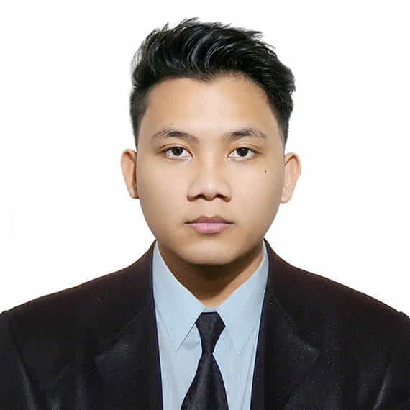**ABAGAT, CHRISTIAN B.**

**#94 Block 2 Purok 13 South Daang Hari Taguig City**

**0995 738 8511**

**christianbabagat@gmail.com**

**OBJECTIVE**

To be part of these company as a hard working and reliable line cook to achieve its goals and willing to grow and provide the best of my skills and knowledge

**EDUCATIONAL BACKGROUND**

**Primary:** C.P. Sta. Teresa Elementary School

2002-2008

**Secondary**: Bagumbayan National High School

2008-2012

**College**: Taguig City University (T.C.U.)

Bachelor of Science in Hotel and Restaurant Management

2012-2016

**WORK EXPERIENCE**

**Taguig City University**

Internship Kitchen Laboratory Staff

2013-2014

* Observe the cleanliness of kitchen laboratory
* Checking appliances and equipments for kitchen safety

**Manila Crown Palace Hotel**

Internship F&B Staff, Kitchen Staff, Bartender andHousekeeping Staff

Nov.2015-Feb.2016

* Ensures that guest is satisfied with my service and meet their expectation
* Worked with passion and willingness
* Maintaining the cleanliness of hotel and restaurant

**Shakey’s Alabang Town Center**

Kitchen Staff and Bartender

Dec.2016-Sept.2017

* Giving all out service to meet guest expectation
* Ensures the quality of the food and drinks before serving

**1898 Hotel Colinia En Las Filipinas**

Room Attendant

* Observe the cleanliness before and after guest visit
* Giving all out service to meet guest expectation

**1771 group of restaurants (Sentro)**

Cook helper

October 7, 2019 - March 7, 2020

* Mep or premade food
* Cooking and preparing food of guest
* Ensuring the cleanliness of area station

**SPECIAL SKILLS**

* Willing to take new challenges
* Eager to learn
* Multi Tasking

**CHARACTER REFERENCES**

**Lilibeth L. Arenas** **Roger M. Lachica**

Business Woman Dentist / Professor / Businessman

Hagonoy Taguig City Taguig City University

0949 916 5009 0918 915 6010

**Juenie Mae O. Sidro Cesar Cabugao**

Supervisor of Watson’s Chef de Cuisine

Stamford mckinley west French Company

Florence way Taguig City 602599682

0995 678 5457

I hereby certify that information contained herein is true and correct to the best of my knowledge.

____________________________

CHRISTIAN B. ABAGAT