Page 105 from Gaddis textbook.

**#3 Math Tutor Application**

You are to create a *Math Tutor* application. The application should display a simple math problem in a Label control. The form should have a button that displays the answer to the math problem in a second label, when clicked. It should also have a button that closes the application. Figure 2-81 (further down in this document) shows an example of the application’s form before the button is clicked to display the answer. Figure 2-82 (further down in this document) shows the form after the *Show Answer* button is clicked. Here are the detailed property specifications:

1. The button that displays the answer should be named btnShowAnswer. Its Text property should read *Show Answer*.
2. The button that closes the application should be named btnExit. Its Text property should read *Exit*.
3. The label that displays the answer to the math problem should be named lblAnswer.
4. The form’s title bar should read *Math Tutor*.

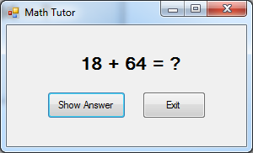

**Figure 2-81** Initial *Math Tutor* application

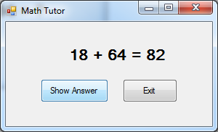

**Figure 2-82** Math Tutor application after *Show Answers* button is clicked.