02 - Math Tutor Test Plan

ITP 112 Visual Basic .NET I -- Mr. Meeks -- Spring 2013

General Instructions
- Save 2 copies of this test plan.
- Complete one copy of the plan for your own program (self test).
- Then pair up with a VB Buddy and complete the second copy using their program while they do yours (buddy test).
Programmer:________________________________
Tester:_____________________________________
Points: _______ of 20

Math Tutor Test Plan
- (5 points) Open the .vbprog file using Visual Studio. Look at the property panel to complete the table.
Control | Property | Value
Form | Text
Button – Show Answer | Name
Button - Exit | Name
Label – Displays Answer | Name
- (5 points) Run the application. If the application does not run, then write down the error message, otherwise write OK.
- (2 points) The application should look like the following. Mark any deviations or write OK.
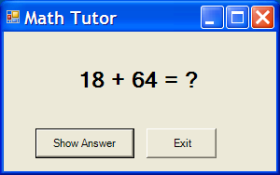
- (2 points) Click the Show Answer button. The application should look like the following. Mark any deviations or write OK.
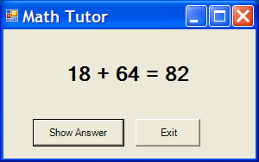
- (2 points) Click the Exit button. The application should close and return to Design view. Write down any error message, otherwise write OK.
- From the Design tab, click a button on the form to display the code tab.
- (2 points) Select File then Print from the menu bar to display the print dialog box. Check the check boxes as shown below and print your event procedures code. We will not be printing code again, just to make sure you know it can be done.
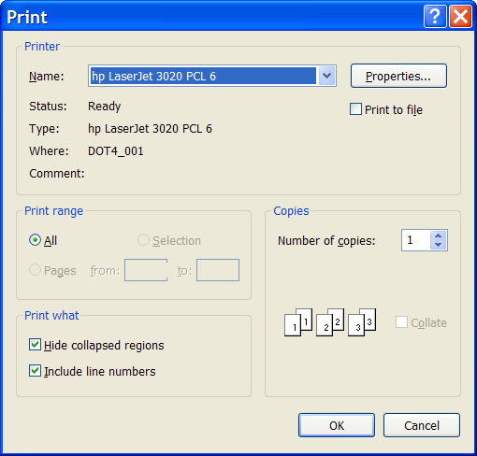
- (2 points)Select all in the code window (CTRL+A). Copy this. Go to your word document and paste (CTRL+V). Save your word document. This is the method we will use to submit code here forward in the class.

Submission Instructions
Submit in class
- The buddy test you did.
- The printout of your code.
Submit in Blackboard or by email
- Self-test on top.
- Your code.

©2013 Carlotta Eaton

