Student Name: AnkanBasu__________________

Class and Section CSC 201 M6__________________

Total Points (50 points) __________________

**Project: Compute Average, Minimum & Maximum Scores – Part Deux**

CSC 201 – Computer Science I

New River Community College

Problem Description:

Your English professor is very much pleased with the program that calculates the following statistical information for the classes that they are teaching this semester.

1. The number of Scores
2. Average Score
3. Maximum Score
4. Minimum Score

But often, have many test scores for different classes and don’t have time to enter the data for all tests at one sitting So they want you to modify the program so that

1. They can calculate the statistical information (Number of scores, Average Score, Maximum Score and Minimum Score) for as many tests as time permits at one sitting.
2. They would like to enter the scores on a single line (89 74 68 88 74 91 67 54 71 66) rather than one score per line.
3. They would like the average score has only two decimal digits.

Modify your project 3 program (if you did not complete Project3, start this one from scratch) so that it would ask the user to enter

1. The name of the course
2. The scores on a single line for that course. Tell the user to add a -1 at the end of the line. Use the -1 as the sentinel value in your program.
3. Your program should then display
   1. The course name.
   2. Number of scores for that course.
   3. The average score (rounded to two decimal digits) for that course.
   4. The minimum score for that course.
   5. The maximum score for that course.
4. After displaying the output, your program should ask the user whether they would like to continue (Use a confirmation dialog box to accomplish this task). If the user likes to continue, repeat steps 1, 2, 3, and 4. If the user does not want to continue terminate the program.

**Here is a sample run:**

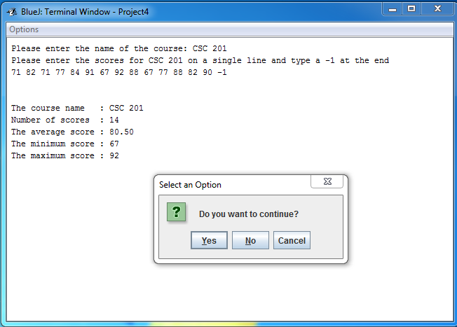

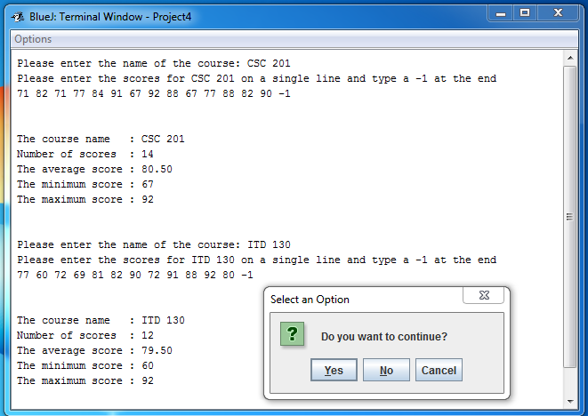

Analysis:

**(Describe the purpose, processing, input and output in your own words.)**

The purpose of the project is to calculate average, minimum and maximum scores for a class.

**Design:**

**(Describe the major steps for solving the problem.)**

The program was initially designed in project 3 and enhanced in project 4. The design of the program implements the following steps:

1. declare global variables to be used in the program,
2. define main method
3. define method to get user input and subsequently check for input validation
4. calculate statistics on the valid entries.
5. Report output to the console
6. ask user whether to continue or exit program

**Testing: (Describe how you test this program)**

logic for the program was already developed in project 3, although the logic is enhanced to use arrays to process user entry and data validation in project 4. Debugging was a continues process during the program development.

Example output from the program showing how the program disregard invalid entries and uses only valid entries to calculate statistics.

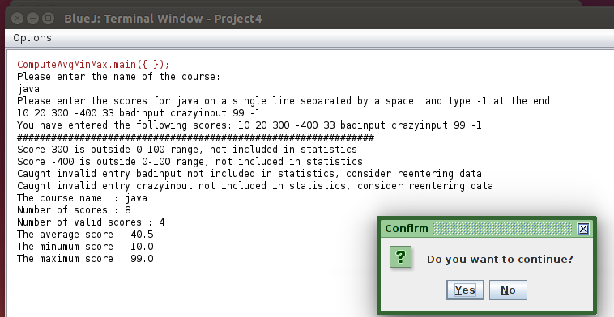

Sample outputs

ComputeAvgMinMax.main({ });

Please enter the name of the course:

java

Please enter the scores for java on a single line separated by a space and type -1 at the end

12 22 9 -1

You have entered the following scores: 12 22 9 -1

###############################################################

The course name : java

Number of scores : 3

Number of valid scores : 3

The average score : 14.33

The minimum score : 9.0

The maximum score : 22.0

######################################################################

Yes button clicked, please continue entering score for the next course

Please enter the name of the course:

java error

Please enter the scores for java error on a single line separated by a space and type -1 at the end

trashinput 100 7000 60 99 10 -1

You have entered the following scores: trashinput 100 7000 60 99 10 -1

###############################################################

Caught invalid entry trashinput not included in statistics, consider reentering data

Score 7000 is outside 0-100 range, not included in statistics

The course name : java error

Number of scores : 6

Number of valid scores : 4

The average score : 67.25

The minimum score : 10.0

The maximum score : 100.0

Good Bye

The jar file has also been tested using terminal window in Ubuntu.

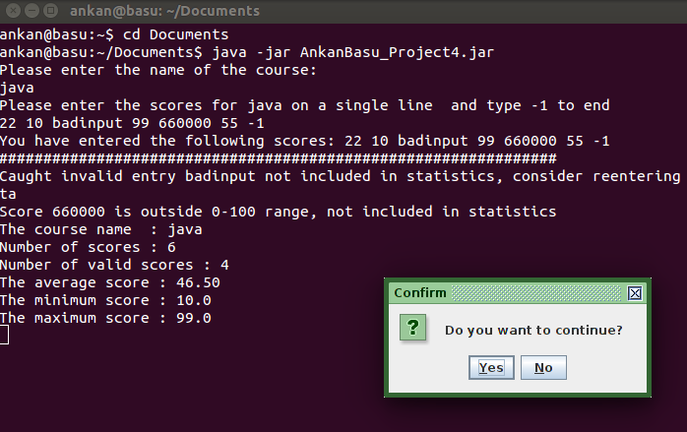

How to submit your assignment

1. Login Blackboard
2. Click on Assignments on the left
3. Click on Week 6 Work folder
4. Read the instruction there and submit the following items:

* Your jar file with source code. **The jar file without the source code will not be graded.** Please use the steps given on Project 1 Instructions to create your jar file. Rename your jar file as YourName_Project4. Suppose your name is Susan Boyd, you should rename your jar file as SusanBoyd_Project4. **Files with wrong name will not be graded.**
* This document with answers for analysis, design and testing. Rename this document as Project4_Yourname. Suppose your name is Susan Boyd, you should rename this document as Project4_SusanBoyd. **Files with wrong name will not be graded.**

This document is worth 10 points and the comments in your program is worth 10 points. Working code is worth 30 points.