Student Name: __________________

**Project: Compute Average, Minimum, Maximum, Median Scores and Standard Deviation using Arrays**

CSC 201 – Computer Science I

New River Community College

Problem Description:

Your English professor now thinks that you are the smartest person on the earth. She is very much pleased with the program that calculates average, minimum and maximum scores. To further analyze her test scores she would like to calculate the standard deviation of the scores and median score. Write a program that calculates

1. The number of Scores
2. Average Score
3. Maximum Score
4. Minimum Score
5. The standard deviation of the scores
6. Median score

* She would like to enter the scores on a single line (89 74 68 88 74 91 67 54 71 66) rather than one score per line. She likes the average, median and the standard deviation have only two decimal digits. She informs you that the largest class she teaches has 40 students.

Write a program using arrays so that it would ask the user to enter

1. The name of the course and the scores on a single line for that course. Tell the user to add a -1 at the end of the line. Use the -1 as the sentinel value in your program.
2. Your program should then display
   1. Number of scores for that course.
   2. The average score (rounded to two decimal digits) for that course.
   3. The minimum score for that course.
   4. The maximum score for that course
   5. The standard deviation (rounded to two decimal digits) for that course. Please see the information on standard deviation at the end of this file.
   6. The scores sorted in the increasing order.
   7. The median score (rounded to two decimal digits) for that course. Please see the information on median at the end of this file.
3. After displaying the output, your program should ask the user whether she/he would like to continue (Use a confirmation dialog box to accomplish this task). If the user likes to continue, repeat steps 1, 2, and 3. If the user does not want to continue terminate the program.
4. Since you know to write method, you should have the following methods in your program:
   1. public static int loadArray( int[] array) to load the scores into an array and return the size of the array. Size is the number of elements that the array contains.
   2. public static double findAverage(int[] array, int length) to find the average score and return it
   3. public static int findMinimum(int[] array, int length) to find the minimum score and return it

cspublic static int findMaximum(int[] array, int length) to find the maximum score and return it

* 1. public static double findSTD(int[] array, int length, double mean) to find the standard deviation and return it
  2. public static void printArray(int[] array, int length) to print the array
  3. public static double findMedian(int[] array, int length) to find the median score and return it.

**Sample Run:**

**Please enter the name of the course: CSC 201**

**P****lease type your scores (integer numbers) separated by spaces and -1 to indicate the end of numbers**

**66 88 99 77 -1**

**The number of scores in CSC 201 is: 4**

**The average score for CSC 201 is 82.50**

**The minimum score for CSC 201 is 66**

**The maximum score for CSC 201 is 99**

**The standard deviation for CSC 201 is 14.20**

**The sorted scores array for CSC 201 is:**

**66**

**77**

**88**

**99**

**The median score for CSC 201 is 82.50**



**Please enter the name of the course: ITD 130**

**Please type your scores (integer numbers) separated by spaces and -1 to indicate the end of numbers**

**60 65 70 80 90 -1**

**The number of scores in ITD 130 is: 5**

**The average score for ITD 130 is 73.00**

**The minimum score for ITD 130 is 60**

**The maximum score for ITD 130 is 90**

**The standard deviation for ITD 130 is 12.04**

**The sorted scores array for ITD 130 is:**

**60**

**65**

**70**

**80**

**90**

**The median score for ITD 130 is 70.00**

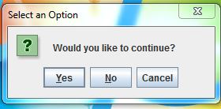

Analysis:

(Describe the purpose, processing, input and output in your own words.)

Project 4 originally had most of the basic algorithm for this project, however, all of the codes are built from scratch to suit arrays.

The hardest part was to think of an way to implement error handling while populating scores array.

In short, Scanner class is used to populate an array and then various methods are written to loop over the arrays for statistical calculations.

Some of the outputs are formatted to have only two digits after the decimal spot.

Design:

(Describe the major steps for solving the problem.)

Design approach was fairly straightforward and defined by the methods. Once the array is populated with scores, apply various methods to the array object to return desired value.

I have use arraycopy to create a subsidiary array to sort the scores. This kept my code simple while calculating median. The main array could also be used here.

Testing: (Describe how you test this program)

Debugging and testing were continues process in the program development. All of the code outputs were also verified using excel program and the given example problem.

Example:

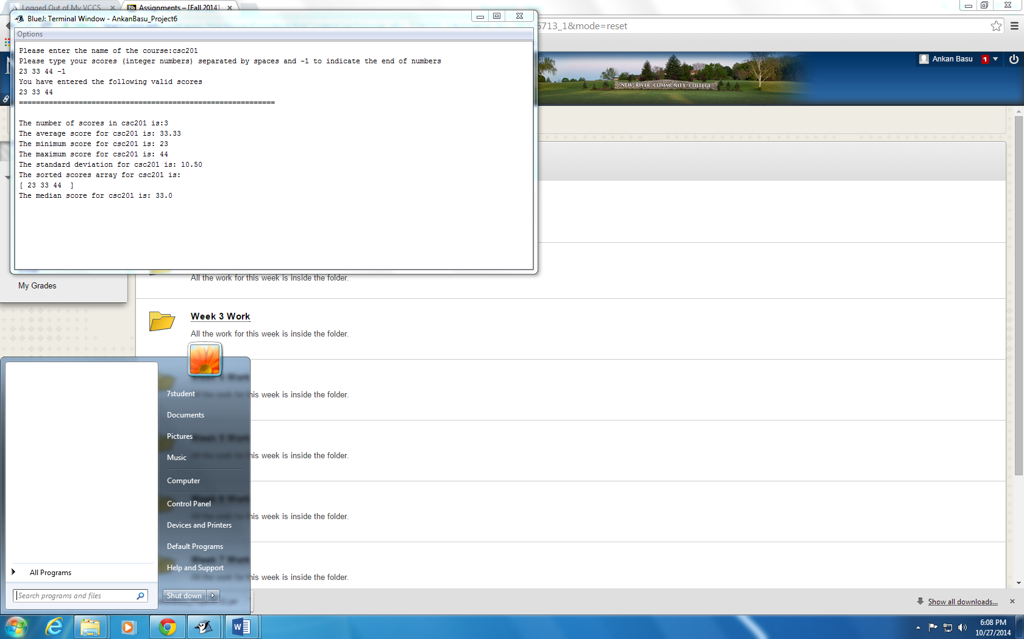

How to submit your assignment

1. Login Blackboard
2. Click on Assignments on the left
3. Click on Week 9 Work folder
4. Read the instruction there and submit the following items:

* Your jar file with source code. **The jar file without the source code will not be graded.** **The jar file should contain the source code for this project only. Remove all other java file you may have.** Please use the steps given on Project 1 Instructions to create your jar file. Rename your jar file as YourName_Project6. Suppose your name is Susan Boyd, you should rename your jar file as SusanBoyd_Project6. **Files with wrong name will not be graded.**
* This document with answers for analysis, design and testing. Rename this document as Project6_Yourname. Suppose your name is Susan Boyd, you should rename this document as Project6_SusanBoyd. **Files with wrong name will not be graded.**

This document is worth 10 points and the comments in your program is worth 10 points. Working code is worth 30 points.

Standard Deviation formula:

The standard deviation of a sample is calculated using the formula:

S = sqrt (sum (x – a)2/(n-1))

where **x** represents each value in the sample, **a** is the mean value of the sample, and **n** is the number of values in the sample.

Median formula:

Organize the data in the increasing order. Pick up the middle value if you have odd number of data. If you have even number of data, you will have two middle data. Find their average.

Example:

67 74 76 88 91 – median is 76 (the middle data)

50 55 60 65 70 75 -- now you have two data ( 60 and 65) in the middle. So the median is 62.5 which is the average of the middle data 60 and 65.