Student Name: Ankan Basu__________________

Class and Section CSC201 M6__________________

Total Points (50 points) __________________

**Project: Count vowels, consonants and other characters**

CSC 201 – Computer Science I

New River Community College

Problem Description:

Write a java program that counts the number of each vowels (a, e, i, o and u), consonants and other characters on a given sentence and displays

1. The number of a’s
2. The number of e’s
3. The number of i’s
4. The number of o’s
5. The number of u’s
6. The number of consonants
7. The number of other characters
8. The length of the given string

The vowels count is case insensitive. The consonants count is also case insensitive.

Use a confirmation dialog box to ask the user whether they would like to continue. If the user clicks the “Yes” button, your program should ask for another sentence to analyze and displays the outputs. Otherwise your program should terminate.

**Note: use a do … while loop to repeat and while loop to process a sentence.**

**Here is a sample run:**

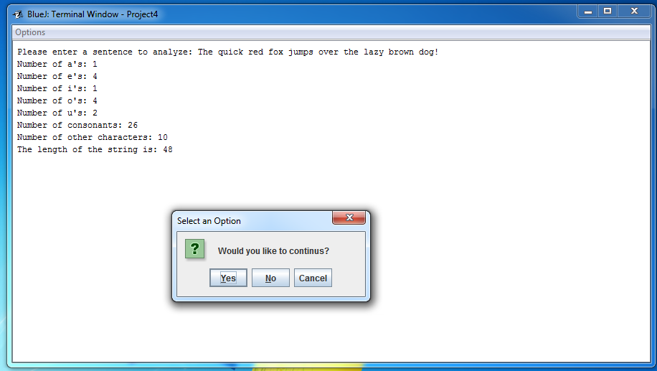

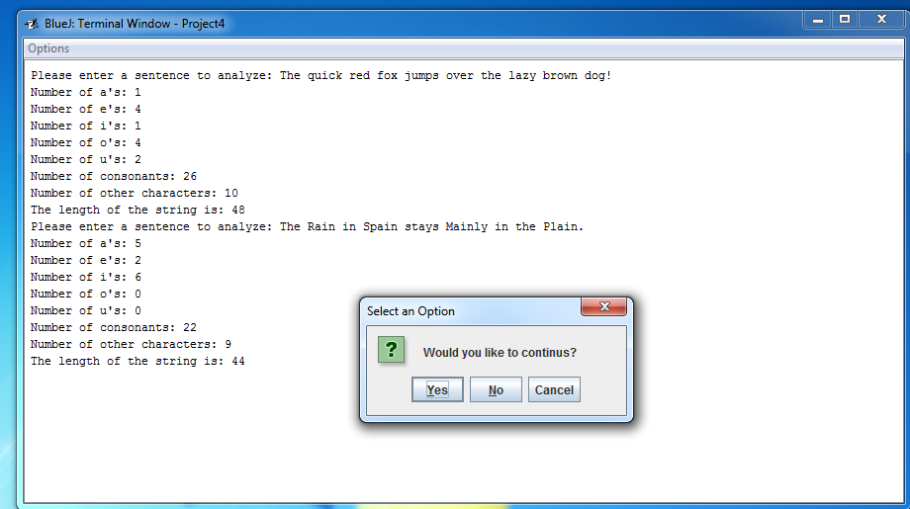

**Analysis:**

(Describe the purpose, processing, input and output in your own words.)

The purpose of the program was to analyze a string input from a user and count the number of vowels, consonants and other characters in the string.

**Design:**

(Describe the major steps for solving the problem.)

Steps

1. Get user input
2. Convert user-input to lowercase using built in method as both upper and lower case letters are treated similar while counting for a vowel or consonant.
3. Store the length of the original input string.
4. Replace all characters that are not among 26 letters (a to z).
5. Store the length the updated string.
6. Build logic for vowel check using char array.
7. Build login to count number of vowels using a loop and integer array
8. print number of occurrences of each vowels to the console
9. Sum all vowels to get total number of vowels.
10. Print number of consonants as (updated string – number of vowels)
11. Print number of other characters as (original string – updated string).
12. Implement dialog-box for user confirmation.

**Testing: (Describe how you test this program).**

The program was tested using various input strings that contained special characters and digits alongside vowels and consonants. The program was also run using input string presented in the project 8 document example outputs.

Several string output format were also edited during the debugging phase.

**Project8_String.main({ });**

PLease enter a sentence to analyze

Oshmo basu

The number of a's=1

The number of e's=0

The number of i's=0

The number of o's=2

The number of u's=1

The number of consonants: 5

Number of other Characters1

The Length of The String is: 10

Good Bye

**Project8_String.main({ });**

PLease enter a sentence to analyze

Oshmo%%^^** 1122 basu

The number of a's=1

The number of e's=0

The number of i's=0

The number of o's=2

The number of u's=1

The number of consonants: 5

Number of other Characters: 13

The Length of The String is: 22

Good Bye

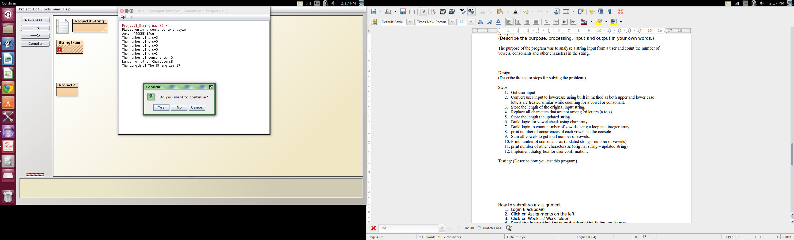

The program was originally developed to use for loop to process statements (submission 1) and used only while loop to repeat sentence processing (submission 1). The program was later updated on 11/17/2014 to meet document guidance on using Do-while loop to repeat and only while loop for sentence processing.

Final program output matches example outputs in the Project 8 documentation.

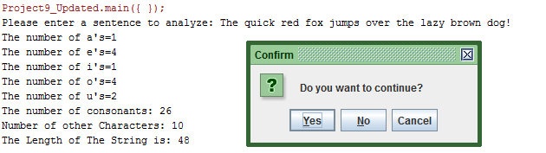

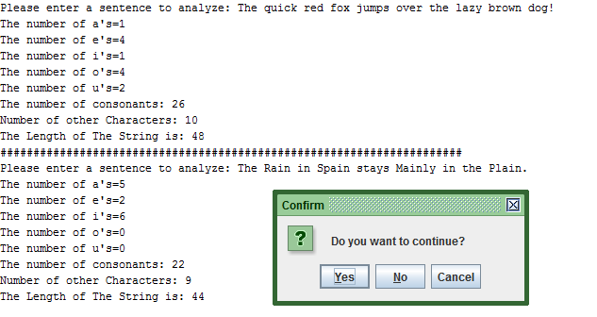

How to submit your assignment

1. Login Blackboard
2. Click on Assignments on the left
3. Click on Week 12 Work folder
4. Read the instruction there and submit the following items:

* Your jar file with source code. **The jar file without the source code will not be graded.** Please use the steps given on Project 1 Instructions to create your jar file. Rename your jar file as **YourName_Project4**. Suppose your name is Susan Boyd, you should rename your jar file as SusanBoyd_Project4. **Files with wrong name will not be graded.**
* This document with answers for analysis, design and testing. Rename this document as **Project4_Yourname**. Suppose your name is Susan Boyd, you should rename this document as Project4_SusanBoyd. **Files with wrong name will not be graded.**
* This document is worth 10 points and the comments in your program is worth 10 points. Working code is worth 30 points.