|  |  |  |  |  |  |  |
| --- | --- | --- | --- | --- | --- | --- |
| Test Scenario | Test Scenario Description | Test Values | Expected Outcome | Actual Outcome | Pass/Fail | Justification  (if needed) |
| 1 | This tests whether a comment post can be posted with blank comment content | Existing Blog Post object.  Comment Name: Li Yun | Comment can’t be posted, with prompt | Comment can’t be posted, with prompt | Pass | A comment cannot exist with only a single field completed. It needs both fields to be completed |
| 2 | This test whether a comment post can be posted with a blank name | Existing Blog Post object.  Comment content: This is great! | Comment can’t be posted, with prompt | Comment can’t be posted, with prompt | Pass | A comment cannot exist with only a single field completed. It needs both fields to be completed |
| 3 | This test whether the blog will show the selected category accordingly based on user’s selection | Existing Blog Post object.  User Selection: CCA | Posts that are tagged to CCA will only show | Posts that are tagged to CCA will only show | Pass |  |
| 4 | This test whether a comment post can be posted with only punctuations as a name | Existing Blog Post object.  Comment name:!?!  Comment content: This is great! | Comment can’t be posted, with prompt for the user to input a proper name | Comment posted as normal with no errors | Fail | This is because there is no validation done for the Name field |
| 5 | This test whether a comment post can be edited after it has been posted | Existing Blog Post object and comment object. | Comment can’t be edited as there is no such option to do so | Comment can’t be edited as there is no such option to do so | Pass |  |
| 6 | This test whether the text fields for input of comment will get cleared away once a comment has been posted | Existing Blog Post object.  Comment name: Li Yun  Comment content: This is great! | Fields will be automatically cleared after a comment has been posted | Fields did not get cleared away after the comment has been posted | Fail | Personally I think this is important to test as a user might want to put up a different comment |

Test Results:

Firstly, I would like to apologise for the fact that I am unable to come up with the pytest for selenium codes in time. These screenshots were done using manual testing and I understand that it’s out of the main requirement.

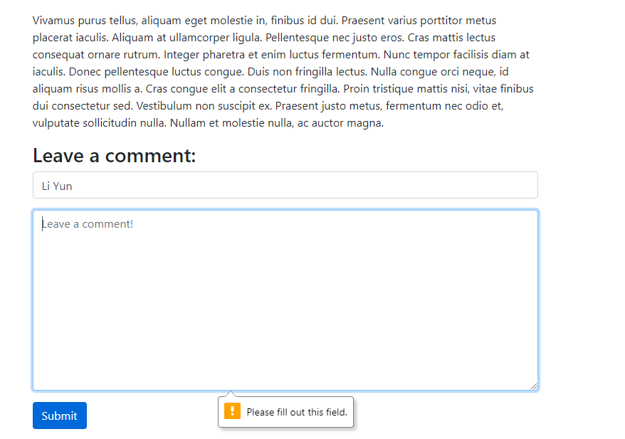

Test Scenario 1

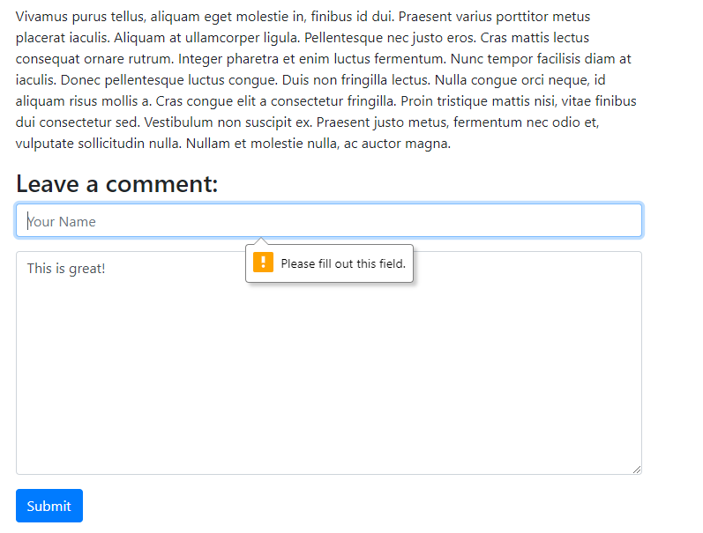

Test Scenario 2

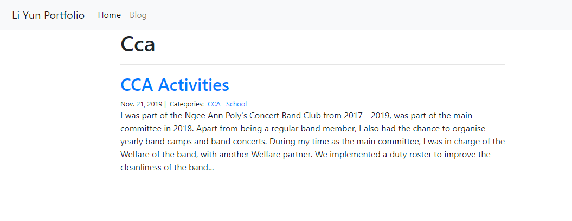

Test Scenario 3

Test Scenario 4 and 5

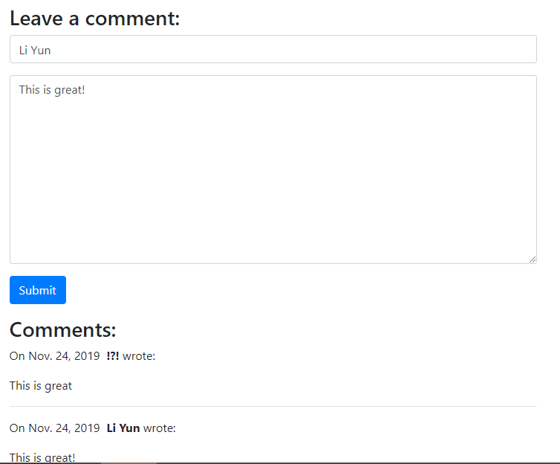

Test Scenario 6