Change Salesforce Labels By RecordType

**-By Vinayendra**

**Setup**

Install the Package: <https://login.salesforce.com/packaging/installPackage.apexp?p0=04tU0000000LeBV>

**Components**

* Cloud Spokes **[**Home Page Component]

Contains required connection file and a javascript file in Static resource called “Rec”

* Rec [Static Resource]

Contains Jquery to replace label and Javascript call to Apex Class RecordTypeLabel calling the method convertString.

* RecordTypeLabel [Apex Class]

Contains Apex code contains method called convertString which has the logic for doing the operation

* Label By RecordType [Custom Setting]

Contains following fields

* + New Label
  + Object API Name
  + Old Label
  + Record Type Id
* RecordTypeLabelTest [Apex Class]

Contains Test methods for RecordTypeLabel class

**Settings**

1. Add the homepage component called “CloudSpokes” to the home page layout of users in the narrow area.
2. Go to setup>Customize>User Interface

Check the following check box

“Show Custom Sidebar Components on All Pages”

1. Go to setup>Develop>Apex Classes>[RecordTypeLabel](https://na12.salesforce.com/01pU0000000DfLt)>Security

Add all the profiles for whom the home page layout is assigned.

1. Go to setup>Develop>Custom Settings>Label By RecordType>Manage>New

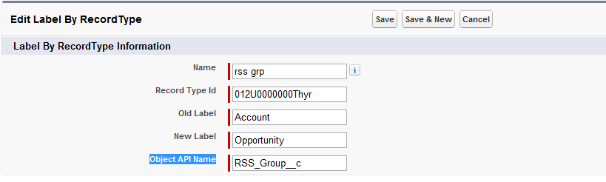

1. Enter the information
   * Name: Any Dummy Unique Name
   * Record Type Id: The 15 digit record type id ( Copy paste by going to [Object]>Record Type>[Record Type Name]>get id from the URL)
   * Old Label: The label of the field whose label needs to be changed
   * New Label: The New label of the field
   * Object API Name: The API Name of the Object.

**Features**

1. You can add multiple objects, multiple record type and multiple fields just be creating new custom settings for each request.
2. Works on Edit Page/Create Page and View Page.
3. The functionality works even though a label is a sub string of another label.
4. Test case coverage:87%

**Improvements**

1. The functionality does not work for the following cases
   * When 2 fields have the same label
   * If the profile has selected only one record type (Only on the create page the label change does not happen)
2. A Jquery code can be written to hide the blank area in the sidebar which is used to do this functionality.

Screencast Video: http://screencast.com/t/DogwAYTq0