# Package Installation

1. Click on Un-managed Package URL in the submission
2. Enter target org credentials and login
3. Click continue on the Package Installation Details



1. In Step 1. Approve Package API Access. Click Next.

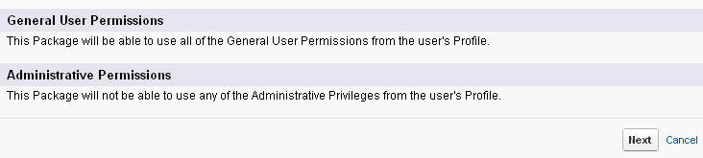

1. In Step 2. Choose security level. Grant access permissions and Click Next.

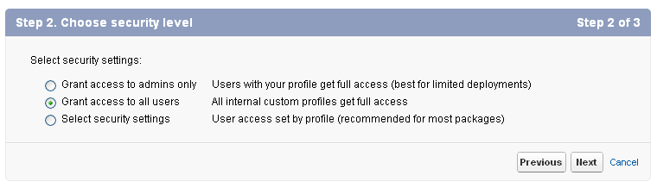

1. In Step 3. Install Package. Click Install.

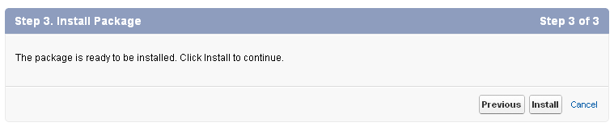

1. After Installation is done. Click on View Component and View Dependencies



1. Add **Asana_ID__c** and **Asana_API_Key__c** field in User Layout
2. Fill **Asana_ID__c** and **Asana_API_Key__c** field of Users
3. Start using by clicking on **‘Asana Toolkit’** app