## Challenge Name : Google Support Bot

Challenge Details: <http://www.cloudspokes.com/challenge_detail.html?contestID=193>

Solution Submitter Name: Romin Irani

Solution Submitter ID: romin

Solution Submitted Profile URL : <http://www.cloudspokes.com/profile.html?username=romin>

Solution File Attached (Full Source Code as Eclipse Project): **MyHelpDeskSupport.zip.**

Solution Details

There is a detailed web site that I have created **as part of this submission**. It is a companion site to help you setup the Support for your organization and start using it quickly.

**Web Site:** [**http://myhelpdesksupport.appspot.com**](http://myhelpdesksupport.appspot.com)

It contains a detailed user guide to using the Bot with screenshots. Please go through that for understanding how to use the Bot. The URL is:

<http://myhelpdesksupport.appspot.com/userguide.jsp>

I am including the complete user guide over here also.

If you have any questions about the submission, please contact me at [romin.k.irani@gmail.com](mailto:romin.k.irani@gmail.com)

Thank You Very Much.

Romin Irani

## High Level Features Implemented

## Setup of Organization, Users and Agents.

## One Administrator defined per Organization who can manage Users/Agents and view Agent Report/Performance.

## All data is segregated by Organization. Solution is multi-tenant capable.

## Google Accounts are used to login to the System.

## Commands like /help, /about, /support , /answer , /thankyou , /rate, /askme, /status, /reply and an additional Admin command called /resetorg

## Users/Agents have to be registered , otherwise simply by adding a bot to their friend list, the commands will not be accepted. The users/agents are registered by the Administrator and the User Guide shows how.

## Features that could not be implemented in time:

## Set the Rating automatically to 5 if no response for 3 minutes. The basic workflow is working, so this should take much time to do.

## Knowledge Base + search

## Automatically seeing if answer is given, etc.

## User Guide

This user guide demonstrates how you can setup your organization to start using Google Support Bot quickly.

To test out the Google Support Bot for your organization, you need to have the following information:

1. The Organization for which you want to setup the Support System
2. An Admin user for the Organization, who will signup the Organization and setup the users
3. The email ids of the Users in your Organization who can ask questions
4. The email ids of the Agents in your Organization who will answer the questions.

Let us go through a sample, where I am going to do the following: (**You can replace it with your accounts when you try out the system)**

* Our **organization** is going to be called Mindstorm
* The **admin** account that I am going to use is my own : [romin.k.irani@gmail.com](mailto:romin.k.irani@gmail.com)
* There is one **user** in Mindstorm organization : [mindstormuser001@gmail.com](mailto:mindstormuser001@gmail.com)
* There is one **agent** in Mindstorm organization : [mindstormagent001@gmail.com](mailto:mindstormagent001@gmail.com)

**Note that the Administrator cannot act as a User or an Agent in the System. So please make sure that you have 3 accounts to test this out with.**

Give this scenario, let’s go:

**Step 1 : Sign and Create Users/Agents**

Visit <http://myhelpdesksupport.appspot.com>. You will see the screen shown below:

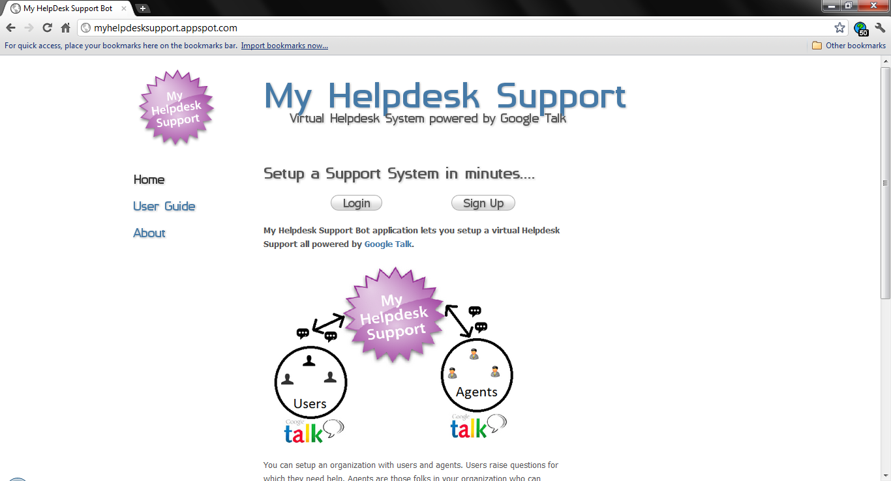

In this case, myself ([romin.k.irani@gmail.com](mailto:romin.k.irani@gmail.com)) is going to be the Administrator in the Mindstorm Organization and I need to first sign up the organization. Since we are not yet signed up, we will click on the **SIGNUP** button.

This will bring up the standard **Google Accounts** verification screen, where I will present my credentials as shown below:

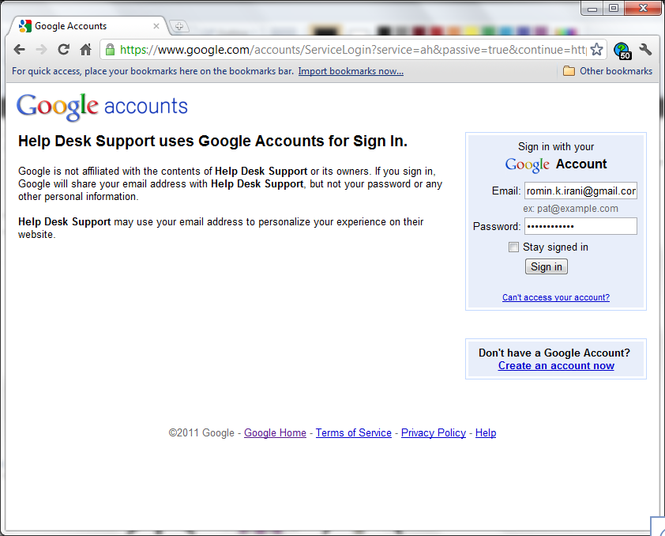

On Signing in, I will be presented with the following screen where I can enter the details of the organization that I want to setup:

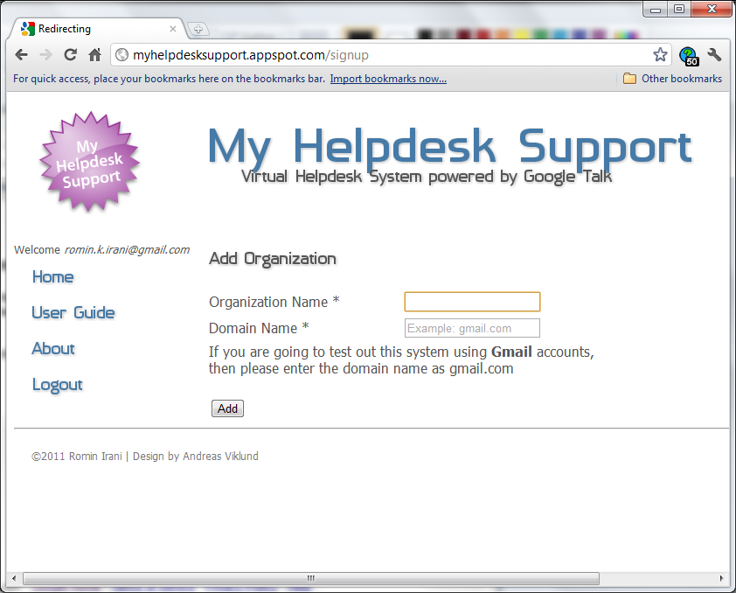

Enter the name of the organization and the Domain name. **Currently the Domain Name field is not used for verification but it could be in the future.** Fill out the fields as shown below and click on the **Add** button.

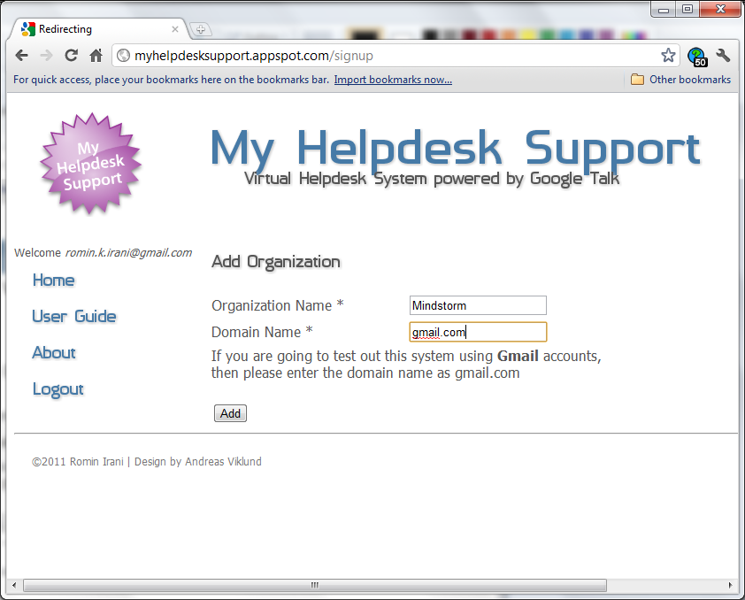

On successful addition, the organization and Administrator account are not setup. And you will see the following screen:

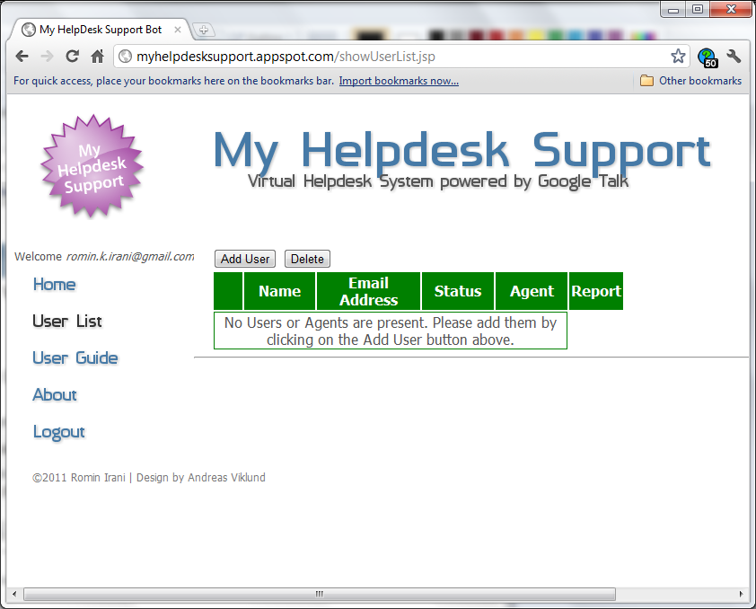

Currently there are no users or Agents defined in the organization. You can now define the Users and Agents. Click on the **Add User** button to add an user. You will see the screen shown below:

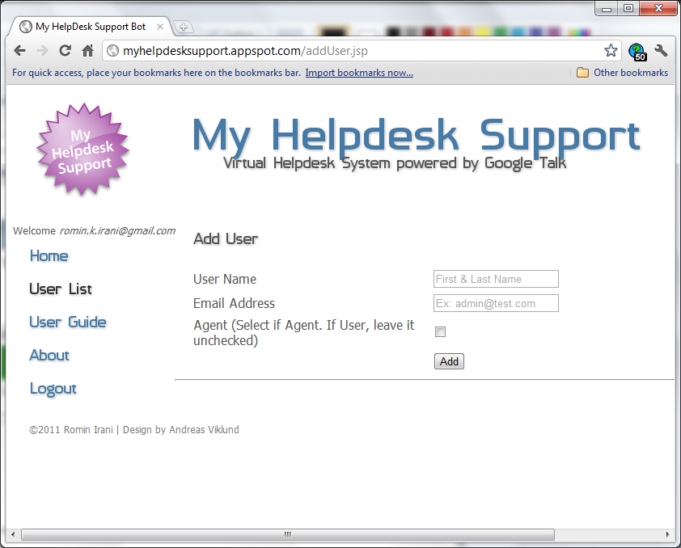

Enter the name and the **Email Address (IMPORTANT since this is what will be used in the GTalk interface too)**. If the User is an Agent, **Check the Agent box**, else leave it empty.

First, I add a user : [**mindstormuser001@gmail.com**](mailto:mindstormuser001@gmail.com). On successful addition, it shows me the screen shown below:

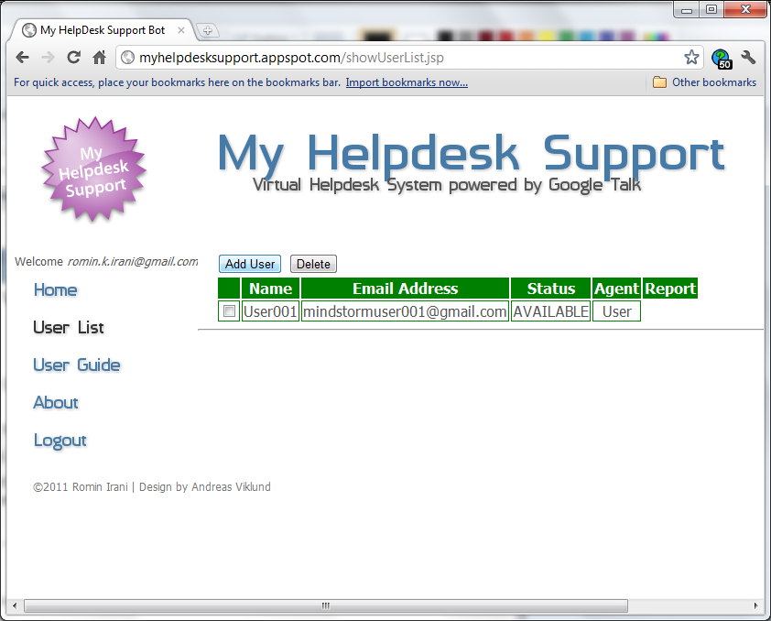

Next, I add an agent : [**mindstormagent001@gmail.com**](mailto:mindstormagent001@gmail.com)and note that I select the Agent checkbox since this is an Agent who will receive support questions and answer them.

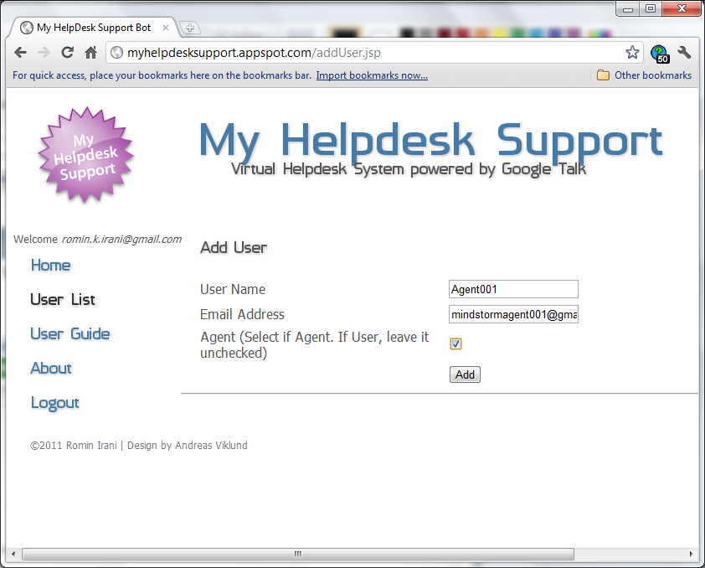

Click on **Add** to add the Agent and then you will see two users now defined in the **Mindstorm** Organization with one user and one agent as shown below:

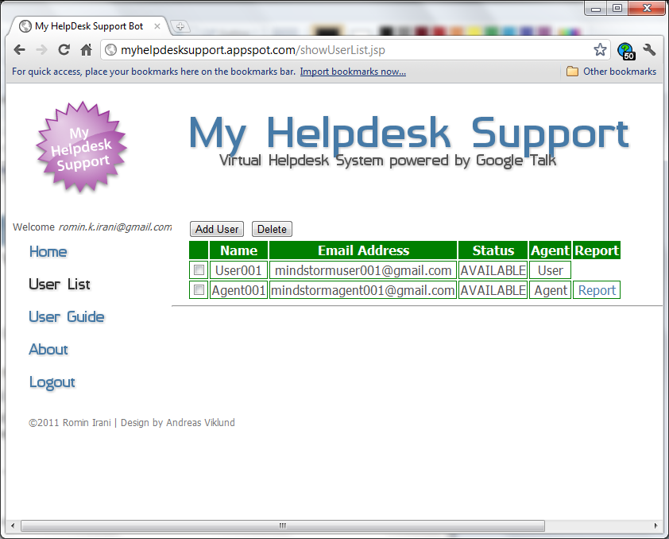

**Step 2: Users and Agents add the Support Bot as their friend**

The next step is for all the users and agents to add the Support Bot as their friend. This is required so that they can start communicating with the Bot. The account that you need to add is [**myhelpdesksupport@appspot.com**](mailto:myhelpdesksupport@appspot.com)**.**

To add the Bot, follow these steps. They have to be done by each user in the System i.e. User and Agent. So in the running example, both user ([mindstormuser001@gmail.com](mailto:mindstormuser001@gmail.com)) and agent ([mindstormagent001@gmail.com](mailto:mindstormagent001@gmail.com))

Launch GTalk application and click on the **“Add”** button shown below:

http://myreminderbot.appspot.com/images/s1.png

Add [**myhelpdesksupport@appspot.com**](mailto:myhelpdesksupport@appspot.com)as a contact as shown below and complete the steps.

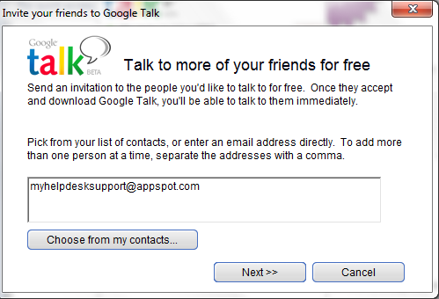

This will add the Bot to your list of friends as shown below:

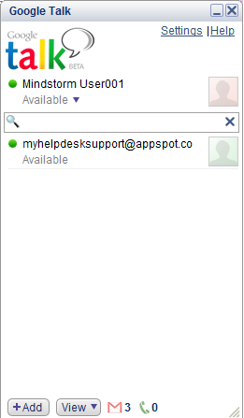

Make sure that if you are the Agent or the User, you do complete this step.

Let us now move to how the User will use the Support Bot to ask Questions.

**Step 3: User workflow – Ask Questions**

If you are the user open up a Chat window as shown below and type **/help**.

This will display the complete set of commands that the Bot understands. And dependending on whether you are the Agent or the User (one who can ask a question), certain commands apply to you and the rest are not permitted.

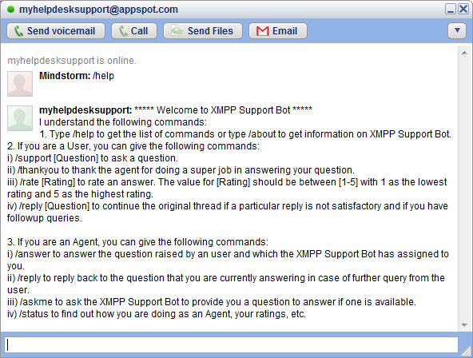

Let us start with USER : [mindstormuser001@gmail.com](mailto:mindstormuser001@gmail.com) . To ask a question, you need to use the **/support [Question]** command.

Shown below in the typing area, is the [mindstormuser001@gmail.com](mailto:mindstormuser001@gmail.com) asking a question about OAuth.

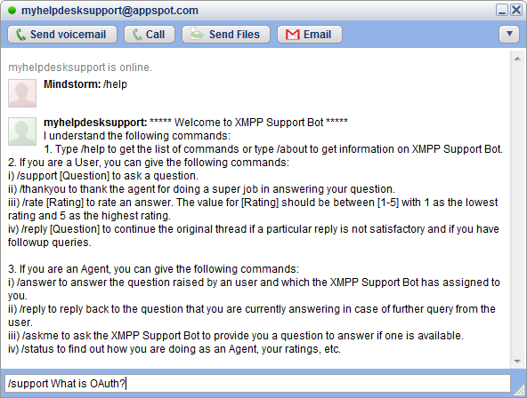

Click Enter to submit the question. The question will be accepted in the Support System and you will receive a message saying that your question has been accepted. Shown below is the result of posting the question.

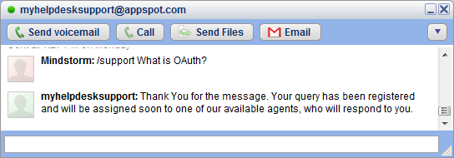

**Thats all for the User.** Now the user will have to wait till the System assigns a question to the Support Agent. Once an answer is received, the user can thank and rate the answer and we shall look at that in **Step 5**. But for now, let us look at the **Agent workflow** in the next section and see how the Agent will answer the Question.

**Step 4: Agent workflow – Reply to Questions**

One of the key features in this system is that the Agent will have to be AVAILABLE in order to receive a question. The System does this by tracking the XMPP Presence command to record if the Agent is available. This happens automatically when the User/Agent uses GTalk and does a successful signon.

Assuming that the Agent is signed in GTalk, the Support application will assign the question if the Agent is available. In our case, the support question got routed by the system to the Agent ([**mindstormagent001@gmail.com**](mailto:mindstormagent001@gmail.com)**)** as shown below:

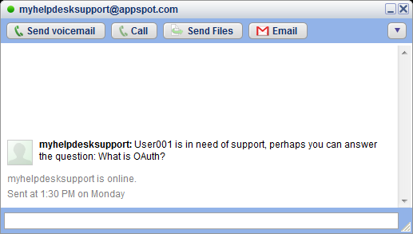

Now, all the Agent needs to do is answer the question. This is done via the

**/answer [answer text]** command.

The Agent answers the question as shown below:

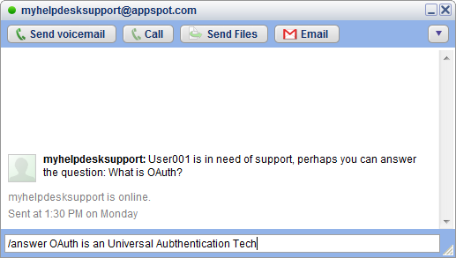

And then clicks Enter. This will send the response to the System which will acknowledge receipt of the answer as shown below:

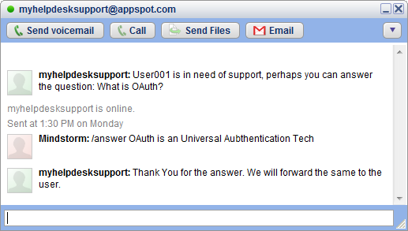

That completes the workflow for the Agent to answer the Question.

**Step 5: User workflow – Thank and Rate the Agent**

Now, the Support application will route the answer back to the User who asked the question. As a result, the answer will be received in the Chat window of [**mindstormuser001@gmail.com**](mailto:mindstormuser001@gmail.com)as shown below:

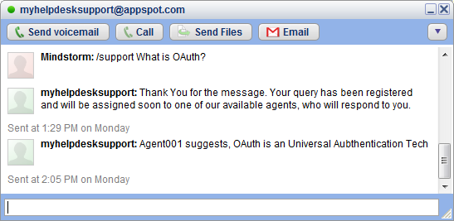

The user can then chose to thank the Agent for the answer by giving the **/thankyou** command as shown below:

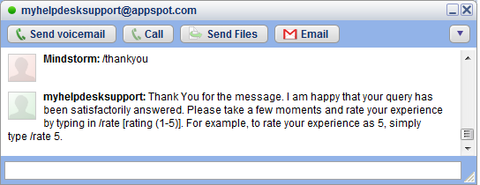

This will prompt the Bot to ask for a Rating, which the user can give back by via the **/rate [rating]** command as shown below:

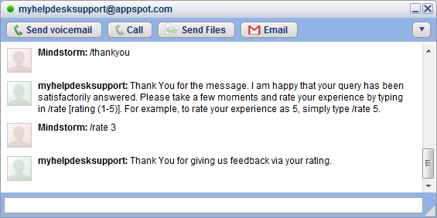

This completes the entire workflow where:

1. The user asked a question
2. The question got routed to an Available Agent
3. The Agent responded with an answer
4. The Answer got routed back to the User
5. Finally, the User gave his/her rating and compliments.

**Step 6: Admin can view Agent reports**

The Administrator of the Organization can view the questions/answers that have been asked. Follow these steps:

1. Login via <http://myhelpdesksupport.appspot.com>
2. Click on User List
3. For every User, who is an Agent, you will see a Report link.
4. Simply click on the Report link and you will see the questions that were routed to this Agent and their answer.

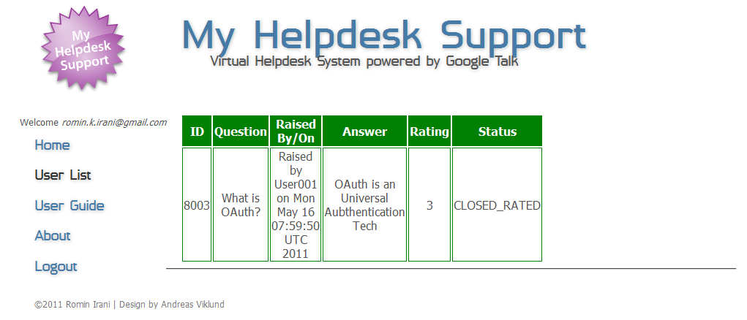

**Step 7: Other commands**

We covered the basic use case so far in this document. However, there is much more:

* **Reply mechanism**

The User might not be satisfied with the answer given by the Agent and might want to ask some additional questions. To do that simply use the **/reply [Message]** command in the Support Bot. This will add a Reply and directly send it to the Agent. The Agent too can then reply to it via the same command. This conversation can keep continuing.

* **Additional Agent commands**

The Agent can also check out how he/she is doing with questions asked/answered and rating. To do that, simply fire the **/status** command to get the current performance as shown below:

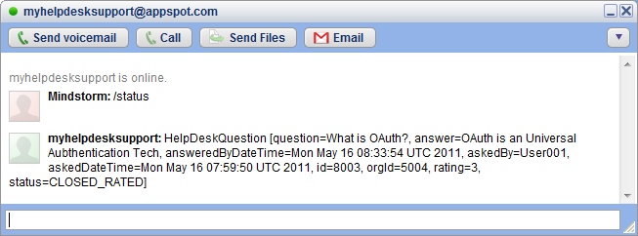

If the Agent is available, they can demand a question to be allocated to them instead of waiting for a system to assign them one. This can be done via the **/askme** command.

* Admin functionality

The Administrator of the Organization can perform one command with the Support Bot. To do that, you will first need to sign on to GTalk with your Administrator credentials and then add [myhelpdesksupport@appspot.com](mailto:myhelpdesksupport@appspot.com) as your friend.

The command **/resetorg** is given only so that you can clear off your user and organization completely from the system and start afresh. This is specially provided, so that you can test out the system and start over again in case of a configuration problem.

If you use the **/resetorg** command, you will need to sign up again.