Azure DevOps Labs

1. Navigate to PartsUnlimited project: <https://dev.azure.com/AliorDevOpsGen/PartsUnlimited>
2. Create a git repo for your user, for instance: alior-devops-s01
3. Copy files from Azure Quickstart Templates [201-customscript-extension-public-storage-on-ubuntu](https://github.com/Azure/azure-quickstart-templates/tree/master/201-customscript-extension-public-storage-on-ubuntu) to your repo.

You can clone the repo and push from your local pc, or upload files directly from the portal.

To Authenticate on Windows use: [Git Credential Manager](https://docs.microsoft.com/en-us/azure/devops/repos/git/set-up-credential-managers?view=azure-devops)

To Authenticate on Linux you can try [Git Credential Manager](https://docs.microsoft.com/en-us/azure/devops/repos/git/set-up-credential-managers?view=azure-devops) but it is advised to use ssh: [Use SSH key authentication](https://docs.microsoft.com/en-us/azure/devops/repos/git/use-ssh-keys-to-authenticate?view=azure-devops)

1. On PartsUnlimited Team Sprint board [Sprint board](https://dev.azure.com/AliorDevOpsGen/PartsUnlimited/_sprints/taskboard/PartsUnlimited%20Team/PartsUnlimited/Sprint%202) add new product backlog item “lab alior-devops-s01-build”, add few tasks to reflect the work that is described in below steps. Assing yourself to those work items.
2. Based on PartsUnlimitedE2E pipeline create a new pipeline for instance alior-devops-s01-build that will copy files from your repo and publish build artifacts

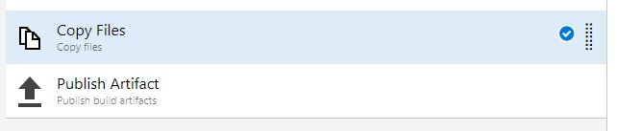

1. Based on PartsUnlimitedE2E release pipeline create a new release pipeline for instance alior-devops-s01-release that will have two stages (lab and prd) and deploy your template to lab and prd resource groups using “Azure resource group deployment” task.

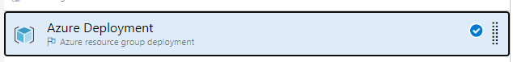

1. Setup continuous integration for your Build
2. Setup continuous deployment for your Release
3. Modify template and push your changes – verify that build and release was triggered automatically.
4. In Release remove build artifact source, and add new source directly from your Azure Repo
5. Modify release accordingly, and make sure the deployment works fine.
6. Use [Wiki](https://dev.azure.com/AliorDevOpsGen/PartsUnlimited/_wiki/wikis/PartsUnlimited_wiki/1/PartsUnlimitedWiki) to write a short documentation of your solution – don’t forget to add some screenshots.
7. Create new [dashboard](https://dev.azure.com/AliorDevOpsGen/PartsUnlimited/_dashboards/dashboard/7b5526ce-2856-4e7b-b255-db0fa092226d), and add two widgets presenting the status of your build and release pipeline.
8. Uppload any file as a [Secure File](https://dev.azure.com/AliorDevOpsGen/PartsUnlimited/_library?itemType=SecureFiles)