**Create a DSC configuration**

You create a simple [DSC configuration](https://docs.microsoft.com/en-us/powershell/scripting/dsc/configurations/configurations) that ensures either the presence or absence of the **Web-Server** Windows Feature (IIS), depending on how you assign nodes.

1. Start [VSCode](https://code.visualstudio.com/docs) (or any text editor).
2. Type the following text:

configuration TestConfig

{

Node IsWebServer

{

WindowsFeature IIS

{

Ensure = 'Present'

Name = 'Web-Server'

IncludeAllSubFeature = $true

}

}

Node NotWebServer

{

WindowsFeature IIS

{

Ensure = 'Absent'

Name = 'Web-Server'

}

}

}

1. Save the file as **TestConfig.ps1**.

This configuration calls one resource in each node block, the [WindowsFeature resource](https://docs.microsoft.com/en-us/powershell/scripting/dsc/reference/resources/windows/windowsfeatureresource). This resource ensures either the presence or absence of the **Web-Server** feature

## Import a configuration into Azure Automation

Next, you import the configuration into the Automation account.

1. Sign in to the [Azure portal](https://portal.azure.com/).
2. On the left, click **All resources** and then the name of your Automation account.
3. On the Automation account page, select **State configuration (DSC)** under **Configuration Management**.
4. On the State configuration (DSC) page, click the **Configurations** tab, then click **Add**.
5. On the Import Configuration pane, browse to the TestConfig.ps1 file on your computer.

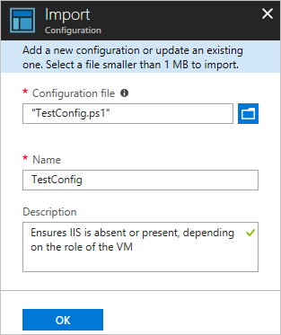

1. Click **OK**.

## View a configuration in Azure Automation

After you have imported a configuration, you can view it in the Azure portal.

1. Sign in to the [Azure portal](https://portal.azure.com/).
2. On the left, click **All resources** and then the name of your Automation account.
3. On the Automation account page, select **State configuration (DSC)** under **Configuration Management**.
4. On the State configuration (DSC) page, click the **Configurations** tab, then click **TestConfig**. This is the name of the configuration you imported in the previous procedure.
5. On the TestConfig Configuration pane, click **View configuration source**.

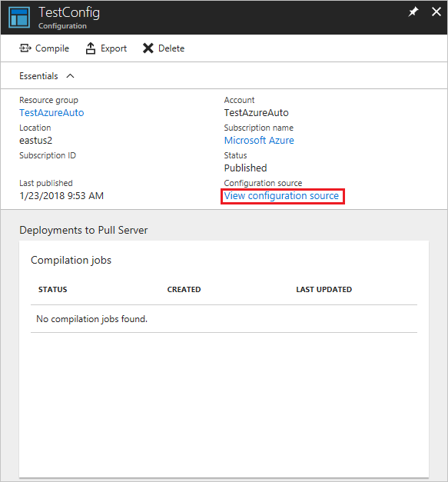

A TestConfig Configuration source pane opens, displaying the PowerShell code for the configuration.

## Compile a configuration in Azure Automation

Before you can apply a desired state to a node, a DSC configuration defining that state must be compiled into one or more node configurations (MOF document), and placed on the Automation DSC Pull Server. For a more detailed description of compiling configurations in State Configuration (DSC), see [Compile configurations in Azure Automation State Configuration](https://docs.microsoft.com/en-gb/azure/automation/automation-dsc-compile). For more information about compiling configurations, see [DSC Configurations](https://docs.microsoft.com/en-us/powershell/scripting/dsc/configurations/configurations).

1. Sign in to the [Azure portal](https://portal.azure.com/).
2. On the left, click **All resources** and then the name of your Automation account.
3. On the Automation account page, click **State configuration (DSC)** under **Configuration Management**.
4. On the State configuration (DSC) page, click the **Configurations** tab, then click **TestConfig**. This is the name of the previously imported configuration.
5. On the TestConfig Configuration pane, click **Compile**, and then click **Yes**. This starts a compilation job.

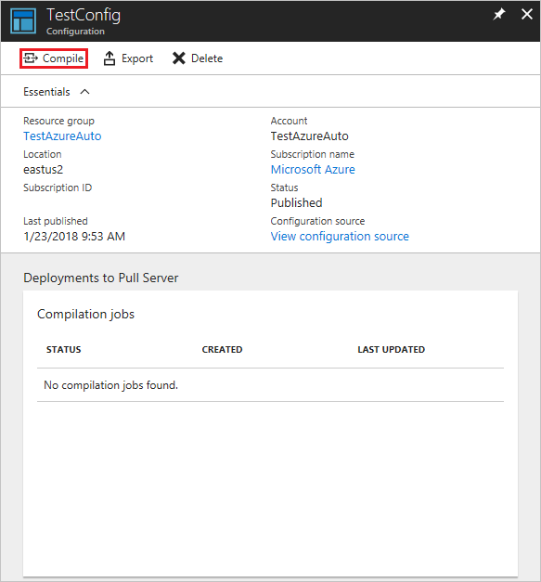

## View a compilation job

After you start a compilation, you can view it in the **Compilation Jobs** tile on the **Configuration** page. The **Compilation Jobs** tile shows currently running, completed, and failed jobs. When you open a compilation job pane, it shows information about that job including any errors or warnings encountered, input parameters used in the configuration, and compilation logs.

1. Sign in to the [Azure portal](https://portal.azure.com/).
2. On the left, click **All resources** and then the name of your Automation account.
3. On the Automation account page, click **State configuration (DSC)** under **Configuration Management**.
4. On the State configuration (DSC) page, click the **Configurations** tab, then click **TestConfig**. This is the name of the previously imported configuration.
5. Under **Compilation jobs**, select the compilation job to view. A Compilation Job pane opens, labeled with the date when the compilation job was started.

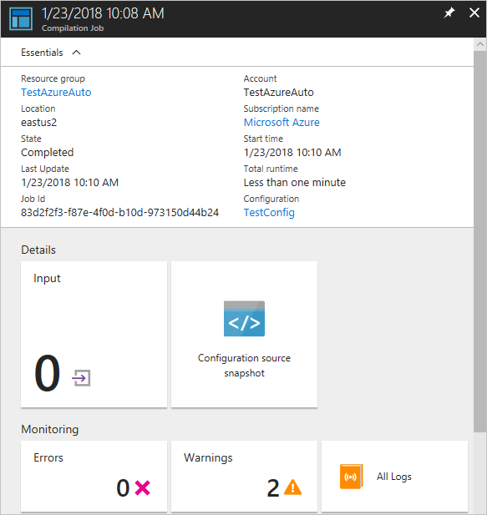

1. Click on any tile in the Compilation Job pane to see further details about the job.

## View node configurations

Successful completion of a compilation job creates one or more new node configurations. A node configuration is a MOF document that is deployed to the pull server and ready to be pulled and applied by one or more nodes. You can view the node configurations in your Automation account on the State configuration (DSC) page. A node configuration has a name with the form ConfigurationName.NodeName.

1. Sign in to the [Azure portal](https://portal.azure.com/).
2. On the left, click **All resources** and then the name of your Automation account.
3. On the Automation account page, click **State configuration (DSC)** under **Configuration Management**.
4. On the State configuration (DSC) page, click the **Compiled configurations** tab.

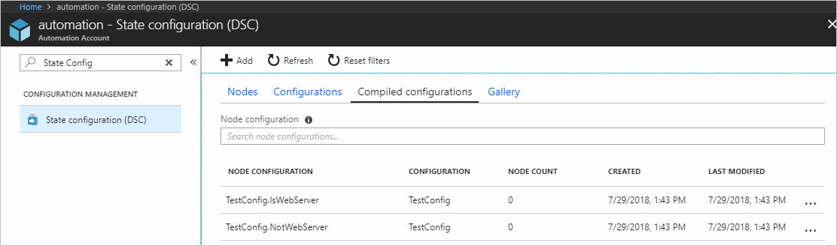

## Enable an Azure Resource Manager VM for management with State Configuration

You can use State Configuration to manage Azure VMs (both classic and Resource Manager), on-premises VMs, Linux machines, AWS VMs, and on-premises physical machines. In this article, you learn how to enable only Azure Resource Manager VMs. For information about enabling other types of machines, see [Enable machines for management by Azure Automation State Configuration](https://docs.microsoft.com/en-gb/azure/automation/automation-dsc-onboarding).

1. Sign in to the [Azure portal](https://portal.azure.com/).
2. On the left, click **All resources** and then the name of your Automation account.
3. On the Automation account page, click **State configuration (DSC)** under **Configuration Management**.
4. On the State configuration (DSC) page, select the **Nodes** tab, then click **+ Add**.

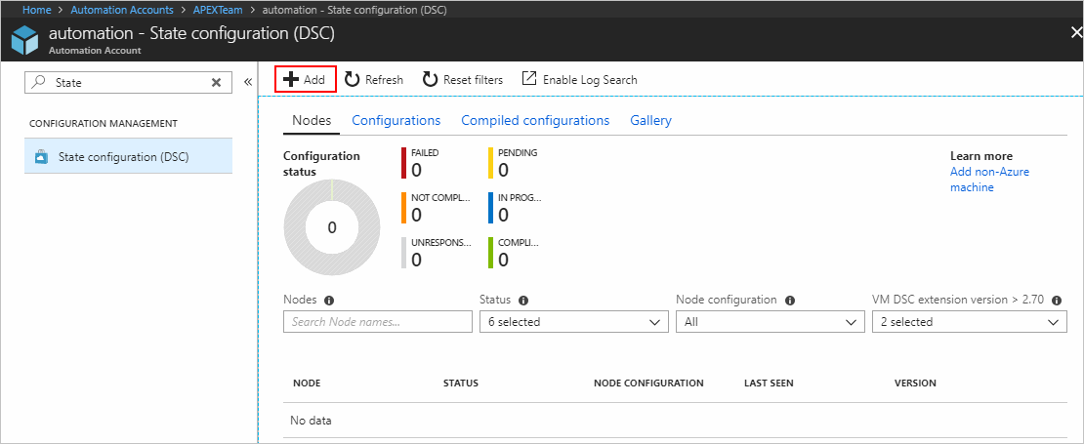

1. On the Virtual Machines pane, select your VM.
2. On the Virtual machine detail pane, click **+ Connect**.
3. On the Registration page, select the name of the node configuration to apply to the VM in the **Node configuration name** field. Providing a name at this point is optional. You can change the assigned node configuration after enabling the node.
4. Check **Reboot Node if Needed**, then click **OK**.

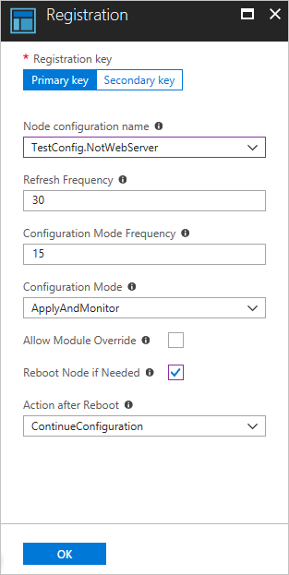

The node configuration you specified is applied to the VM at intervals specified by the value provided for **Configuration Mode Frequency**. The VM checks for updates to the node configuration at intervals specified by the **Refresh Frequency** value. For more information about how these values are used, see [Configuring the Local Configuration Manager](https://docs.microsoft.com/en-us/powershell/scripting/dsc/managing-nodes/metaConfig).

Azure starts the process of enabling the VM. When it is complete, the VM shows up in the **Nodes** tab of the State configuration (DSC) page in the Automation account.