MWS-001 — Login Page
Jira Story · MillworkSuite UX Implementation
──────────────────────────────────────────────────────────────────────────────────────────

Story ID | MWS-001
Epic | MWS — Public & Auth Pages
Type | Story
Priority | P0 — Blocker
Story Points | 5
Labels | frontend, auth, UX
Route | /login

User Story
As a MillworkSuite user, I want to sign in to the platform with my email and password so that I can access my company's estimating workspace securely.

Screen Reference
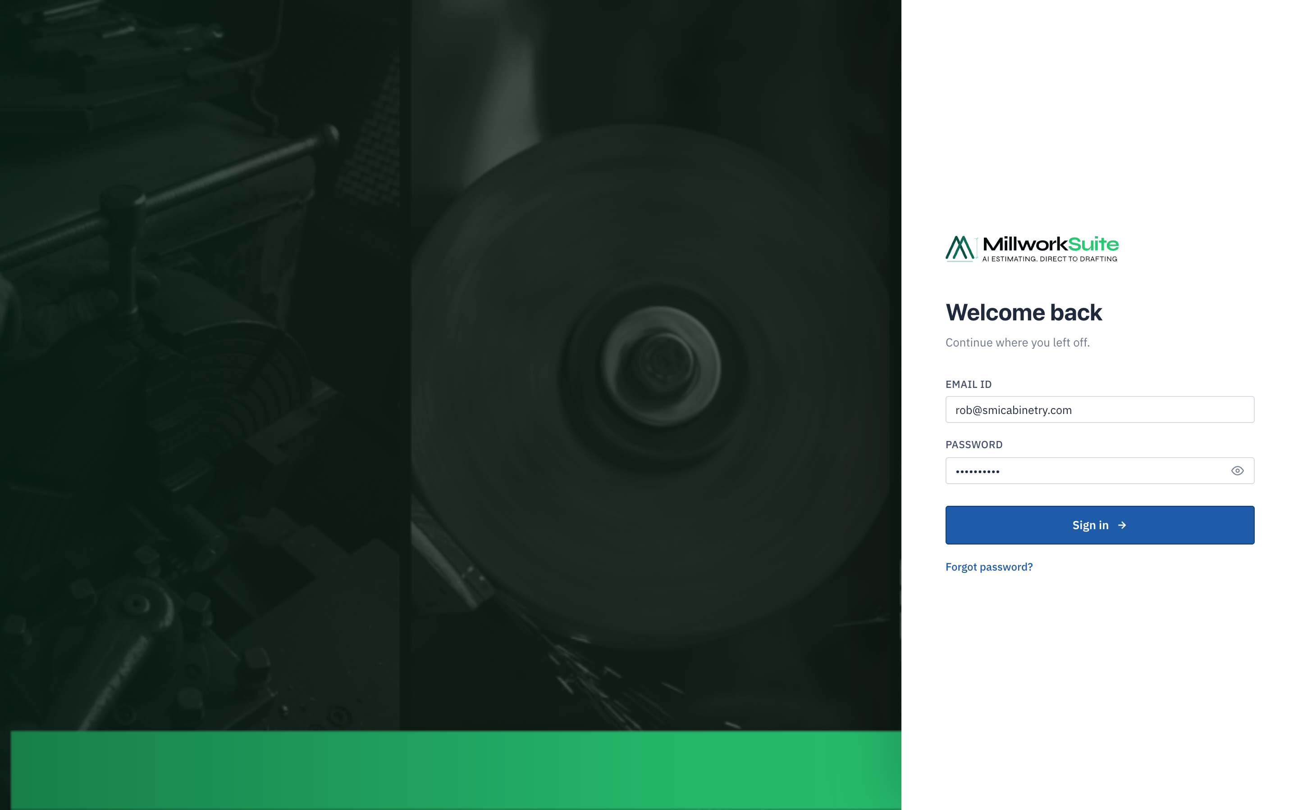
Fig 1 — Login screen (1440 × 900, @2x)
──────────────────────────────────────────────────────────────────────────────────────────

Page Components
1. Background
- • Full-viewport dark gradient (deep navy/forest) — no topbar or navigation visible.
- • Background uses a millwork-themed photo overlay at reduced opacity.

2. Login Card
- • Centered white card, fixed width ≈ 380 px, rounded corners, soft box-shadow.
- • Vertically centered in the viewport.

2a. Logo
- • MillworkSuite SVG logo at height 30 px, top of card.

2b. Heading & Sub-heading
- • H1: "Welcome back" — bold, ~20 px, dark ink.
- • Sub: "Continue where you left off." — muted, secondary ink.

2c. Email Field
- • Label: "Email ID" (micro-label, uppercase).
- • Input type: email, autocomplete="email".
- • Placeholder: rob@smicabinetry.com.
- • Full-width, ~36 px height, blue focus ring (--blue-500).

2d. Password Field
- • Label: "Password" (micro-label, uppercase).
- • Input type: password, autocomplete="current-password".
- • Show/Hide toggle — eye icon inside right edge of input.
- - Click toggles type between password and text.
- - Icon swaps between open-eye and eye-slash.
- - aria-label="Show or hide password" required.

2e. Sign In Button
- • Label: "Sign in" + right-arrow icon (→).
- • Full-width, primary blue, ~44 px height.
- • Disabled when either field is empty.
- • Loading spinner shown while auth request is in flight.
- • On success: triggers EULA modal (first login) or navigates to App Hub.

2f. Forgot Password
- • Text link below button: "Forgot password?"
- • Navigates to password reset flow (MWS-005).

──────────────────────────────────────────────────────────────────────────────────────────

Behaviour & States
State | Behaviour
Empty fields | Sign in button disabled; no error until submit attempted
Invalid email | Inline error: "Please enter a valid email address"
Wrong credentials | Card-level error banner: "Incorrect email or password."
Successful auth | EULA modal (first login) or direct to App Hub
Forgot password | Navigate to password reset screen
Network error | "Could not connect. Check your connection and try again."

Accessibility Requirements
- All form fields must have associated <label> elements — not just placeholders.
- Password toggle must toggle aria-label between "Show password" and "Hide password".
- Sign in button is keyboard-submittable via Enter key from any field.
- Error messages announced via aria-live="polite".
- Focus order: Logo → Email → Password → Show/Hide → Sign in → Forgot password.

──────────────────────────────────────────────────────────────────────────────────────────

Acceptance Criteria
# | Acceptance Criterion
1 | Background is full-viewport dark gradient with no topbar or nav.
2 | MillworkSuite logo renders at correct size, visible against dark bg.
3 | Email and password fields are correctly labelled and focusable.
4 | Password show/hide toggle switches input type and swaps icon correctly.
5 | Sign in button is disabled when either field is empty.
6 | Successful sign in triggers EULA on first login; bypasses on subsequent logins.
7 | Inline validation errors appear for empty / invalid inputs.
8 | Card-level error appears for wrong credentials.
9 | "Forgot password?" link is present and navigates to reset flow.
10 | Page passes WCAG 2.1 AA keyboard navigation and screen-reader audit.
11 | Responsive layout works on mobile, tablet, and desktop.

