MWS-002 — Marketing Landing Page
Jira Story · MillworkSuite UX Implementation
──────────────────────────────────────────────────────────────────────────────────────────

Story ID | MWS-002
Epic | MWS — Public & Auth Pages
Type | Story
Priority | P0 — Blocker
Story Points | 8
Labels | frontend, marketing, UX
Route | / (public root)

User Story
As a prospective millwork company, I want to visit the MillworkSuite landing page so that I can understand the product, see proof of its value, and take action to sign in or book a demo.

Full Page Screenshot
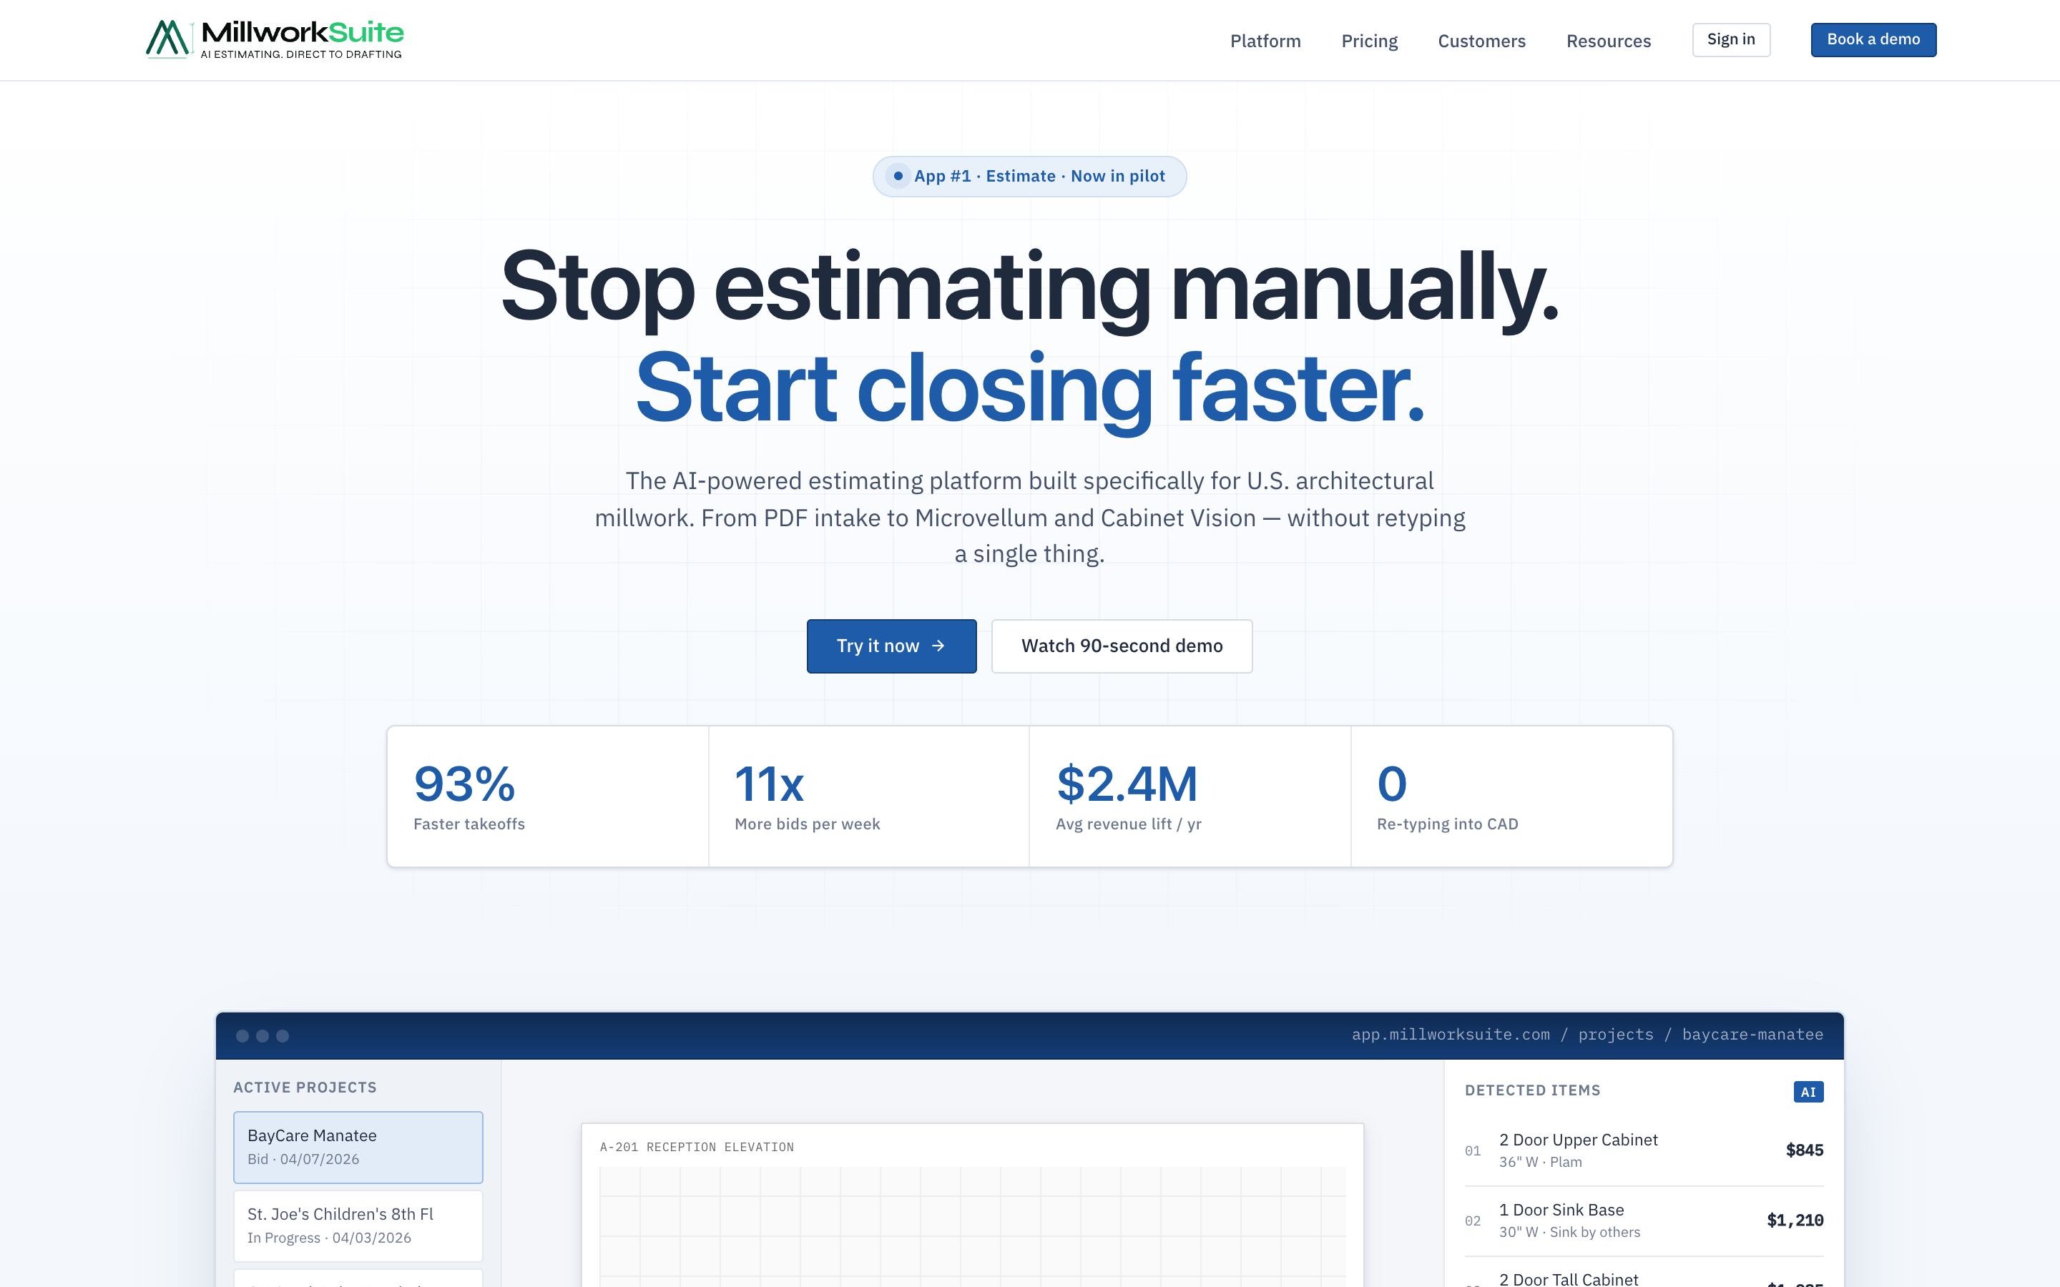
Fig 1 — Landing page, above the fold (1440 × 900, @2x)
──────────────────────────────────────────────────────────────────────────────────────────

Section 1 — Top Navigation Bar
- • Logo: MillworkSuite SVG, height 28 px. Click → scroll to top of landing page.
- • Nav links (4): Platform, Pricing, Customers, Resources — plain text, hover underline.
- • "Sign in" button: secondary/ghost style → navigates to /login.
- • "Book a demo" button: primary blue → opens booking modal (future story).
- • Nav is sticky — gains a shadow after scrolling past the hero.
- • Mobile: links collapse into a hamburger menu.

Section 2 — Hero
2a. Pilot Badge
- • Small pill: pulsing green dot + "App #1 · Estimate · Now in pilot".
- • Green dot has a continuous pulse/glow CSS animation.

2b. Headline (H1)
- • "Stop estimating manually." — plain dark ink.
- • "Start closing faster." — brand accent color, italic treatment.
- • Font: display weight, ~44–52 px.

2c. Sub-headline
- • One paragraph, ~2 lines of secondary ink text.
- • Describes: AI-powered, U.S. architectural millwork, PDF → Microvellum/Cabinet Vision.

2d. CTA Row
- • Primary: "Try it now →" — blue filled, arrow icon. Navigates to /estimate (App Hub).
- • Secondary: "Watch 90-second demo" — ghost outline. Opens video modal (future story).
- • Side-by-side on desktop, stacked on mobile.

2e. Stats Strip
- • 4 metrics in a horizontal row with thin vertical dividers:
- 93% — Faster takeoffs
- 11x — More bids per week
- $2.4M — Avg revenue lift / yr
- 0 — Re-typing into CAD
- • Values: ~28–32 px bold display font. Labels: small muted text below.

Section 3 — App Preview Window
A faux browser window showing the app in action. Contains three panels side by side:
Panel | Contents
Browser chrome | 3 dots (red/yellow/green) + address bar: app.millworksuite.com/projects/baycare-manatee
Left rail | Header "Active Projects" + 4 project rows (name, status, date). First row is highlighted/active.
Center — PDF canvas | Blueprint-style PDF background. 3 AI detection boxes overlaid: "2 Door Upper", "1 Door Sink Base", "2 Door Tall". Each box is a blue outline with a label chip.
Right rail | Header "Detected Items" with blue AI badge. 4 line items (number, name, spec, price). Subtotal row at bottom: Reception · Sub — $4,460.

Section 4 — Features Grid (6 cards, 3×2)
Headline: "Everything automated. Nothing missed."
# | Title | Description
1 | PDF intake → detection | Forward bid emails or drag-and-drop. Detection runs in under 90 seconds across the full sheet set.
2 | Estimating & Drafting modes | Toggle modes with a click. Estimators see margin; drafters see CAD export type. No app-switching.
3 | Direct-to-Microvellum | Detected items map to the Company Product Catalogue and export natively to Microvellum or Cabinet Vision.
4 | Your catalog. Your prices. | Linear, sqft, tiered, formula-based, flat + add-ons. Map MWS types to internal SKUs once, reuse forever.
5 | Versioned bids, immutable wins | Every revision is its own version. Won bids are locked. 90-day soft-delete recovery on everything.
6 | Granular role permissions | Roles tied to features, not labels. Grant consultant access without exposing pricing.

Each card: SVG icon, H3 title, description text. Hover: translateY(-2px) + increased box-shadow.

Section 5 — CTA Band
- • Dark/navy full-width band, white text.
- • H2: "Your team estimates in days. We do it in minutes."
- • Primary button: "Open the demo workspace" → navigates to App Hub.
- • Secondary ghost button: "Book onboarding call" (placeholder).

Section 6 — Footer
- • Single-line footer: left — "© 2026 MillworkSuite · Orlando, Florida".
- • Right — "v3.2.1.60.3 · pilot release" in monospace font.
- • Minimal — no link columns for pilot phase.

──────────────────────────────────────────────────────────────────────────────────────────

Interaction Table
Interaction | Behaviour
Click "Sign in" (nav) | Navigate to /login
Click "Try it now →" (hero) | Navigate to App Hub (/estimate)
Click "Open the demo workspace" | Navigate to App Hub (/estimate)
Click "Book a demo" / "Book call" | Open booking modal (future story)
Click "Watch 90-second demo" | Open video modal (future story)
Hover nav links | Underline + color shift to --blue-700
Hover feature cards | translateY(-2px) + increased box-shadow
Scroll past nav | Nav becomes sticky with subtle drop-shadow

Responsive Behaviour
Breakpoint | Behaviour
Desktop (≥1200px) | Full 3-column feature grid; hero + preview side by side
Tablet (768–1199px) | 2-column feature grid; preview stacks below hero
Mobile (<768px) | 1-column everything; nav → hamburger; CTA buttons stack

Acceptance Criteria
# | Acceptance Criterion
1 | Sticky nav renders with logo, 4 nav links, Sign in and Book a demo buttons.
2 | Clicking "Sign in" navigates to the login screen.
3 | Hero headline renders with two-tone styling (plain + accent italic).
4 | Pilot badge animates with a pulsing dot.
5 | 4 stats render in a horizontal row with correct values and dividers.
6 | "Try it now" and "Open the demo workspace" both navigate to App Hub.
7 | App preview window renders: faux browser chrome, left rail, PDF canvas with 3 detection boxes, right-rail line items and subtotal.
8 | 6 feature cards render in a 3×2 grid on desktop with icon, title, and description.
9 | CTA band renders dark with correct headline and two buttons.
10 | Footer renders with copyright (left) and version string (right, monospaced).
11 | Page is fully responsive across desktop, tablet, and mobile breakpoints.
12 | Nav becomes sticky with shadow after scrolling.
13 | Page passes WCAG 2.1 AA audit.

