MWS-003 — Estimate · Projects Dashboard
Jira Story · MillworkSuite UX Implementation
──────────────────────────────────────────────────────────────────────────────────────────

Story ID | MWS-003
Epic | MWS — Estimate App
Type | Story
Priority | P0 — Blocker
Story Points | 13
Labels | frontend, estimate, projects, UX
Route | /estimate/projects
Breadcrumb | Home / Estimate

User Story
As an estimator or company admin, I want to see all my company's projects in one place so that I can quickly find, filter, and open a project to begin or continue estimating work.

Screen References
LIST VIEW (default)
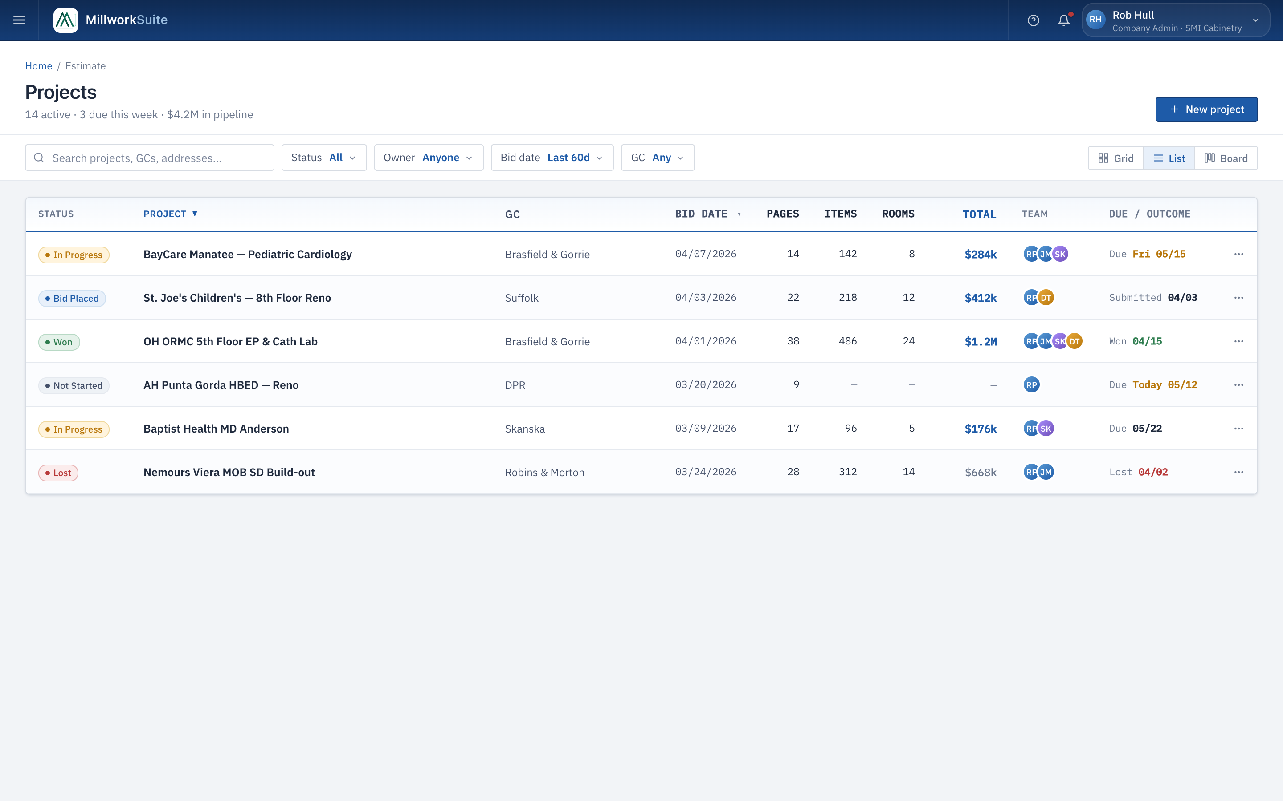
Fig 1 — Projects Dashboard — List view (1440 × 900, @2x)
GRID VIEW
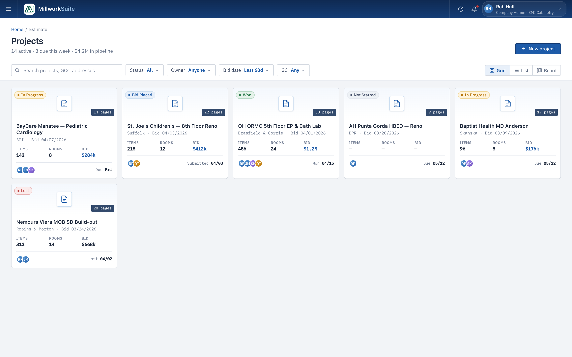
Fig 2 — Projects Dashboard — Grid view (1440 × 900, @2x)
BOARD (KANBAN) VIEW
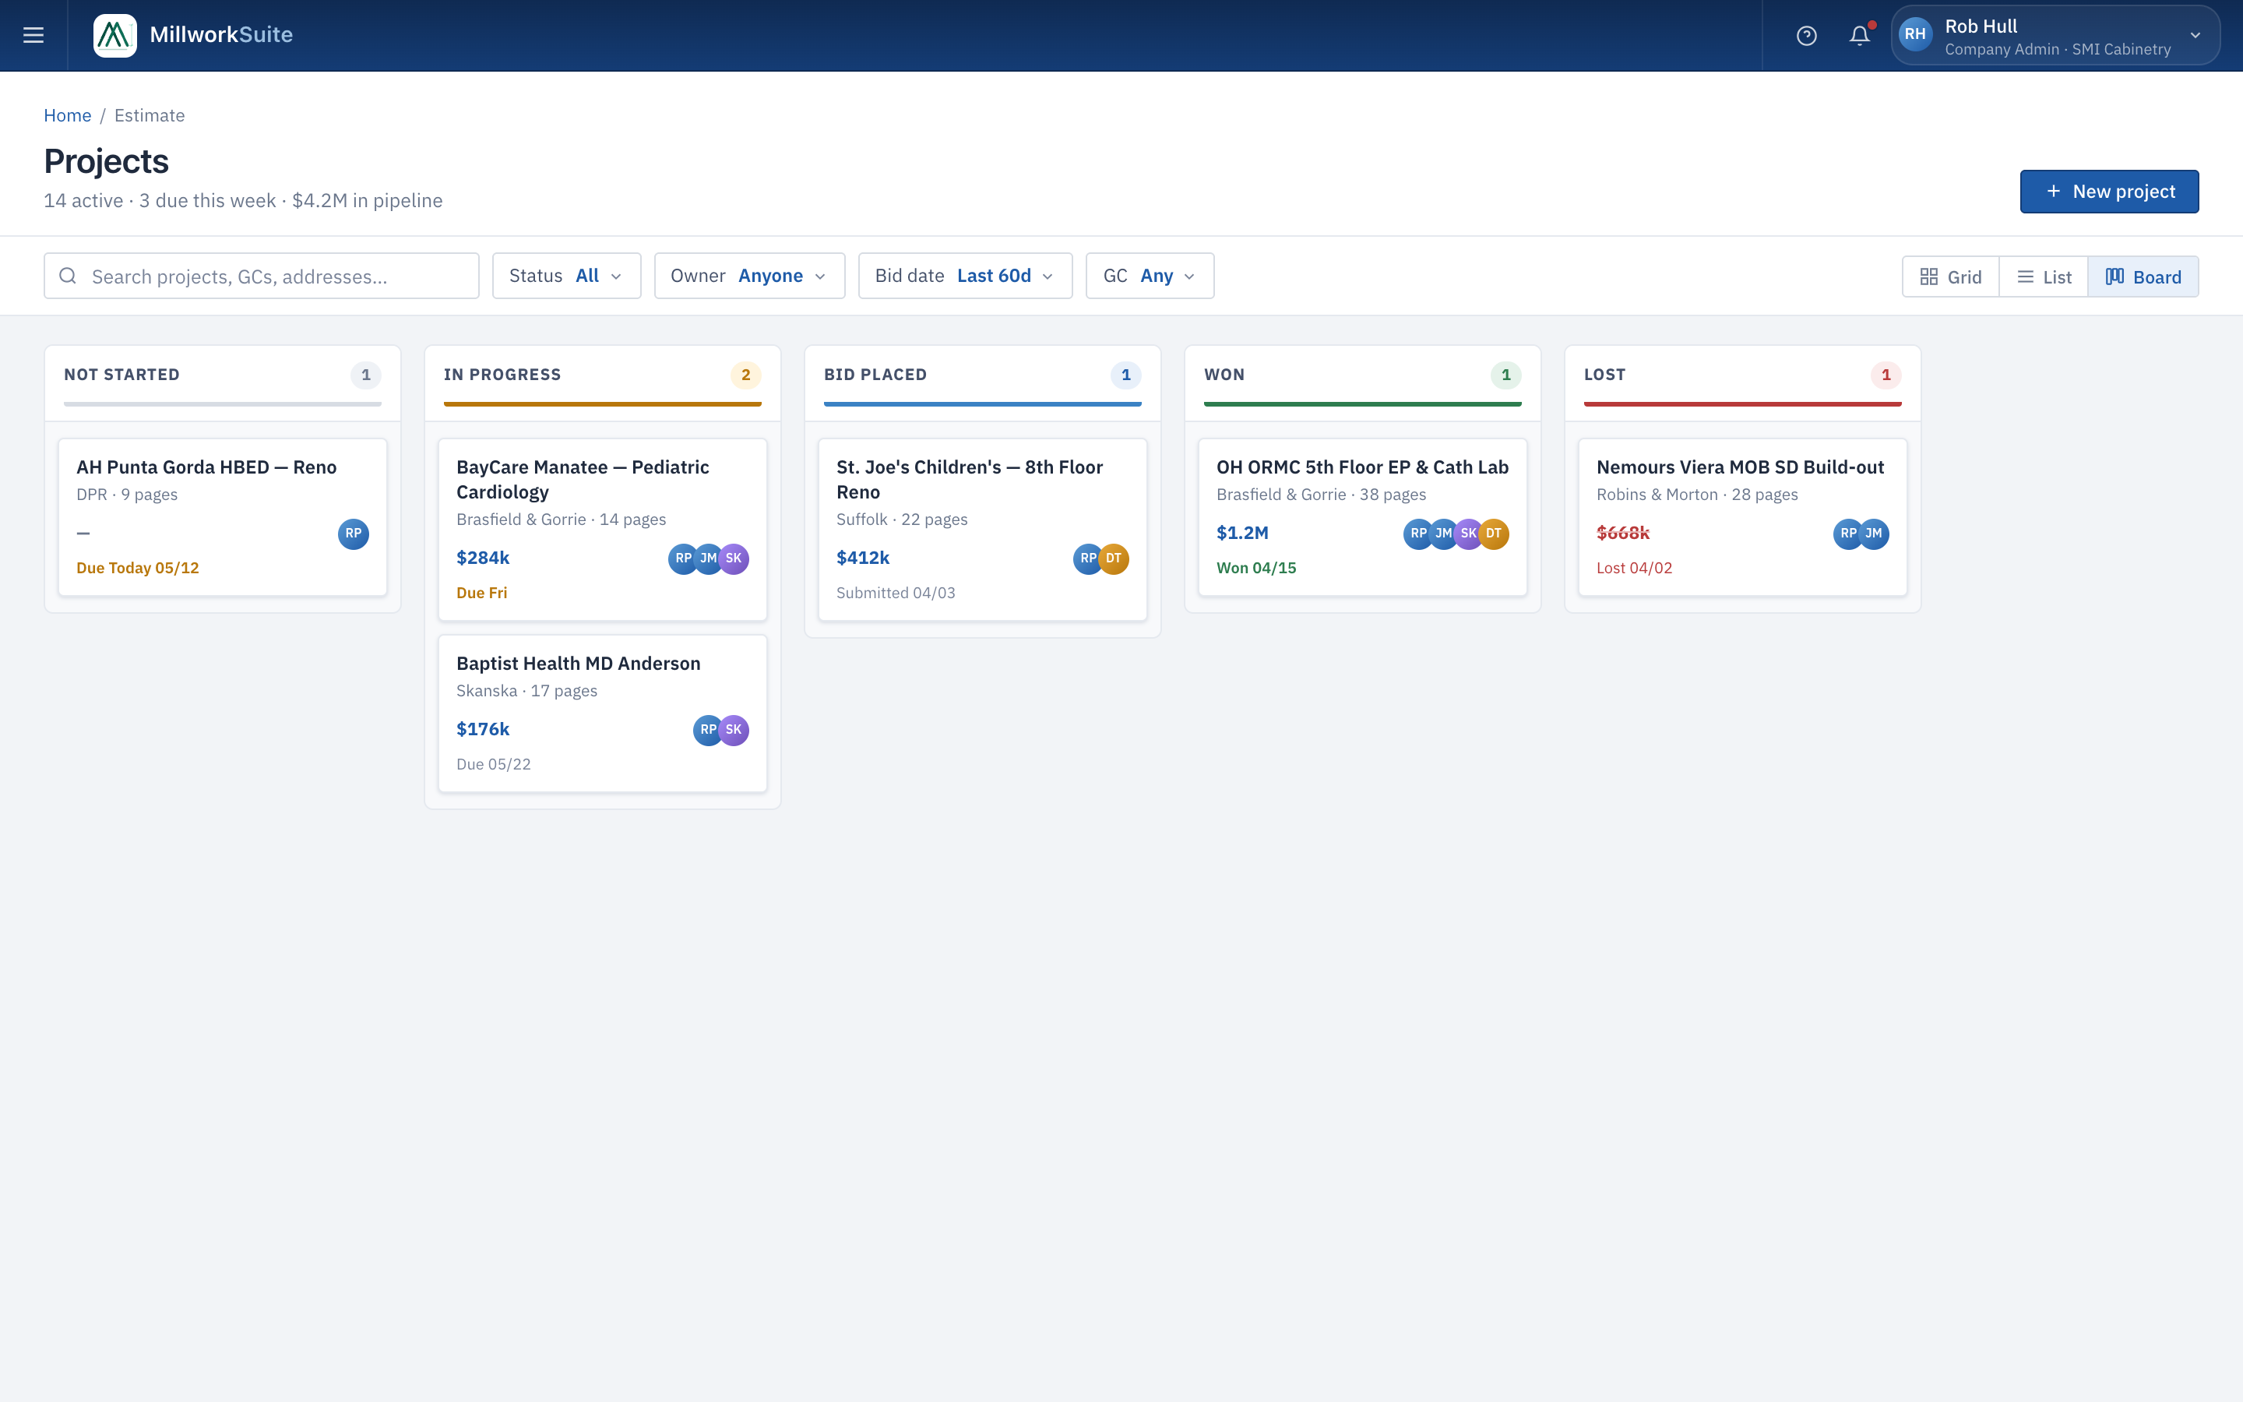
Fig 3 — Projects Dashboard — Board/Kanban view (1440 × 900, @2x)
──────────────────────────────────────────────────────────────────────────────────────────

Component 1 — Page Header
1a. Breadcrumb
- • "Home" — clickable link, navigates to App Hub (/).
- • "/" separator.
- • "Estimate" — plain text, current location.
- • Font: 11 px, --ink-3 muted color.

1b. Title Row
- • H1: "Projects" — bold, 22 px.
- • Sub-line (live-computed): "14 active · 3 due this week · $4.2M in pipeline".
- • "+ New project" primary blue button — top right. Opens New Project Wizard.

Component 2 — Toolbar
2a. Search Input
- • Width: ~280 px. Magnifying glass icon on the left.
- • Placeholder: "Search projects, GCs, addresses…"
- • Real-time filter (debounced ~300 ms) — matches name, GC, address, status.

2b. Filter Dropdowns
Filter | Default | Options
Status | All | Not Started, In Progress, Bid Placed, Won, Lost
Owner | Anyone | List of team members in the company workspace
Bid date | Last 60d | Last 7d, Last 30d, Last 60d, Last 90d, Custom range
GC | Any | Dropdown of all GCs in the company workspace

- • Active (non-default) filter: --blue-100 background, --blue-700 text.
- • Filters combine with AND logic across all active selections.

2c. View Toggle
Button | Icon | Default | Behaviour
Grid | 4-square | No | Responsive card grid
List | 3 lines | Yes | Full-width data table
Board | 3 column bars | No | Kanban board by stage

Selected view persists in localStorage per user.

Component 3 — Grid View
Responsive card grid (auto-fill, min card 258 px, 12 px gap).
Each card contains:
Area | Element | Detail
Thumbnail (top ~90 px) | Document icon | SVG, centered, muted blue
Thumbnail | Status tag | Colored pill with dot — bottom-left of thumb
Thumbnail | Page count | e.g. "14 pages" — bottom-right, monospace
Body | Project name | Bold 13 px, 2-line max with ellipsis
Body | Client · GC | "SMI · Bid 04/07/2026", muted 11.5 px
Body | Stats row | Items / Rooms / Bid — 3 metric columns
Footer | Team avatars | Stacked overlapping circles (initials), max 4 then +N
Footer | Due / Outcome | Right-aligned: "Due Fri", "Won 04/15", "Lost 04/02"

Click anywhere on card → navigate to project workspace.
Hover: card lifts translateY(-2px) with increased shadow.

Component 4 — List View (Default)
Column | Width | Notes
Status | 110 px | Colored status tag with dot
Project | flex | Project name, bold; entire row is clickable
GC | 140 px | General contractor name
Bid Date | 100 px | MM/DD/YYYY; sortable
Pages | 60 px | Right-aligned number
Items | 60 px | Right-aligned; "—" if not started
Rooms | 60 px | Right-aligned; "—" if not started
Total | 90 px | Blue if active; red strikethrough if lost
Team | 90 px | Stacked avatar circles
Due/Outcome | 120 px | "Due Fri MM/DD", "Won MM/DD", "Lost MM/DD"
Actions | 36 px | ⋯ icon button — opens context menu

Table Header behaviour:
- • Sticky positioned — stays visible on scroll.
- • Background: gradient --blue-50 → white. Bottom border: 2 px solid --blue-700.
- • Sortable columns: Project and Bid Date. Click cycles: asc → desc → default.
- • Active sort column text shifts to --blue-700.

Status Tag Color System:
Status | Dot Color | Text Color | Background
Not Started | --ink-3 grey | --ink-2 | --panel
In Progress | --amber | --amber | --amber-bg
Bid Placed | --blue-500 | --blue-700 | --blue-100
Won | --green | --green | --green-bg
Lost | --red | --red | --red-bg

Due / Outcome cell styling:
State | Style
Due > 3 days | Normal --ink-2
Due ≤ 2 days | Red bold, --red color (urgent)
Submitted | Normal with date
Won | Green text + date
Lost | Red text + date

Component 5 — Board (Kanban) View
Horizontal scroll of 5 stage columns, 230 px wide each, 14 px gap.
Stage | Badge Color | Accent Bar
Not Started | Grey background | --border grey
In Progress | Amber background | --amber
Bid Placed | Blue background | --blue-500
Won | Green background | --green
Lost | Red background | --red

Kanban Card structure:
- • Project name — bold 12 px, max 2 lines.
- • GC + page count — muted 10.5 px.
- • Footer: bid value (left, blue bold) + team avatars (right, 20 px, -4 px overlap).
- • Due line — color-coded by urgency (normal / amber / green won / red lost).
- • Hover: translateY(-1px) + increased shadow.
- • Click: navigate to project workspace.

Component 6 — Empty States
Scenario | Message
No projects exist | "No projects yet. Create your first project." + primary + New project button
Search returns nothing | "No projects match your search." + Clear filters link
All filtered out | "No projects match the active filters." + Clear filters link

Sample Project Data (Implementation Reference)
Project | GC | Status | Bid Date | Pg | Items | Rooms | Total
BayCare Manatee — Pediatric Cardiology | Brasfield & Gorrie | In Progress | 04/07/2026 | 14 | 142 | 8 | $284k
St. Joe's Children's — 8th Floor Reno | Suffolk | Bid Placed | 04/03/2026 | 22 | 218 | 12 | $412k
OH ORMC 5th Floor EP & Cath Lab | Brasfield & Gorrie | Won | 04/01/2026 | 38 | 486 | 24 | $1.2M
AH Punta Gorda HBED — Reno | DPR | Not Started | 03/20/2026 | 9 | — | — | —
Baptist Health MD Anderson | Skanska | In Progress | 03/09/2026 | 17 | 96 | 5 | $176k
Nemours Viera MOB SD Build-out | Robins & Morton | Lost | 03/24/2026 | 28 | 312 | 14 | $668k

Role-Based Access
Role | See Projects | Create | Delete | See Financials
Company Admin | ✓ All | ✓ | ✓ | ✓
Estimator | ✓ All | ✓ | Own only | ✓
Drafter | ✓ All | ✗ | ✗ | ✗
Viewer | ✓ Read-only | ✗ | ✗ | ✗

Navigation & Routing
Action | Destination
Click "Home" breadcrumb | App Hub (/)
Click any project | /estimate/projects/:id (Workspace)
Click "+ New project" | /estimate/projects/new (Wizard)
⋯ → Duplicate | Confirm modal → duplicate → reload list
⋯ → Archive | Confirm modal → remove from active list
⋯ → Delete | Warning modal → soft-delete (90-day recovery)

──────────────────────────────────────────────────────────────────────────────────────────

Acceptance Criteria
# | Acceptance Criterion
1 | Breadcrumb "Home / Estimate" renders; "Home" navigates to Hub.
2 | Page H1 reads "Projects" with live-computed summary sub-line.
3 | "+ New project" button navigates to the new project wizard.
4 | Search input filters list in real-time by name, GC, and address.
5 | All 4 filter dropdowns render with correct defaults and option lists.
6 | Active (non-default) filters are visually highlighted (blue background).
7 | Multiple filters combine with AND logic.
8 | Grid, List, and Board view toggle buttons switch the view instantly.
9 | Active view button is highlighted in blue; selection persists in localStorage.
10 | Grid view: all 6 sample cards render with thumbnail, status tag, page count, stats, team avatars, due date.
11 | Clicking a card navigates to the workspace.
12 | List view: sticky table header, all 10 columns, correct data, sort indicators on Project and Bid Date.
13 | Clicking a row navigates to workspace; clicking ⋯ does not.
14 | Board view: 5 columns in correct stage order with color coding, count badges, and accent bars.
15 | Kanban cards show name, GC, pages, bid value, team avatars, and due line.
16 | All 3 empty states render correctly.
17 | Status tag color variants render correctly across all three views.
18 | Role-based visibility: financials hidden for Drafters and Viewers.
19 | Page is fully responsive at desktop, tablet, and mobile breakpoints.
20 | Page passes WCAG 2.1 AA audit.

