MWS-004 — EULA Acceptance Modal
Jira Story · MillworkSuite UX Implementation
──────────────────────────────────────────────────────────────────────────────────────────

Story ID | MWS-004
Epic | MWS — Public & Auth Pages
Type | Story
Priority | P0 — Blocker
Story Points | 5
Labels | frontend, auth, legal, UX
Trigger | Immediately after successful credential validation on Sign in
Legal entity | VIEWPOINT DATA SYSTEMS, INC. d/b/a MillworkSuite
EULA version | v1.0 · Effective 01 Jan 2026

User Story
As a first-time MillworkSuite user, I must read and accept the End User License Agreement before I can access the platform, so that Viewpoint Data Systems is legally protected and I understand my rights and obligations regarding the software.

Screen References — All States
STATE 1 — Initial (locked): Scroll hint visible, checkbox disabled, Accept button disabled
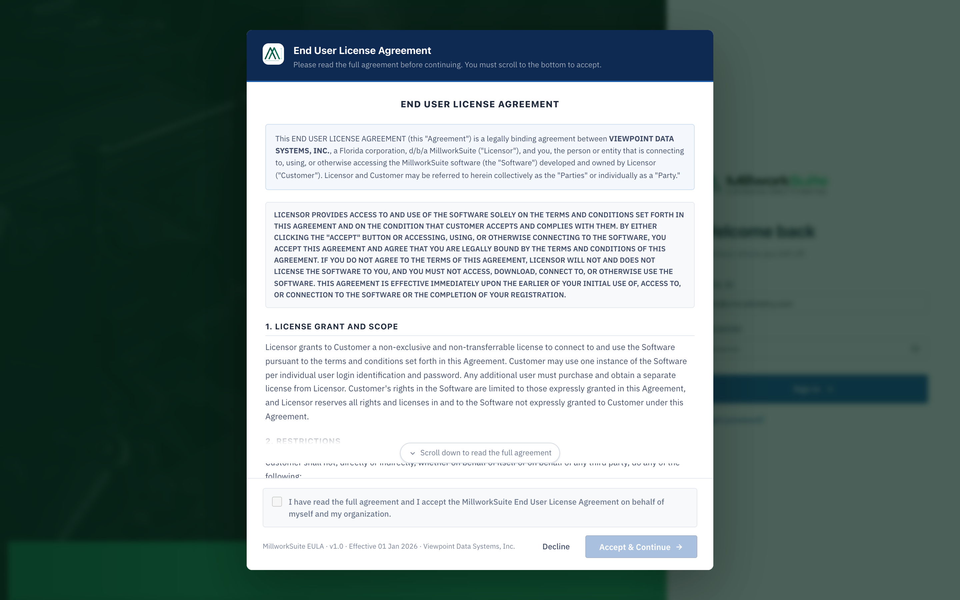
Fig 1 — EULA modal, initial state. User has not yet scrolled. Checkbox and Accept button are locked.
STATE 2 — Scrolled to bottom: Scroll hint hidden, checkbox enabled, Accept button still disabled until checked
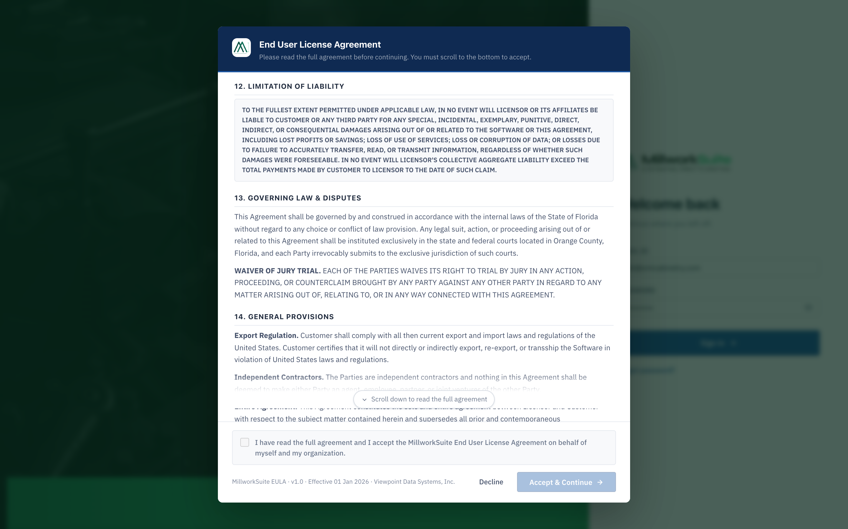
Fig 2 — EULA modal after scrolling to bottom. Checkbox is now enabled. Accept button still disabled.
STATE 3 — Checkbox checked: Accept & Continue button becomes active
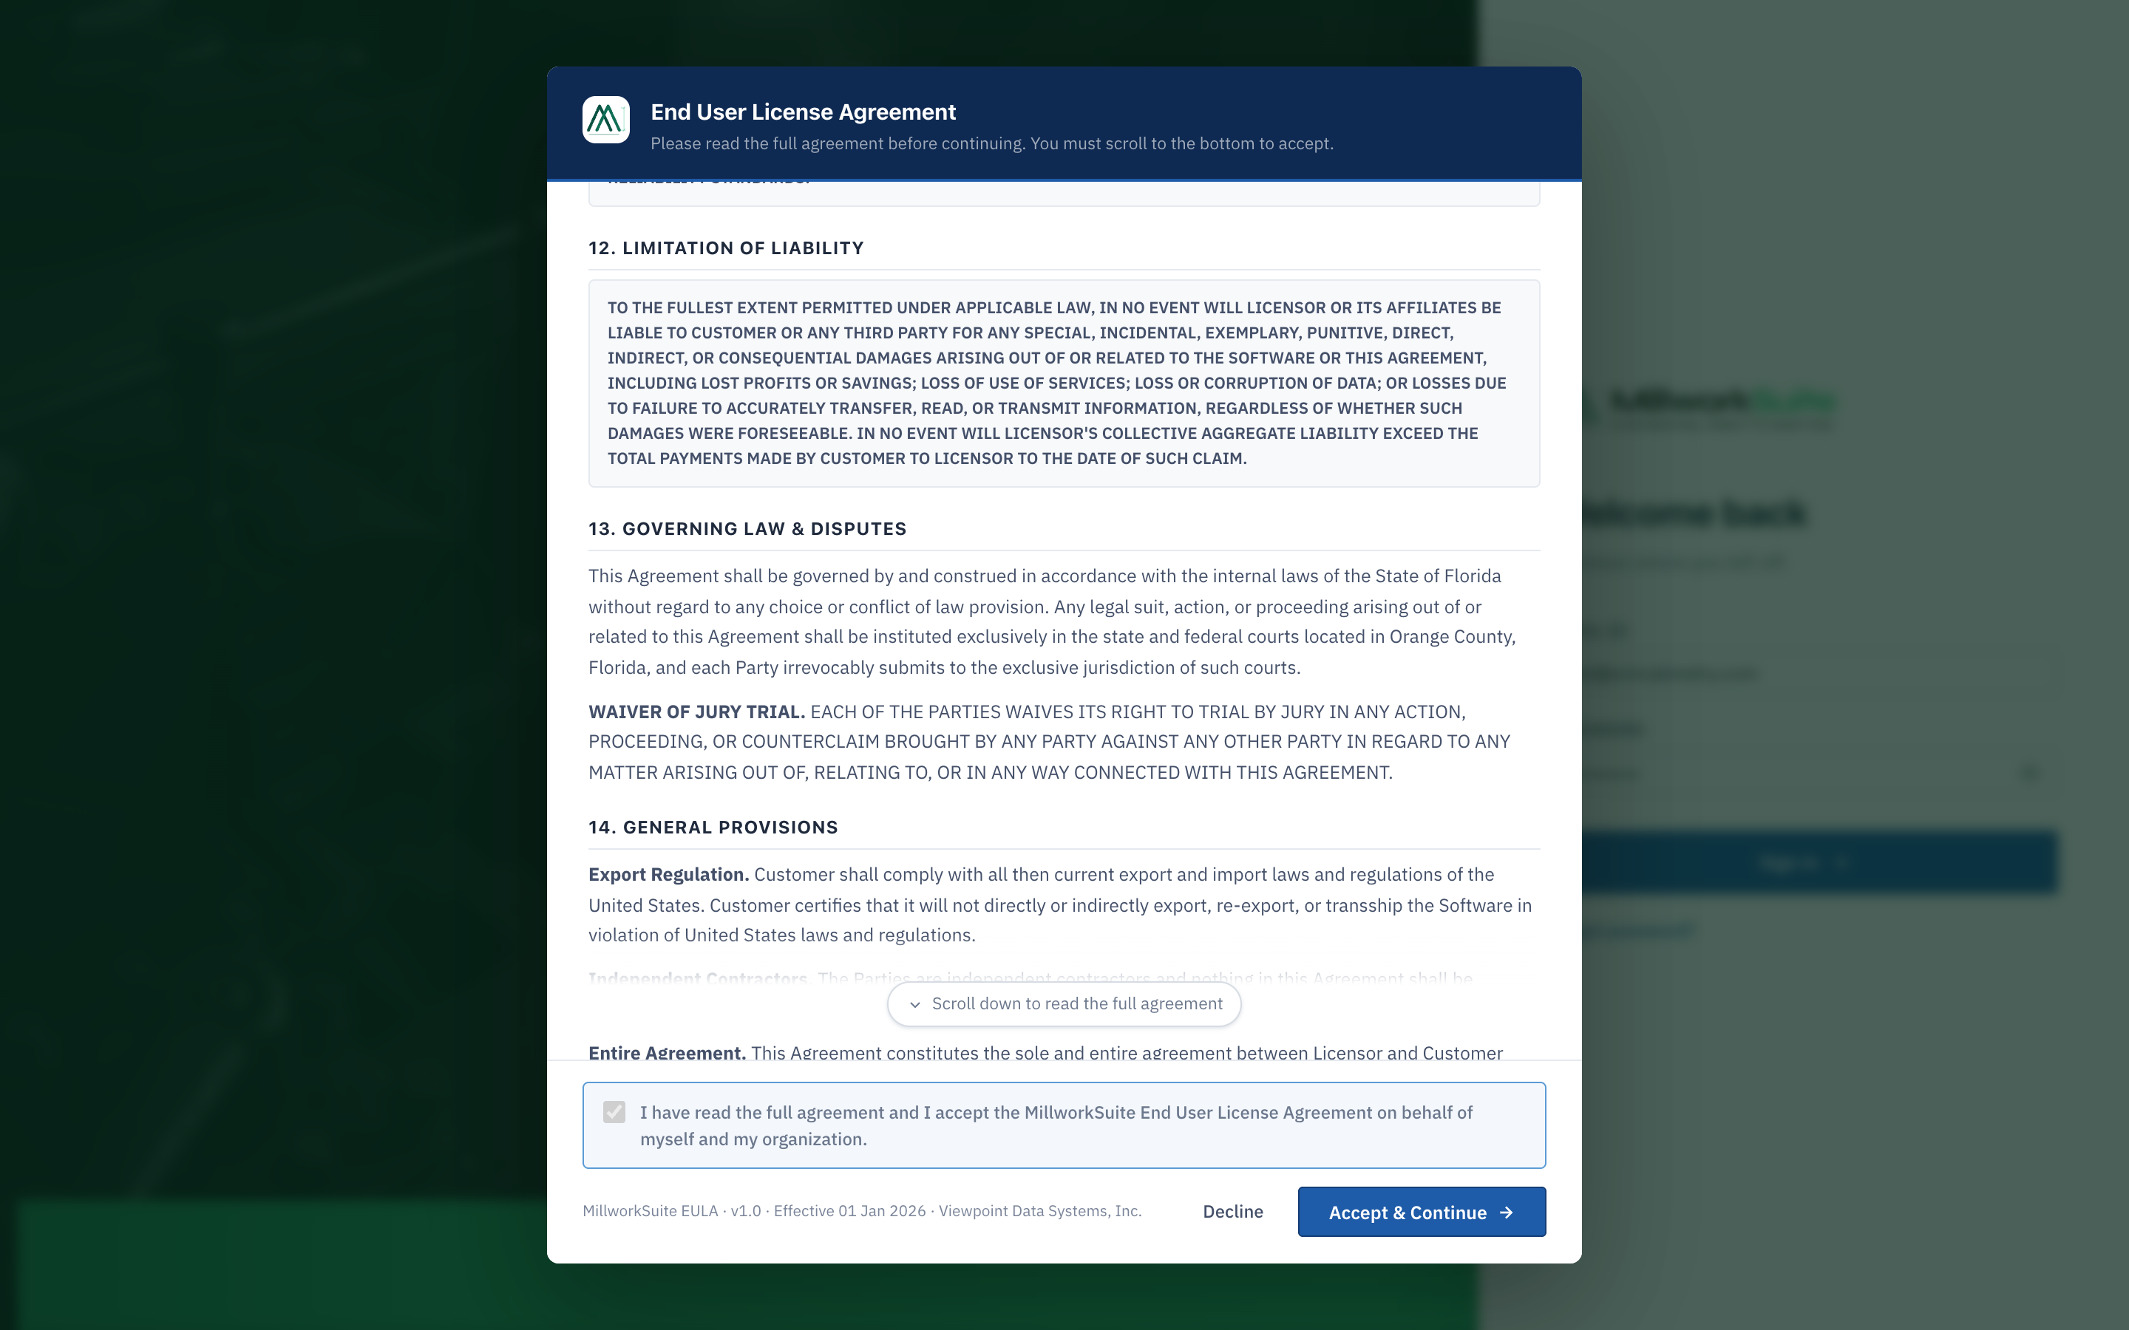
Fig 3 — Checkbox checked. "Accept & Continue →" button is now active and clickable.
STATE 4 — Decline confirmation dialog
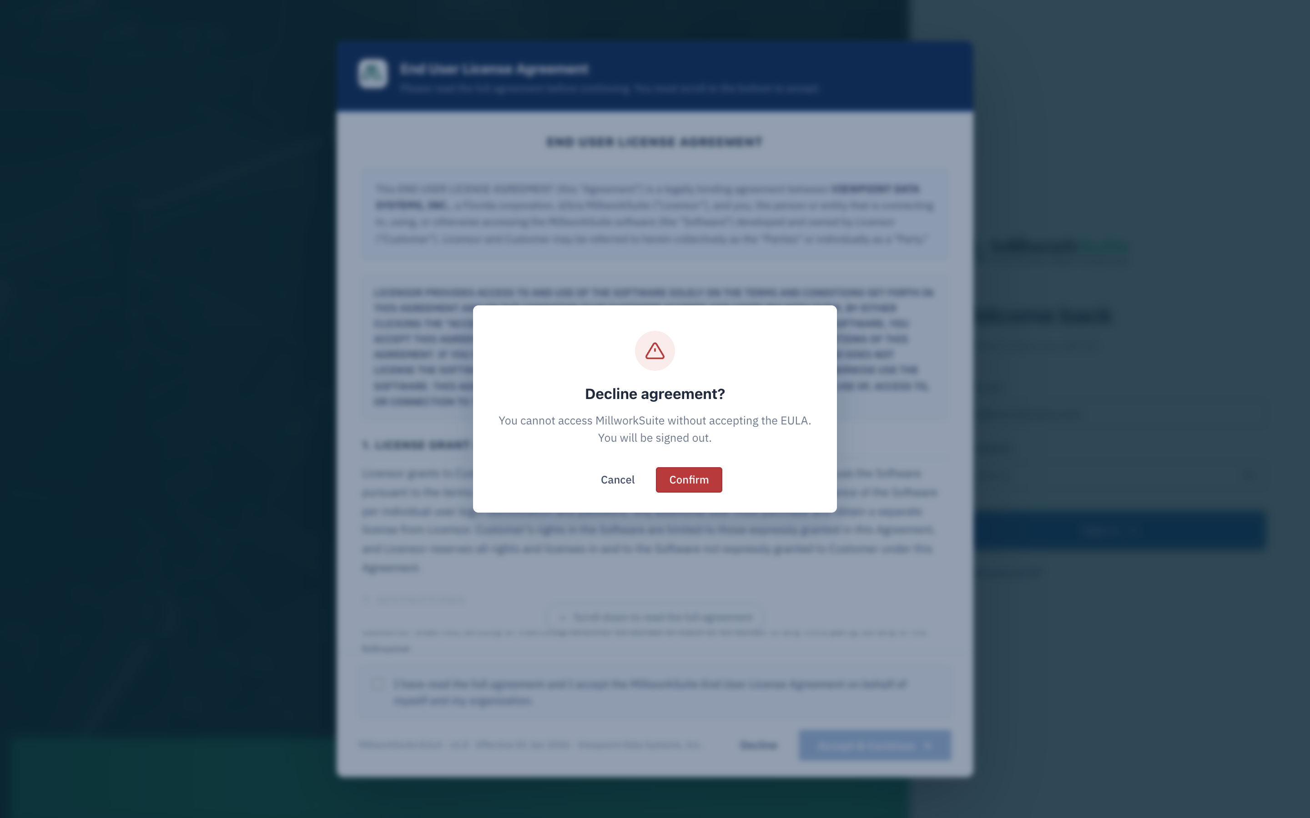
Fig 4 — Clicking "Decline" surfaces a confirmation dialog before signing the user out.
──────────────────────────────────────────────────────────────────────────────────────────

Component 1 — Modal Overlay
- • Full-screen dark overlay (rgba backdrop) covers the entire app — nothing underneath is accessible.
- • role="dialog" aria-modal="true" aria-labelledby="eulaTitle" for screen-reader compliance.
- • Modal cannot be dismissed by clicking outside or pressing Escape — user must Accept or Decline.
- • Centered white modal card, max-width ~760 px, with three distinct zones: header, scrollable body, footer.

Component 2 — Modal Header (dark navy bar)
- • Background: dark navy gradient matching the app topbar (--blue-900 → --blue-800).
- • Left: MillworkSuite favicon/logo icon (28 × 28 px).
- • Title: "End User License Agreement" — white, bold, 15 px, display font.
- • Sub-title: "Please read the full agreement before continuing. You must scroll to the bottom to accept." — white/60% opacity, 11.5 px.
- • No close (×) button — intentional. User must choose Accept or Decline.

Component 3 — Scrollable Body
The body is a fixed-height, overflow-y: scroll container with all legal content.
Content structure (14 numbered sections):
Section | Title | Key Content
Preamble | Agreement parties | Identifies Viewpoint Data Systems, Inc. and the Customer
Opening cap | Acceptance clause | All-caps: clicking Accept or using the software constitutes legal agreement
§1 | License Grant and Scope | Non-exclusive, non-transferable license; one license per user login
§2 | Restrictions | 8 bullet prohibitions: no reverse-engineering, no sub-licensing, no competitive use, etc.
§3 | Fees | Monthly billing in advance; non-refundable; USD only
§4 | Intellectual Property | Licensor retains all IP; Customer has no ownership interest
§5 | Use of Information / AI | AI Outputs are informational only; Customer assumes all risk; no warranty on AI outputs
§6 | Maintenance & Support | Updates provided per standard support program; Licensor may charge for support
§7 | Customer Data | Customer retains data ownership; Licensor may use data to improve AI models
§8 | Indemnification | Customer defends/indemnifies Licensor against third-party claims
§9 | Confidentiality | Mutual confidentiality obligations on proprietary information
§10 | Term and Termination | Licensor: 15-day cure or immediate; Customer: 30-day cure period
§11 | Limited Warranties | All-caps: Software provided "AS IS"; no implied warranties
§12 | Limitation of Liability | All-caps: No consequential/punitive damages; aggregate cap = total fees paid
§13 | Governing Law & Disputes | Florida law; Orange County courts; JURY TRIAL WAIVER (all-caps)
§14 | General Provisions | Export compliance, independent contractors, entire agreement, no assignment, severability, attorneys fees
Closing cap | Final acceptance clause | All-caps restatement that accessing the software = binding agreement

Typography rules within body:
- • H1: "END USER LICENSE AGREEMENT" — section title at top of body.
- • H2: Section numbers and titles (§1 through §14) — bold, with bottom border.
- • P: Body paragraphs — 13 px, line-height 1.6.
- • UL: Bulleted restriction list in §2.
- • .eula-caps: All-caps blocks (preamble caps, §11, §12, §13 jury waiver, closing caps) — monospace or uppercase font, smaller size (~11 px), background tint, used for legally significant passages.
- • .eula-preamble: Opening paragraph — slightly larger, 13 px, with bottom border.

Component 4 — Scroll Gate
- • A "Scroll down to read the full agreement ↓" hint strip is shown at the bottom of the body on load.
- • The hint is ONLY hidden once the user scrolls to within 140 px of the bottom.
- • Simultaneously, the checkbox is enabled (disabled attribute removed) and its label loses the "locked" style.
- • Logic is event-driven on the scroll event of the eulaBody element.
- • The user CANNOT check the checkbox or click Accept without having scrolled through the entire document.

Component 5 — Footer
5a. Checkbox + Agreement Label
- • Checkbox input (type="checkbox", id="eulaAgree") — initially disabled.
- • Label text: "I have read the full agreement and I accept the MillworkSuite End User License Agreement on behalf of myself and my organization."
- • Label text is muted/grey ("locked" class) while checkbox is disabled; turns dark ink when enabled.
- • The checkbox row has a highlighted background when checked (--blue-50 tint, blue border).
- • Checking the checkbox does NOT yet trigger any navigation — it only enables the Accept button.

5b. Version Tag
- • Bottom-left text: "MillworkSuite EULA · v1.0 · Effective 01 Jan 2026 · Viewpoint Data Systems, Inc."
- • Font: 10.5 px, muted ink, left-aligned.

5c. Action Buttons (right-aligned)
Button | Style | Enabled when | On click
Decline | Ghost / secondary | Always | Opens Decline Confirmation dialog (see Component 6)
Accept & Continue → | Primary blue + arrow | Checkbox is checked | Stores acceptance timestamp in localStorage (mws_eula_v1), closes modal, navigates to App Hub, shows success toast

Component 6 — Decline Confirmation Dialog
Clicking "Decline" does NOT immediately sign the user out. It first surfaces a confirmation dialog.
- • Dialog title: "Decline agreement?"
- • Body: "You cannot access MillworkSuite without accepting the EULA. You will be signed out."
- • Style: danger (red icon/accent).
- • Two buttons: Cancel (returns to EULA modal, no action taken) and Confirm (signs user out → navigates to /login).
- • Dialog appears as a second modal layer on top of the EULA modal.

──────────────────────────────────────────────────────────────────────────────────────────

State Machine
State | Scroll hint | Checkbox | Accept button | Trigger to advance
1. Initial | Visible | Disabled (grey) | Disabled (grey) | User scrolls to within 140 px of bottom
2. Scrolled | Hidden | Enabled (active) | Disabled (grey) | User checks the checkbox
3. Ready to accept | Hidden | Checked (blue) | Enabled (blue) | User clicks "Accept & Continue"
4. Accepted | — | — | — | Modal closes; App Hub loads; success toast shown
Decline path | Any | Any | Any | User clicks Decline → Confirm → returns to login

Post-Acceptance Behaviour
- • localStorage key mws_eula_v1 is set to the ISO timestamp of acceptance (e.g. "2026-05-30T01:14:00.000Z").
- • On subsequent sign-ins: showEula() detects the key, clears it, and still shows the EULA — ensuring the modal always shows. (Current prototype behavior: always show for demo purposes.)
- • Production behavior: If mws_eula_v1 exists in the user's server-side profile, skip EULA and go directly to App Hub.
- • On Accept: success toast appears top-right — "Agreement accepted · Welcome to MillworkSuite, [Name]."
- • The acceptance timestamp and version (v1.0) must be stored server-side per user for compliance/audit.

Admin Visibility — Users & Roles Screen
The Users & Roles admin screen shows a per-user EULA column with three possible states:
Status | Icon | Color | Meaning
Accepted | Checkmark ✓ | Green | User has accepted — shows acceptance date (e.g. "19 May 26")
Pending login | Info circle ℹ | Amber | User account exists but has not yet signed in for the first time
Not accepted | Warning ⚠ | Red | User signed in but declined or has not completed the flow

Company admins can see EULA status for all users but cannot accept on their behalf.

Accessibility Requirements
- • role="dialog" aria-modal="true" aria-labelledby="eulaTitle" on the overlay element.
- • Focus must be trapped inside the modal while it is open (tab cycles only through modal elements).
- • Escape key must NOT close the modal (user must explicitly choose Accept or Decline).
- • Checkbox must have an associated <label> element (not aria-label alone).
- • Accept button disabled state must use the disabled HTML attribute (not just CSS opacity).
- • Success toast after acceptance must be announced via aria-live="polite".
- • All-caps legal sections must remain readable by screen readers (use CSS text-transform, not HTML uppercase).
- • Scroll container must be keyboard-scrollable (focusable, responds to arrow keys/Page Down).

──────────────────────────────────────────────────────────────────────────────────────────

Acceptance Criteria
# | Acceptance Criterion
1 | EULA modal appears immediately after successful credential validation on first sign-in.
2 | Full-screen overlay prevents interaction with any app content behind the modal.
3 | Modal header shows MillworkSuite logo, title "End User License Agreement", and scroll instruction sub-title.
4 | No close (×) button is present — modal can only be dismissed via Accept or Decline.
5 | Body renders all 14 sections in correct order with proper heading hierarchy (H1, H2, P, UL).
6 | All-caps legal blocks (.eula-caps) render in distinct monospace/uppercase styling.
7 | Scroll hint ("Scroll down to read the full agreement ↓") is visible on load and hidden after scrolling.
8 | Checkbox is disabled and greyed-out until user scrolls within 140 px of the bottom.
9 | Checkbox label is muted ("locked" styling) while disabled; becomes dark ink when enabled.
10 | Accept & Continue button remains disabled until both: (a) user has scrolled to bottom AND (b) checkbox is checked.
11 | Clicking "Decline" opens the confirmation dialog with correct title, body text, and danger styling.
12 | Confirming decline: modal closes, user is navigated back to /login.
13 | Cancelling decline: confirmation dialog closes, user returns to EULA modal (state preserved).
14 | Clicking "Accept & Continue": modal closes, mws_eula_v1 timestamp stored, user navigates to App Hub.
15 | Success toast appears top-right: "Agreement accepted · Welcome to MillworkSuite, [Name]."
16 | Footer version string reads: "MillworkSuite EULA · v1.0 · Effective 01 Jan 2026 · Viewpoint Data Systems, Inc."
17 | Users & Roles admin table shows per-user EULA status (Accepted + date, Pending login, Not accepted).
18 | Focus is trapped inside the modal while it is open.
19 | Scroll container is keyboard-navigable (Page Down / arrow keys).
20 | Page passes WCAG 2.1 AA audit for the modal.

