MWS-005 — App Hub (Home Page)
Jira Story · MillworkSuite UX Implementation
──────────────────────────────────────────────────────────────────────────────────────────

Story ID | MWS-005
Epic | MWS — App Shell
Type | Story
Priority | P0 — Blocker
Story Points | 8
Labels | frontend, hub, home, UX
Route | / (post-login home)
Access | All authenticated users

User Story
As an authenticated MillworkSuite user, I want to see a personalised home dashboard immediately after signing in so that I can quickly understand my pipeline status, jump into active work, and navigate to any part of the platform.

Screen Reference
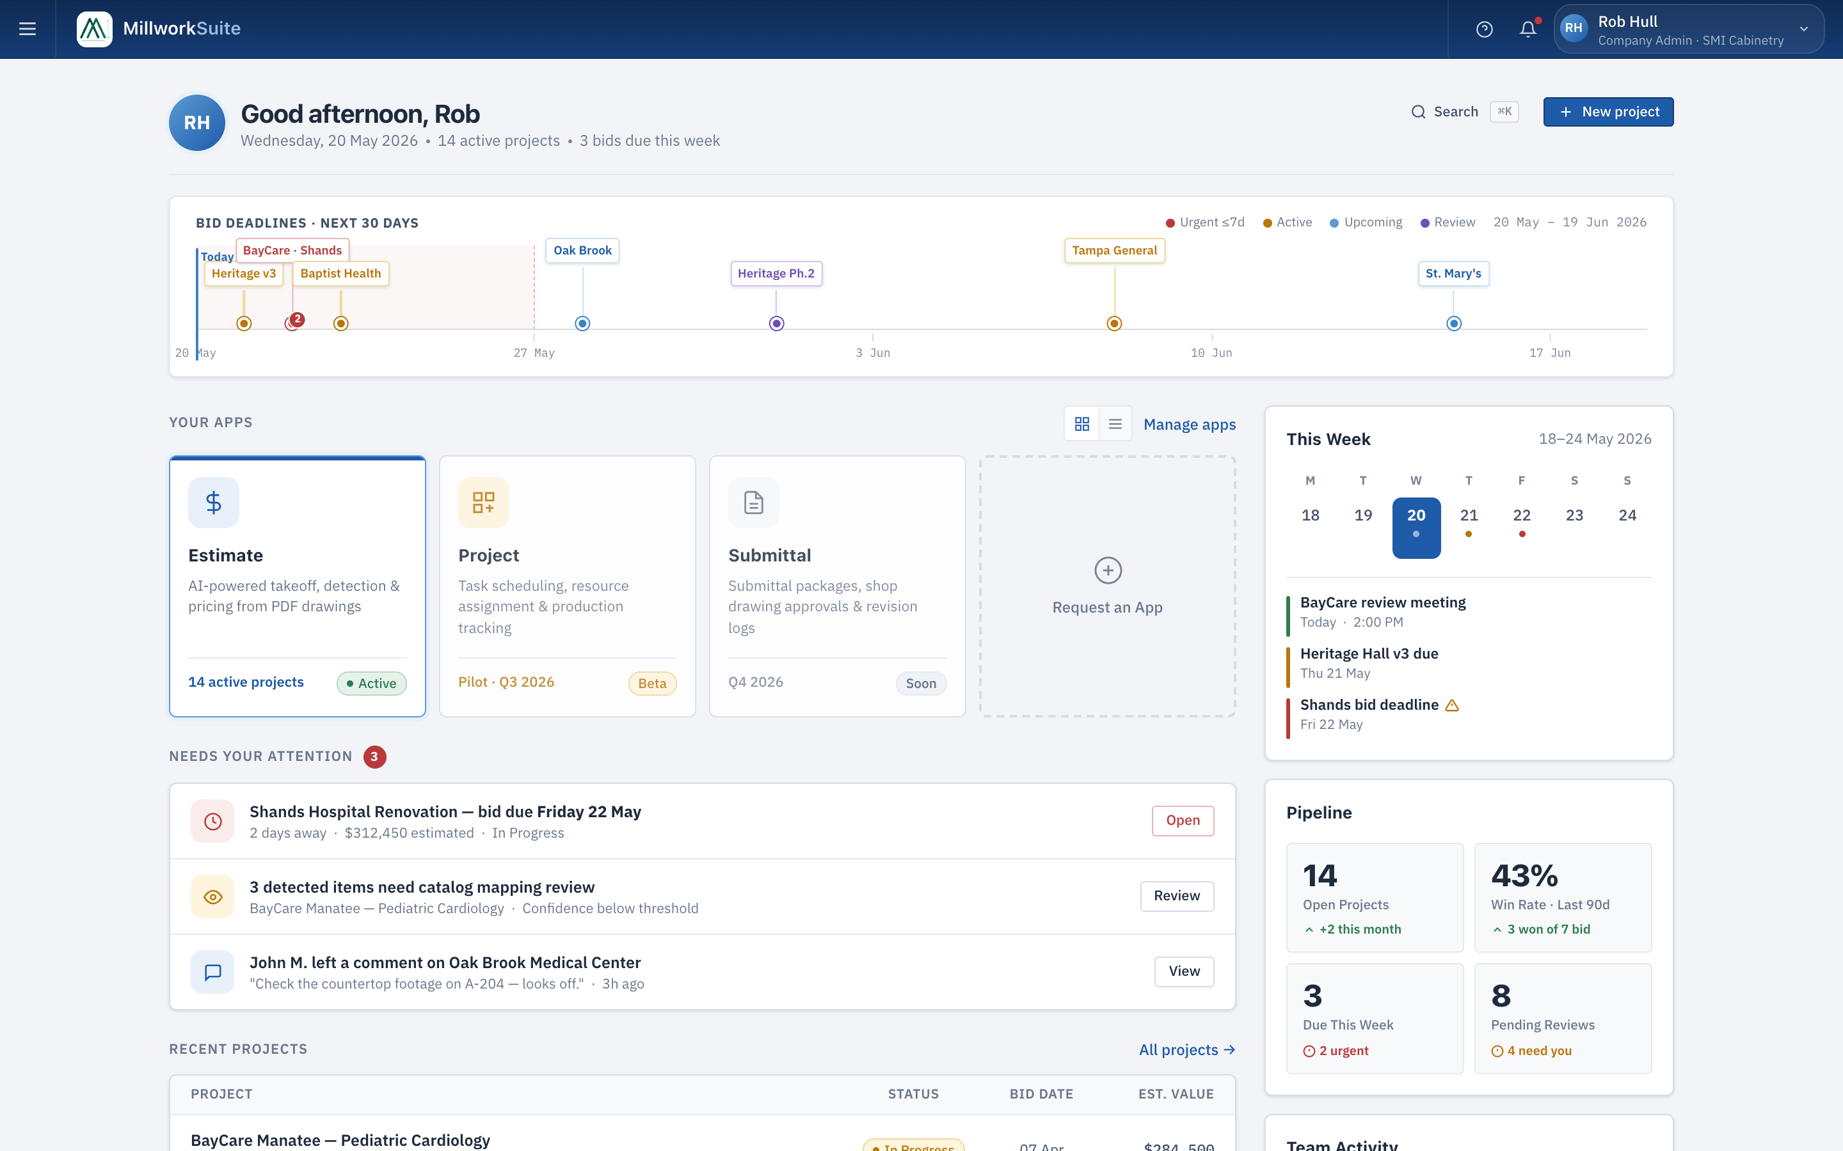
Fig 1 — App Hub home page (1440 × 900, @2x)
Notifications panel (top-right bell icon)
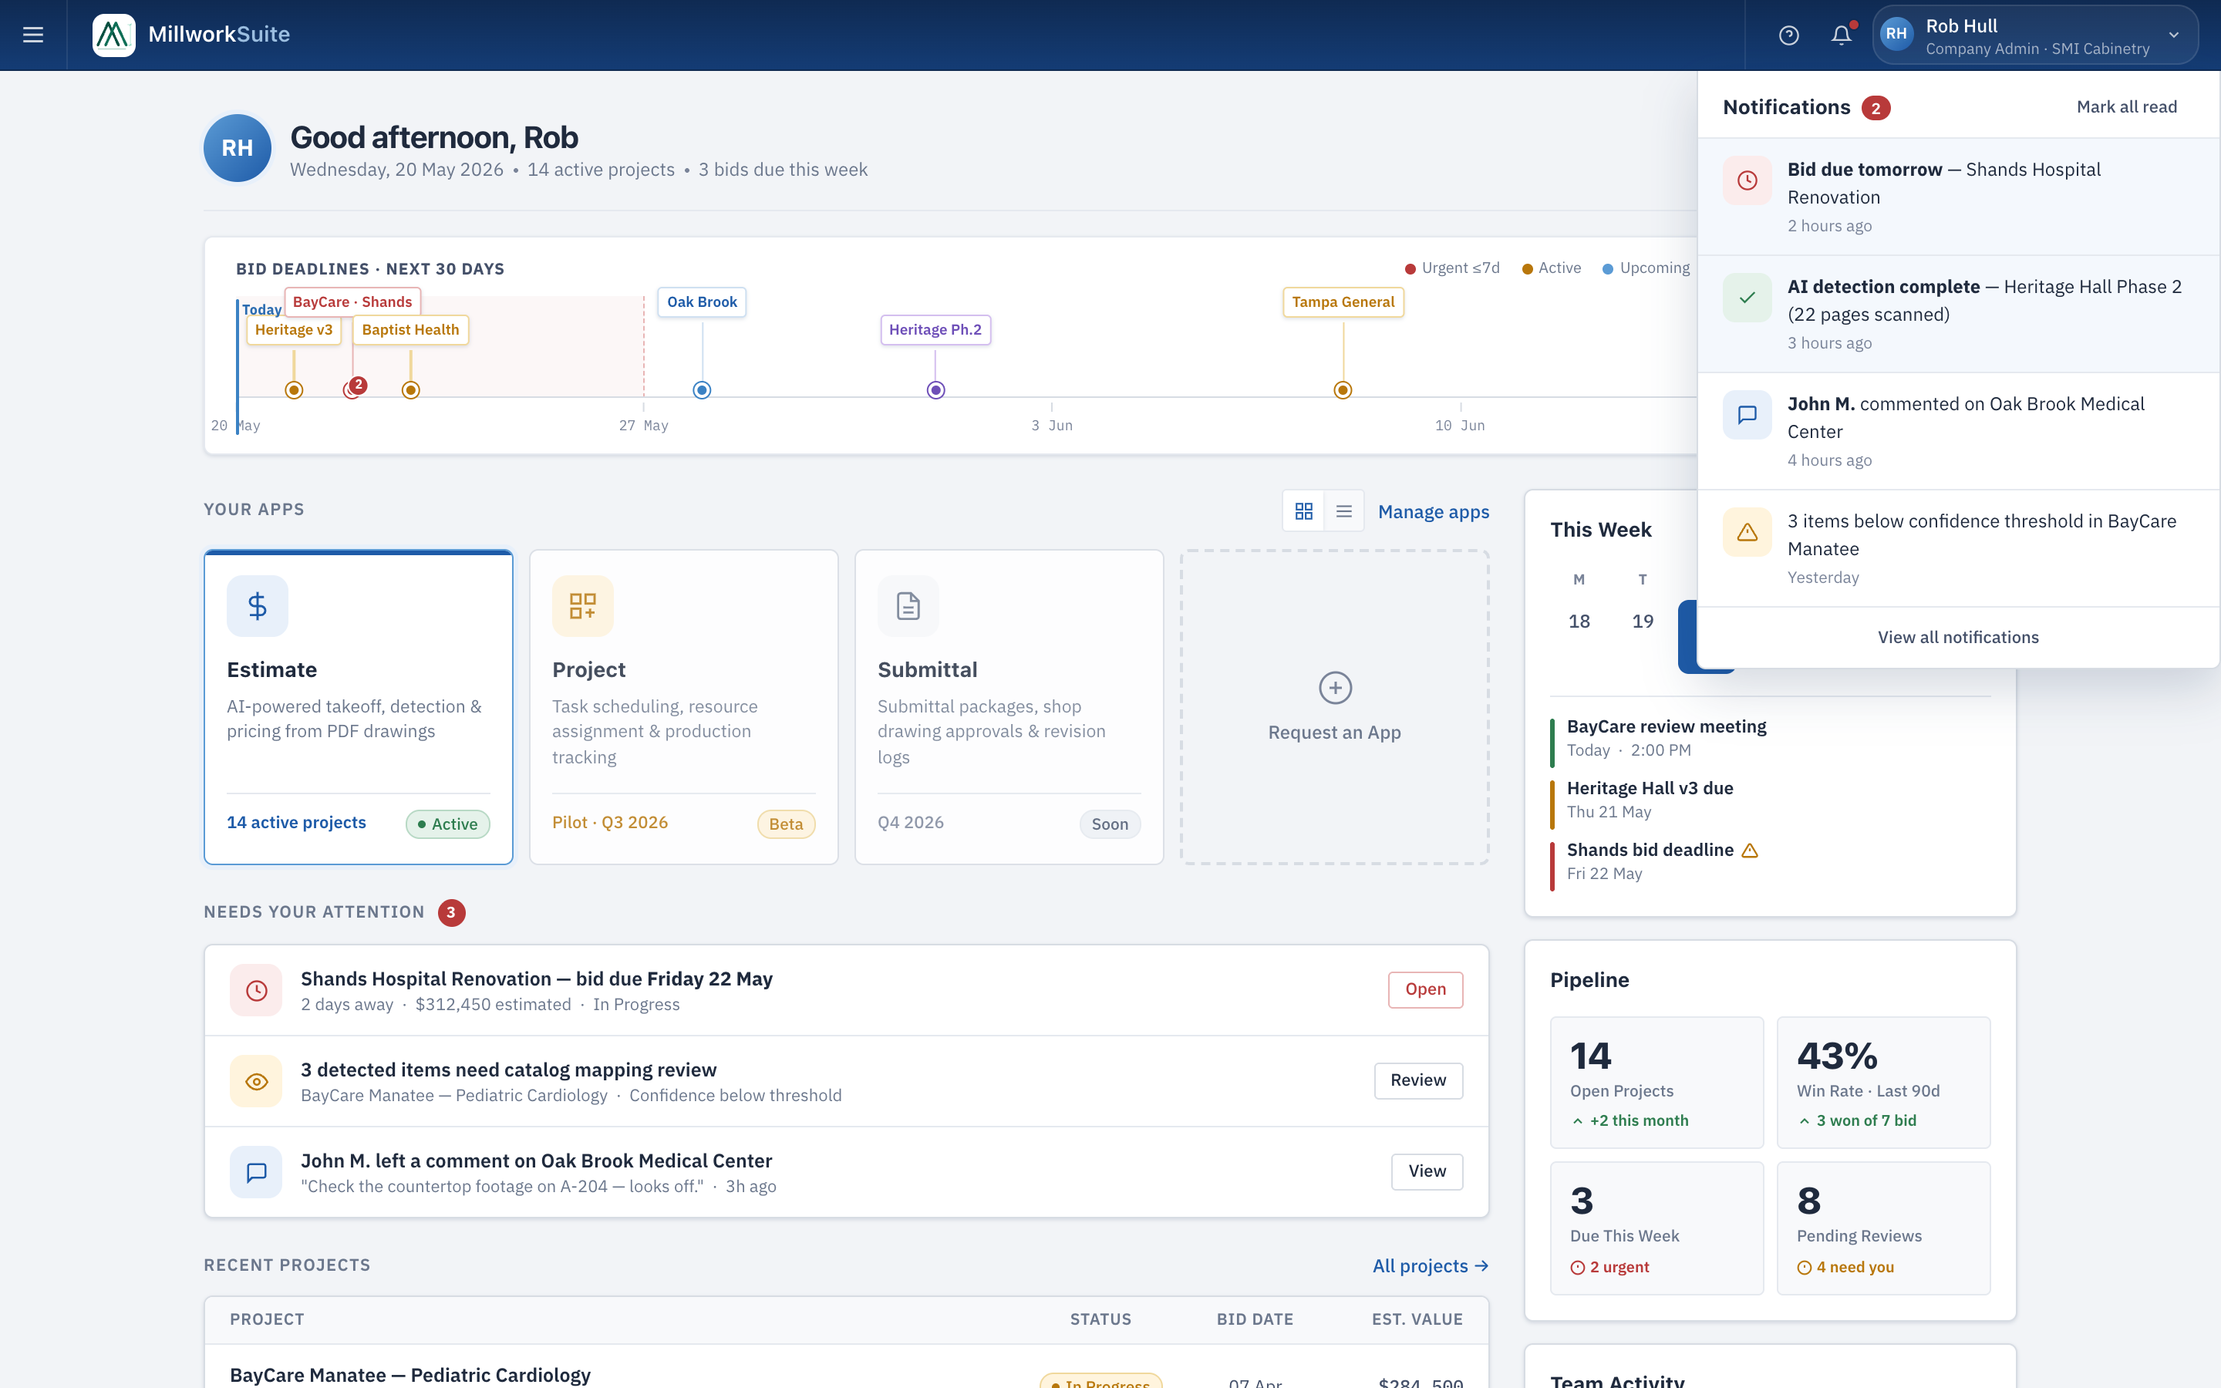
Fig 2 — Notification panel open
User chip dropdown (top-right user card)
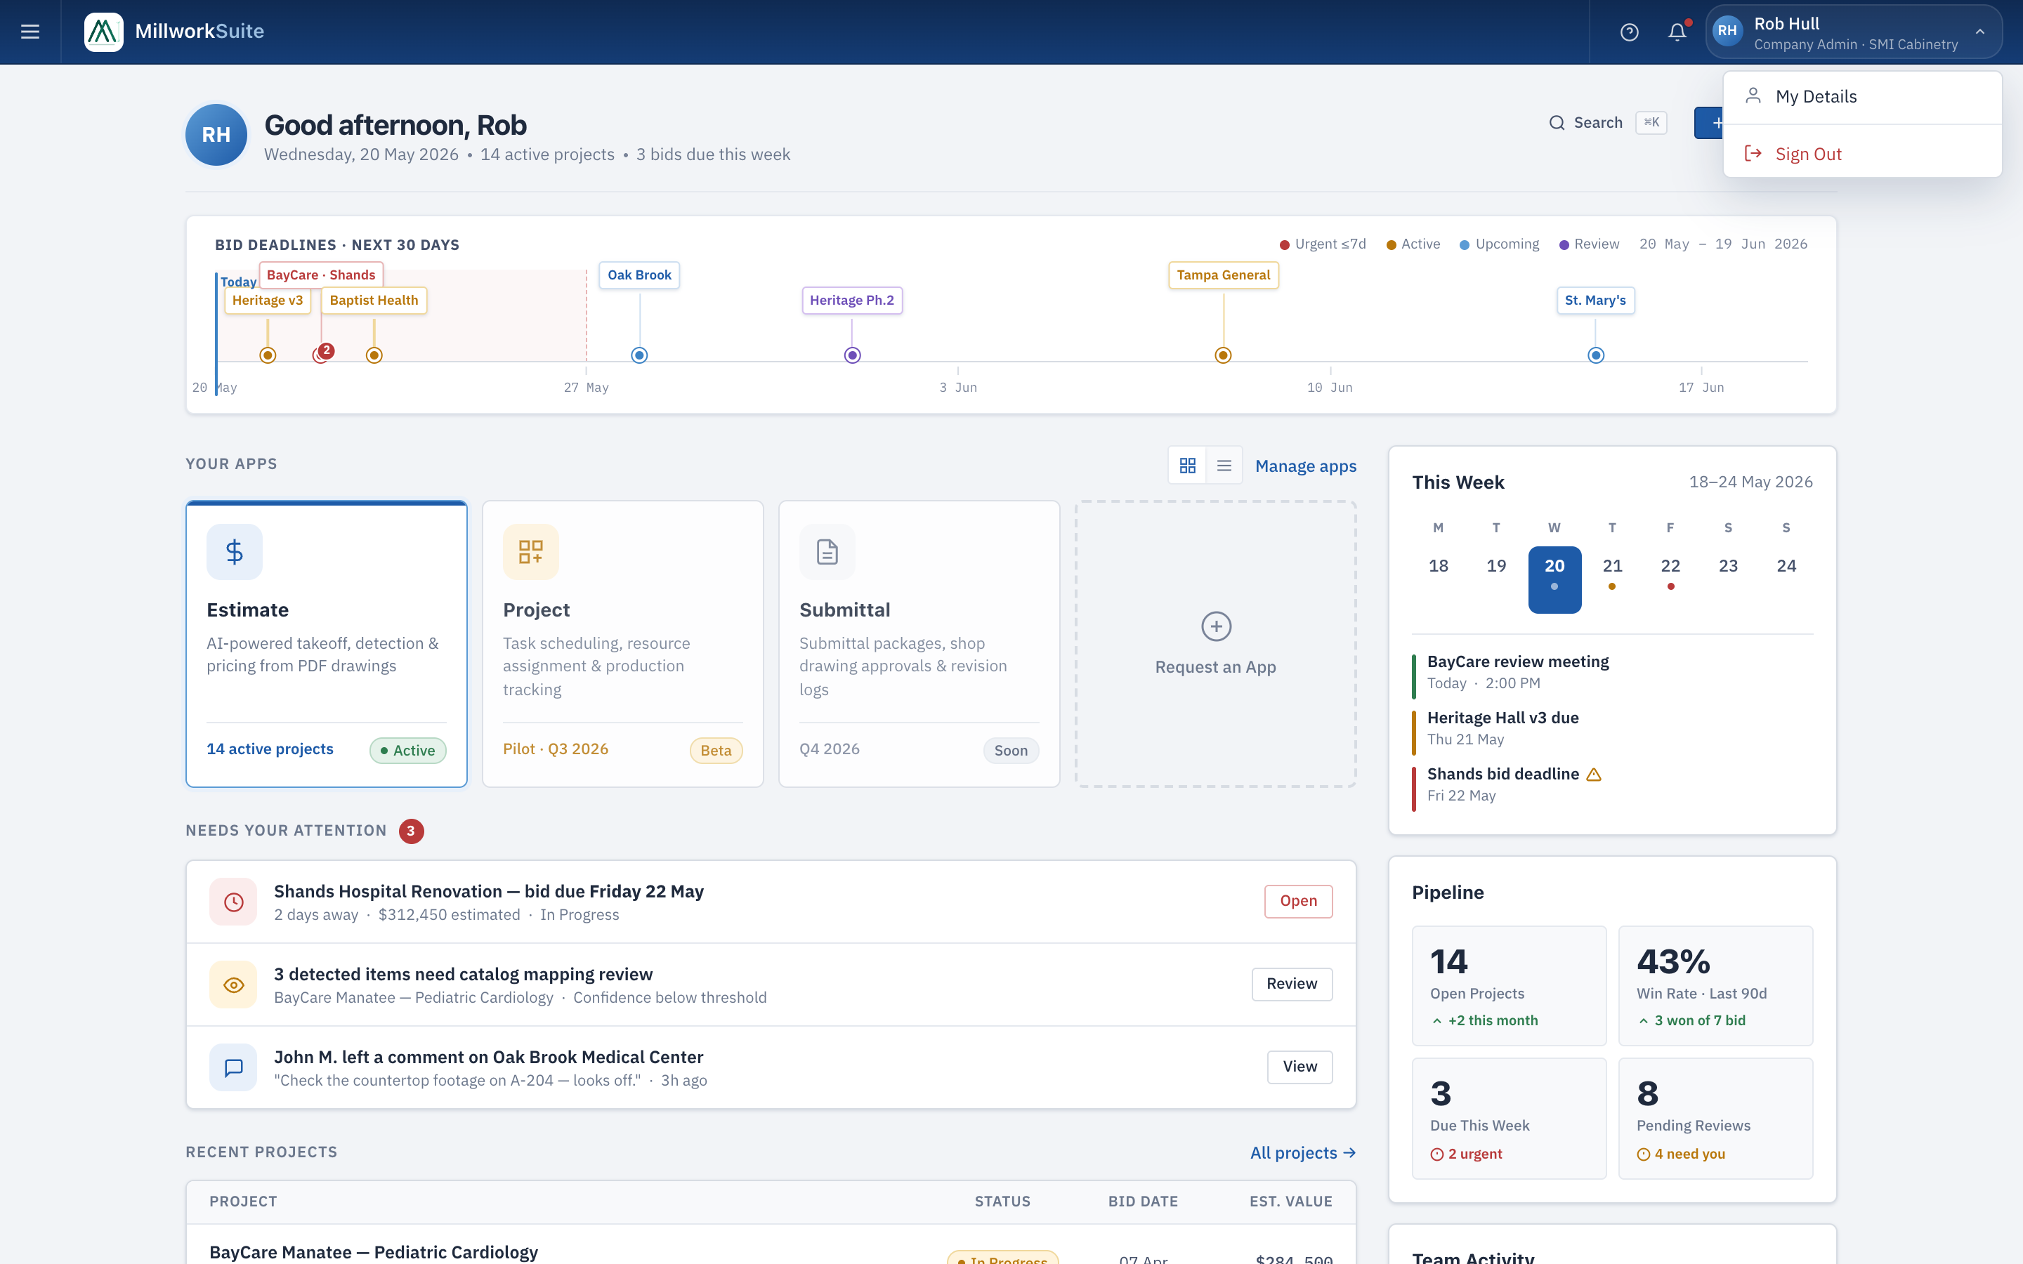
Fig 3 — User chip dropdown open
──────────────────────────────────────────────────────────────────────────────────────────

Component 1 — Top Bar (Global Shell)
Persistent across all authenticated screens. Contains:
- • Hamburger menu button (left) — opens the left navigation drawer.
- • MillworkSuite logo + wordmark — click navigates to App Hub.
- • Help icon button — opens contextual help.
- • Bell (notifications) icon — opens the notifications panel (see Component 1b).
- • User chip (right) — shows avatar initials, full name, role · company name, and a chevron ↓.
- - Clicking opens a dropdown with: "My Details" (→ Settings) and "Sign Out".
- - Chevron rotates 180° when dropdown is open.
- - Clicking outside the dropdown closes it.

1a. Left Navigation Drawer
- • Slides in from the left, starts below the 46 px topbar (does not overlap it).
- • Dark overlay covers the rest of the app while drawer is open.
- • Clicking anywhere outside the drawer closes it.
- • Escape key closes the drawer.
- • Contains: Apps group (Estimate expandable with sub-items: Projects, Catalogue, Templates), Admin group (Users & Roles, Settings).
- • Active screen is highlighted with blue background in the nav item.

1b. Notifications Panel
- • Slides out from the top-right when bell icon is clicked.
- • Bell shows a red dot badge when unread notifications exist.
- • Panel lists individual notifications with icon, title, body, and timestamp.
- • "View all notifications" button at the bottom.
- • Clicking outside the panel closes it.

Component 2 — Greeting Bar
- • Large avatar circle (initials, e.g. "RH") — left side.
- • "Good [morning/afternoon/evening], [First name]" — time-aware greeting, bold 18 px.
- • Sub-line: "[Day], [Date] · [N] active projects · [N] bids due this week" — dynamic, muted.
- • Right side: Search button (⌘K shortcut) and "+ New project" primary button.
- • Search button opens global command palette (Cmd/Ctrl + K).

Component 3 — 30-Day Bid Deadline Strip
Full-width horizontal timeline spanning the next 30 days, below the greeting bar.
- • Title: "Bid Deadlines · Next 30 Days" with legend: Urgent ≤7d (red), Active (amber), Upcoming (blue), Review (purple).
- • Date range label (e.g. "20 May – 19 Jun 2026") — monospace, right-aligned in legend.
- • Red shaded zone covers the first 7 days with a dashed right boundary (urgent window).
- • Blue "Today" line anchored at the left edge with a "Today" label above.
- • Week tick marks at 7-day intervals with date labels (e.g. 27 May, 3 Jun, 10 Jun, 17 Jun).
- • Deadline pins: each project appears as a vertical pin (label chip → stem → dot) at its deadline position.
- - Color matches status: red = urgent, amber = active, blue = upcoming, purple = in review.
- - Tall stems (40 px) and short stems (22 px) alternate to reduce label overlap.
- - When 2+ projects share a deadline, a ×N badge appears on a grouped pin.
- • Each pin is clickable → navigates to that project's workspace.
- • Pins have title tooltips on hover.

Component 4 — Main Column
4a. Your Apps Section
- • Section header: "Your Apps" + grid/list view toggle + "Manage apps" link.
- • Grid view (default): app cards in a responsive grid.
- • Each app card contains: icon (color-coded), app name, description, footer with stats + status tag.
- • Estimate card (Active): blue icon, "14 active projects" stat, green "Active" tag. Click → Projects.
- • Project card (Beta/Pilot): amber icon, "Pilot · Q3 2026" label, amber "Beta" tag. Dimmed/non-clickable.
- • Submittal card (Coming soon): grey icon, "Q4 2026" label, grey "Soon" tag. Dimmed.
- • "+ Request an App" placeholder card — outlined dashed style.
- • List view: cards collapse to a single horizontal row each.

4b. Needs Your Attention Section
- • Section header: "Needs Your Attention" with a red count badge (e.g. "3").
- • List of action items, each with: color-coded icon (red/amber/blue), title, meta text, action button.
- • Item types: bid deadline warnings (red), AI detection review flags (amber), team comments (blue).
- • Clicking the item row or its action button navigates to the relevant workspace.

4c. Recent Projects Section
- • Section header: "Recent Projects" + "All projects →" link (→ Projects dashboard).
- • Mini table: 4 columns — Project (name + client/GC), Status (tag), Bid Date, Est. Value.
- • Shows last 5 projects ordered by most recently accessed.
- • Clicking a row navigates to that project's workspace.
- • Est. Value shown in monospace font, right-aligned.

Component 5 — Right Sidebar
5a. This Week Calendar Widget
- • Header: "This Week" + date range (e.g. "18–24 May 2026").
- • 7-day calendar row (Mon–Sun) with day numbers.
- • Today is highlighted (blue circle).
- • Days with events show a small colored pip below the number.
- • Event list below: each event has a color bar, event name, and date/time.
- - Green: regular meetings.
- - Amber: upcoming deadlines.
- - Red: urgent/overdue deadlines (with a warning ⚠ icon).

5b. Pipeline Stats Widget
- • 4 stat boxes in a 2×2 grid:
- Open Projects: count + "+N this month" delta (green).
- Win Rate · Last 90d: percentage + "N won of N bid" delta (green/red).
- Due This Week: count + "N urgent" delta (red if >0).
- Pending Reviews: count + "N need you" delta (amber).
- • Each box: large bold number, label below, small delta line with colored arrow icon.

5c. Team Activity Feed
- • Section header: "Team Activity".
- • List of recent team actions, newest first.
- • Each item: avatar (color-coded by team member), action text (bold name + action description), timestamp.
- • Actions include: created project, uploaded drawings, mapped items, finalized version.
- • "You" refers to the signed-in user (shown with default avatar color).

──────────────────────────────────────────────────────────────────────────────────────────

Interactions
Interaction | Behaviour
Click hamburger (☰) | Opens left navigation drawer
Click outside drawer | Closes drawer
Click bell icon | Toggles notifications panel
Click user chip | Toggles My Details / Sign Out dropdown
Click My Details | Navigates to Settings screen
Click Sign Out | Shows confirm dialog → returns to /login
Click app card (Estimate) | Navigates to Projects Dashboard
Click attention item / button | Navigates to relevant project workspace
Click recent project row | Navigates to project workspace
Click "All projects →" | Navigates to Projects Dashboard
Click bid strip pin | Navigates to that project's workspace
Click "+ New project" | Opens New Project Wizard
Click Search / press ⌘K | Opens global command palette / search
Click "Manage apps" | Placeholder for app management screen

Acceptance Criteria
# | Acceptance Criterion
1 | Top bar renders with hamburger, logo, help, bell, and user chip on all authenticated screens.
2 | User chip shows avatar, full name, role, and company name (e.g. "Company Admin · SMI Cabinetry").
3 | Clicking user chip opens dropdown with "My Details" and "Sign Out"; chevron rotates 180°.
4 | Clicking outside the chip dropdown closes it.
5 | Clicking "Sign Out" shows a confirmation dialog before navigating to /login.
6 | Left nav drawer slides in below the topbar (46 px from top) and does not overlap it.
7 | Clicking outside the drawer or pressing Escape closes it.
8 | Bell badge shows when unread notifications exist; panel opens/closes correctly.
9 | Greeting shows time-aware salutation, current date, active project count, and bids due count.
10 | "+ New project" button navigates to the New Project Wizard.
11 | Bid deadline strip renders with today line, 7-day urgent zone, week ticks, and all project pins.
12 | Deadline pins are color-coded by status; grouped pins show ×N badge.
13 | Clicking a pin navigates to the correct project workspace.
14 | Your Apps section renders all 3 app cards with correct status tags and click behavior.
15 | Estimate app card stat shows live active project count.
16 | Needs Your Attention section shows items with correct color icons and action buttons.
17 | Attention item count badge matches number of items displayed.
18 | Recent Projects table shows 5 most recent projects with status, bid date, and est. value.
19 | Clicking a recent project row navigates to the workspace.
20 | Pipeline widget shows all 4 stat boxes with correct values and delta lines.
21 | Win Rate box shows percentage + "N won of N bid" sub-line.
22 | This Week calendar highlights today; event pips and event list render correctly.
23 | Team Activity feed shows recent team actions with correct avatars and timestamps.
24 | Page is fully responsive at desktop, tablet, and mobile breakpoints.
25 | Page passes WCAG 2.1 AA audit.

