MWS-006 — Project Workspace (Estimate Screen)
Jira Story · MillworkSuite UX Implementation
──────────────────────────────────────────────────────────────────────────────────────────

Story ID | MWS-006
Epic | MWS — Estimate App
Type | Story
Priority | P0 — Blocker
Story Points | 21
Labels | frontend, estimate, workspace, AI, UX
Route | /estimate/projects/:id
Breadcrumb | ← Projects / [Project Name]

User Story
As an estimator, I want to open a project and see the AI-detected millwork items overlaid on the original PDF drawing so that I can review, correct, and price each item, then export the finalised estimate to Microvellum or Cabinet Vision.

Screen Reference
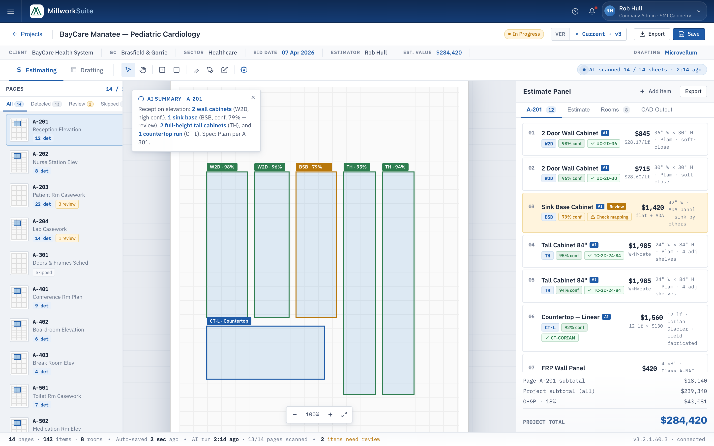
Fig 1 — Project Workspace — Estimating mode, A-201 active (1440 × 900, @2x)
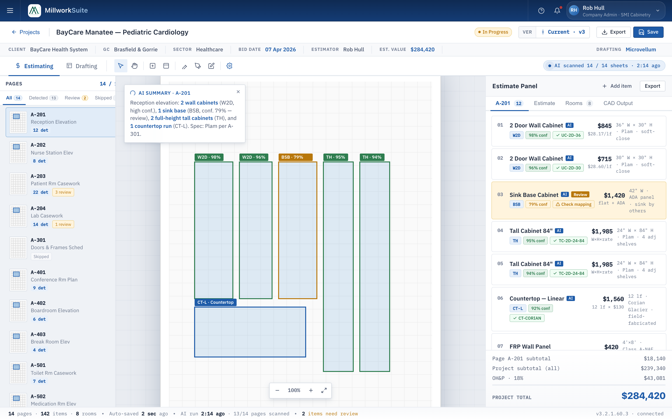
Fig 2 — Workspace with AI Summary overlay open on the PDF canvas
──────────────────────────────────────────────────────────────────────────────────────────

Component 1 — Project Header Bar
- • "← Projects" back button — navigates back to the Projects Dashboard.
- • Project name: "BayCare Manatee — Pediatric Cardiology" — bold H2.
- • Status tag: colored pill (e.g. amber "In Progress") — flex-shrink:0, always visible.
- • Version indicator: "Ver Current · v3" with a version icon — shows current revision number.
- • Export button (secondary): triggers Microvellum export; shows info toast: "Export started — Generating Microvellum file…"
- • Save button (primary blue): saves current state; shows success toast: "BayCare Manatee saved successfully."

Component 2 — Project Info Strip
A horizontal row of metadata chips below the header. Non-editable (read-only context bar).
Chip | Example Value | Highlight
Client | BayCare Health System | Plain text
GC | Brasfield & Gorrie | Plain text
Sector | Healthcare | Plain text
Bid Date | 07 Apr 2026 | Bold/colored — urgent if near deadline
Estimator | Rob Hull | Plain text
Est. Value | $284,420 | Bold colored (blue)
Drafting | Microvellum | Blue bold — indicates CAD output target

Component 3 — Mode & Tool Bar
3a. Mode Tabs
- • Two mode tabs: "Estimating" (active by default) and "Drafting".
- • Estimating mode: right panel shows prices, margins, confidence. Focused on pricing.
- • Drafting mode: right panel shows CAD export type per item. Focused on production handoff.
- • Switching modes changes the right-panel column layout but not the PDF canvas or left rail.

3b. Toolbar Tools
Tool | Icon | Function
Select | Cursor arrow | Default — click to select a detection box on canvas
Pan | Hand icon | Drag to pan the PDF canvas
Add Room | Rectangle + plus | Draw a new room boundary on the canvas
Add Elevation | Rectangle + line | Add a new elevation view marker
Measure | Ruler/pencil | Measure distances on the drawing
Markup | Pen/arrow | Add freehand markup annotations
Annotate | Note/pen | Add text annotations to the drawing
AI Re-scan | Gear/circle (blue) | Trigger a fresh AI detection pass on the current page

3c. AI Scan Status Pill
- • Shown right-aligned in the modebar: "● AI scanned 14 / 14 sheets · 2:14 ago".
- • Green dot indicates scan is complete.
- • Amber dot + "Scanning…" shown while a re-scan is in progress.
- • Shows how many sheets have been processed and time elapsed since last scan.

Component 4 — Three-Panel Body Layout
The workspace body is a fixed three-panel layout: Pages rail (left) | PDF Canvas (center) | Estimate Panel (right).

4a. Pages Rail (Left, ~230 px)
- • Header: "Pages" + "14 / 14" count in blue monospace.
- • Filter tabs: All (14) | Detected (13) | Review (2, amber badge) | Skipped (1).
- • Each page item:
- - Thumbnail swatch: blue = detected, amber = needs review, white = not yet processed, grey = skipped.
- - Page number (e.g. A-201) — bold.
- - Page title (e.g. "Reception Elevation") — muted.
- - Status chips: "12 det" (blue), "3 review" (amber), "Skipped" (grey).
- • Active page is highlighted with a blue left border and blue background.
- • Clicking a page item: loads that sheet into the center canvas and updates the right panel.
- • Review filter shows only pages with items needing attention.

4b. PDF Canvas (Center)
- • Renders the actual PDF drawing sheet for the selected page.
- • Grid overlay (subtle dot grid) behind the PDF.
- • Sheet header inside the canvas: page number + title (e.g. "A-201 — RECEPTION ELEVATION") and scale.
- • Stamp at the bottom: "DRAWN: RH · 04/02/2026 · SHEET A-201 OF 14".
- • AI Detection bounding boxes overlaid on the drawing, color-coded by confidence:
- - Green border + label: high confidence (≥90%) — e.g. "W2D · 98%".
- - Amber border + label + ⚠ warning icon: medium confidence (70–89%) — e.g. "BSB · 79% ⚠".
- - Red border: low confidence (<70%) — needs manual review.
- • Each detection box shows the AWI type code + confidence percentage.
- • Clicking a detection box highlights the corresponding row in the right panel.
- • Canvas zoom controls (bottom right): − | 100% | + | Fit-to-screen.
- • Canvas is pannable (drag) and zoomable (scroll wheel).

4c. AI Summary Overlay (canvas overlay)
- • A floating card appears on the canvas when triggered (via AI Re-scan or auto-open).
- • Header: "AI Summary · A-201" with a pulsing spinner icon.
- • Body: plain-language summary of all detected items on the page, e.g.:
- "Reception elevation: 2 wall cabinets (W2D, high conf.), 1 sink base (BSB, conf. 79% — review), 2 full-height tall cabinets (TH), and 1 countertop run (CT-L). Spec: Plam per A-301."
- • Close (×) button dismisses the overlay without affecting detections.

4d. Estimate Panel (Right)
Header: "Estimate Panel" + "Add item" + "Export" buttons. Four tabs:
Tab | Content
A-201 (12) | Detected items list for the active page — see Item Row detail below
Estimate | Category breakdown with markup settings (OH&P rate, sales tax) and subtotals by category
Rooms (8) | Room-level grouping of items — each room shows item count and subtotal
CAD Output | Per-item CAD export target (Microvellum SKU / Cabinet Vision mapping)

Item Row (Detections tab) — anatomy:
Element | Detail
Line number | 01, 02, 03… — sequential per page
Item name | Full description + blue "AI" badge (or no badge if manually added)
AWI type chip | Short code (e.g. W2D, BSB, TH, CT-L) with tooltip on hover
Confidence chip | Green (≥90%), amber (70–89%), or grey "Manual" for hand-entered items
Catalog mapping | Green ✓ + SKU code if mapped; amber ⚠ "Check mapping" if gap; catalogue link
Price (right) | Dollar amount, bold — derived from catalog pricing method
Price sub | Unit breakdown (e.g. "$28.17/lf", "flat + ADA", "12 lf × $130")
Spec line | Dimensions + material + notes (e.g. "36" W × 30" H · Plam · soft-close")
Flagged row | "Review" badge + amber left border — for items with confidence <80% or mapping gaps

Estimate tab — markup settings:
- • OH&P rate: editable input (default 18%), updates all line item prices in real-time.
- • Sales tax: editable input (default 0.0%).
- • Category breakdown: each product category shows icon, name, item count, sheet reference, and subtotal.
- • Categories: Casework, Countertops, Custom Millwork, Wall Panels, etc.
- • PROJECT TOTAL shown at the bottom — large bold, sum of all categories with markup applied.

──────────────────────────────────────────────────────────────────────────────────────────

Confidence Color System
Level | Threshold | Border Color | Chip Color | Action Required
High | ≥90% | Green | Green bg | None — auto-accepted
Medium | 70–89% | Amber | Amber bg | Estimator review recommended
Low | <70% | Red | Red bg | Manual confirmation required
Manual | N/A | None | Grey bg | Manually added item, no AI source

Export Behaviour
- • Export button in header: triggers export of the full project estimate.
- • Export target shown in the info strip ("Drafting: Microvellum").
- • In Drafting mode, each item row shows its CAD export SKU/mapping.
- • Toast on export start: "Export started — Generating Microvellum file for [Project Name]…"
- • Toast on export complete: "Export ready — [filename].mvd ready to download."
- • Export tab in the right panel shows per-item CAD Output mapping.

Versioning
- • Version indicator in the header: "Current · v3".
- • Every Save creates a new version automatically if changes were made.
- • Won bids are locked (read-only) — no edits possible on a won version.
- • Version history is accessible from the version indicator dropdown.

Acceptance Criteria
# | Acceptance Criterion
1 | Project header renders with back button, project name, status tag, version indicator, Export, and Save buttons.
2 | Info strip shows all 7 metadata chips: Client, GC, Sector, Bid Date, Estimator, Est. Value, Drafting target.
3 | Mode bar renders with Estimating and Drafting tabs; toggling changes right-panel layout.
4 | All 8 toolbar tools render with correct icons and tooltips.
5 | AI scan status pill shows scanned sheet count and elapsed time.
6 | Pages rail renders with All/Detected/Review/Skipped filter tabs and correct counts.
7 | Active page is highlighted in the rail; clicking a page loads it in the canvas.
8 | Page items show thumbnail swatch (blue/amber/white/grey), page number, title, and status chips.
9 | PDF canvas renders the active sheet with grid overlay, sheet header, and scale.
10 | AI detection bounding boxes render on the canvas with correct AWI codes and confidence percentages.
11 | Detection box colors match confidence levels: green ≥90%, amber 70–89%.
12 | Clicking a detection box highlights the corresponding row in the right panel.
13 | Canvas zoom controls (−, %, +, Fit) work correctly.
14 | Canvas is pannable by dragging and zoomable by scroll wheel.
15 | AI Summary overlay renders on canvas with plain-language summary and a close button.
16 | Right panel Detections tab lists all items with line number, name, AI badge, AWI code, confidence chip, mapping chip, price, and spec line.
17 | Flagged items (confidence <80% or mapping gap) show amber "Review" badge and amber left border.
18 | Manual items show grey "Manual" chip instead of confidence percentage.
19 | Estimate tab shows markup inputs (OH&P, sales tax) and category breakdown with subtotals.
20 | Changing OH&P rate updates all line item prices in real-time.
21 | PROJECT TOTAL updates whenever items or markup rates change.
22 | Export button triggers export and shows correct info toast.
23 | Save button saves current state and shows success toast.
24 | Page is fully responsive at desktop and tablet breakpoints.
25 | Page passes WCAG 2.1 AA audit.

