湘潭县项目数据库设计文档

1. **存储结构模型图**

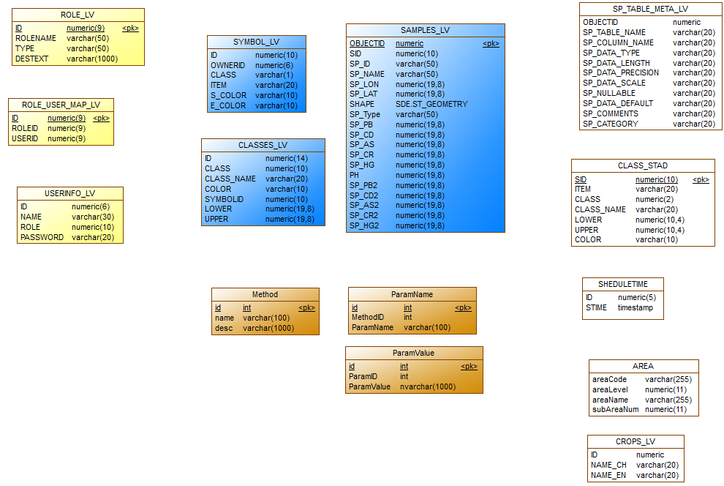

1. **数据库表描述**

**1、标准数据表**

**表名：AREA**

|  |  |  |  |  |  |  |  |  |  |  |
| --- | --- | --- | --- | --- | --- | --- | --- | --- | --- | --- |
| **序号** | **列名** | **数据类型** | **长度** | **小数位** | **标识** | **主键** | **外键** | **允许空** | **默认值** | **说明** |
| 1 | areaCode | varchar | 255 | 0 |  |  |  | 否 |  |  |
| 2 | areaLevel | numeric | 9 | 0 |  |  |  | 否 |  |  |
| 3 | areaName | varchar | 255 | 0 |  |  |  | 是 |  |  |
| 4 | subAreaNum | numeric | 9 | 0 |  |  |  | 否 |  |  |

**表名：CLASS_STAD**

|  |  |  |  |  |  |  |  |  |  |  |
| --- | --- | --- | --- | --- | --- | --- | --- | --- | --- | --- |
| **序号** | **列名** | **数据类型** | **长度** | **小数位** | **标识** | **主键** | **外键** | **允许空** | **默认值** | **说明** |
| 1 | SID | numeric | 9 | 0 |  | 是 |  | 否 |  |  |
| 2 | ITEM | varchar | 20 | 0 |  |  |  | 否 |  |  |
| 3 | CLASS | numeric | 5 | 0 |  |  |  | 否 |  |  |
| 4 | CLASS_NAME | varchar | 20 | 0 |  |  |  | 否 |  |  |
| 5 | LOWER | numeric | 9 | 4 |  |  |  | 否 |  |  |
| 6 | UPPER | numeric | 9 | 4 |  |  |  | 否 |  |  |
| 7 | COLOR | varchar | 10 | 0 |  |  |  | 否 |  |  |

**表名：CROPS_LV**

|  |  |  |  |  |  |  |  |  |  |  |
| --- | --- | --- | --- | --- | --- | --- | --- | --- | --- | --- |
| **序号** | **列名** | **数据类型** | **长度** | **小数位** | **标识** | **主键** | **外键** | **允许空** | **默认值** | **说明** |
| 1 | ID | numeric | 9 | 0 |  |  |  | 是 |  |  |
| 2 | NAME_CH | varchar | 20 | 0 |  |  |  | 是 |  |  |
| 3 | NAME_EN | varchar | 20 | 0 |  |  |  | 是 |  |  |

**表名：SHEDULETIME**

|  |  |  |  |  |  |  |  |  |  |  |
| --- | --- | --- | --- | --- | --- | --- | --- | --- | --- | --- |
| **序号** | **列名** | **数据类型** | **长度** | **小数位** | **标识** | **主键** | **外键** | **允许空** | **默认值** | **说明** |
| 1 | ID | numeric | 5 | 0 |  |  |  | 是 |  |  |
| 2 | STIME | timestamp | 8 | 0 |  |  |  | 是 |  |  |

**表名：SP_TABLE_META_LV**

|  |  |  |  |  |  |  |  |  |  |  |
| --- | --- | --- | --- | --- | --- | --- | --- | --- | --- | --- |
| **序号** | **列名** | **数据类型** | **长度** | **小数位** | **标识** | **主键** | **外键** | **允许空** | **默认值** | **说明** |
| 1 | OBJECTID | numeric | 9 | 0 |  | 是 |  | 否 |  |  |
| 2 | SP_TABLE_NAME | varchar | 20 | 0 |  |  |  | 是 |  |  |
| 3 | SP_COLUMN_NAME | varchar | 20 | 0 |  |  |  | 是 |  |  |
| 4 | SP_DATA_TYPE | varchar | 20 | 0 |  |  |  | 是 |  |  |
| 5 | SP_DATA_LENGTH | varchar | 20 | 0 |  |  |  | 是 |  |  |
| 6 | SP_DATA_PRECISION | varchar | 20 | 0 |  |  |  | 是 |  |  |
| 7 | SP_DATA_SCALE | varchar | 20 | 0 |  |  |  | 是 |  |  |
| 8 | SP_NULLABLE | varchar | 20 | 0 |  |  |  | 是 |  |  |
| 9 | SP_DATA_DEFAULT | varchar | 20 | 0 |  |  |  | 是 |  |  |
| 10 | SP_COMMENTS | varchar | 20 | 0 |  |  |  | 是 |  |  |
| 11 | SP_CATEGORY | varchar | 20 | 0 |  |  |  | 是 |  |  |

**2、（插值）模型数据表**

**表名：Method**

|  |  |  |  |  |  |  |  |  |  |  |
| --- | --- | --- | --- | --- | --- | --- | --- | --- | --- | --- |
| **序号** | **列名** | **数据类型** | **长度** | **小数位** | **标识** | **主键** | **外键** | **允许空** | **默认值** | **说明** |
| 1 | id | int | 4 | 0 |  | 是 |  | 否 |  |  |
| 2 | name | varchar | 100 | 0 |  |  |  | 是 |  |  |
| 3 | desc | varchar | 1000 | 0 |  |  |  | 是 |  |  |

**表名：ParamName**

|  |  |  |  |  |  |  |  |  |  |  |
| --- | --- | --- | --- | --- | --- | --- | --- | --- | --- | --- |
| **序号** | **列名** | **数据类型** | **长度** | **小数位** | **标识** | **主键** | **外键** | **允许空** | **默认值** | **说明** |
| 1 | id | int | 4 | 0 |  | 是 |  | 否 |  |  |
| 2 | MethodID | int | 4 | 0 |  |  |  | 是 |  |  |
| 3 | ParamName | varchar | 100 | 0 |  |  |  | 是 |  |  |

**表名：ParamValue**

|  |  |  |  |  |  |  |  |  |  |  |
| --- | --- | --- | --- | --- | --- | --- | --- | --- | --- | --- |
| **序号** | **列名** | **数据类型** | **长度** | **小数位** | **标识** | **主键** | **外键** | **允许空** | **默认值** | **说明** |
| 1 | id | int | 4 | 0 |  | 是 |  | 否 |  |  |
| 2 | ParamID | int | 4 | 0 |  |  |  | 是 |  |  |
| 3 | ParamValue | nvarchar | 1000 | 0 |  |  |  | 是 |  |  |

**3、权限管理数据表**

**表名：USERINFO_LV**

|  |  |  |  |  |  |  |  |  |  |  |
| --- | --- | --- | --- | --- | --- | --- | --- | --- | --- | --- |
| **序号** | **列名** | **数据类型** | **长度** | **小数位** | **标识** | **主键** | **外键** | **允许空** | **默认值** | **说明** |
| 1 | ID | numeric | 5 | 0 |  |  |  | 是 |  |  |
| 2 | NAME | varchar | 30 | 0 |  |  |  | 是 |  |  |
| 3 | ROLE | numeric | 9 | 0 |  |  |  | 是 |  |  |
| 4 | PASSWORD | varchar | 20 | 0 |  |  |  | 是 |  |  |
| 5 | GROUPID | numeric | 5 | 0 |  |  |  | 是 |  |  |

**表名：ROLE_LV**

|  |  |  |  |  |  |  |  |  |  |  |
| --- | --- | --- | --- | --- | --- | --- | --- | --- | --- | --- |
| **序号** | **列名** | **数据类型** | **长度** | **小数位** | **标识** | **主键** | **外键** | **允许空** | **默认值** | **说明** |
| 1 | ID | numeric | 5 | 0 |  | 是 |  | 否 |  |  |
| 2 | ROLENAME | varchar | 50 | 0 |  |  |  | 否 |  |  |
| 3 | TYPE | varchar | 50 | 0 |  |  |  | 否 |  |  |
| 4 | DESTEXT | varchar | 1000 | 0 |  |  |  | 否 |  |  |

**表名：ROLE_USER_MAP_LV**

|  |  |  |  |  |  |  |  |  |  |  |
| --- | --- | --- | --- | --- | --- | --- | --- | --- | --- | --- |
| **序号** | **列名** | **数据类型** | **长度** | **小数位** | **标识** | **主键** | **外键** | **允许空** | **默认值** | **说明** |
| 1 | ID | numeric | 5 | 0 |  | 是 |  | 否 |  |  |
| 2 | ROLEID | numeric | 5 | 0 |  |  |  | 否 |  |  |
| 3 | USERID | numeric | 5 | 0 |  |  |  | 否 |  |  |

**4、采样数据表**

**表名：SAMPLES_LV**

|  |  |  |  |  |  |  |  |  |  |  |
| --- | --- | --- | --- | --- | --- | --- | --- | --- | --- | --- |
| **序号** | **列名** | **数据类型** | **长度** | **小数位** | **标识** | **主键** | **外键** | **允许空** | **默认值** | **说明** |
| 1 | OBJECTID | numeric | 9 | 0 |  | 是 |  | 否 |  |  |
| 2 | SID | numeric | 9 | 0 |  |  |  | 是 |  |  |
| 3 | SP_ID | varchar | 50 | 0 |  |  |  | 是 |  |  |
| 4 | SP_NAME | varchar | 50 | 0 |  |  |  | 是 |  |  |
| 5 | SP_LON | numeric | 9 | 8 |  |  |  | 是 |  |  |
| 6 | SP_LAT | numeric | 9 | 8 |  |  |  | 是 |  |  |
| 7 | SP_Type | varchar | 50 | 0 |  |  |  | 是 |  |  |
| 8 | SP_PB | numeric | 9 | 8 |  |  |  | 是 |  |  |
| 9 | SP_CD | numeric | 9 | 8 |  |  |  | 是 |  |  |
| 10 | SP_AS | numeric | 9 | 8 |  |  |  | 是 |  |  |
| 11 | SP_CR | numeric | 9 | 8 |  |  |  | 是 |  |  |
| 12 | SP_HG | numeric | 9 | 8 |  |  |  | 是 |  |  |
| 13 | PH | numeric | 9 | 8 |  |  |  | 是 |  |  |
| 14 | SP_PB2 | numeric | 9 | 8 |  |  |  | 是 |  |  |
| 15 | SP_CD2 | numeric | 9 | 8 |  |  |  | 是 |  |  |
| 16 | SP_AS2 | numeric | 9 | 8 |  |  |  | 是 |  |  |
| 17 | SP_CR2 | numeric | 9 | 8 |  |  |  | 是 |  |  |
| 18 | SP_HG2 | numeric | 9 | 8 |  |  |  | 是 |  |  |

**表名：CLASSES_LV**

|  |  |  |  |  |  |  |  |  |  |  |
| --- | --- | --- | --- | --- | --- | --- | --- | --- | --- | --- |
| **序号** | **列名** | **数据类型** | **长度** | **小数位** | **标识** | **主键** | **外键** | **允许空** | **默认值** | **说明** |
| 1 | ID | numeric | 9 | 0 |  |  |  | 是 |  |  |
| 2 | CLASS | numeric | 9 | 0 |  |  |  | 是 |  |  |
| 3 | CLASS_NAME | varchar | 20 | 0 |  |  |  | 是 |  |  |
| 4 | COLOR | varchar | 10 | 0 |  |  |  | 是 |  |  |
| 5 | SYMBOLID | numeric | 9 | 0 |  |  |  | 是 |  |  |
| 6 | LOWER | numeric | 9 | 8 |  |  |  | 是 |  |  |
| 7 | UPPER | numeric | 9 | 8 |  |  |  | 是 |  |  |

**表名：SYMBOL_LV**

|  |  |  |  |  |  |  |  |  |  |  |
| --- | --- | --- | --- | --- | --- | --- | --- | --- | --- | --- |
| **序号** | **列名** | **数据类型** | **长度** | **小数位** | **标识** | **主键** | **外键** | **允许空** | **默认值** | **说明** |
| 1 | ID | numeric | 9 | 0 |  |  |  | 是 |  |  |
| 2 | OWNERID | numeric | 5 | 0 |  |  |  | 是 |  |  |
| 3 | CLASS | varchar | 1 | 0 |  |  |  | 是 |  |  |
| 4 | ITEM | varchar | 20 | 0 |  |  |  | 是 |  |  |
| 5 | S_COLOR | varchar | 10 | 0 |  |  |  | 是 |  |  |
| 6 | E_COLOR | varchar | 10 | 0 |  |  |  | 是 |  |  |