# Install-Guides

<https://tomcat.apache.org/tomcat-8.5-doc/index.html>

<https://www.tecmint.com/install-apache-tomcat-in-centos/>

# Steps:-

# Pre-req Java 8 , utilities Installation

sudo yum install java-1.8.0-openjdk -y

sudo yum install wget

# tomcat 8 download

sudo mkdir /opt/tomcat

sudo chown ec2-user -R /opt/tomcat

cd /opt/tomcat

sudo wget <http://www.gtlib.gatech.edu/pub/apache/tomcat/tomcat-8/v8.5.23/bin/apache-tomcat-8.5.23.tar.gz>

sudo tar -xvf apache-tomcat-8.5.23.tar.gz

sudo chown ec2-user -R /opt/tomcat

cd /opt/tomcat/apache-tomcat-8.5.23/bin

./startup.sh

# Test the tomcat startup

Goto :-

http://<<ec2-public-DNS>>:8080/

ex: <http://ec2-34-201-62-67.compute-1.amazonaws.com:8080/>

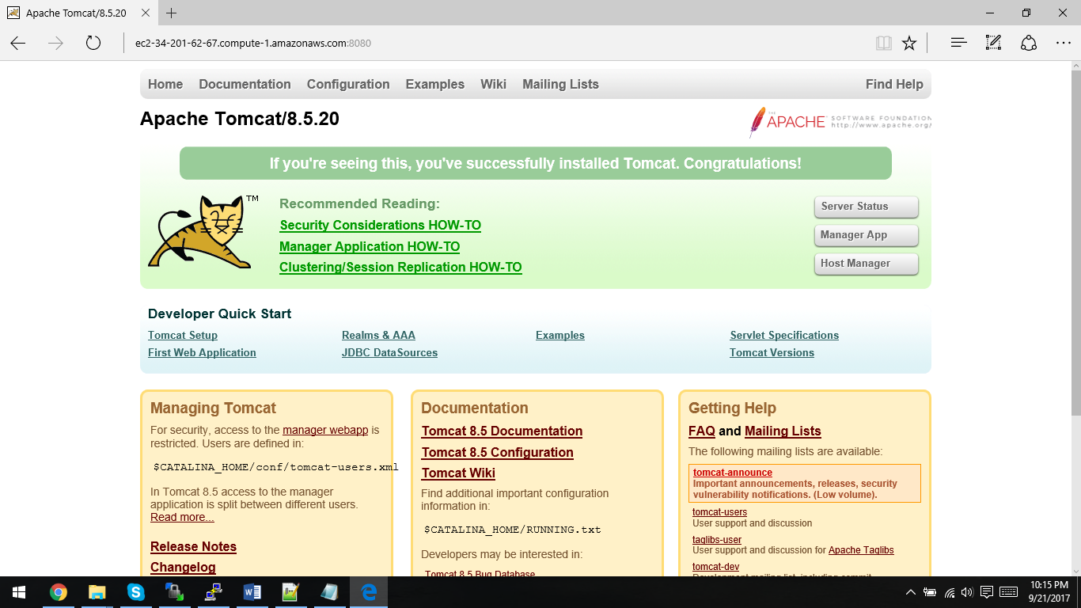

# Shutdown after confirmation

./shutdown.sh