a)

<https://console.aws.amazon.com/ec2>

b)

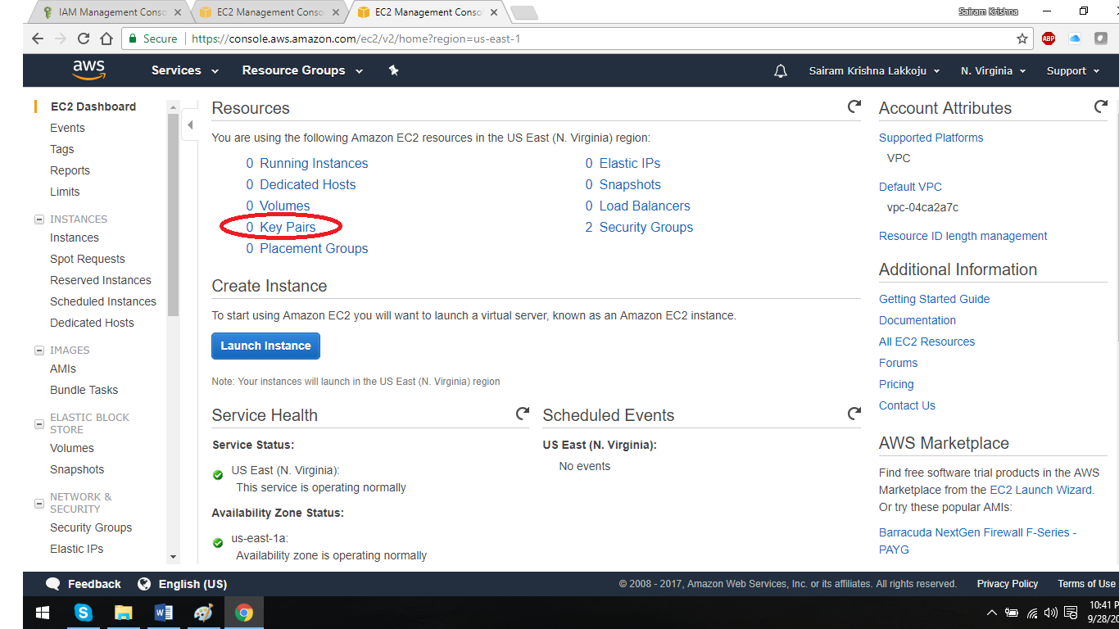

**Create Key Pair**

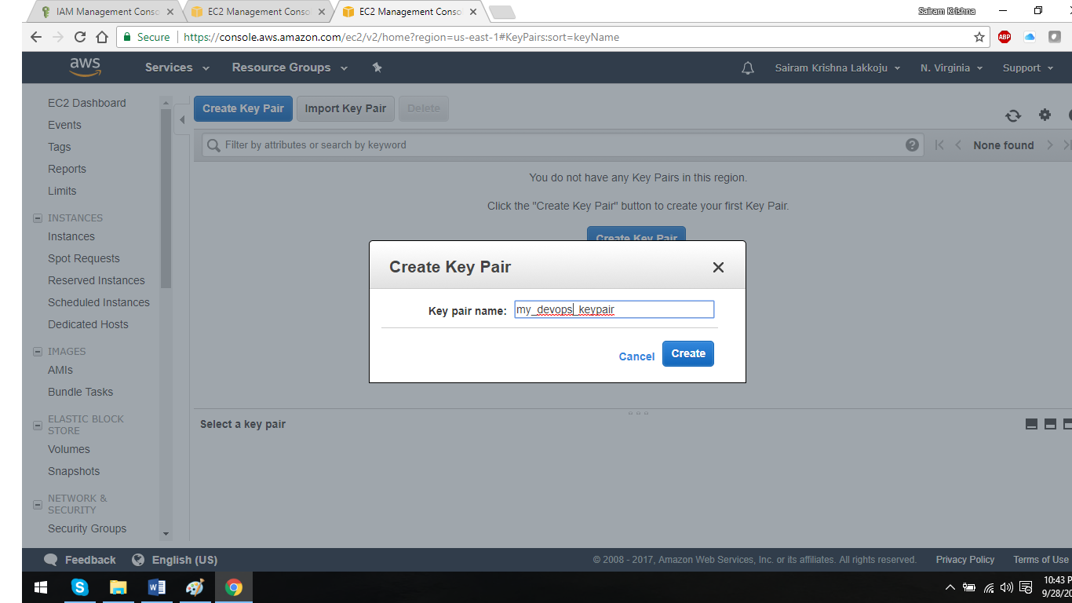

Save the file in your local desktop in a secure location.This is your private key to sign-in (ssh ) to the remote EC2 linux VMs