# Installation and Configuration Guide

https://wiki.jenkins.io/display/JENKINS/Installing+Jenkins+on+Red+Hat+distributions

# Installation Commands

# Pre-req Java 8 , utilities Installation

sudo yum install java-1.8.0-openjdk -y

sudo yum install java-devel

sudo yum install wget

# Jenkins package installation

sudo wget -O /etc/yum.repos.d/jenkins.repo http://pkg.jenkins-ci.org/redhat/jenkins.repo

sudo rpm --import https://jenkins-ci.org/redhat/jenkins-ci.org.key

sudo yum install jenkins

sudo service jenkins start

sudo chkconfig jenkins on

# Access your Jenkins

http://<<ec2-instance_public_dns>>:8080

ex: <http://ec2-54-84-83-156.compute-1.amazonaws.com:8080>

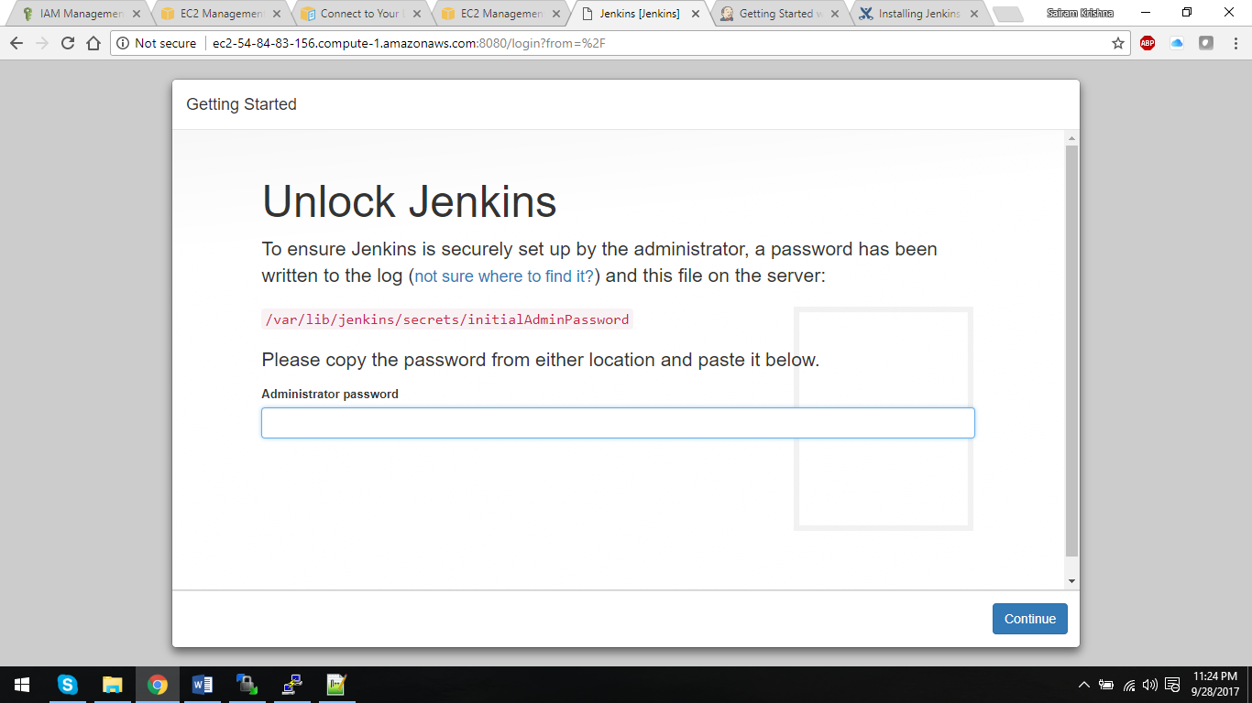

ssh to you ec2 instance and get the intial password:-

sudo cat /var/lib/jenkins/secrets/initialAdminPassword

Install Suggested Plugins

Fill out **all** the details and create an admin user