# Installation and Configuration Guide

1. **ssh to Jenkins VM and install git**

sudo yum install git

**b) sonar scanner**

Login to Jenkins and go to

Jenkins >> Manage Jenkins >> Manage Plugins

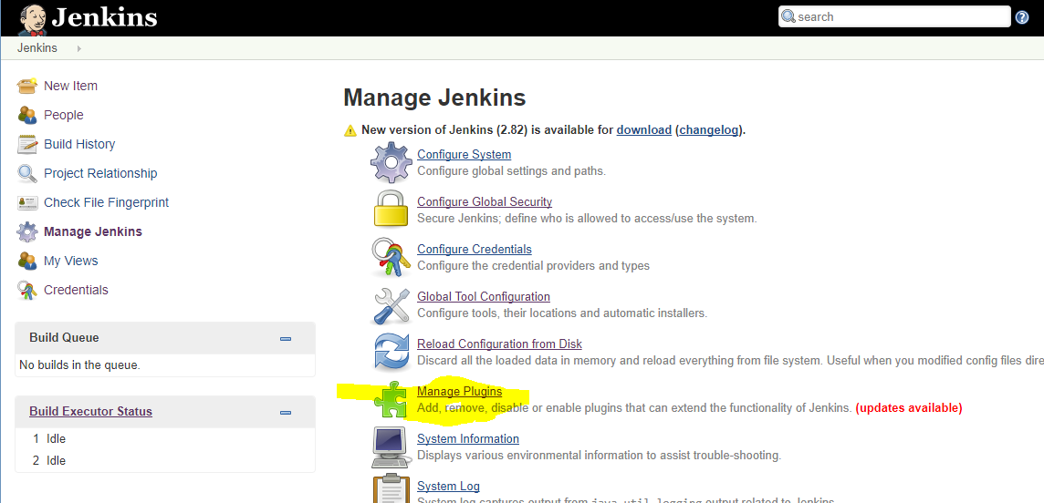

Click on ‘Available’ Tab and search for sonarqube

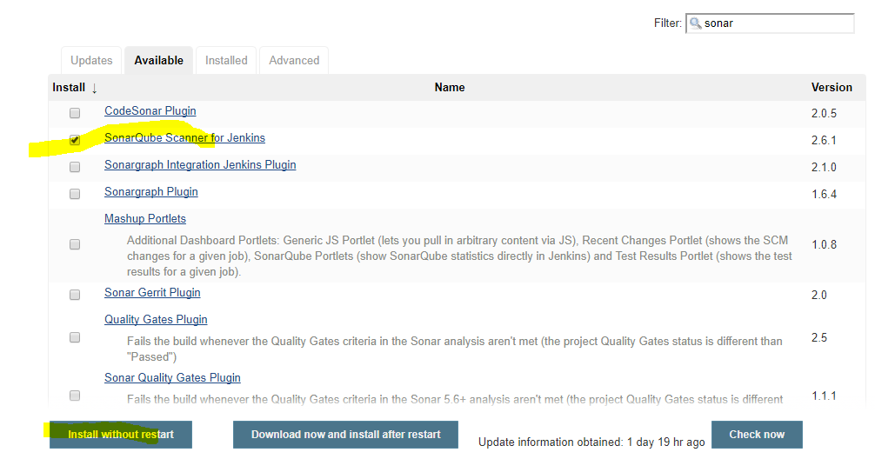

Go to :- Jenkins >> Global Tool Configuration

and set the config for sonar scanner as shown below:-

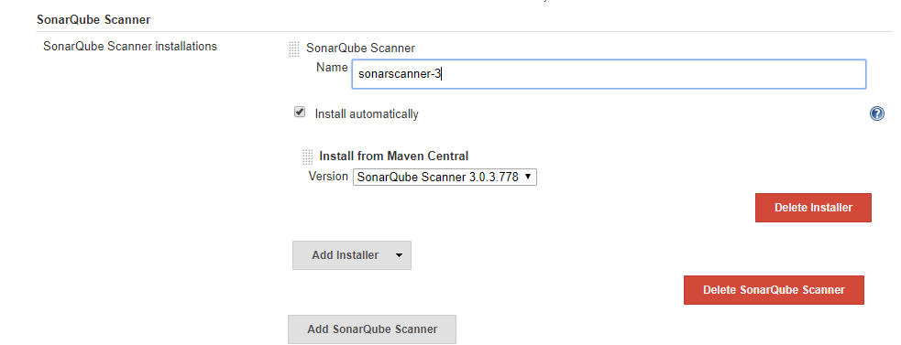

**SonarQube Server Config**

Go to :- Jenkins >> Manage Jenkins >> Configure System

nd set ‘SonarQube servers’ as shown below

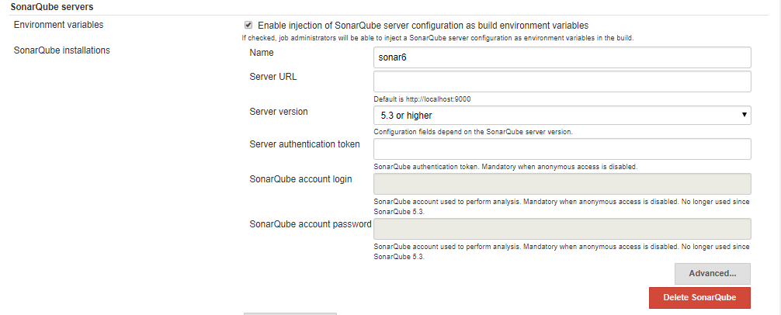

**c) Maven**

Login to Jenkins and go to

Jenkins >> Global Tool Configuration

Set Maven tool configuration

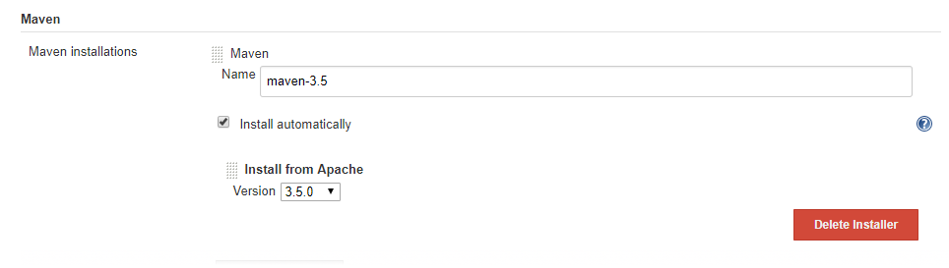

d) Ansible

Jenkins >> Manage Jenkins >> Manage Plugins

Search for  [Ansible plugin](https://wiki.jenkins-ci.org/display/JENKINS/Ansible+Plugin) and install it

e)

Jenkins >> Manage Jenkins >> Manage Plugins

Search for  [Build Pipeline Plugin](https://wiki.jenkins-ci.org/display/JENKINS/Ansible+Plugin)  and install it

f)

Jenkins >> Manage Jenkins >> Manage Plugins

Search for [[Parameterized Trigger plugin](https://plugins.jenkins.io/parameterized-trigger)](https://wiki.jenkins-ci.org/display/JENKINS/Ansible+Plugin) and install it

g)

#Create a settings.xml file for nexus upload credentials

sudo mkdir /opt/jenkins_settings

sudo chmod 755 /opt/jenkins_settings

sudo chown ec2-user -R /opt/jenkins_settings

copy  to /opt/jenkins_settings

h) sudo yum install java-devel