**Lab Manual**

Step: --

1. Create a repo in local machine
2. Create a file (default it would be as master) with 1st line.
3. Add 2nd line to the file and save it to the BRANCH on GIT local repo
4. Merge the file to the master on the GIT Local repo
5. Edit the file with an Editor on the local machine, and add 3rd line to the file and save it on your machine, Commit this change to the Branch copy on GIT local repo.
6. Push master origin to GITHUB.com & Push branch origin to GITHUB.com
7. Finally, merge the Branch on GITHUB.com to Master on GITHUB.com.

**Step1: Create an repo in local machine**

Install the GITHUB desktop and login with GITHUB.com credentials

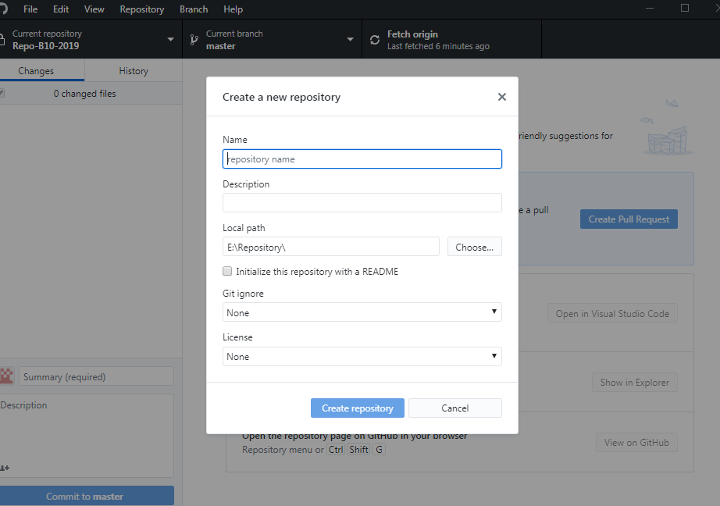

**The repo 🡪 “VCL-repo” and click on “Create Repository”**

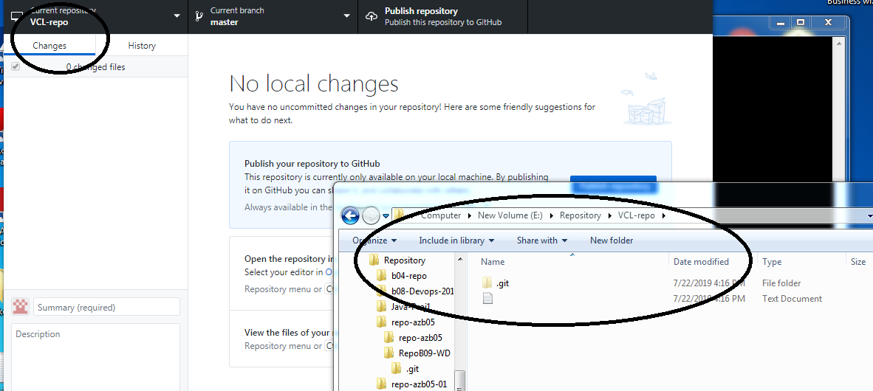

This would create a folder with “.git” in it.

Note🡪 to to see the hiden file , please enable “show hidden files” in the folder options.

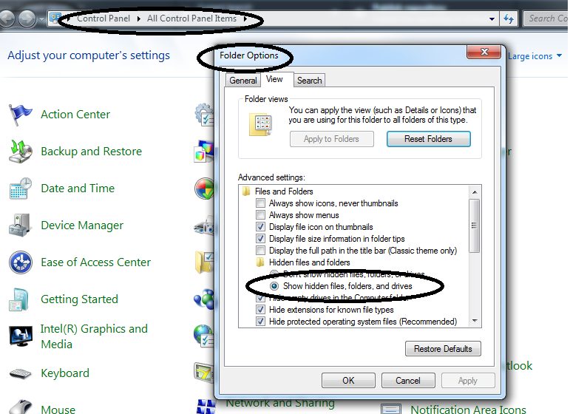

**Step2: Create a file (default it would be as master) with 1st line.**

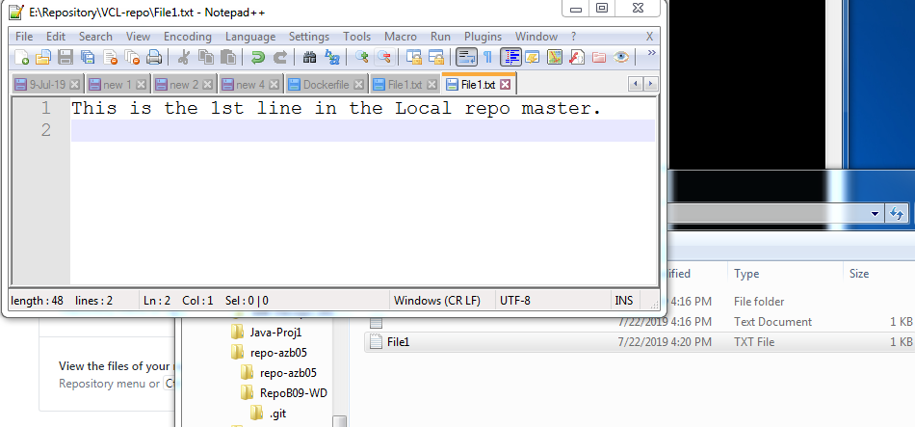

Save the file.

And once you click on the “GITHUB desktop”

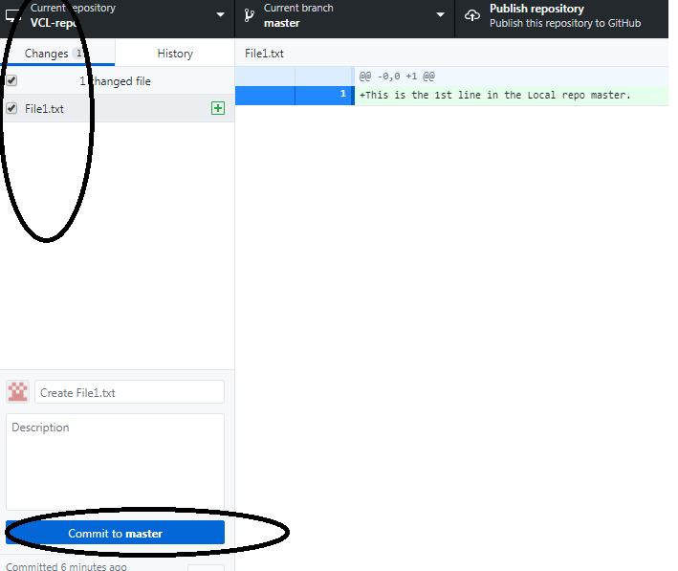

The changes are automatically detected.

Click on “Commit” to commit the changes to the local repo.

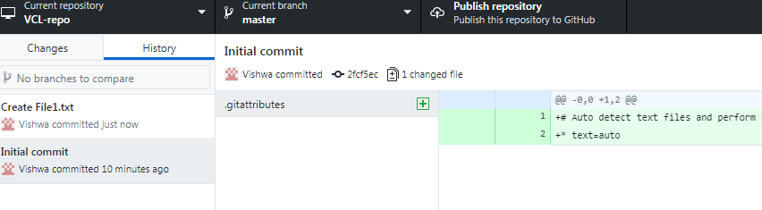

Once the commit is done, the details would reflect in the “history”

**Step3: Add 2nd line to the file and save it to the BRANCH on GIT local repo**

Create an branch “b1” now.

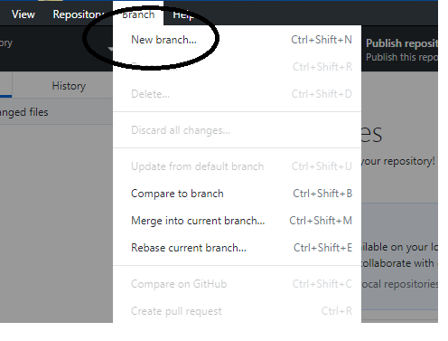

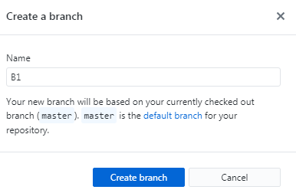

Click on “create Branch”

Next, lets add the 2nd line in the branch

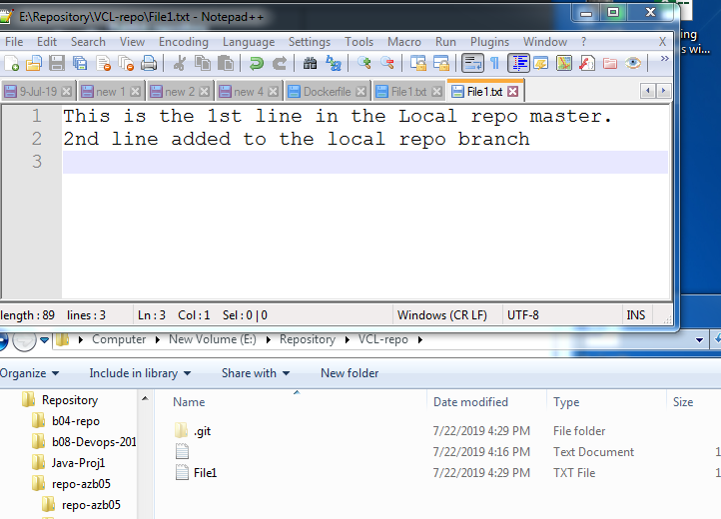

The changes would be detected in the GITHUB desktop

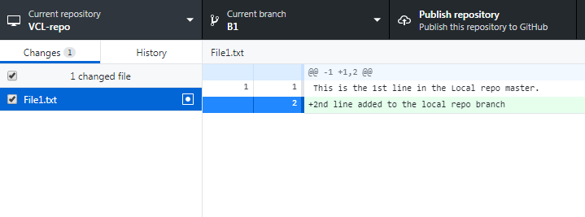

“Commit” the changes.

The “history” would show like below

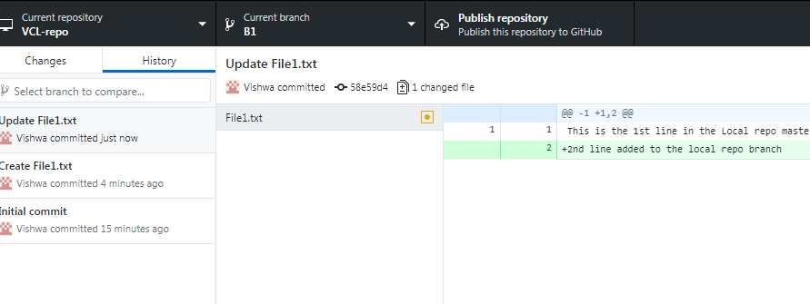

Note🡪 Once u change the “current Branch” to master.

The notepad++, will say that “the file was modified” and the “2n line” would disappear.

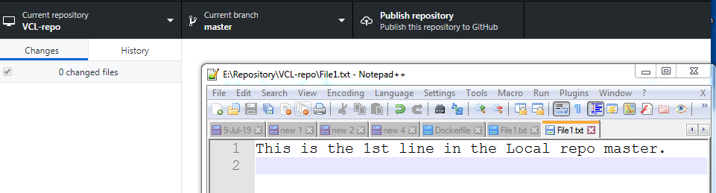

**Step4: Merge the file to the master.**

Switch back to master.

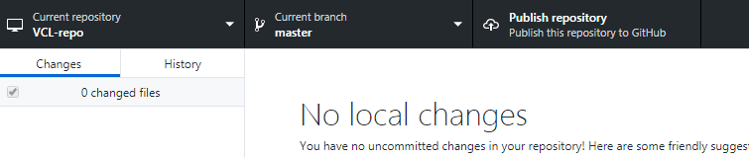

Now let’s merge the branch1 to master.

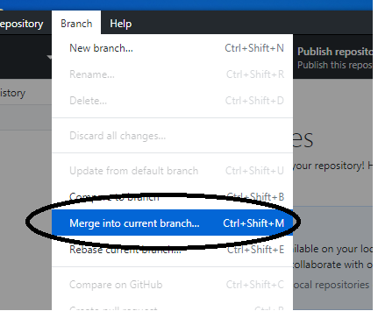

Click on the Branch 🡪 Merge into current branch,

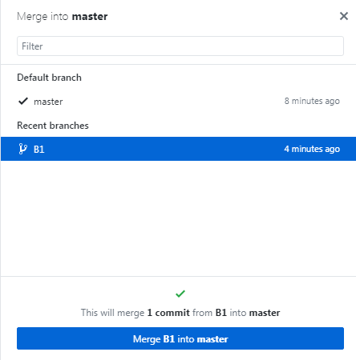

Select the Branch “B1” that needs to be merged with the master.

Then click on 🡪 “Merge B1 into master”

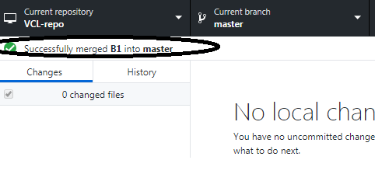

To test the output.

The Branch “b1” and the Master should show both the lines in the file.

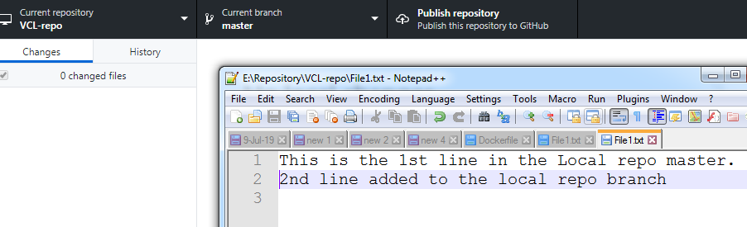

**Step5: Push local master to GITHUB.com.**

**To push the files from local repo git to GITHUB.com,**

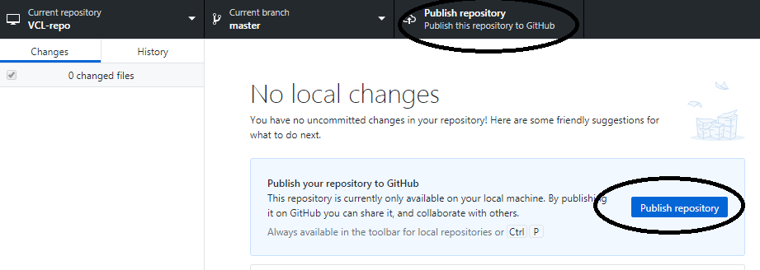

Select the “**Master**” and click on “**Publish Repository**”

**This would automatically create the repository in the GITHUB.com and push the files there.**

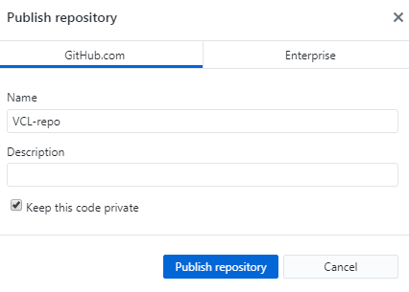

Make sure the “Keep this code private” is UNTICKED.

Note🡪 The remote repo name does not need to be the same as the local repo.

Just for our comfort we keep it the same.

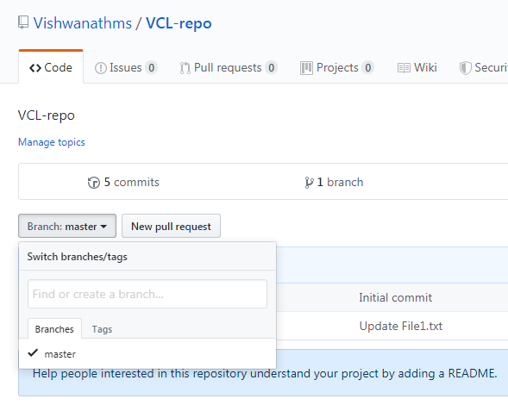

**The master copy of the “file1.txt” is visible in the GITHUB.com.**

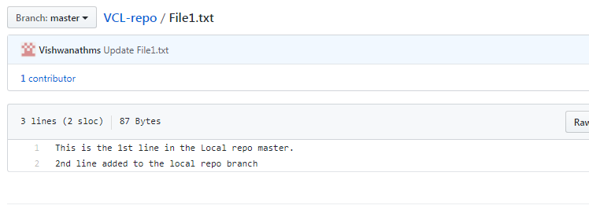

Now lets push branch copy.

Change the Current branch in the “Github desktop” to B1.

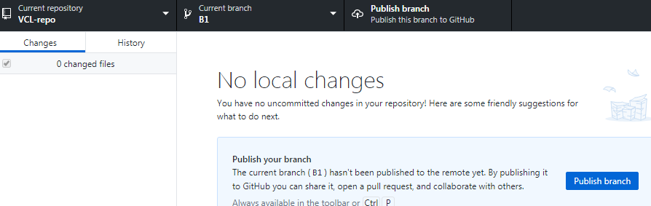

**Click on the “publish Branch”**

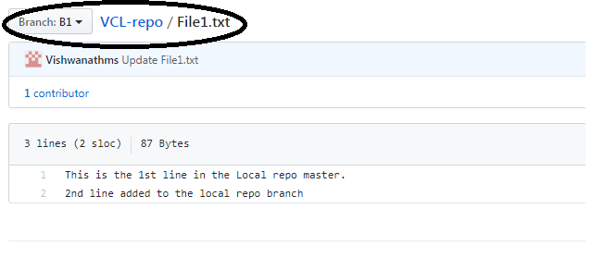

**This is the output of on the GITHUB.com on the branch.**

**Step7:**

**Finally, merge the Branch on GITHUB.com to Master on GITHUB.com.**

**Add 2 lines in the branch of GITHUB.com**

**To edit the branch**

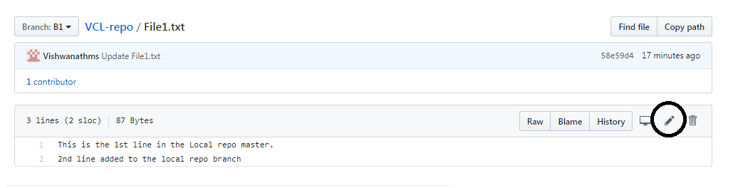

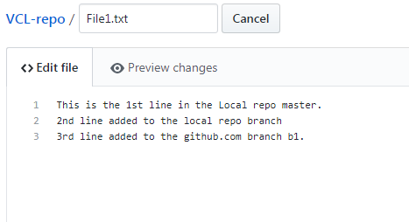

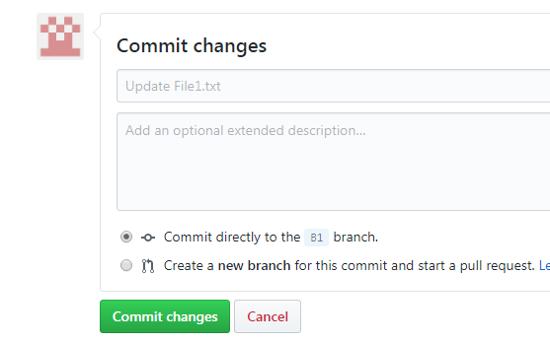

**Click On “Commit Changes”. This would commit to the Branch “b1”**

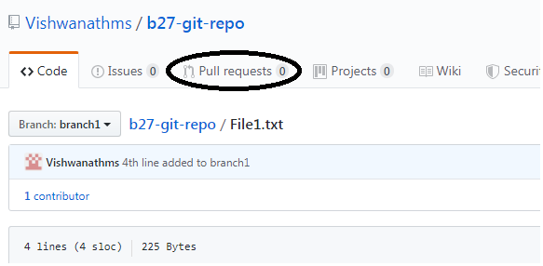

Click on **“Pull requests”**

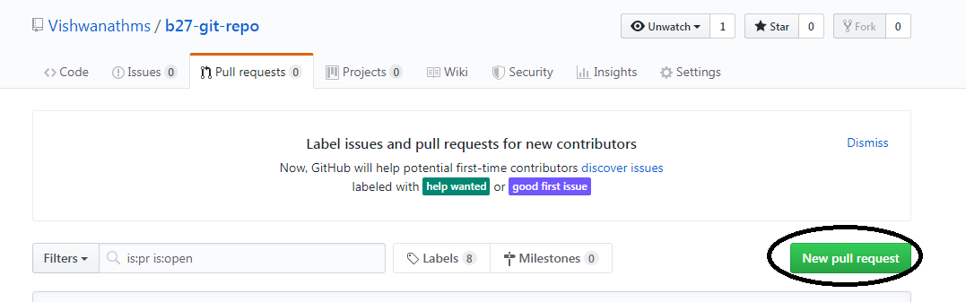

Click on **“New pull request”**

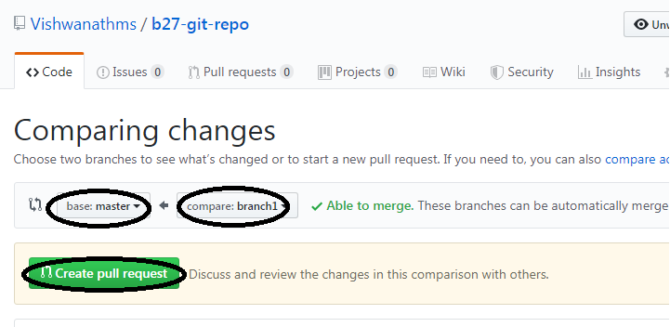

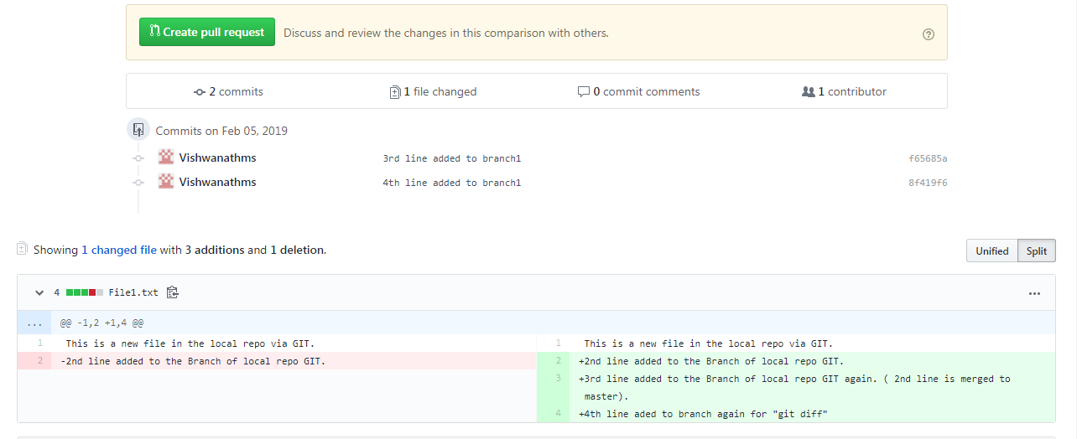

Select the source **“branch1”** and destination as **“master”**

There would be an comparison below between **branch** and **master**.

Then click on **“Create pull request”.**

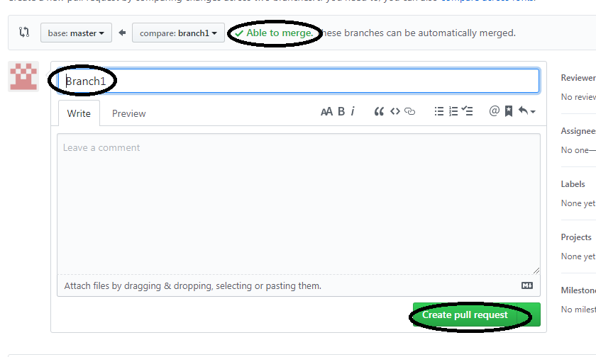

Once the **“Able to merge”** is highlighted then click on **“Create pull request”**

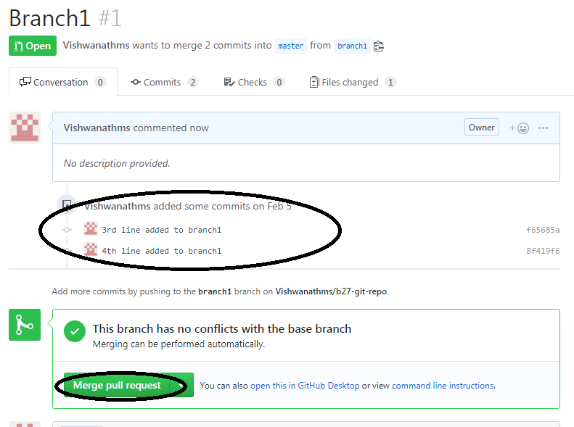

Click on “**Merge pull request**”

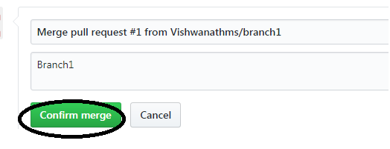

Click on **“Confirm Merge”**

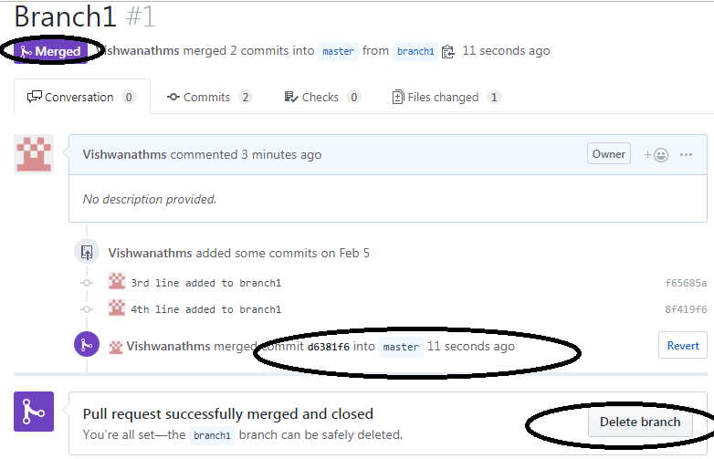

Now you have an option to “**Delete Branch”** after the merger.

**Output:**

