Create a file and commit it

Add a line to the file ( DO nOT Commit it )

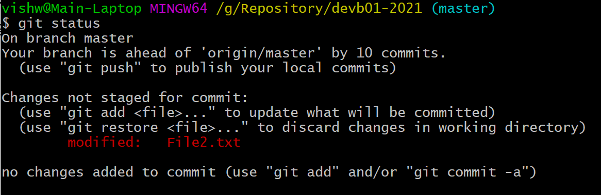

Run “**git stash**”

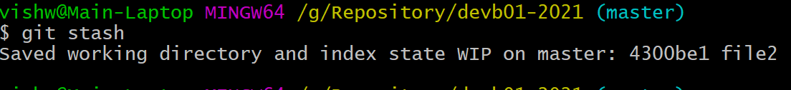

Run “git status” – this

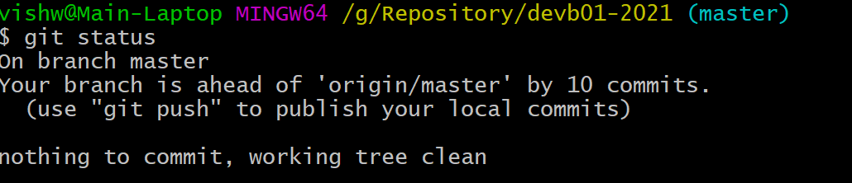

Running “git stash list” would list all the stashed messages

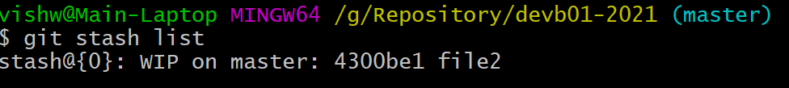

Now lets add –3rd line to the file

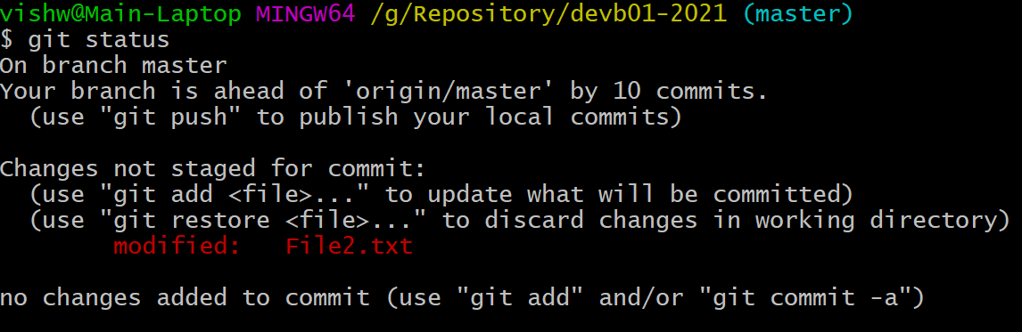

And then stash it again



Git stash list again

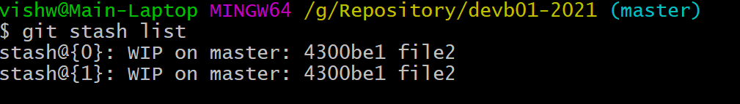

There are 2 stashed messages. Here the last stashed would be marked with index value of “0”.

Lets now stash with some message

Add 4th line in the file (**do not Commit it**)

But **stash** it

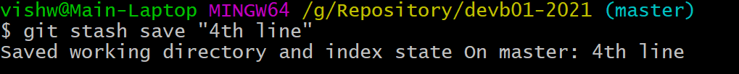

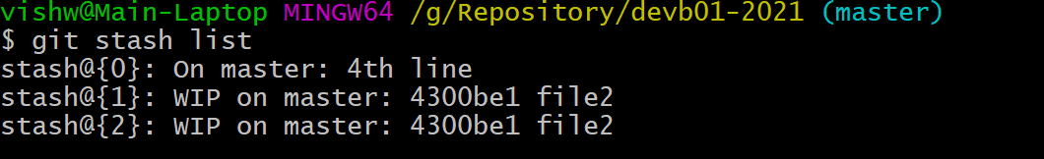

Now lets get the information from the stash back to the working directory.

In This case, we will get the specific stash

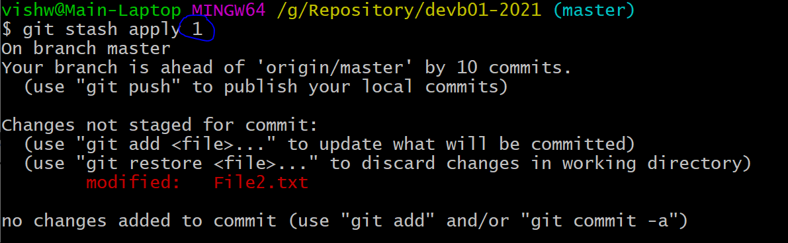

So instead of taking the first index value “0”, we are taking ‘1”.

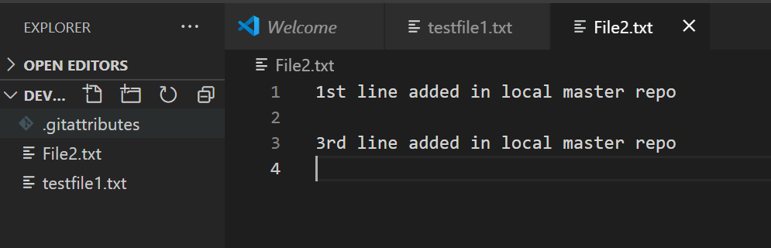

The copy of the stash message still remains in the stash

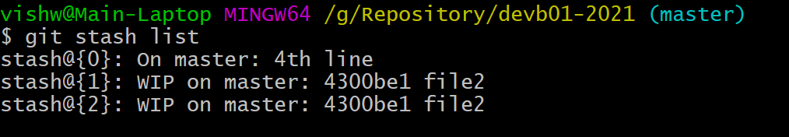

We could a commit this

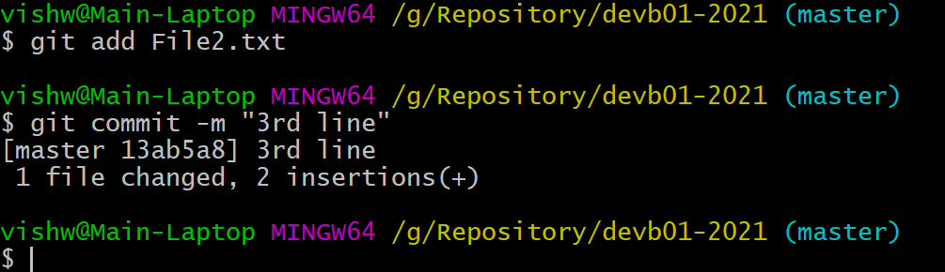

Now lets stash the index “2”.

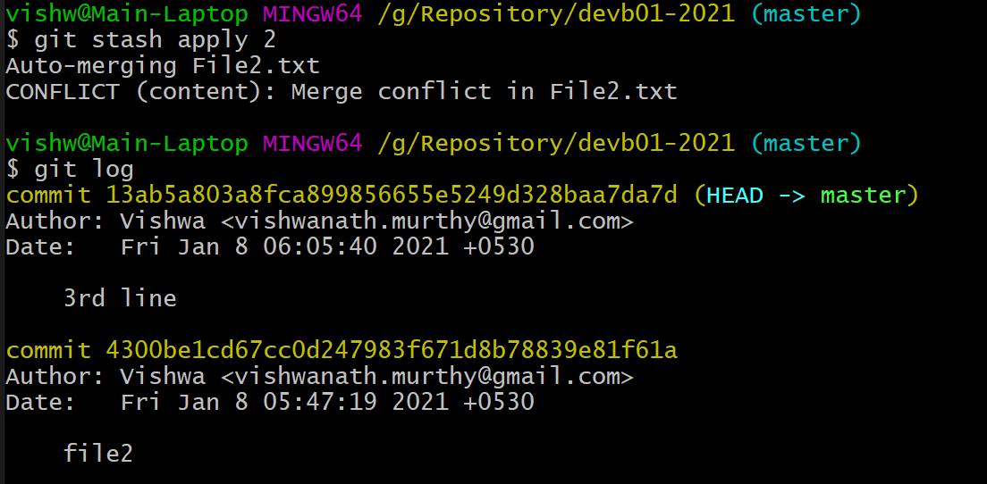

There would be an merge conflict, and it has to be cleared, bcz stash “2” has “4300be1c” commit as the ref .

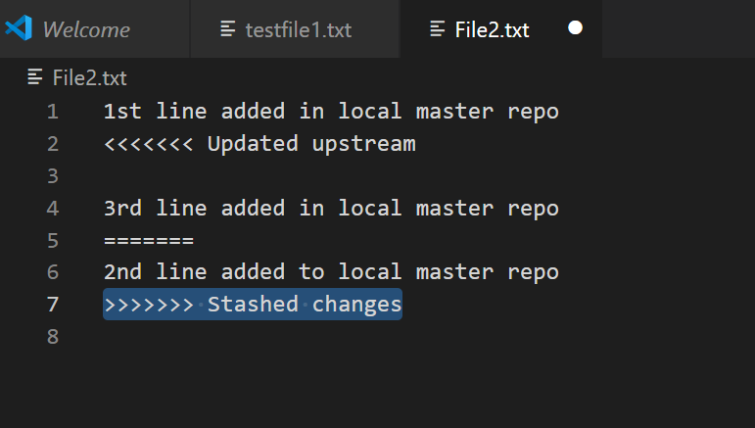

Clean up the code.

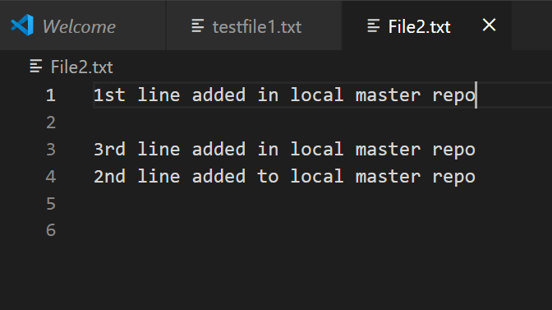

And commit it

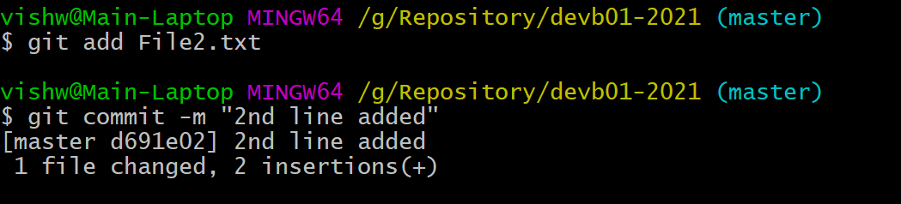

Git stash show

This would show the details of file

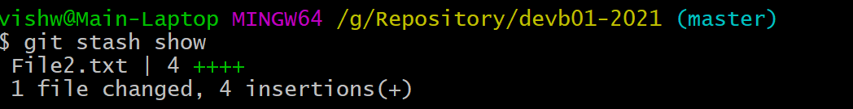

“git stash show -p 1”

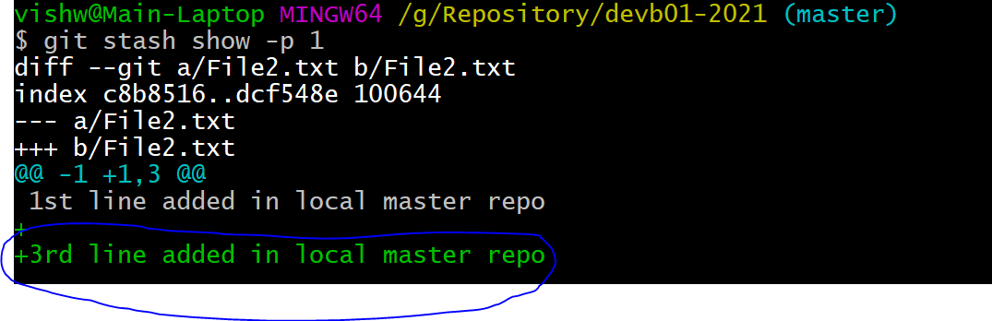

Showing the changes

Now lets clean the stash

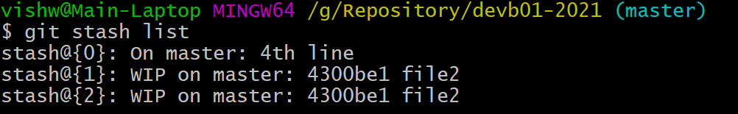

Lets remove the “1” stash



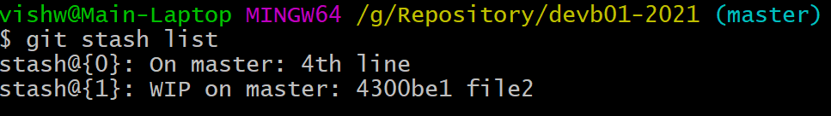

Even though we hve removed “1” now the index 2 is moved to “1”.

