How to ssh to vm on virtual box

Steps

1. Create an “NAT Network” and enable dhcp in that
2. Attach the VM to the above “NAT network”.
3. Restart the network service for linux machines
4. **Get the Ip of the VM .**
5. confiure the port forwarding on the virtual box NAT network.
6. Test the Connection from the laptop to the VM (Linux)

**Step:1**

Create an “NAT Network” and enable dhcp in that

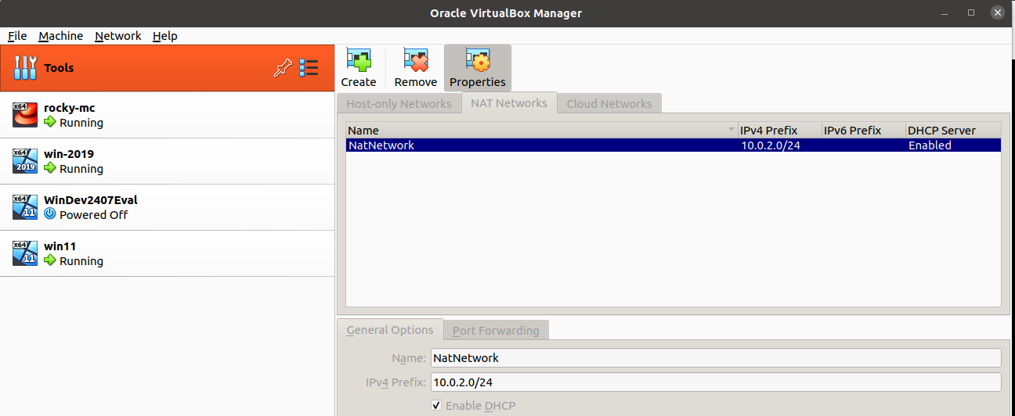

In the above image,

First Click on the “Tools” on the top left.

Then click on the “NAT Network”

Then Click on “Create” to create an entry as “NatNetwork” with default ipv4 prefix “10.0.2.0/24”.

In the Bottom, make the “DHCP “ is enabled.

Then finally in the right bottom corner, click on “Apply”.

**Step2:**

Attach the VM to the above “NAT network”.

On the VM click on the menu “Machine” --> “Settings”

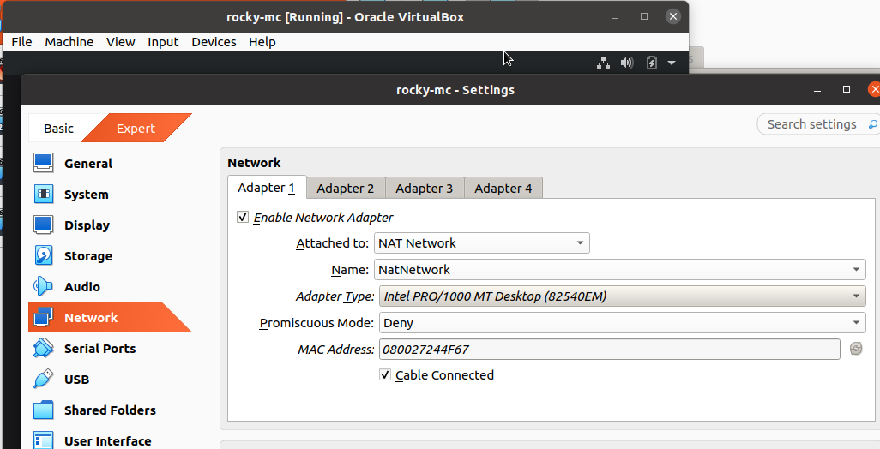

In the Settings, Click on “Network”

And against the “Attached to” – select “NAT Network”, automatilly in the Name below the name of the network should populate.

Click on “OK” in the bottom right corner.

**Step3:**

Restart the network service for linux machines

“systemctl restart NetworkManager”

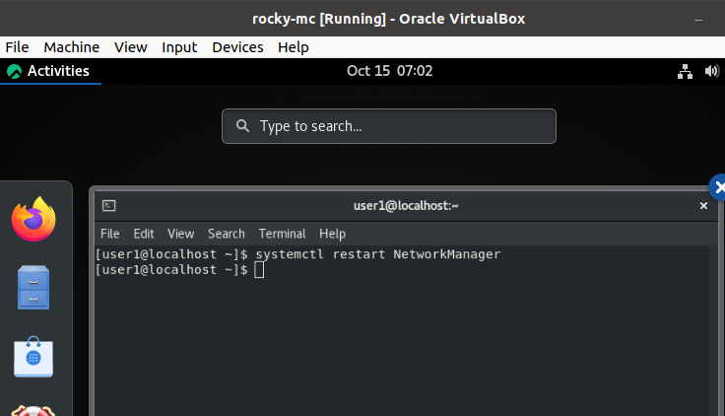

**Step4:**

**Get the Ip of the VM .**

$ ip a

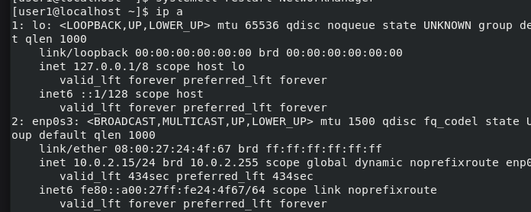

here our ip is **“10.0.2.15”**

Step5:

Confiure the port forwarding on the virtual box NAT network.

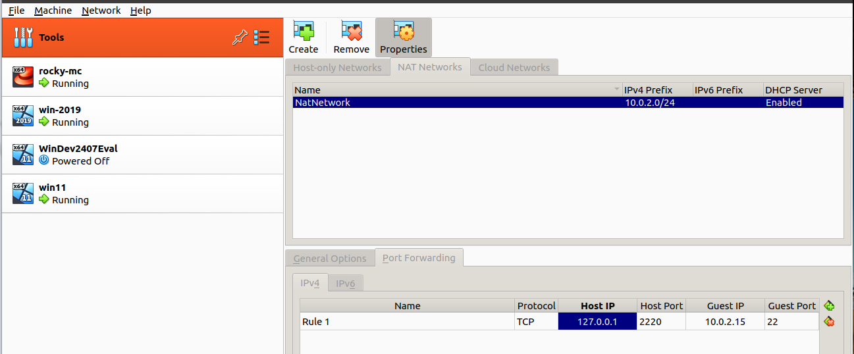

Bottom entryto be made on the “port Forwarding”

Rule1 TCP

protocol : TCP

Host IP : 127.0.0.1

Host Port : 2220 ( to be used any port above 2000, this would be ampped on the laptop port)

Guest IP : 10.0.2.15 ( the rocky linux ip address)

Guest port: 22

1. Test the connection

$ ssh -p 2220 [user1@127.0.0.1](mailto:user1@127.0.0.1)

1. Similarly for the windows

